TITLE | BILLING & PAYMENT TO CONTRACTORS
OBJECTIVE | To ensure timely billing of Contractor’s Accomplishment in order to process payroll payment promptly.
SCOPE | This procedure covers activities from receipt of Contractor’s Accomplishment and Billing Statement to releasing of payroll for payment.

Responsibility | Activities |  | Interfaces
Contractor/Site Engineer/Specialty Engineer/Admin – Project Site | Billing Preparation | Note 1 | Labor only contracts  1. Accomplishment Report  2. Scanned Pictures  3. Straight Line Diagram  4. Computation/Other Attachment  5. Project Materials Report  6. Contract
Admin – Project Site | Transmittal to Main Office
Document Controller | Scanning for Proof of Receipt and Documentation | Note 2
Junior Engineer | Checking and Verification of all Billing documents | Note 3
 | Approved?  NO  YES  Return to Project Site for Review and Correction | Note 3
Payroll Officer/Payroll Head | Checking and Verification | Note 4 | Summary of Payment
Finance Officer/ CFO/Payroll Head | Preparation of Check Payment and  Approval | Note 5 | Payment Voucher/ Overall Payroll Summary
President/CEO | Approval of Contractors Billing | Note 6 | Check  Payment Voucher  Project Accomplishment Report  Billing Summary Report  Labor Billing
Document Controller | Scanning for Documentation
Cashier | Release of Payment to Contractor | Note 7 | Payment Voucher

NOTE 1:

- Contractor submits Contractor’s Accomplishment Declaration Form to Project Site.

- Warehouse encoder shall ensure that all issuances of materials are encoded for the Project Materials Report.

- Site Engineer/Specialty Engineer shall prepare the following:
    - Pictures of accomplished areas
    - Key Plan
    - Computation Sheet
    - Work Checklist

- The Specialty Engineer shall:

  - Accomplish the Project Accomplishment Report
  - Compute for the Labor Only Billing
  - Prepare the Billing Summary.
  - Create the Project Contract (Labor Only)
  - Ensure that all necessary billing documents are complete for transmittal to Bata Office.

- Project Site Admin will create Transmittal Report and have the Billing Documents delivered to the Bata Office.

NOTE 2:

- Document Controller scans Contractors Billing documents upon receipt from Project Site and endorse it to Junior Engineer.

NOTE 3:

- Junior Engineer checks the following:

- All the contents of the report, accomplishments done and verify if there’s any double payments.
- Ensure that all supporting documents are attached on the Project Accomplishment Report
- Check if the accomplishments matched with the Computation Sheet

- Forward all Billing documents to the Payroll Officer for processing of billing and payment summary.

NOTE 4:
- The Payroll Officer shall ensure that all billing documents have complete attachments with signature of signatories and all computations are accurate.
- The Payroll Officer submits the checked documents to the Payroll Head for verification and forwards verified documents to the Finance Officer for check preparation.

NOTE 5:

      - Finance Officer shall then prepare payment voucher and check payment for contractors and forwards said documents to Chief Finance Officer for further checking and approval.
      - Finance Head forwards approved billing documents to Payroll Head.
      - Payroll Head shall create an Overall Payroll Summary and forward to President/CEO for approval.

NOTE 6:

- President/CEO shall approve by signing the following:
- Check
- Payment Voucher
- Project Accomplishment Report
- Billing Summary Report
- Labor Billing

- Payroll Head shall forward the approved payment voucher (PV) to Document Controller for scanning and forward to Cashier thereafter.

NOTE 7:

- Cashier shall release the payment to Contractor.

RECORDS GENERATED:

- Contractor’s Accomplishment Declaration HW-FM-FIN-007, HW-FM-FIN-007a
- Project Materials Report HW-FM-FIN-003
- Key Plan
- Issuance Slips HW-FM-IMA-002a-2b
- Computation Sheet HW-FM-CON-008
- Pictures of accomplished areas
- Project Accomplishment Report HW-FM-FIN-002
- Billing Summary Report
- Overall Payroll Summary
- Check
- Payment Voucher
- Labor Billing
- Project Contract (Labor Only) HW-FM-FIN-001a
- Project Contract (Labor and Materials) HW-FM-FIN-001b

REFERENCES:

- Construction Guidelines
- House Rules and Regulations

Prepared by:  Joymie R. Reyes  QMS Assistant | Confirmed by:  Karen Ramirez  Finance Head | Approved by:  Suzette B. Baguitan  Corporate QMS Head
Date: January 4, 2022 | Date: January 4, 2022 | Date: January 4, 2022

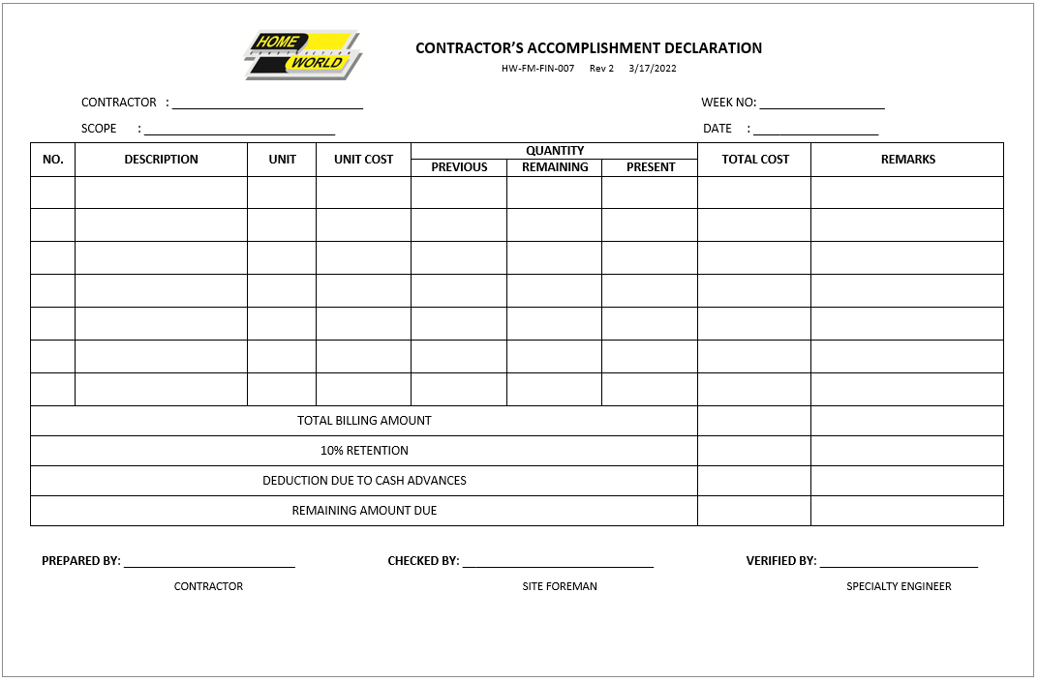
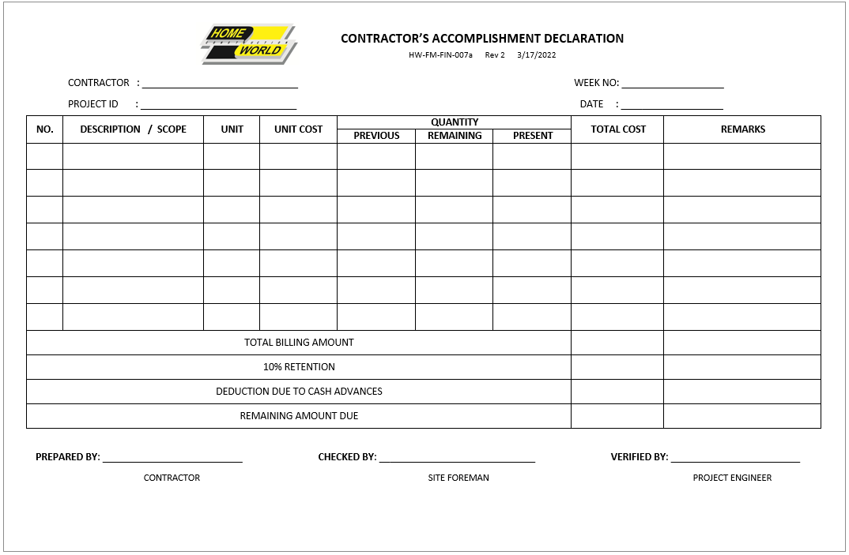
Contractor’s Accomplishment Declaration HW-FM-FIN-007, HW-FM-FIN-007a

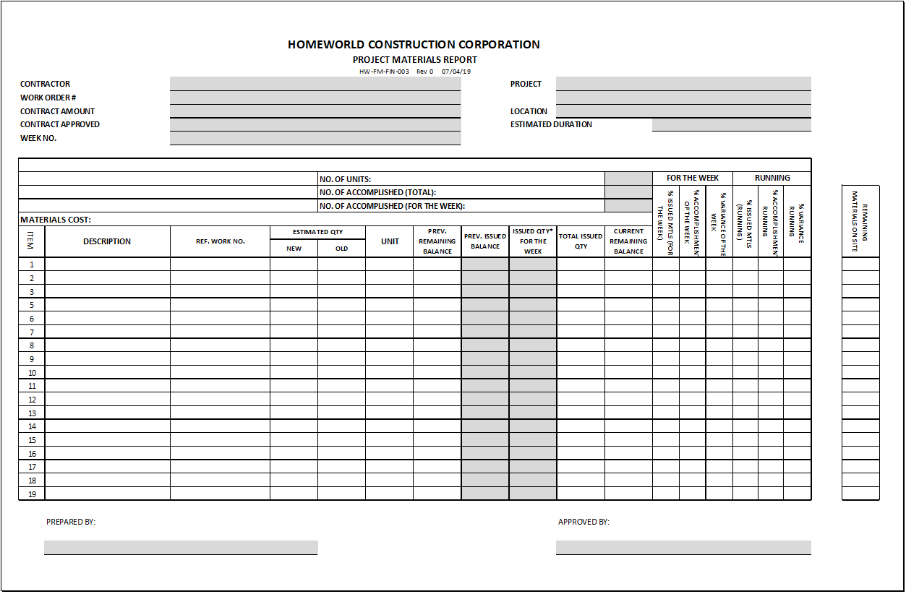
Project Materials Report HW-FM-FIN-003

Issuance Slips HW-FM-IMA-002a-2b
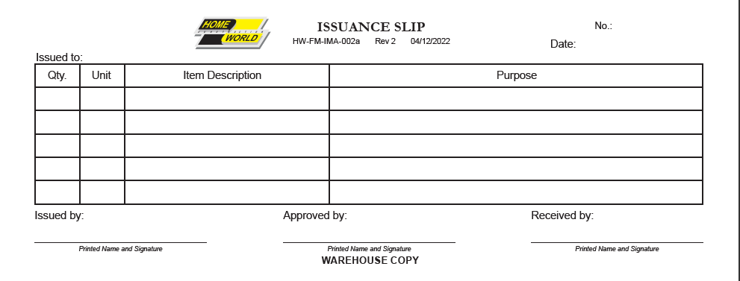

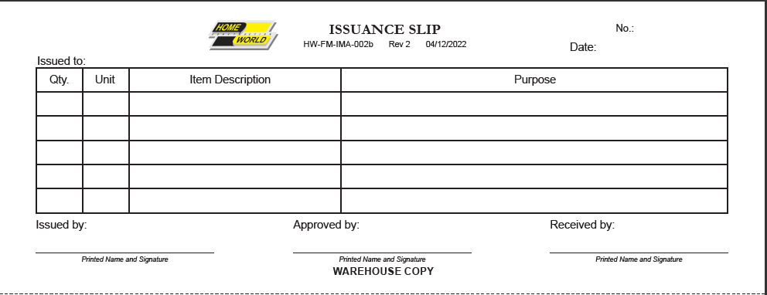

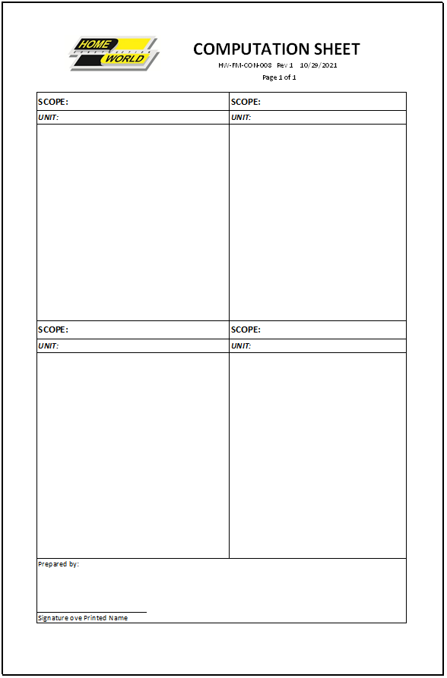
Computation Sheet HW-FM-CON-008
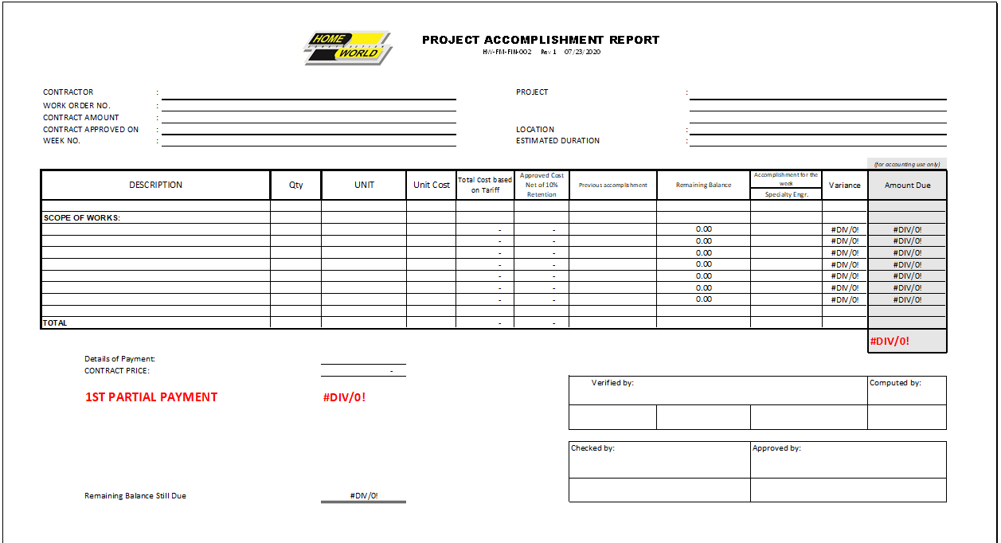
Project Accomplishment Report HW-FM-FIN-002

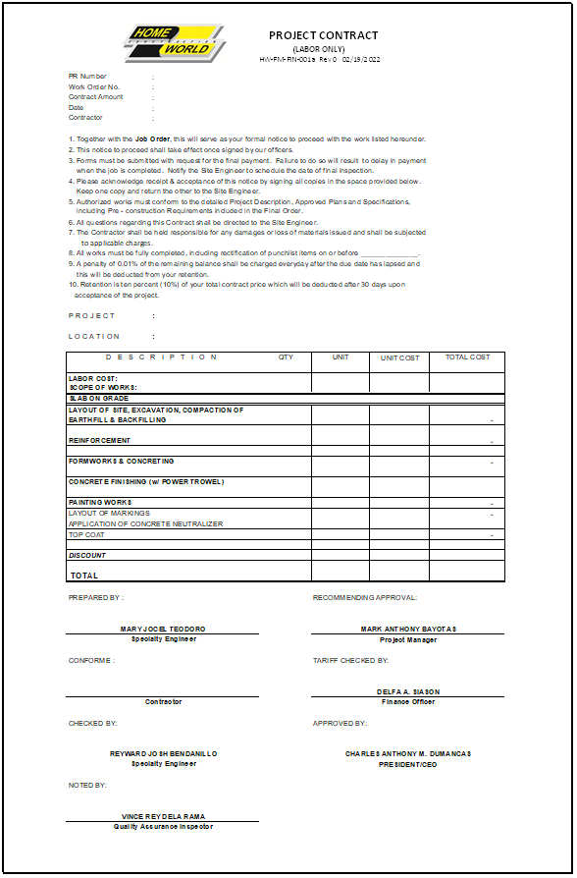
Project Contract (Labor Only) HW-FM-FIN-001a

Project Contract (Labor and Materials) HW-FM-FIN-001b
