Cumulative – 01

1. An API which returns information on all teachers - select \* from teachers

1. An API which returns all information on a teacher - select \* from teachers where teacherid = {inputId}

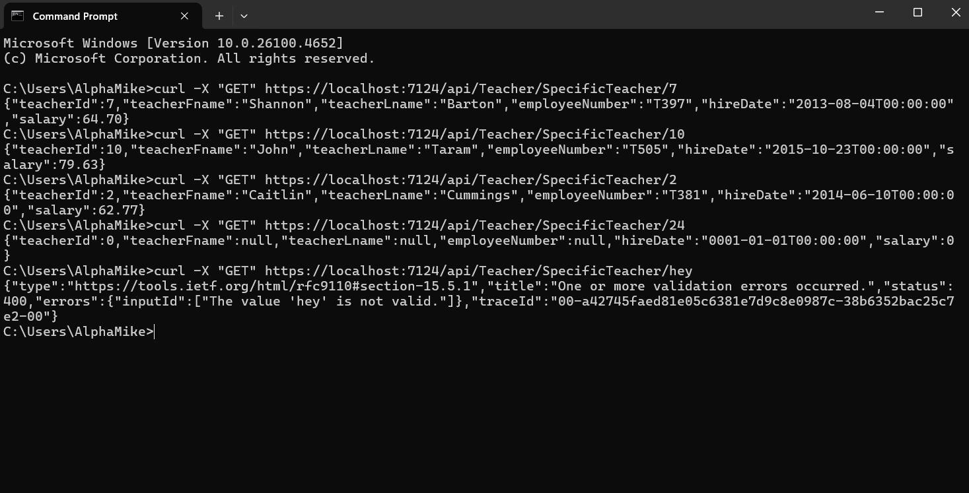

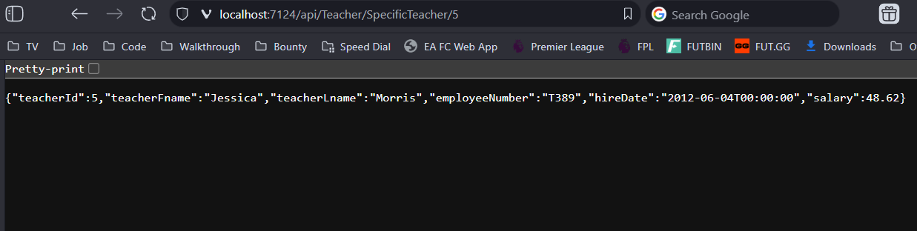

1. A web page that displays information on all teachers

1. A web page that displays all information on a teacher

