**Requirements**

You are required to complete the DevAssessment application only to allow any client to save and retrieve data from the below ERD. The client will send and receive the following structure.

**Please work in you own branch don’t check into the master Branch**

export class Student{

    id: number

    name :string

    surname:string

    gander:string

    email? : string

    phoneNumber ? : number

    contactPreference: string

    dateOfBirth :Date

    department:string

    isActive:boolean

    photoPath?:string

}

Follow the example already coded for department. Only provide functionality to save and retrieve student records.

**ERD**

Convert the below ERD into tables in sql server and add sample data. Please check in back your runnable scripts to create the database, tables and insert sample data in the route folder. Please note that all primary keys are auto generated



**Front End Part**

This application will run in vs code and below is the instruction to build and run the application

**Set up your environment.**

**1 install vs code**

**2 .Install Node js (** [**https://nodejs.org/en/**](https://nodejs.org/en/)**)**

**3 .Run install npm command against the folder StudentPortal\StudentPortal in the project**

**4. Install angular cli (https://cli.angular.io/)**

Test

Currently the application have the student data hard coded , Change this part to be responsive(pull from the database) use given api and follow the design principle for the project

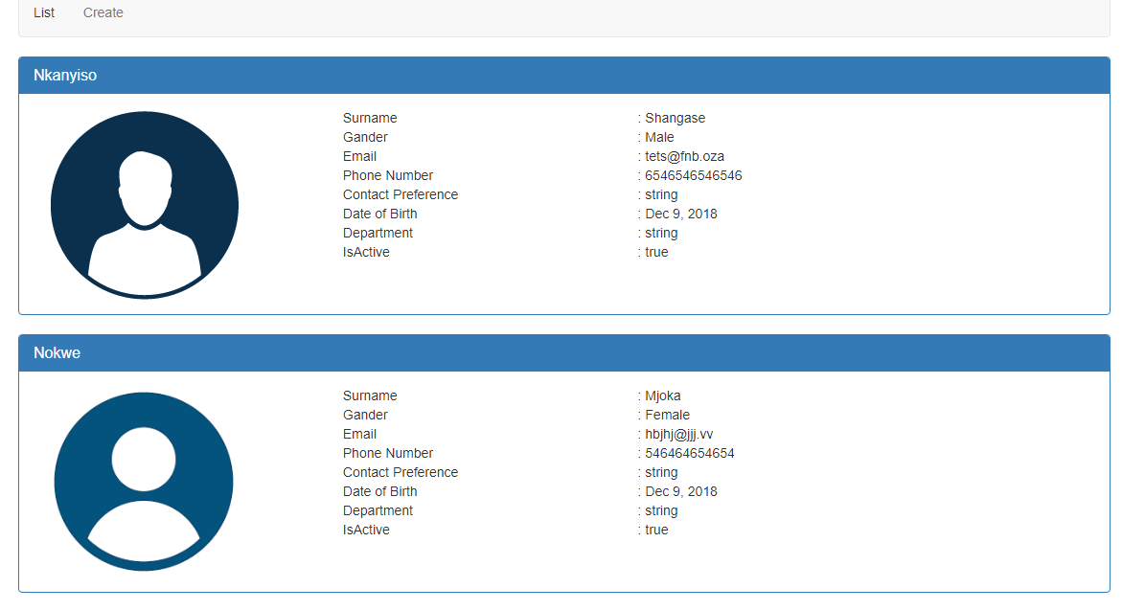

**Under Create Tab**

Fix **Save Button** to correctly save data to database

Create one more Tab called **PageNotFound** and config that page with the corresponding component (Note that this component does not exist).

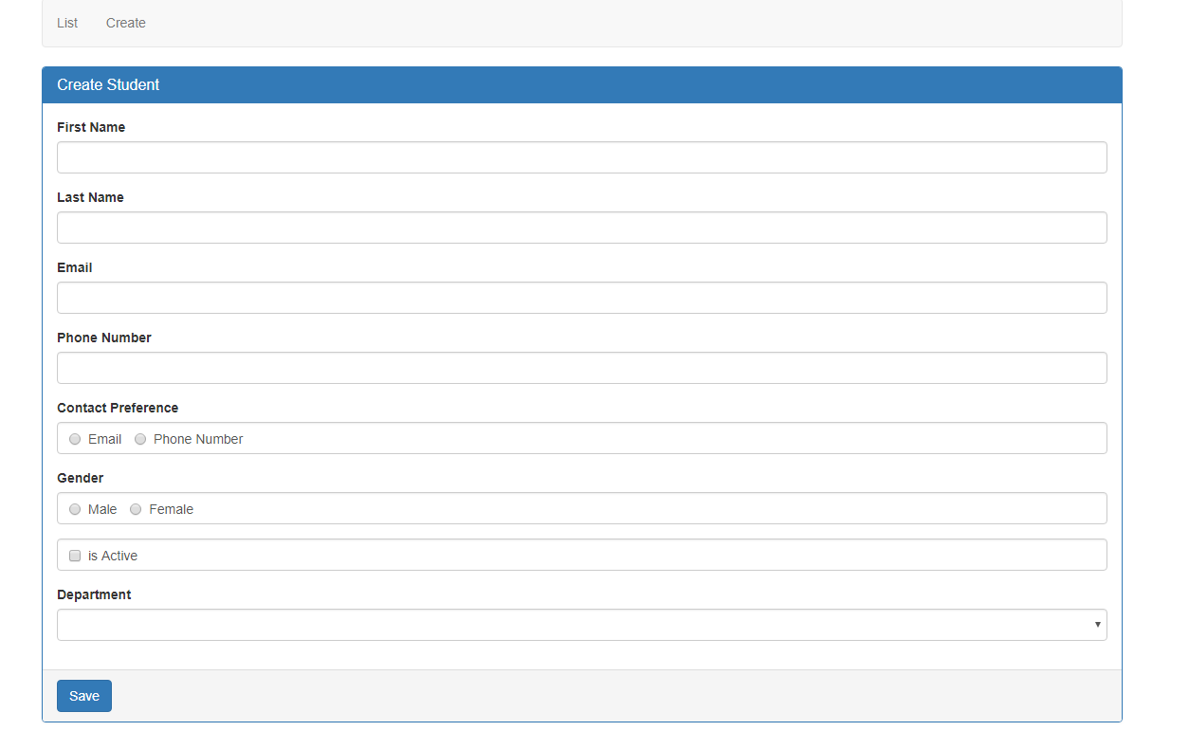

If I click on the **PageNotFound Tab** it should display the **PageNotFound** component

**Remember to check in you work when done Good lucky!!!!**