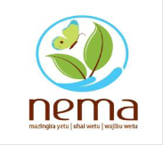

NATIONAL ENVIRONMENT MANAGEMENT AUTHORITY (NEMA)

County Director of Environment,

Bomet County,

P.O. Box 304,

Bomet.

Telegram: “NEMA” – Bomet

Cell phone: 0721551977

Email: [bomet@nema.go.ke](mailto:bomet@nema.go.ke)

Next to ‘Social Services’ Department Offices

**30th March, 2023**

**TO WHOM IT MAY CONCERN**

RE: **BRIAN KIPKIRUI (35237891), APPLICATION REFERENCE 1611298, MS ENVIRONMENTAL AND RESOURCE MANAGEMENT.**

Reference to your email for my professional reference, I wish to recommend him for the opportunity to advance his studies in your University without any hesitation whatsoever.

BRIAN KIPKIRUI ID No. 35237891 is well known to me at a professional level for a period of two (2) years having worked under my supervision for one (1) year while on attachment at National Environmental Management Authority (NEMA), Bomet Office.

He has an outstanding character, personal initiative, a young man of high integrity, dedicated to his work and a good team player. He demonstrate excellent communication and reporting skills.

I recommend him for the opportunity to advance his studies, he has the potential and all that it takes to perform much better in the scholarly world by improving his knowledge base.

Thanks in advance for your consideration.

Yours Sincerely,

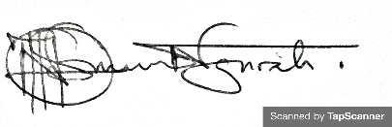

Mr. OSIEMO NGIRA

Senior Environment Officer-NEMA