**An Introduction to ATHENA-CDS (Assessment and Treatment for Healthcare: Evidence-based Automation - Clinical Decision Support System)**

**- Draft -**

*Document authors:*

**Susana Martins, MD1**

**Samson W. Tu, MS2**

**Mary K. Goldstein, MD1, 2, 3**

1. Geriatric Research Education and Clinical Center (GRECC), VA Palo Alto Health Care System, Palo Alto, California

2. Stanford BioMedical Informatics Research (BMIR), Department of Medicine, Stanford University, Stanford, California

3. Center for Primary Care and Outcomes Research (PCOR), Department of Medicine, Stanford University, Stanford, California

Views expressed are those of the authors and not necessarily those of the Department of

Veterans Affairs

Note: This Introduction uses, as an example of how the system can be presented to clinician users, the graphical user interface for the initial ATHENA CDS application, which focused on hypertension (HTN). Most recently, a new user interface, new methods of connection to the VA Regional Data Warehouse, and other extensions have been developed under a VHA Innovations Award.

Nothing in this Introduction should be taken as medical advice. Medical information is displayed for purposes of illustration only.

No actual patient information is contained in this Introduction. Any patient information displayed, such as blood pressure or list of medications or diagnoses, is synthetic data not linked to an actual patient.

For further information, contact: Mary K. Goldstein, MD

Director, Geriatrics Research Education and Clinical Center (GRECC) VA Palo Alto Health Care System

Phone: 650-493-5000 extension 6-2105

Email: [mary.goldstein@va.gov](mailto:mary.goldstein@va.gov)

Alternate contact: GRECC administrative staff 650-858-3933

TABLE OF CONTENTS

I. Introduction 5

I.1. ATHENA-CDS SYSTEM 5

I.1.1. What Is ATHENA-CDS SYSTEM? 5

I.1.2. ATHENA-CDS’s Technical Features 6

I.1.3. ATHENA-CDS Deployment 6

II. ATHENA-CDS Functions and Architecture 8

II.1. System Functions and Display 8

II.1.1. Recommendations Tab 9

II.1.2. Precautions and Assumptions Tabs 11

II.1.3. Lifestyle, Adherence, and Glossary Tabs 13

II.1.4. Supporting Documents 16

II.1.5. BP-Prescription Graphs 17

II.1.6. Patient Summary 18

II.1.7 Updated Graphical User Interface 19

II.2. System Architecture 21

II.2.1. EON System Architecture 22

II.2.2. ATHENA-CDS System Architecture 25

III. For Further Reading 31

IV. References 31

Preface

We believe that the clinical content of the Clinical Decision Support (CDS) should be based on an appropriate authoritative source, which should be identified by the health care system that is implementing the CDS. We take the “S” in CDS seriously, that is, we believe that the CDS should support the health professional, not push or attempt to replace the health professional.  The CDS should present information that will be helpful to the decision-maker, not attempt to make the decision for them.  It should assume a professional approach and recognize the importance of clinical judgment, presenting options for consideration with the final decision to be made based on clinical judgment in consideration of patient goals and preferences.  Good clinical care calls for individualization of therapy.  Computers should do things that computers do well – search, retrieval, calculation – and leave judgment to the human decision-maker. In order to be able to do the above, it is useful to have a computing infrastructure that allows for rapid entry and updating of clinical knowledge, revision of message content, etc, so that the clinical content encoded into computable format can be tailored to the content desired by the appropriate clinical authority.

1. Introduction
   1. ATHENA-CDS SYSTEM
      1. What Is ATHENA-CDS SYSTEM?

ATHENA-CDS refers to a clinical decision-support system that generates patient-specific recommendation for guideline-based care. The initial system focused on the management of hypertension [1]. Now it includes multiple knowledge bases in different clinical domains. We have pilot tested and published about ATHENA-Opiate Therapy (OT), developed to assist health professionals with safe management of opiates in chronic pain [ref]. We have also developed ATHENA-CDS knowledge bases for heart failure (HF), diabetes mellitus (DM), chronic kidney disease (CKD) and hyperlipidemia. The end-users of the system are clinicians who are making decisions on the management of care for patients who have these diseases. We currently use “ATHENA-CDS” to refer to the system as a whole, and use “ATHENA-HTN” to refer to the initial system.

ATHENA-CDS SYSTEM—also referred to simply as ATHENA-CDS—takes patient information from an electronic health record (EHR), combines it with encoded knowledge of about how to manage a disease, and generates patient-specific recommendations, explanations and evidence-based education. ATHENA-HTN uses guideline knowledge based on the widely endorsed Seventh Report of the Joint National Committee on Prevention, Detection, Evaluation, and Treatment of High Blood Pressure (JNC 7) [2] and on Department of Veteran Affairs guidelines [3]. The other knowledge bases are based primarily on VA guidelines. ATHENA-CDS can be configured with alternative displays for end users. For example, ATHENA-HTS displays recommendations in a pop-up window over the EHR cover page for specified patients at selected times.[[1]](#footnote-1) It makes recommendations to add, substitute, delete, or change drug dosages, according to how well blood pressures are controlled and to comorbid diseases that represent “compelling” (per JNC 7) indications (e.g., beta adrenergic receptor antagonists after myocardial infarction), relative indications (e.g., thiazides for patients with osteoporosis), relative contraindications (e.g., beta adrenergic receptor antagonists for patients with depression), and strong contraindications (e.g., beta adrenergic receptor antagonists for patients with asthma). The system also displays messages that detail precautions, assumptions the system makes in generating recommendations, and additional explanatory text [1, 4].

ATHENA-CDS is part of a larger research program that has developed methods for and evaluated the implementation of clinical practice guidelines and for computing complex performance measures for panels of patients.

* + 1. ATHENA-CDS’s Technical Features

ATHENA-CDS SYSTEM uses the EON architecture for developing guideline-based decision-support systems [5]. The EON architecture, created at Stanford Center for Biomedical Informatics Research, provides ATHENA-CDS with the platform-independent technology to:

1. encode guidelines in computer-interpretable form [6, 7];
2. apply guideline knowledge to data for individual patients, through the EON Guideline Interpreter [9].

ATHENA-CDS uses Protégé [10] as the tool to build and maintain its knowledge base.[[2]](#footnote-2) Also developed at Stanford, Protégé provides an interface that clinician-managers can easily use to browse and update the guideline knowledge base.

A platform-independent system, ATHENA-CDS is designed for integration with legacy patient data systems, such as the system used by clinics at Department of Veteran Affairs (VA) medical centers. VA clinics’ data system is composed of the Veterans Health Information Systems and Technology Architecture (VistA) [12] and its user interface, Computerized Patient Record System-Graphical User Interface (CPRS-GUI; [13-15]. ATHENA-CDS has been implemented on VistA and integrated into the CPRS, displaying recommendation pop-ups when appropriate (see Subsection ).

* + 1. ATHENA-CDS Deployment

The hypertension version of ATHENA-CDS has been deployed and evaluated in two large randomized, controlled trials. The first took place in the primary care clinics at three VA medical centers—VA Palo Alto Health Care System (VAPAHCS), San Francisco VA Medical Center, and Durham VA Medical Center. The trial lasted 15 months, ending in July 2003. The trial evaluated the impact of providing ATHENA-CDS’s guideline-based decision support for patient care. The primary outcome measures for the trial were patients’ blood pressure control and clinicians’ concordance with guideline-based drug recommendations.

The second evaluation of ATHENA-HTN took place in ....

To deploy ATHENA-CDS at a VA medical center, clinical managers who are expected to decide whether or not to implement and monitor ATHENA-CDS may want to browse the knowledge in the system and test the system in their own clinical practice.

Clinical managers at each medical center could, in theory, change the ATHENA-CDS Knowledge Base or other aspects of the system for their medical center. For instance, a clinician-administrator can modify the hypertension knowledge in the knowledge base (e.g., formulary preferred drugs or the strength of indications and contraindications). However, to date, the clinical managers outside VAPAHCS have opted to leave all maintenance of the ATHENA-CDS Knowledge Base to the developers at VAPAHCS. This relieves them of taking on the responsibility and training entailed by testing the system for accuracy and installing updates to the system.

In addition to choices about encoding the guideline knowledge, system implementation involves decisions requiring clinical input such as when to display recommendations. For instance, a clinical manager can modify the triggers for popping up ATHENA-CDS’s advisory window. She may consider questions such as: Do clinicians want to see the recommendations for all patients with targeted disease who meet the inclusion criteria? Or only those patients who do not meet performance measures or whose key indicators, such as hemoglobin A1C, are above certain threshold? Do they want to see recommendations only on the day of a clinic appointment? Or do they want to see recommendations within a window of a certain number of days surrounding a clinic appointment? The ATHENA-HTN system was programmed to pop up an advisory window when a participating clinician in a primary care clinic logs onto CPRS-GUI and opens the record of an eligible patient within a five-day window of a previously scheduled primary care clinic appointment. However, the system can be reprogrammed to function differently in different settings, as desired and appropriate.

In contrast, clinician end-users will not generally make such changes to the ATHENA-CDS Knowledge Base, but can use ATHENA-CDS to receive guideline-based advisories on the management of care for patients who have targeted disease. They may want to use ATHENA-CDS to try what-if scenarios, modifying a patient’s clinical data through the ATHENA-CDS user interface to see what advisories the system would generate.

The purpose of this Introduction is to provide an overview of the functions and architecture of ATHENA-CDS SYSTEM. It is aimed at clinical investigators and managers who need a conceptual understanding of the capability, architecture, and operational requirements of ATHENA-CDS SYSTEM. The rest of the document describes the functions and architecture of the ATHENA-CDS SYSTEM, including its components, its construction using EON architecture, and the flow of information in generating guideline-based recommendations. It gives a general idea of how various components work and affect each other.

1. ATHENA-CDS Functions and Architecture

The optimal presentation of ATHENA recommendations to end-users will depend on the clinical roles of the intended users, the targeted disease, and clinic workflow in which ATHENA-CDS is embedded. This section summarizes the display window of ATHENA-HTN as an example of how ATHENA-CDS functions can be presented to a prospective user (Subsection II.1), then describes the architecture of the overall system and how components of the system work together to generate these functions (Subsection II.2).

* 1. System Functions and Display

ATHENA-HTN delivers its decision-support functions through a pop-up window that appears on-screen within the Computerized Patient Record System (CPRS) window. When an eligible health-care provider accesses the electronic medical record of a patient diagnosed with hypertension and medical conditions that satisfy ATHENA-HTN’s inclusion criteria, the window appears superimposed on the CPRS coversheet. From the first pop-up window (Figure 1), the user has the option to bring up a second pop-up window that displays a summary of patient information relevant to the management of hypertension.

At the top of the first pop-up window, shown in Figure 1, are the name (not shown in the figure, but displayed in the deployed system) and Social Security Number (also not shown in the figure, but displayed in the deployed system) of a dummy patient. Below the demographic information are the most recent blood pressures, used to generate the recommendation.

**ATHENA-HTN computes the appropriate target blood pressures based on the comorbidities of the patient (e.g., diabetes diagnosis) and displays the guideline goal systolic blood pressure (SBP) and diastolic blood pressure (DBP). It compares the most recent blood-pressure measurements to the targets in order to determine whether the patient’s blood pressures are under control. A message flags when blood pressure is not under control, as shown in red in** Figure 1. An ATHENA-HTN user has the option of entering today’s decision-making diastolic and systolic blood pressures (BP taken by a nurse, a BP recheck, home BPs, or an aggregate of these) and getting an updated advisory (i.e., set of recommendations).

The rest of ATHENA-HTN’s decision-support functions are organized in a number of tabs: Recommendations, Precautions, Assumptions, Lifestyle, Adherence, Glossary, and BP-Prescription Graphs. Additional explanations are provided through ATHENA-HTN’s evidence-based supporting documents. The tabs, supporting documents, and patient information summary are described in the following subsections.

* + 1. Recommendations Tab

The Recommendations tab presents recommendations to bring the health management of the selected patient into compliance with the encoded hypertension guidelines. This tab appears as default, it includes a primary recommendation message section, a table of drug-related recommendations with corresponding reasons for the suggested changes, an area for the clinician to enter comments, and buttons for the clinician to indicate whether the recommendations were taken into consideration.

Primary recommendation: The primary recommendation, consisting of the most important advisory messages, is seen at the top of the tab page. For a patient with blood pressure that does not seem to be controlled, a message may say “Consider INTENSIFYING drug treatment; BP ELEVATED based on most recent BP” (see Figure 1). This example tells the clinician that the patient's blood pressure is not at a level the guidelines consider to be acceptable for a patient in the given condition, and that the patient's prescription(s) should be modified. In this case, the details are provided in the drug recommendation table, below the primary recommendation table.

Drug recommendation: The recommendations for modifying drug treatment in accord with the primary recommendation(s) are shown in the table below the primary recommendation. In Figure 1, “Increase dosage of lisinopril,” “Add DHP Calcium Channel Blocker,” and “Add Cardioselective Beta Blocker” are offered as guideline-concordant therapeutic possibilities for a clinician to consider. Clicking on the Info buttons next to these suggestions brings up additional information that may be important in evaluating each possibility.

Entries in the Reasons column encapsulate patient-specific considerations involved in each therapeutic recommendation. Icons for Compelling Indication, Relative Indication, Strong Contraindication, Relative Contraindication, and Adverse Events indicate the status of each consideration. For example, DHP calcium channel blocker is recommended because “Isolated Systolic Hypertension” is a compelling indication for its use. Cardioselective beta blocker has a relative indication of the patient’s coronary artery disease, but the patient’s obstructive pulmonary disease is a relative contraindication for its use.

The Feedback buttons in the right column give a clinician the opportunity to supply coded reactions to each drug recommendation (e.g., “Patient had not tolerated this drug in the past” or “Patient is not adhering to medications already prescribed”; see Figure 3).

Comment section: A textbox, shown below the drug recommendation table in Figure 1, allows clinicians to enter free-text comments. The comments can help ATHENA-HTN developers understand what clinicians find useful or problematic in ATHENA-HTN, so they can improve the system.

**Check box for DO NOT DISPLAY:** Until this box is checked the advisory appears in a pop-up window each time the patient’s record is accessed by an appropriate clinician within the 5 day window of the clinic appointment. Some clinicians review charts prior to clinic visits and want to see the advisory again when the patient is in clinic and an updated BP has been taken. However, they do not want to continue to see the advisory when accessing the patient record for other reasons after they have addressed the blood pressure.

Disposition buttons: Black buttons at the bottom of the Recommendations tab (*Recommendations considered, Not Read, Not a clinical priority today* in Figure 1) provide a quick way for a clinician to close the ATHENA-HTN pop-up window, while also supplying feedback on their use of the ATHENA-HTN SYSTEM.

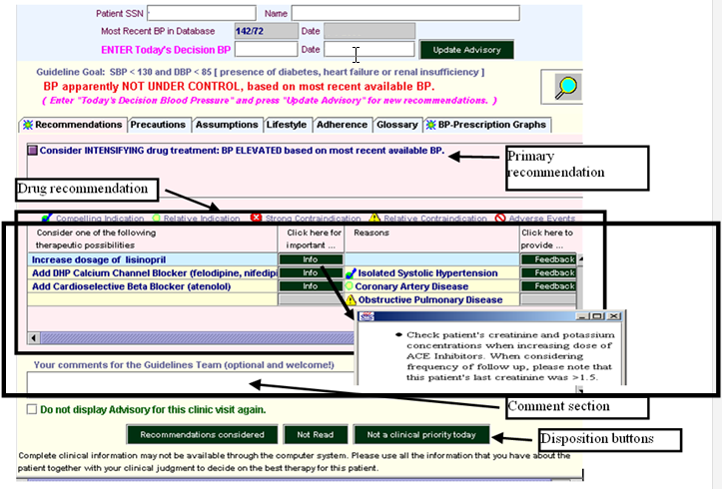

Figure - ATHENA-HTN hypertension advisory window, showing details of the Recommendations tab

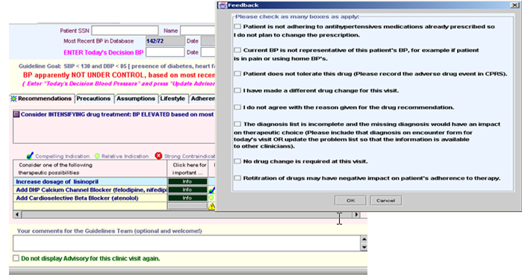

Figure - ATHENA-HTN Recommendations tab, showing Feedback form

* + 1. Precautions and Assumptions Tabs

The Precautions tab (Figure 4) contains patient-specific comments and warnings about the patient’s medical conditions and about the antihypertensive agents that have already been prescribed.

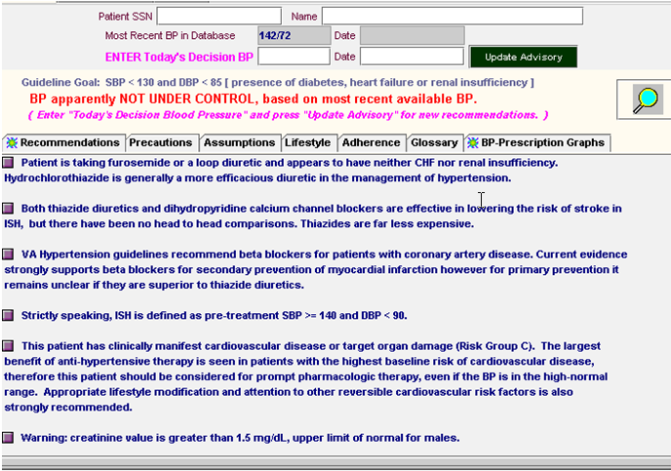

Figure - ATHENA-HTN Precautions tab

The Assumptions tab (Figure 5) contains messages that state ATHENA-HTN’s boundaries, limitations and assumptions. For example, ATHENA-HTN does not deduce any diagnoses from procedure reports (e.g., EKG, X-Ray). Furthermore, if no adverse reaction is listed for a currently prescribed antihypertensive drug, then ATHENA-HTN assumes that there is none.

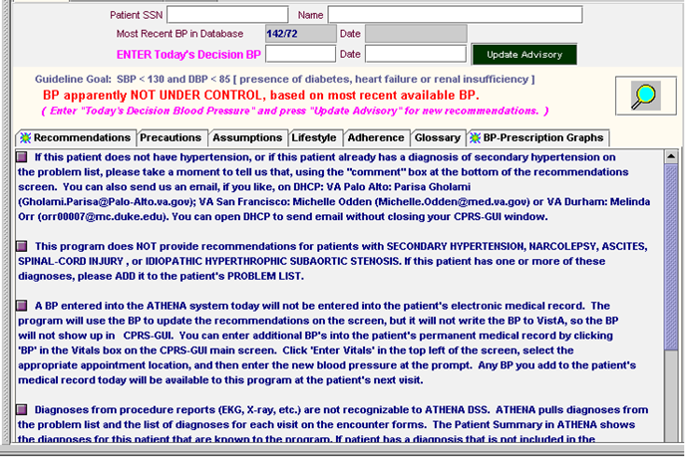

Figure - ATHENA-HTN Assumptions tab

* + 1. Lifestyle, Adherence, and Glossary Tabs

The Lifestyle, Adherence, and Glossary tabs respectively give:

1. evidence supporting lifestyle changes that may have an impact on hypertension, regarding factors such as diet, smoking cessation, exercise, and alcohol consumption (Figure 6);
2. general suggestions of ways to improve patient adherence to a therapeutic regime (Figure 7); and
3. a glossary providing definitions for terms used in the pop-up windows (Figure 8).

These three tabs open static pages containing general content not custom tailored to the specific conditions of a patient.

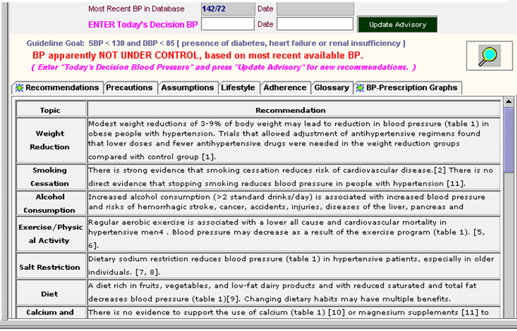

Figure - ATHENA-HTN Lifestyle tab

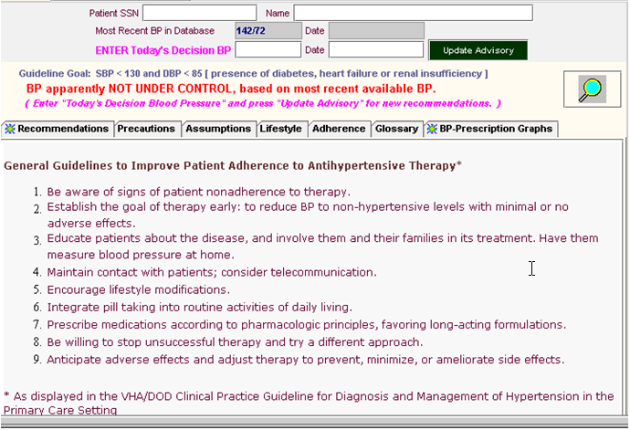

Figure - ATHENA-HTN Adherence tab

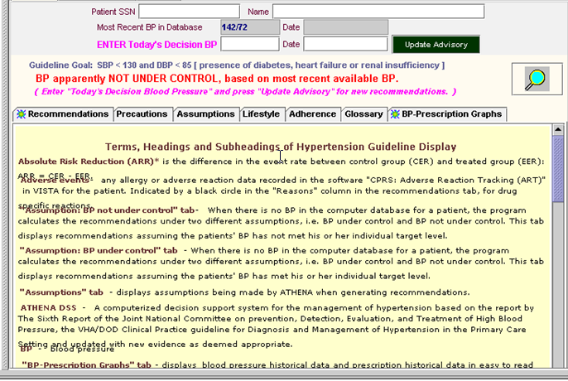

Figure - ATHENA-HTN Glossary tab

* + 1. Supporting Documents

The ATHENA-HTN system provides explanatory supporting documents on the use of specific drugs in the presence of certain comorbidities. It activates these documents when a user drags the magnifying glass icon (woz_icon) and drops it on top of a compelling indication (e.g., Isolated Systolic Hypertension) for the use of an antihypertensive agent (e.g., DHP Calcium Channel Blocker). These supporting documents are provided in HTML format and accessible through a tab-based interface (Figure 9 ). They include studies, guidelines, and evidence supporting the particular recommendations made for a patient. The Short Summary tab (see Figure 9) provides a summary of the evidence related to the use of a class of antihypertensive agents in the presence of a comorbidity. Subsequent tabs present relevant literature from *ACP Journal Club, Clinical Evidence*, *The Sixth Report of the Joint National Committee Guidelines on Prevention, Detection, Evaluation, and Treatment of High Blood Pressure (JNC 6), PubMed,* and the *VA Guidelines*.

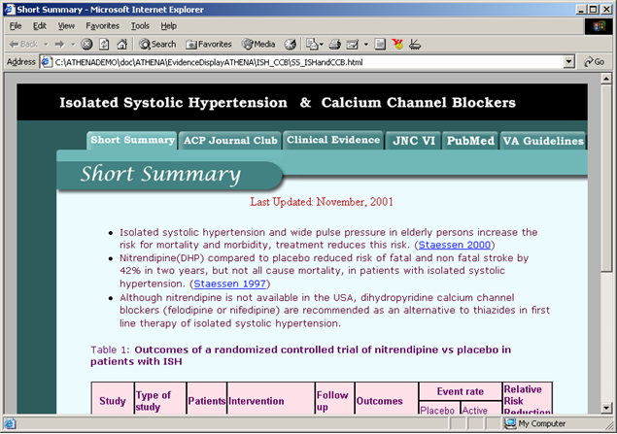

Figure - Short Summary portion of ATHENA-HTN’s supporting documentation on the use of a class of antihypertensive agents in the presence of a comorbidity. The other tabs present relevant literature in *ACP Journal Club, Clinical Evidence*, *The JNC 6 Guidelines, PubMed,* and the *VA Guidelines*.

* + 1. BP-Prescription Graphs

The BP-Prescription Graphs (Figure 10) show past blood pressure records and prescription data, using a common time axis. Blood pressure data from three years before the current time to present are plotted together with the prescription history of antihypertensive agents. Drug doses are displayed in boxes at initiation of a drug or a change in dose. The extents of the prescription intervals are computed from prescription information and refill history. Gaps in the lines of the prescription history indicate that a patient should have run out of medications *if* he or she has adhered to the instructions in the prescription. Accordingly, gaps may reflect lack of medication adherence. A user can scroll the two graphs in lock step to see blood pressures and prescriptions recorded earlier. Thus, as shown in Figure 10, a user can see the prescription intervals for diltiazem SA, which was prescribed before, but not after, October 1999, by scrolling the graph to the left.

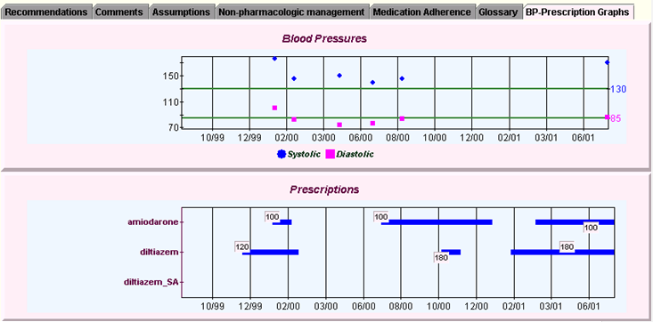

Figure - ATHENA-HTN BP-Prescription Graphs

* + 1. Patient Summary

By clicking the “Patient Summary” button, ATHENA-HTN users can bring up a Patient Summary pop-up window that displays an abstract of patient data relevant to hypertension management (see Figure 12).

The window organizes the data into categories such as Labs, Vitals, Related Drugs (currently active drugs for managing hypertension), Related Comorbidities (the patient's diseases and syndromes that may affect the management of hypertension), and ADRs/Allergies (adverse drug reactions or drug allergies the patient may have). Data shown in this window are taken into account when the system computes recommendations for the patient’s treatment.

By displaying the active prescriptions, ATHENA-HTN SYSTEM encourages medication reconciliation. The clinician can review the active prescriptions and update the status of medications, for example if the clinician asked the patient to stop taking the meds but did not discontinue it in the prescription file.

If the ATHENA-HTN user has additional patient information that is not in the VA database, or if the user wishes to see what ATHENA-HTN would recommend based on hypothetical data, she can change data by using the **+**, **-**, and **->** buttons to bring up a dialog form. For example, she can add a new drug to the Related Drugs list, add a new comorbidity to Related Comorbidities, or change the dosage of an existing drug. By clicking the Update Advisory button at the bottom, she can get an updated advisory that uses the newly entered data.

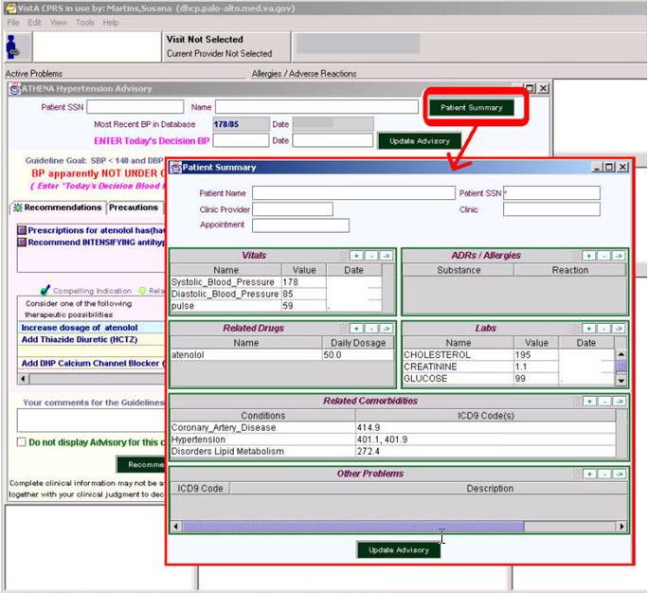

Figure - The Patient Summary window. The window pops up on top of the ATHENA-HTN hypertension advisory window when a user clicks on the Patient Summary button highlighted in the figure.

II.1.7 Updated Graphical User Interface

Circa 2008, the ATHENA project commissioned a user-interface (Figure 12a) to give it a more modern look. The details of the BP/drug graph are shown in Figure 12b.

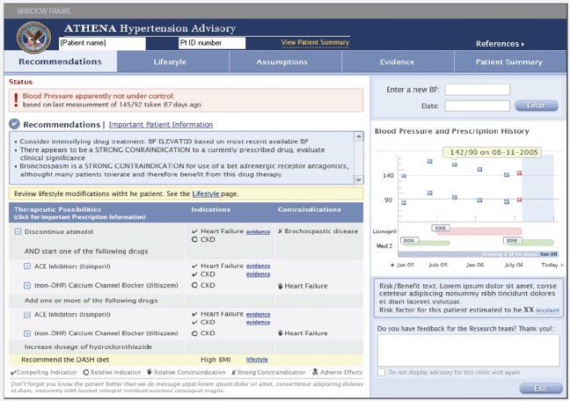

Figure 12a. An updated ATHENA HTN GUI

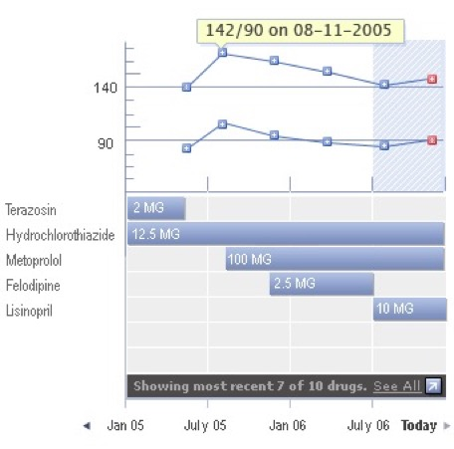

Figure 12b. Details of the BP/Drugs graph

* 1. System Architecture

The architecture of a software system consists of the system’s constituent components and the relationships among them. ATHENA-CDS SYSTEM’s system architecture reflects the fact that it uses Stanford BMIR EON technology for developing decision-support systems for guideline-based care [4-6, 8, 9]. Subsection II.2 will first present the EON system architecture, because it provides the technological foundation of ATHENA-CDS SYSTEM; it will then describe the architecture of ATHENA-CDS SYSTEM, showing how it has added components to embed EON software within the VA’s clinical information system. Through the discussion of ATHENA-CDS components, the operation of ATHENA-CDS SYSTEM will be introduced, indicating how data are extracted from VA’s VistA database, how advisories are computed, and how advisories are delivered to physicians at the point of care.

* + 1. EON System Architecture

EON is an extensible architecture for developing decision-support tools for various aspects of protocol-based care. Initially developed to create systems for executing clinical trial protocols for the treatment of cancer and HIV infection [16], it has been extended for the management of chronic diseases and of other types of guidelines. Because of the generic nature of the EON technology, ATHENA-CDS SYSTEM has the potential to be extended to encode additional guidelines, to be extended for additional decision-support tasks, and to be implemented in clinical information systems outside the VA environment.

The functionality of the tools provided by EON has been shaped by the tasks they were designed to perform. As shown in Figure 13, an EON application may contain several classes of components (further described in Subsections to .:

1. problem-solving modules such as the EON Guideline Interpreter;
2. a declarative guideline knowledge base that defines all clinical protocols and guidelines in terms of a general guideline model; and
3. client programs that access the services provided by problem-solving modules.

The current EON implementation provides a Java Application Programming Interface (API) that client programs can call to access the services provided by the EON Guideline Interpreter. A previous version of the API is available as web services. The Guideline Interpreter accesses the guideline knowledge base through Protégé’s API. Depending on the services a client program provides to end users, a client program may or may not access the knowledge base.

* + - 1. EON Guideline Interpreter

The EON Guideline Interpreter (see Figure 13) accesses a guideline knowledge base consisting of models of clinical guidelines, patient data, and medical concepts that are created in and accessed through the Protégé tool. The EON Guideline Interpreter, shown in the middle in Figure 13, performs the computations necessary to automate specific tasks associated with guideline-directed therapy. It takes as input a standard clinical guideline description and relevant patient data, and generates as output situation-specific recommendations for the current patient encounter [9].

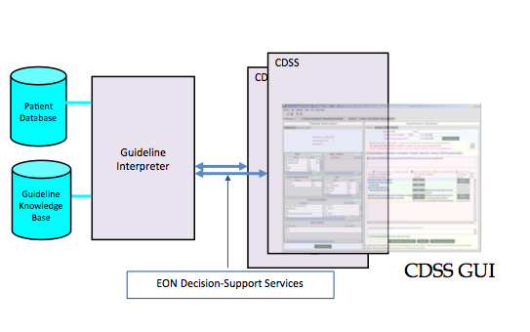

Figure - Architecture of EON guideline applications

* + - 1. EON Knowledge Base

EON contains a declarative knowledge base that includes the EON Guideline Model, medical-concept model, and patient data model. This subsection gives a brief overview; and Figure 14 shows a portion of the EON knowledge base as represented in the Protégé editor.

1. The **EON Guideline Model** [6] consists of a set of classes and attributes that describe concepts and relations with which the content of clinical guidelines are formalized. The content of a particular guideline is encoded as instances and as attribute values of these classes. The EON Guideline Model includes classes and attributes for modeling concepts such as the target population of the guideline (eligibility\_criteria attribute in Figure 14), goals (goal attribute in Figure 14), and a clinical algorithm that sequences the decisions and actions of a guideline (the screen shot in the upper-right corner of Figure 14). Depending on the nature of the guideline knowledge to be modeled, the EON Guideline Model may allow a clinical algorithm to be specified as a collection of scenarios, decisions to be made in these scenarios, and preferred alternatives at these decision points. Alternatively, when complex sequencing of decisions and actions is required, the model allows a clinical algorithm to make use of additional operators that perform iteration, multiple branching, and synchronization of concurrent threads of execution.
2. The **medical-concept model** defines the particular clinical interventions that are typical for a given area of medicine, and the types of patient findings and patient problems that are most commonly reported in a given medical discipline. The medical-concept model is an explicit component of the EON knowledge base, in the acknowledgement that different classes of health-care providers tend to make different classes of observations about their patients and perform different kinds of patient-care activities. In ATHENA-CDS, the medical-concept model consists primarily of comorbidities affecting the management of hypertension and of the classes of antihypertensive drugs that the system may need to cover.
3. A **patient data model** defines the classes and attributes of patient information required by the rest of the system. This simplified view of patient data, created for the purpose of aiding in clinical decisions, supports: (a) a structured data model for representing information related to individual patients, (b) domains for values of attributes in the data model, and (c) logical expressions through which guideline decision-support systems can test the states of the patient.

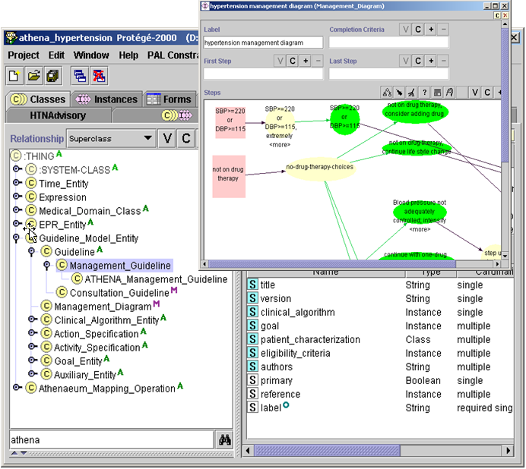

Figure - The EON Guideline Model in the Protégé editor. The left panel shows part of the hierarchy of classes in the model. The Management\_Guideline class is selected, shown by the violet highlighting. The template slots shown in the right panel include the clinical\_algorithm slot. The clinical algorithm represents guideline recommendations in terms of patient scenarios, decision points, and action alternatives. The floating screen shot in the figure shows the hypertension management diagram (an instance of the Management\_Diagram class) presented as a Protégé graph.

* + 1. ATHENA-CDS System Architecture

ATHENA-CDS can be integrated into a clinical environment in a variety of ways. In general, it needs (1) a way to invoke the decision-support service, (2) a client program that interacts with the EON Guideline Interpreter and presents the CDS recommendations to the end user, and (3) a way of extracting data from the EHR and converting them into a form usable by the EON Guideline Interpreter. As an example of such deployment, within the VA medical centers’ information technology environment, ATHENA-CDS extends the EON architecture in five ways:

1. the ATHENA-CDS Knowledge Base, which encodes—according to nationally recognized hypertension guidelines—the knowledge required to support decisions for managing, for example, hypertension, patients;
2. a system for extracting data from VA data sources and converting them into a form usable by the EON Guideline Interpreter;
3. a mechanism for precomputing and storing guideline-based advisories;
4. the ATHENA Client program, through which guideline-based recommendations are delivered to physicians in a pop-up window as described in Section II.1; and
5. an event monitor (also known as the Controller) that keeps track of provider logins and patient selection in VA’s Computerized Patient Record System (CPRS) information system, and that activates ATHENA Client (see Section II.2.2.4).

The following sections describe the five ATHENA-CDS components.

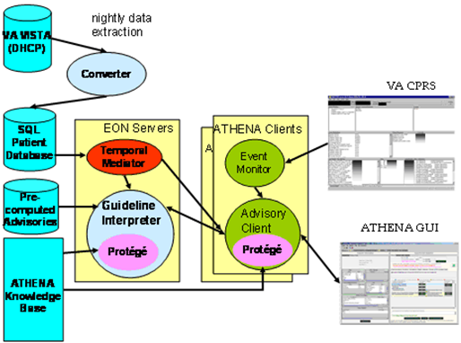

Figure - ATHENA-CDS system architecture. The current implementation of ATHENA-CDS SYSTEM is integrated into the VA clinical information system.

* + - 1. ATHENA-CDS Knowledge Base

The ATHENA-CDS Knowledge Base extends the EON knowledge base, such that it: (1) represents medical concepts used in the treatment of a target disease; and (2) encodes details of the guidelines that are required to allow the Guideline Interpreter to reason about the treatment of the target disease and related comorbidities for a particular patient.

1. *Medical concepts –* Guidelines are usually written with general terms (eg “diabetes mellitus” that are represented in the patient data by many different files ( eg ICD9 codes for diabetes include 250.01, 250.03, 250.11, 250.13 …). When recommendations of a clinical guideline or protocol are encoded in a computer-interpreter model, they are constructed as formal statements. The statements reference medical concepts describing patient states of health and also interventions that have been or should be performed for a patient. These medical concepts are formalized as a hierarchy of concept classes and are part of the EON medical concept model. The concept classes are used to provide conceptual categories through which the patient findings, diagnosis, and ongoing treatment can be expressed. They include: vital signs (e.g., Weight), diagnostic terms (e.g., Diabetes-Mellitus-Type1), ICD9 codes (e.g., 274.9 for “Gout, unspecified”), laboratory-test results (e.g., Creatinine), demographic concepts (e.g., Race and Sex), drug classes (e.g., Thiazide\_Diuretics), generic drugs (e.g., atenolol), units of measure (e.g., milligram), and defined concepts (e.g., risk group A: no risk factor and no target organ damage or clinical cardiovascular disease).[[3]](#footnote-3)
2. *Guideline-based decision-support knowledge* *–* The decision-support knowledge for guideline-based care includes criteria for applying the guidelines to a patient case (e.g., patient must have a diagnosis of hypertension and must not be pregnant), patient scenarios for disease management, alternative choices and justifications for them, guideline-based indications and contraindications for each class of drug agents, and dose ranges of individual drug components. The decision-support knowledge is encoded as instances of the EON Guideline Model (see Figure 14).

In Figure 15, the ATHENA-CDS Knowledge Base is displayed as a rectangle. In the deployed system, the knowledge base is stored on a fileserver as a collection of Protégé files. The knowledge base is accessed by other EON and ATHENA-CDS components through Protégé’s Application Programming Interface (API), shown as a pink oval in Figure 15.

* + - 1. Data Extractor, Converter, and Precomputation of Advisories

This subsection describes the data extraction and conversion that are necessary for the ATHENA-HTN SYSTEM to use data from the VA VistA database. As part of other projects, ATHENA-CDS has also been programmed to use data from XXXXX. This section also covers the precomputation and storage of ATHENA-CDS advisories to be delivered to clinicians when they access patient records in VA’s CPRS system. The process is diagramed in Figure 16.



Figure - Nightly extraction and conversion of data, and precomputation of ATHENA-HTN advisories

To generate patient-specific advisories for the management of patients with hypertension, ATHENA-HTN SYSTEM depends on data extracted from the VA VistA database. Because VistA uses the hierarchical MUMPS[[4]](#footnote-4) database system—not a relational database system, as required by EON software components—data must be extracted from VistA and transformed into a relational format. The extraction is done by a M program that writes out selected patient data into a tabular flat file. This file is then loaded, through MS SQL Server data transformation service (DTS) scripts, to tables in an SQL Server database, referred to as the ATHENA-CDS database.

The MS SQL Server DTS scripts perform basic data scrubbing operations. For instance, they:

1. convert date and numeric string data into date and numeric SQL Server fields;
2. transform the “systolic blood pressure/diastolic blood pressure” string used in VistA into two separate data entries;
3. separate Vitals data (e.g., heights, weights, blood pressure, and pulses) into another table;
4. combine diagnostic data derived from multiple sources into a single table; and
5. scrub out obvious erroneous data entries, such as dates in the future or impossible lab values.

After the creation of relational ATHENA-CDS tables, a Java program—Converter.java—performs further conversions to normalize and format data to populate tables in the ATHENEON database. ATHENEON is used by the EON components as well as ATHENA-CDS Client.

1. Computes a prescription’s daily dose in milligrams from the prescription information.
2. Generates prescription history where the valid time of a data record represents the period during which, judging by the prescription and refill history, the patient should have a supply of the prescribed medications.
3. Identifies prescriptions as “active and currently filled,” “active but not currently filled,” or “inactive”.

Using solely data available from VistA, the ATHENA-HTN will pop up a window to display a patient-specific advisory based on the ATHENA Knowledge Base. In order to minimize the time it takes to display the pop-up window, a batch program precomputes advisories for all patients in the Encounters table in the ATHENEON database. To generate the precomputed advisories, the batch program uses the same Application Programming Interface (API) provided by the Guideline Interpreter as the ATHENA-HTN Client uses to pop up the advisory window (see II.2.2.4).

The Guideline Interpreter can be programmed to make certain assumptions when relevant data are not available. For example, if a patient is not recorded as having a comorbidity, the Guideline Interpreter assumes that the patient does not have that comorbidity. If there are no blood pressure data at all, the ATHENA-HTN configures the Guideline Interpreter to first compute an advisory assuming that blood pressure is under control, and then compute an alternative advisory assuming that blood pressure is not under control.

A number of MS SQL Server data transformation service scripts automate the process of extracting data from VistA to the file system. The scripts are configured to run every night, extracting data and computing advisories associated with any patient who has a primary-care appointment during a five-day window (three days before to one day after the date of extraction). Thus, for three days before and one day after a patient’s appointment day, the ATHENA-HTN advisory for the patient will be available to clinicians caring for the patient. Because of the five-day window, if a clinician accesses the patient’s medical record on Friday to plan a Monday encounter, he will see an ATHENA-HTN advisory for the expected patient. Similarly, a clinician who wishes to review results from the previous day’s encounters will see ATHENA-HTN advisories.

*Mapping knowledge:* For the Guideline Interpreter to apply the encoded guideline recommendations to a specific patient, the terms used in patient data (e.g., “HDL”) must be mapped to guideline terms used in the ATHENA-CDS Knowledge Base (e.g., HDL\_Cholesterol). In the current implementation, these mappings are specified in relational database tables.

* + - 1. Event Monitor

ATHENA-HTN relies on an Event Monitor that is started whenever a clinician logs into a clinical workstation where ATHENA-HTN SYSTEM is installed. The Event Monitor starts the ATHENA-HTN Client, a Java process that is responsible for managing the delivery of ATHENA advisories (sets of recommendations) to clinicians.

* + - 1. ATHENA-HTN Client

When the ATHENA Client starts up on a clinical workstation, it establishes connections to the Guideline Interpreter. It also loads the ATHENA-CDS Knowledge Base, from which it gets the medical concept hierarchy used to assist entry of data into the Patient Summary pop-up. Once ATHENA Client is started up, it runs in the background, waiting for messages from the Event Monitor.

When ATHENA Client receives a message indicating the patient identifier of a record being accessed by a clinician, it queries the ChronusII temporal mediator to see if the clinician should receive ATHENA-CDS’s decision support. If so, ATHENA Client then requests a precomputed advisory from the Guideline Interpreter. If there is no precomputed advisory, then it requests that an advisory be computed in real time using data available in the ATHENEON database. If the advisory—i.e., the results computed by the Guideline Interpreter—suggests that the patient does not satisfy the eligibility criteria of the ATHENA hypertension guidelines, then no pop-up is generated; otherwise, ATHENA Client pops up a window that displays the advisory on top of the CPRS cover sheet. It also generates a patient information summary (see Subsection II.1.6) from data queried from the ChronusII mediator. A user may enter data through the ATHENA Client’s graphical user interface and get an updated advisory from the Guideline Interpreter.

The ATHENA Client can be configured to log its operations in two ways:

1. The data used by the system or entered by the user, the advisories that are precomputed, displayed or updated, and all user actions can be logged to SQL tables.
2. Errors in system operations (e.g., the ATHENA Client not being able to connect to the ChronusII mediator) can be logged to files that are scanned automatically to generate email messages that alert ATHENA-CDS team members of these errors
3. For Further Reading

…

1. References

1. The pop-up window is currently displayed for clinicians who are designated ATHENA-HTN users and who access the records of patients who have been diagnosed with hypertension, meet a set of inclusion criteria, and have appointments at primary care clinics within a five-day window. [↑](#footnote-ref-1)
2. A knowledge base is a collection of statements—expressed in a computer-interpretable knowledge-representation language—that represents assertions about the world (11. Russell, S. and P. Novig, *Artificial Intelligence: A Modern Approach*. 2nd edition ed. 2003, Upper Saddle River, New Jersey: Pearson Education, Inc. In the case of ATHENA-CDS, as will be described later in more detail, the knowledge base statements include assertions about the structure of computer-interpretable guidelines, medical concepts, and detailed clinical knowledge on the management of hypertension. [↑](#footnote-ref-2)
3. Classes in the medical concept hierarchy are derived from the VA database terms in four ways: (1) The VA uses ICD9 codes to record diagnostic information, the ICD9 codes in the concept hierarchy correspond directly to the VistA data dictionary; (2) The knowledge-base mapping described in #3 defines a correspondence between a concept (e.g., a laboratory test term such as Serum Creatinine) and a VA term. In the case of drugs, the mapping is done in the drug table in the ATHENEON database, matching drug names used in VA prescriptions to the generic drugs in the concept hierarchy. (ATHENA-CDS currently has a hybrid set up where some mapping occurs in the knowledge base and some in the database); (3) A defined concept (e.g., risk group A) has a computable definition (e.g., absence of any risk factor, and no target organ disease or clinical cardiovascular disease) that is evaluated at run-time in terms of other concepts and (4) Concepts that contain any of the previously mapped concepts (e.g., ICD9 codes) as direct or indirect subclasses match VA data through their subsumed relationship to these previously matched concepts. [↑](#footnote-ref-3)
4. Programming language M, formerly MUMPS originally stood for ***M****assachusetts General Hospital* ***U****tility* ***M****ulti-****P****rogramming* ***S****ystem*, which had been developed by Octo Barnett's lab at Massachusetts General Hospital (MGH) in the 1960s. The term “MUMPS” is no longer considered to be an acronym. [↑](#footnote-ref-4)