Drug Ontology Documentation

The Butte Lab
Stanford Center for Biomedical Informatics Research, Stanford University, Stanford, CA
Please send comments to
Samson W. Tu
MSOB X259, 251 Campus Drive, Stanford, CA 94305-5479
Phone: +1 650-725-3391
Fax: +1 650-725-7944
Electronic mail: swt@stanford.edu

Introduction
The nosology project seeks to discover new therapeutic uses and adverse effects of drugs by finding diseases that have gene expression profiles similar to those of the known indications and adverse effects of drugs. For this purpose we have developed a prototype drug ontology that (1) defines a core set of concepts and relationships that allow us to integrate information from multiple sources, (2) provides classification services along multiple axes, (3) provides links to external sources so that data not in the ontology can be queried from these sources. No existing drug ontology have these properties.
We used Protégé, an ontology editor developed at Stanford University, to defined a drug ontology using the Web Ontology Language (OWL) ¹. We organize the drug ontology as having three parts: (1) core ontology consisting of classes and relationships that characterize major axes for classifying drugs, (2) drug taxonomies consisting of compositional hierarchies defined using the core concepts and relationships, and (3) mappings that link concepts from multiple information sources to those in the core ontology (Figure 1).
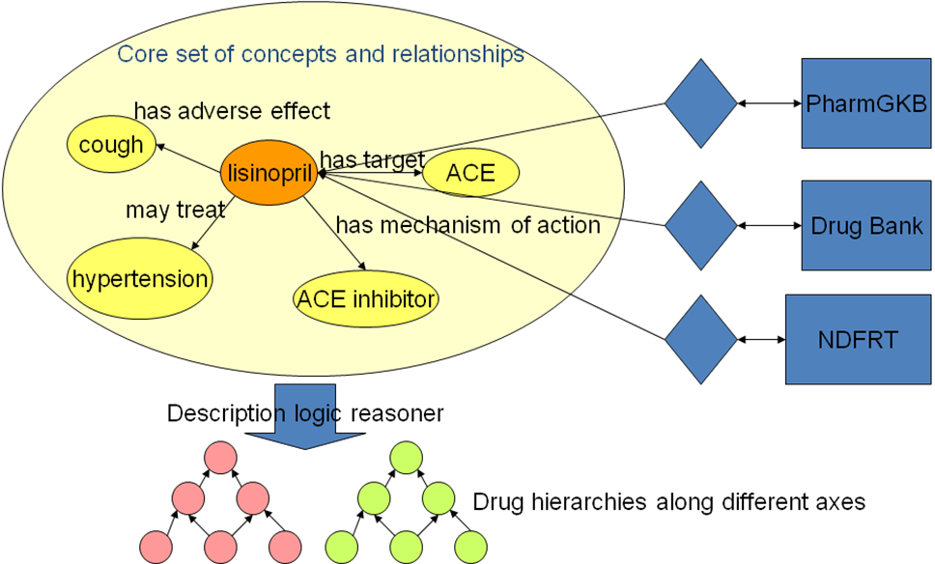
Figure 1 Components of Drug Ontology, illustrated using the drug lisinopril
Using the distinctions made in the National Drug File – Reference Terminology (NDF-RT) ² and RxNorm ³ as starting point, we defined, in the core ontology, disjoint hierarchies such as Drug, Mechanism of Action, Dose Form and Strength, Drug Target, and Clinical Finding and relationships such as may_treat, may_prevent, has_mechanism_of_action, has_drug_targets, has_adverse_reaction. We model the relationship Lisinopril may_treat Hypertension as an existential some restriction between individuals of the Lisinopril and Hypertension classes. The property hierarchy feature of OWL allows us to unify the may_treat, may_prevent, FDA approved indication and non-FDA approved indications used in different sources as subproperty of one indication relationship.
Recognizing that many users do not want to access the Drug Ontology as an OWL file and also because we want to join drug information with other types of data, we export the terms and relationships in the ontology to a relational database. Most of this document is devoted to describing the schema of the database. We assume that users of the OWL version are familiar with Protégé OWL and can browse the ontology.

Sources
Using Protégé’s application programming interface, we wrote scripts to import may_treat, may_prevent, and mechanism_of_action information from NDF-RT, all ingredient-level drugs from RxNorm, all approved and experimental drugs and their targets from Drug Bank ⁴, and the indication and adverse effects information from a commercial drug database. We use UMLS to map concepts from the different sources whenever possible, and use string matching on drug names when necessary.
Currently, the Drug Ontology draws from the following sources:
- RxNorm (NLM)
- National Drug File Reference Terminology (NDF-RT) (VA and Apelon)
- DrugBank (Genome Alberta and Genome Canada)
- A commercial drug database (not distributable)

Versions and Content
Currently, we have two versions of the drug ontology: Stanford BMIR and Export versions. Each version comes in two format: Protégé OWL file and a set of MYSQL database tables. The Export version (DrugOntology04.owl and the export tables) does not contain relations extracted from the commercial drug database.
The current drug ontology contains the following:
- generic ingredient drugs from RxNorm in UMLS2007aa
- has_mechanism_of_action, may_treat, and may_prevent relations from NDFRT in UMLS2007aa
- has_drug_target relations from DrugBank (accessed 2007-0411). Drug targets are indexed by their gene names.
- fda_approved_indication, non_fda_approved_indication and has_adverse_effect relations from the commercial database.
We chose these particular relations for inclusion based on current needs. The scripts that extract information from the sources are fairly generic and we can extract additional relations as needs arise.

Database Description
There are 4 tables in the drugontologyexport database that holds the information related to the Drug Ontology.

DOConcept table

Definition
+-----------------+---------------+------+-----+---------+-------+
| Field | Type | Null | Key | Default | Extra |
+-----------------+---------------+------+-----+---------+-------+
| conceptId | varchar(200) | NO | MUL | | |
| conceptCategory | varchar(20) | NO | | | |
| label | varchar(1000) | YES | | NULL | |
| preferredLabel | tinyint(4) | YES | | NULL | |
| source | varchar(100) | YES | | NULL | |
| batchNumber | varchar(10) | YES | MUL | NULL | |
| asserted | tinyint(4) | YES | | NULL | |
+-----------------+---------------+------+-----+---------+-------+
conceptId: unique identifier of concept
conceptCategory: toplevel types of concepts, such as IngredientDrug, ClinicalFinding, MechanismOfAction, DrugTarget
label: descriptive text
preferredLabel: preference, if any, for descriptive text
source: original source of concept
batchNumber: convenience field for content development, should be ignored by users
asserted: always 1 in this table

Example
+-----------+-----------------+-------+----------------+--------+-------------+----------+
| conceptId | conceptCategory | label | preferredLabel | source | batchNumber | asserted |
+-----------+-----------------+-------+----------------+--------+-------------+----------+
| C0000294 | IngredientDrug | Mesna | 1 | RXNORM | 001 | 1 |
+-----------+-----------------+-------+----------------+--------+-------------+----------+
C0000294 (Mesna) is an IngredientDrug that came from RXNORM.

DORestriction table

Definition
+-----------------+--------------+------+-----+---------+-------+
| Field | Type | Null | Key | Default | Extra |
+-----------------+--------------+------+-----+---------+-------+
| conceptId | varchar(200) | NO | MUL | | |
| filler | varchar(200) | NO | | | |
| restrictionType | varchar(20) | NO | | | |
| propertyName | varchar(100) | YES | | NULL | |
| source | varchar(100) | YES | | NULL | |
| batchNumber | varchar(10) | YES | MUL | NULL | |
| asserted | tinyint(4) | YES | | NULL | |
+-----------------+--------------+------+-----+---------+-------+
conceptId: the “subject” of the relationship
filler: the “object” of the relationship
restrictionType: one of some, only, max, min, exactly, value, isa. The semantics of the restrictionType came from the Ontology Web Language (OWL).
propertyName: name of relationship
source: original source of relationship
batchNumber: convenience field for content development, should be ignored by users
asserted: 1 in this table

Example
+-----------+----------+-----------------+--------------+--------+-------------+----------+
| conceptId | filler | restrictionType | propertyName | source | batchNumber | asserted |
+-----------+----------+-----------------+--------------+--------+-------------+----------+
| C0291771 | C0000737 | some | may_treat | NDFRT | 001 | 1 |
This tuple asserts that instances of C0291771 (alosetron hydrochloride) may_treat some (e.g., at least one) instance of C0000737 (abdominal pain) according to NDFRT.

DOIndividual Table

Definition
+--------------+---------------+------+-----+---------+-------+
| Field | Type | Null | Key | Default | Extra |
+--------------+---------------+------+-----+---------+-------+
| individualId | varchar(200) | NO | PRI | | |
| type | varchar(20) | NO | MUL | | |
| label | varchar(1000) | YES | | NULL | |
| source | varchar(100) | YES | | NULL | |
| batchNumber | varchar(10) | YES | MUL | NULL | |
| asserted | tinyint(4) | YES | | NULL | |
+--------------+---------------+------+-----+---------+-------+
IndividualId: the unique id of the individual
type: the class of the individual
label: descriptive text
source: original source of concept
batchNumber: convenience field for content development, should be ignored by users
asserted: always 1 in this table

Exmaple
+--------------+----------+-------+-----------+-------------+----------+
| individualId | type | label | source | batchNumber | asserted |
+--------------+----------+-------+-----------+-------------+----------+
| YDIB | GeneName | YDIB | Drug Bank | 002 | 1 |
+--------------+----------+-------+-----------+-------------+----------+
YDIB is a GeneName that came from Drug Bank

DOInfo table

Definition
+-------------+---------------+------+-----+---------+-------+
| Field | Type | Null | Key | Default | Extra |
+-------------+---------------+------+-----+---------+-------+
| id | varchar(200) | NO | MUL | | |
| infoType | varchar(20) | NO | | | |
| infoName | varchar(100) | NO | | | |
| infoValue | varchar(1000) | NO | | | |
| source | varchar(100) | YES | | NULL | |
| batchNumber | varchar(10) | YES | | NULL | |
| asserted | tinyint(4) | YES | | NULL | |
+-------------+---------------+------+-----+---------+-------+
id: id of the subject of the information is about
infoType: type of information (e.g., idmapping)
infoName: some description of information
infoValue: the specific information about the subject
source: derivation of the information
batchNumber: convenience field for content development, should be ignored by users
asserted: always 1 in this table

Example
+----------+-----------+----------+-----------+--------------------+-------------+----------+
| id | infoType | infoName | infoValue | source | batchNumber | asserted |
+----------+-----------+----------+-----------+--------------------+-------------+----------+
| C0000392 | idmapping | drugbank | DB03107 | generic_name/label | 101 | 1 |
+----------+-----------+----------+-----------+--------------------+-------------+----------+

This tuple says that C0000392 (beta-Alanine) has a mapping to Drug Bank DB0317. The mapping is derived from matching the label of the concept with the generic name of Drug Bank entry.

Sample Usage

Querying asserted Drug Ontology information
As an example, let's get drugs for which Heart Failure is an indication. Note that "%approved_indication " covers both approved and unapproved indications
select distinct C1.label, C1.ConceptId
from DORestriction as R, DOConcept as C1, DOConcept as C2
where C2.label = "Heart Failure" and C2.preferredLabel = 1 and
C1.conceptId = R.conceptId and C2.conceptId = filler and
(propertyName = 'may_treat' or
propertyName = 'may_prevent' or
propertyName like "%approved_indication")
This query will only get the asserted, but not inferred, indicating relationships. If some drugs are indicated for conditions more specific to Heart Failure, they will not be part of the query result.
There are many types of inferences that can be made in the Drug Ontology. For the Butte lab, I will entertain requests for needed inferred information and augment the database with them.

Exporting and Querying inferred Drug Ontology Information

Use case
Canadian Adverse Drug Reaction Information System (1965-2003) is a data set that contains reported drug adverse reactions with the following set of tables:
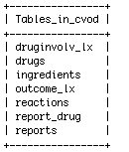
We wish to query, for all drugs with some mechanism of action, the number of reports that have specified outcome codes

Construct hierarchy of drugs by mechanism of actions and export to database
We wrote a script to generate OWL classes defined as drug classes that have specific mechanisms of action (Figure 2).
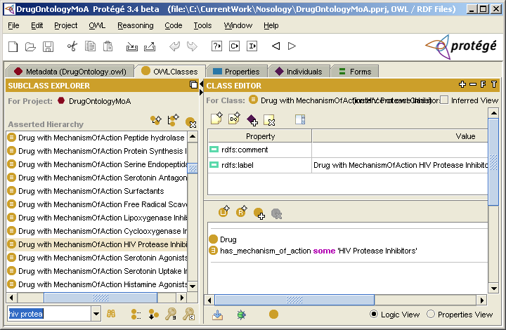
Figure 2 Drug class definitions by mechanisms of action
Using a Description Logic Reasoner, we arrange the drug classes as an hierarchy where ingredient drugs are organized along the line of more general mechanisms of action (Figure 3).
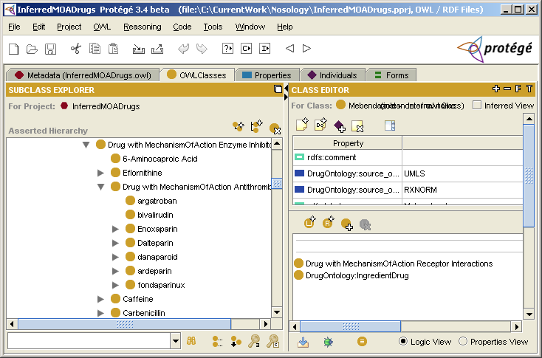
Figure 3 Part of drug-by-mechanisms-of-action hierarchy
We wrote a script to dump the inferred hierarchy to the database. So the isa relationships are in the database (Figure 4).
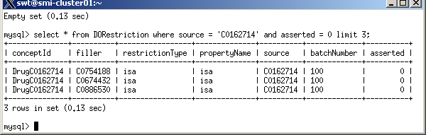
Figure 4 Example of inferred isa relationships exported to the database. The first line says that Amprenavir is in the drug class HIV Protease Inhibitor.

Finding number of HIV Protease Inhibitor adverse reaction reports
We first identify the drug ids in cvod that corresponds to HIV Protease Inhibitor drugs in the drug ontology and save the results to a temporary table called cvod_HIVPI_drugs. Next we query for the count of outcomes in reports related to HIV Protease Inhibitor (Figure 5).
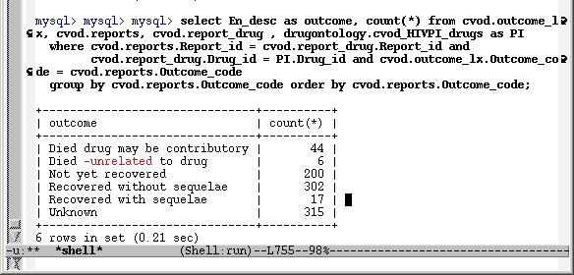
Figure 5 Query for outcomes in reports related to HIV Protease Inhibitor.

Acknowledgement
Numerous people have contributed to the Drug Ontology work, including Samson W. Tu, Annie Chiang, Nigam Shah, Daniel Rubin, Amar Das and David Kao. We authors acknowledge support from the Lucile Packard Foundation for Children's Health, the National Library of Medicine (K22 LM008261), and National Institute of General Medical Sciences (R01 GM079719).

References
1. World-Wide Web Consortium. Web Ontology Language (OWL). 2004 [cited 2007 January 22]; Available from: http://www.w3.org/2004/OWL/.
2. Carter, J.S., et al., Initializing the VA medication reference terminology using UMLS metathesaurus co-occurrences. Proc AMIA Symp, 2002: p. 116-120.
3. Liu, S., et al., RxNorm: Prescription for Electronic Drug Information Exchange. IT Pro, 2005: p. 17-23.
4. Wishart, D.S., et al., DrugBank: a knowledgebase for drugs, drug actions and drug targets. Nucleic Acids Res, 2008. 36(Database issue): p. D901-906.

