**Computer Networks**

**Project – 1**

**MultiThreaded WebClient And Server**

**Samson Yerraguntla (1001234836)**

**ENVIRONMENT :**

Operating System: Windows 10

Browsers : Internet Explorer v9, Mozilla Firefox v38.0.5

Development Platform:Python 2.7

Tool: Command prompt

**PROJECT DESCRIPTION :**

• The program can run on any available port of the system.

• Multiple requests can be handled by the server at the same time. Client requests are handled in separate threads.

• If the file exists on the server, the server responds with "HTTP/1.1 200 OK” along with the contents of the file.

• If the file is not found, server responds with a "HTTP/1.0 404 Not Found” message.

**PROGRAM EXECUTION INSTRUCTIONS :**

• Install Python 2.7

• Unzip the file‘1001234836_SamsonYerraguntla.zip’ .

• Open the command prompt and navigate to the path where the zipped folder is extracted.

• For compiling Client Server communication compile following

python WebServer.py

python WebClient.py

• For compiling Client multithreadServer communication compile following

python WebMultiThreadServer.py

python WebClient.py

Screenshots of Execution:

1. Compiling WebServer.py and the server ready for connection on port 6789 ……

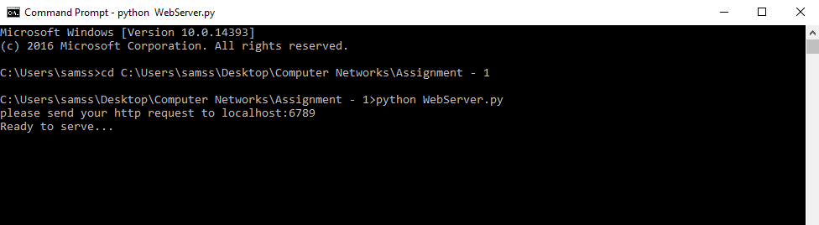

1. Compiling the WebClient.py, connection was established with the server with help of socket connection. If the output shows HTTP/1.1 200 OK for successful execution.

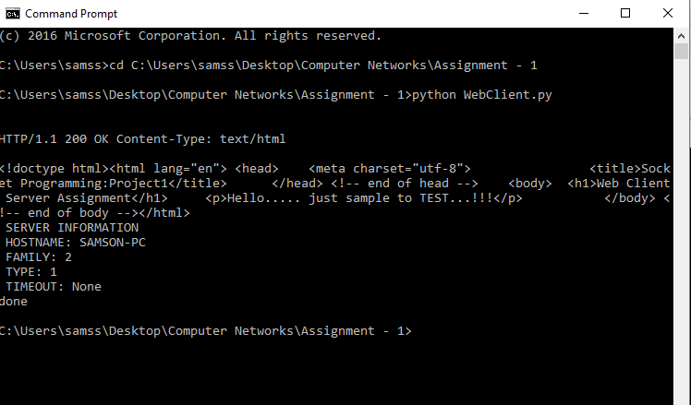

1. Displaying the client parameters after successful connection with the server.

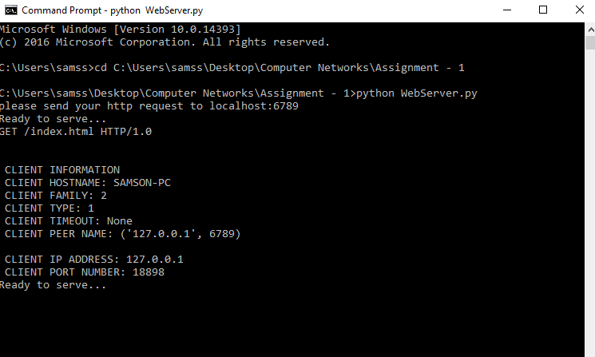

1. On successful execution while calling the server through web browser.

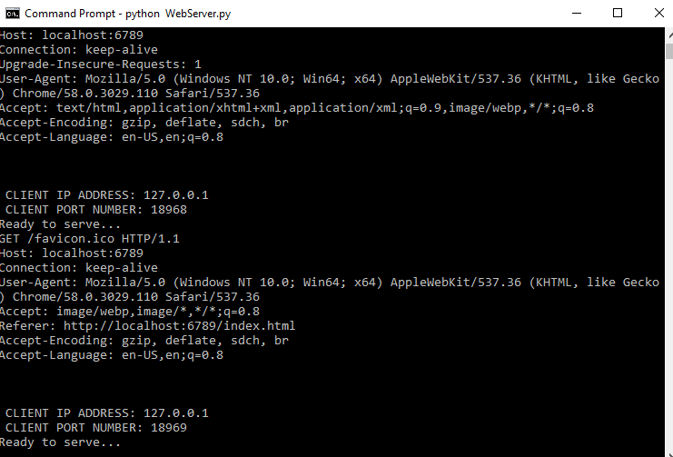

1. Output from the Web Browser

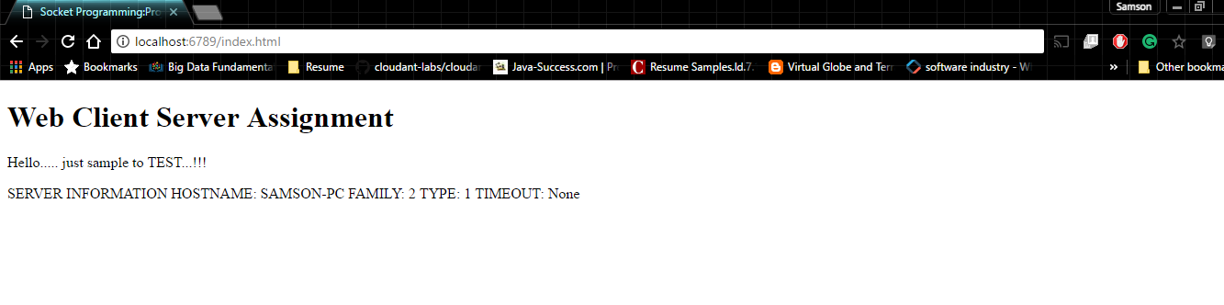

1. Compiling WebMutlithreadedServer.py and ready for connection on port 8080 …….

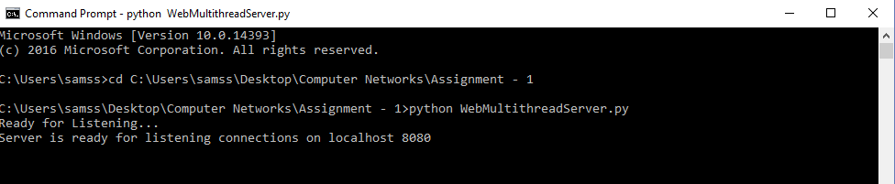

1. Showing the console of multiple connections to the server from Web Browser

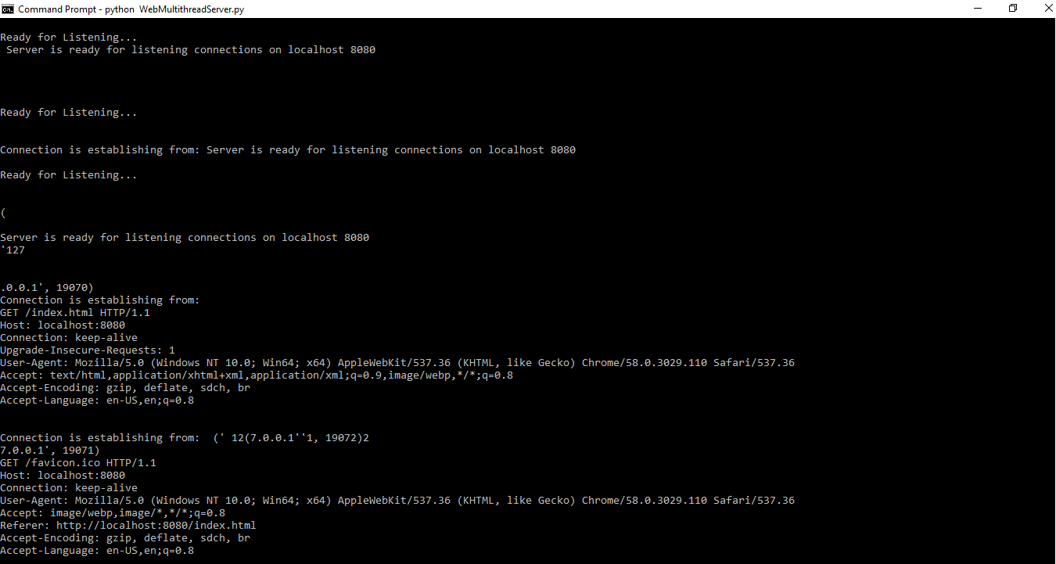

References:

1) <http://www.tutorialspoint.com/python/python_multithreading.htm>

2) <https://docs.python.org/2/contents.html>

3) <https://docs.python.org/2/howto/sockets.html>

4) <http://www.w3resource.com/python/python-tutorial.php>

5)<http://stackoverflow.com/questions/2846653/how-to-use-threading-in-python>

6) <https://docs.python.org/2/library/threading.html>

7) <https://www.toptal.com/python/beginners-guide-to-concurrency-and-parallelism-in-python>

8) <http://ilab.cs.byu.edu/python/threadingmodule.html>