NAME: ADERINLOKUN OLUWASEUN EBENEZER
MATIC NO.: CSC/2017/160
COURSE CODE: CPE401
DATE: 11/05/2020

SCHEMATICS
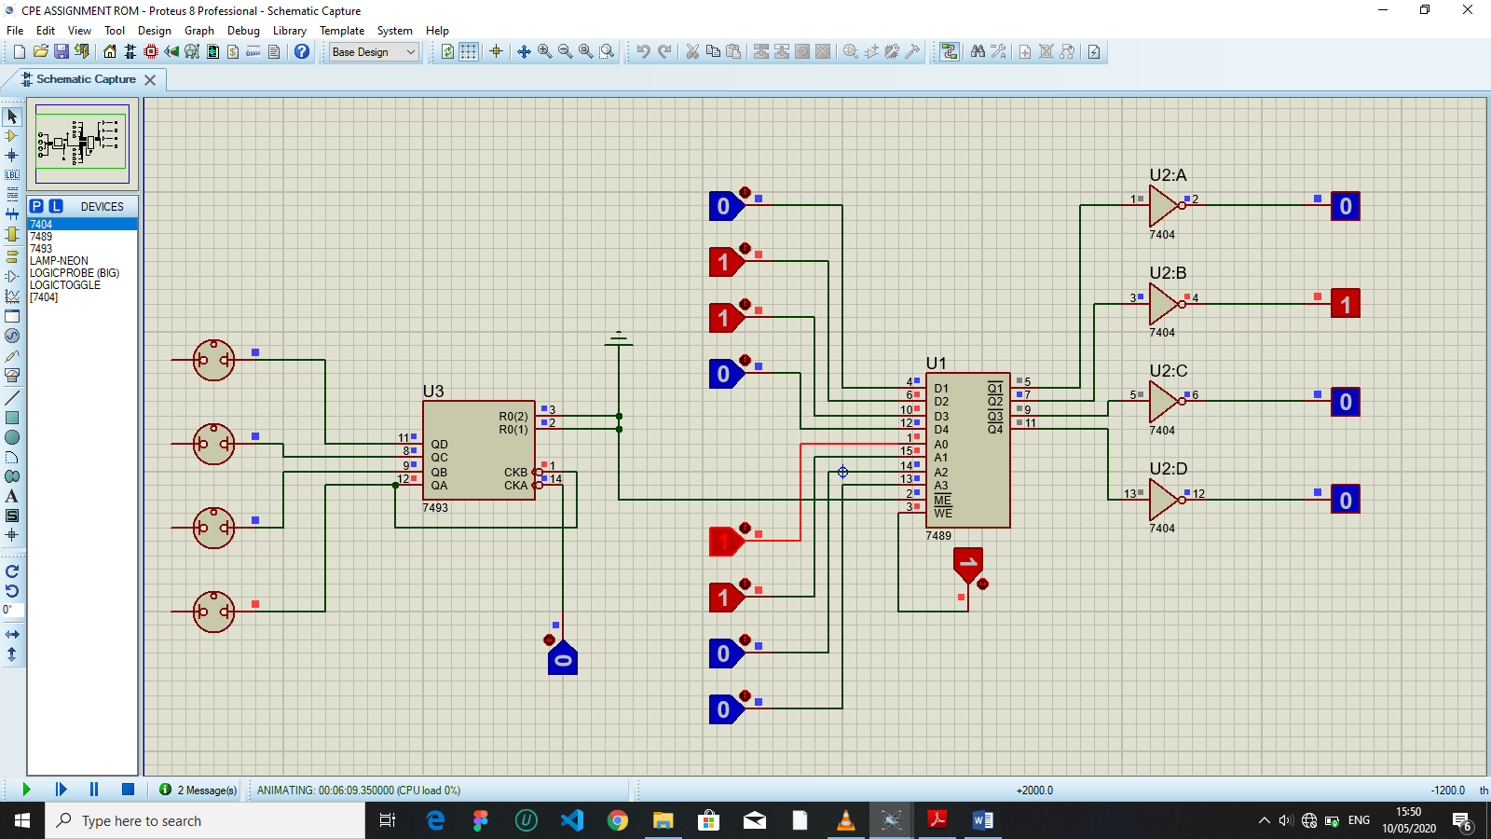

Fig 1.1

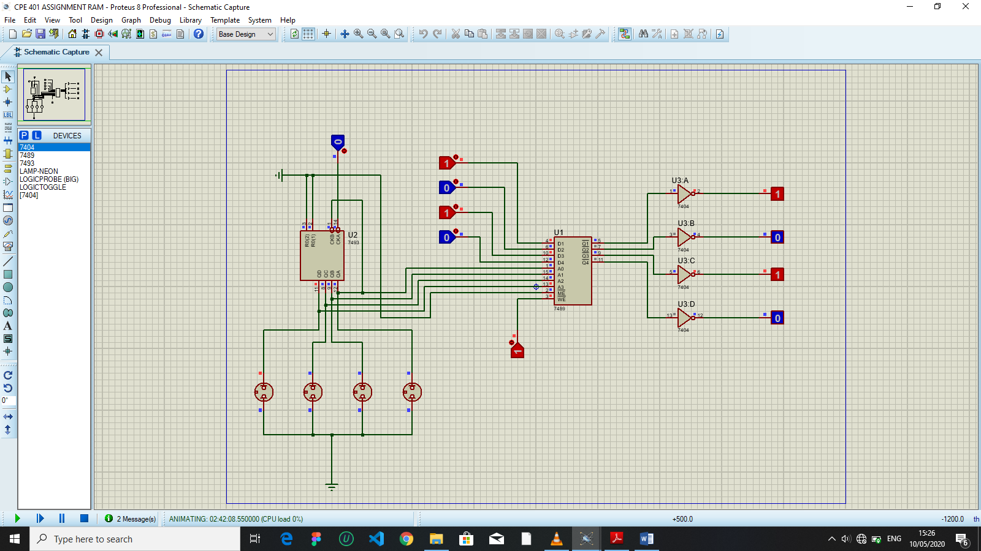

Fig 1.2

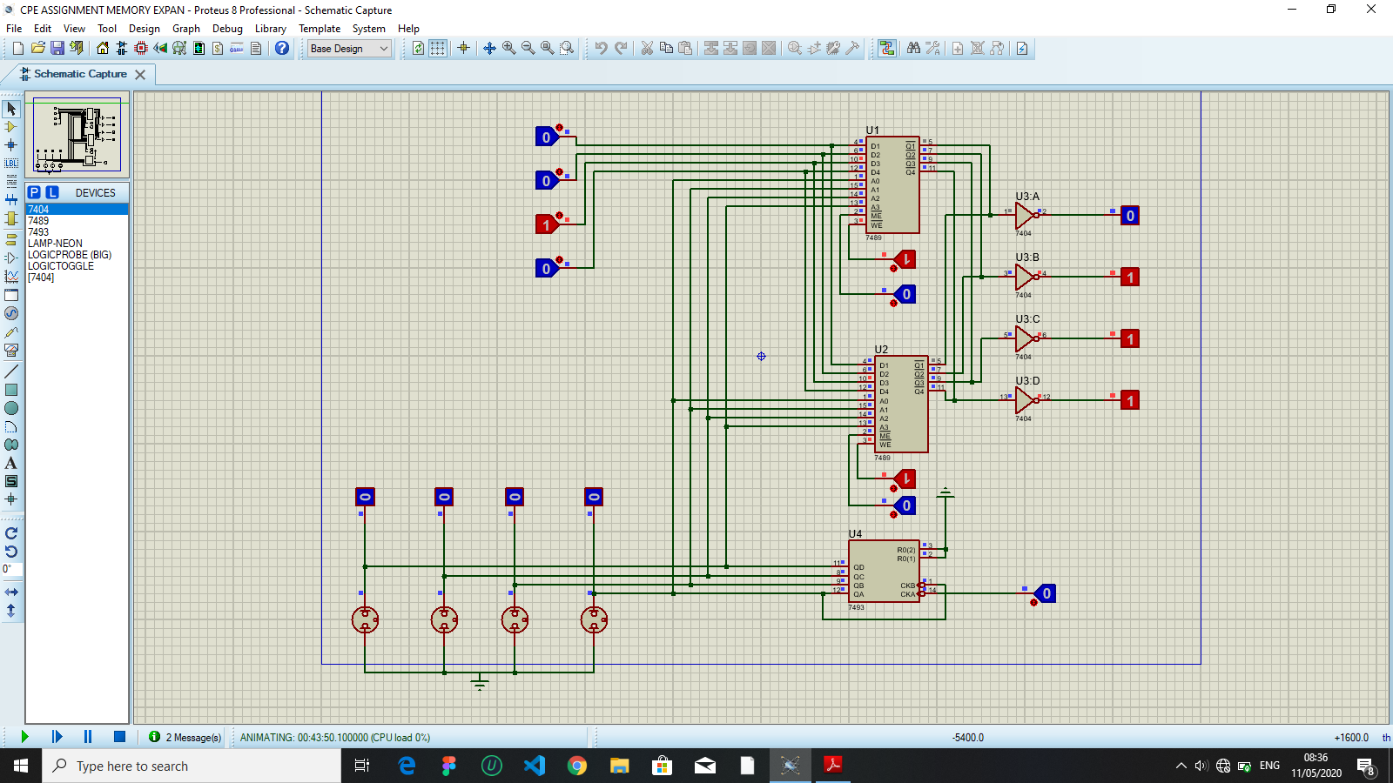

Fig 1.3

RAM TESTING - Fig 1.1: The diagram is the schematics of the RAM circuit with the specified components being connected properly as stated in the instructions. The simulation of the circuit is as follows:
- Set WE to 1 which implies read enabled.
- Set WE to 0 which implies write enabled.
- ME is being enabled by connecting it to ground(0).
Observation: The data input into the circuit before setting the WE to 0 is what is displayed as data output after setting WE to 0, and 1 respectively.

ROM SIMULATION - Fig 1.2: The above ROM Simulator circuit schematics with the specified components from the instructions. The simulation of the circuit is as follows:
- Set the data input to be the gray code of an integer number (base 10).
- Set address input to be the equivalent binary number(base 2) of the integer number.
- Repeat step 1, and step 2 for integer numbers 1,2,3,4,5 and remembering to toggle WE to 1 before step 1, and 0 after step 2) for each of the integer numbers.
Observation: Changing the address input to the binary value of any of the integer numbers used in the simulation(1,2,3,4,5), the data output will be the corresponding gray code.

MEMORY EXPANSION SIMULATION - Fig 1.3: The above Memory Expansion circuit schematics with the specified components from the instructions. The simulation of the circuit is as follows:
- ME is connected to toggle logic in order to enable and disable it during data input and after data input.
- The ME of the first IC is set to 0, while the ME of the second IC is set to 1. Then store the first section of the input, e.g. 010₂(2) by toggling WE to 0, then 1, then 0, and then disable ME by toggling back to 1.
- The ME of the first IC is set to 1, while the ME of the second IC is set to 0. The store the other section of the iniput, e.g. 101₂(5) by toggling WE to 1, then 0, then 1.
- Toggle both IC’s ME to 0, and WE to 1.
Observation: The result((0111₂)7) is displayed in the data output.

