* Complete the Spring tutorial found here: http://spring.io/guides/gs/rest-service/

For your research, upload a document with screenshots of:

1. your code

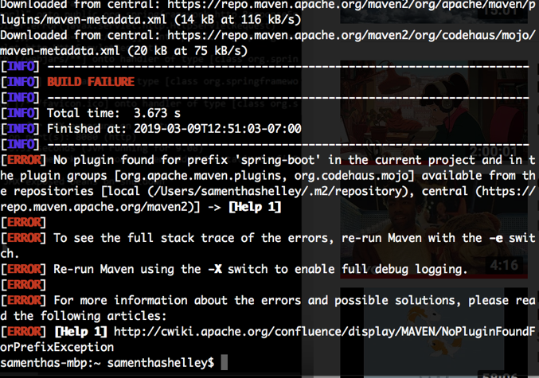

2. sending 3 different requests to the greeting service and the responses via postman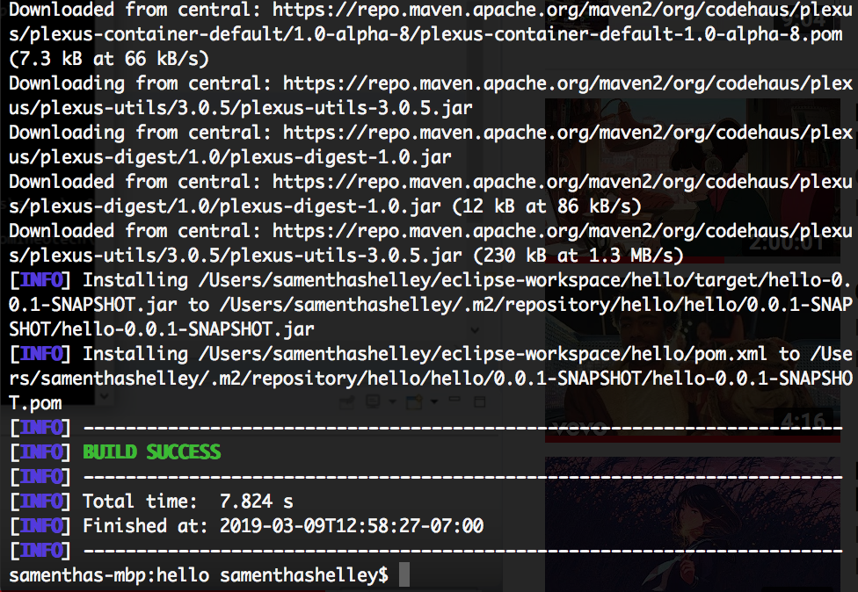

* Write a paragraph describing what issues you encountered in this tutorial and how you overcame them.

For me I feel like I’m getting a lot of errors that can be frustrating to figure out what I am doing wrong. I am getting a lot of build failures, I feel like I have to overcome the over whelming feeling I get when I look at this type of code. When I spend more time on understanding the magic behind spring boot I feel like I will grow to love it.

* Write another paragraph about what you learned.

I have a lot to learn. I don’t feel like I quiet get what I’m doing wrong or how to properly use this program and application.