Relational Databases with MySQL Week 4 Coding Assignment

**Points possible:** 70

|  |  |  |
| --- | --- | --- |
| Category | Criteria | % of Grade |
| Functionality | Does the code work? | 25 |
| Organization | Is the code clean and organized? Proper use of white space, syntax, and consistency are utilized. Names and comments are concise and clear. | 25 |
| Creativity | Student solved the problems presented in the assignment using creativity and out of the box thinking. | 25 |
| Completeness | All requirements of the assignment are complete. | 25 |

**Instructions:** Using a text editor of your choice, write the queries that accomplishes the objectives listed below. Take screenshots of the queries and results and paste them in this document where instructed below. Create a new repository on GitHub for this week’s assignments and push this document, with your Java project code, to the repository. Add the URL for this week’s repository to this document where instructed and submit this document to your instructor when complete.

**Coding Steps:**

Write 5 stored procedures for the employees database.

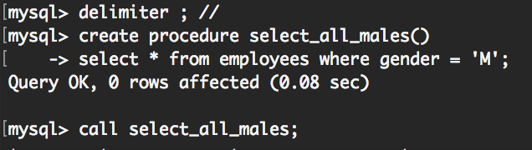

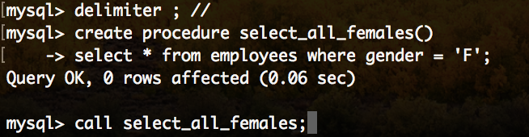

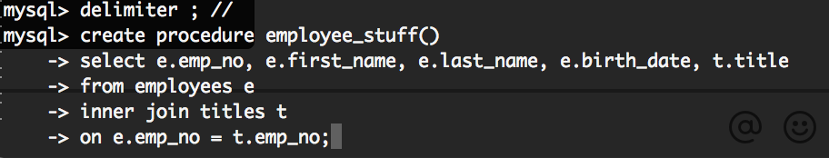

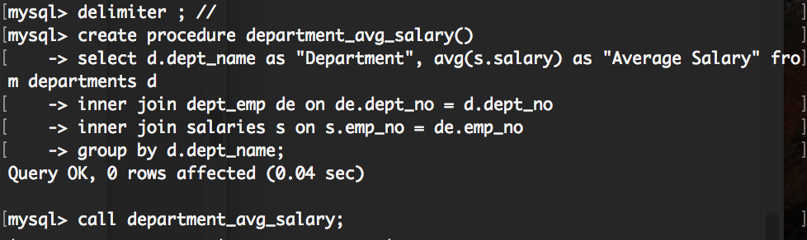

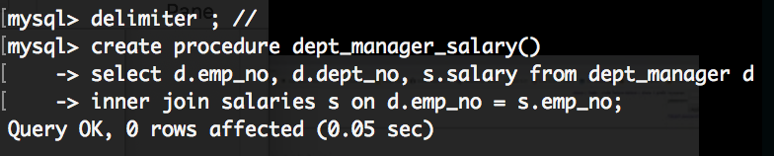

Write a description of what each stored procedure does and how to use it.

1. This stored procedure will make it easy to select all males from employees, you just call select_all_males; and it will pull all the men who are in employees.
2. This stored procedure will make it easier to access all the women who are listed in employees. You just call select_all_females; then all the females are listed.
3. This stored procedure will make it easy to see the employee number, first name, last name, and their title. You just call employee_stuff;
4. This stored procedure is to help call the departments average salaries, this helps a lot because it shortens the amount of typing you need. You just call department_avg_salary;
5. This stored procedure is to show how much the department manager makes and what department they are in. you just call dept_manager_salary; And it will pull all the department managers up.

Procedures should use constructs you learned about from your research assignment and be more than just queries.

**Screenshots:**

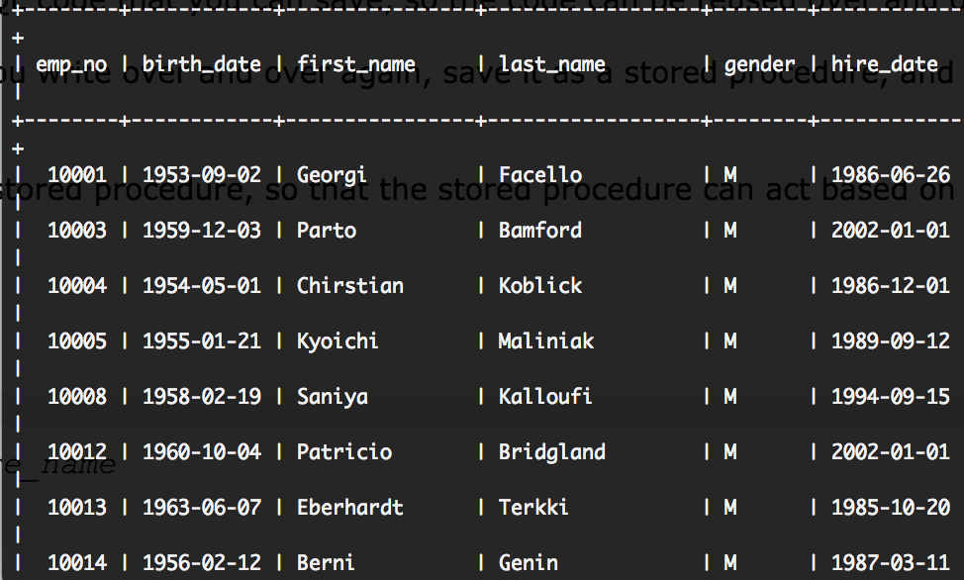

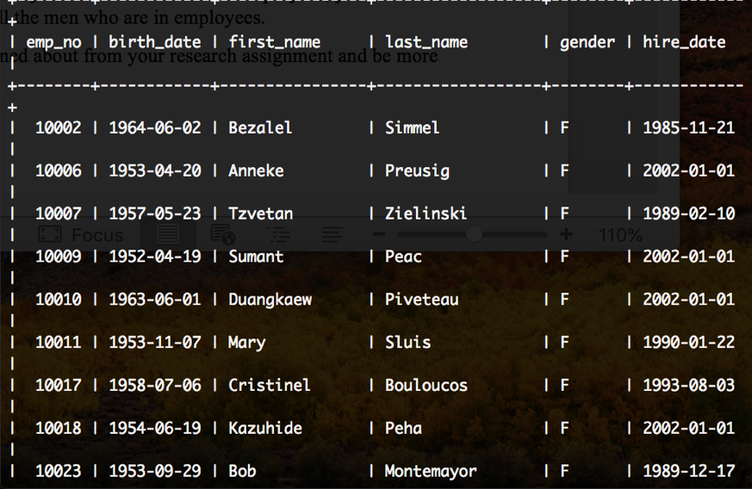

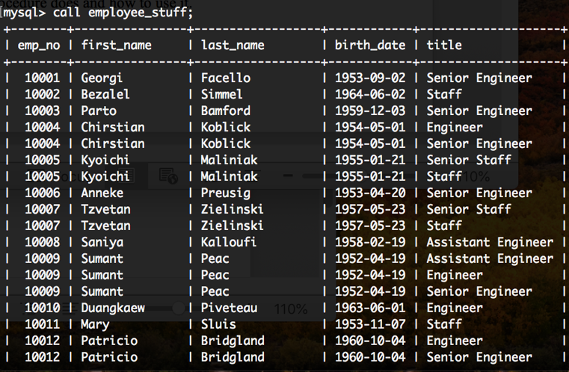

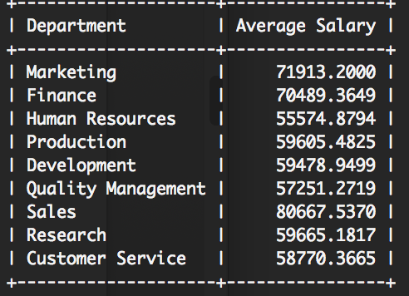

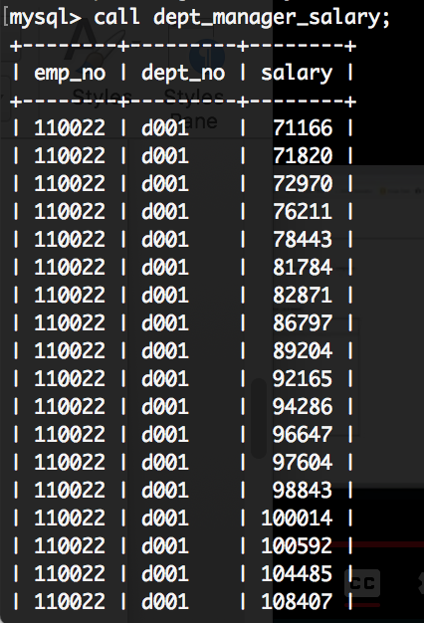

**URL to GitHub Repository:**