Relational Databases with MySQL Week 2 Research Assignment

**Points possible:** 30

|  |  |  |
| --- | --- | --- |
| Category | Criteria | % of Grade |
| Accuracy | Is the information accurate? | 25 |
| Organization | Is the essay clean and organized? Ideas are presented in a logical order. | 25 |
| Citations | Students reference and cite at least 5 sources. | 25 |
| Completeness | All requirements of the assignment are complete. | 25 |

**Instructions:** In however many words necessary, write a thorough essay response to each of the below prompts. Be sure to include at least 5 references for this assignment. Do not copy and paste text from the internet or any other source; use the information you find in your research, summarize, in your own words, the concepts. Plagiarism will result in a zero for the assignment as well as disciplinary actions. Push this document to your GitHub repository for this week. Add the URL for this week’s repository to this document where instructed and submit this document to your instructor when complete.

**Look up 10 different functions available in MySQL that were not covered in the video curriculum. What do they do and how can you use them?**

POWER: the power function returns m raised to the nth power.

UCASE: this function converts all characters in the specified string to uppercase.

CURRENT_TIME: this function returns the current time.

NOW: this function returns the current date and time.

USER: this function returns the user name and host name from the current MySQL user.

DATE_SUB: this function returns a date after which a certain time/date interval has been subtracted.

ATAN: this function returns the arc tangent of a number or returns the arc tangent of n and m.

CEIL: this function returns the smallest integer value that is greater than or equal to a number.

EXP: this function returns e raised to the power of number.

FLOOR: this function returns the largest integer value that is equal to or less than a number.

**Write a query using each of the 10 functions you described above (10 queries in total, one for each function).**

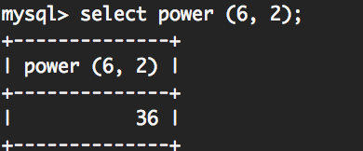

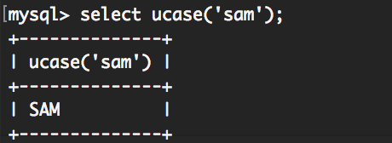

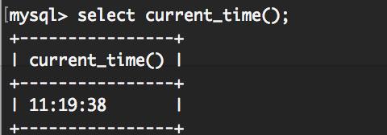

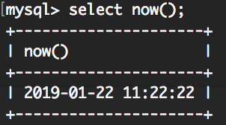

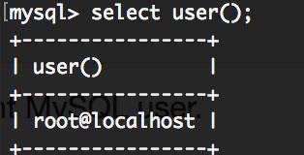

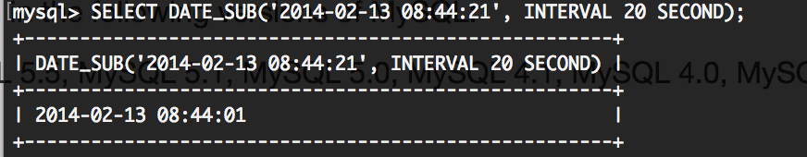

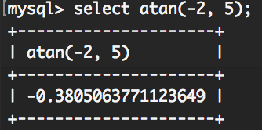

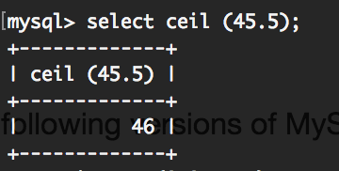

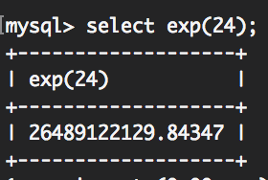

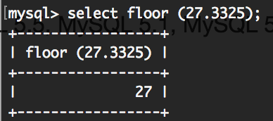

**What is your favorite thing you learned this week?**

I enjoyed learning about all the different functions available to use in mysql. I can use the terminal like a fancy calculator! So cool with all the things I can do in here.

**References:**

<https://www.techonthenet.com/mysql/functions/index.php>

**URL to GitHub Repository:**

[**https://github.com/samsquanch27/DBweektwo**](https://github.com/samsquanch27/DBweektwo)