SaNaSoft 1.2 tutorial
Your first fsQCA, step by step
A complete worked example using a SmartPLS model of AAIR, HAIC, AIGM and BVC with 378 respondents. Every screenshot comes from SaNaSoft running on the study’s latent variable scores.
Developed by Prof. S. Sabraz Nawaz and Prof. Ghazanfar Ali
Time needed: about 25 minutes. You need: your latent variable scores (CSV or Excel) and your model diagram.
Software: SaNaSoft, in any web browser — https://samssabraznawaz.github.io/sanasoft/

Contents

If the contents list is empty, right-click it in Word and choose Update Field.

Before you start
fsQCA asks a different question from SmartPLS. SmartPLS estimates how much each variable contributes on average. fsQCA asks which combinations of variables lead to a high (or low) result. SaNaSoft calls these combinations recipes; papers call them configurations.
This tutorial walks through a complete analysis of the model below, using its latent variable scores for 378 respondents (Book1.csv). Every screenshot comes from SaNaSoft 1.2 running on that file.
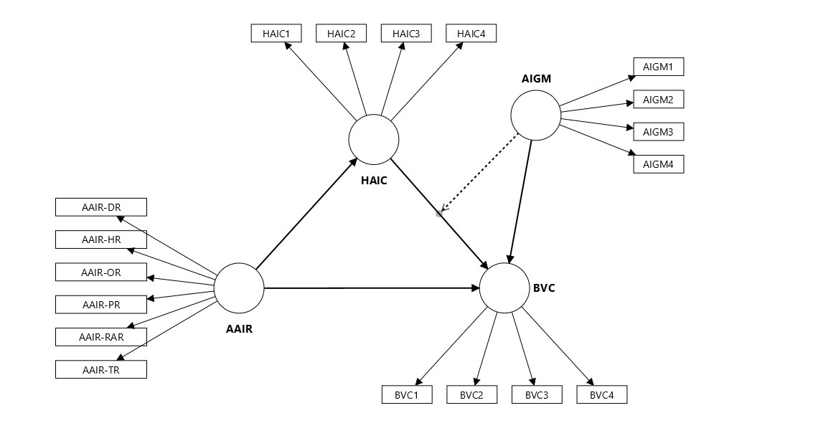
The SmartPLS model used in this tutorial. AAIR points to HAIC and BVC, HAIC points to BVC, and AIGM points to BVC and moderates the HAIC → BVC path (dotted arrow).
Here is how each part of the model is used in fsQCA:
In SmartPLS | Role in SaNaSoft | What happens in fsQCA
BVC | Dependent variable | The result you want to explain.
AAIR | Independent variable | A factor for HAIC and for BVC.
HAIC | Mediator | Analysed twice: as a result of AAIR, and as a factor for BVC.
AIGM | Moderator (also a direct arrow to BVC) | Included as an ordinary factor for BVC. No interaction term is needed.

Tip. Words with a dotted underline show the technical term used in papers when you point at them or tap them. The Theme menu at the top switches between Light, Dark and Match device.

1. Upload your scores
Open SaNaSoft in any web browser. The green bar at the top shows the developers, a Theme menu and, once data are loaded, a Save project button. The green panel on the left lists the seven steps; the panel on the right explains each step in plain language.
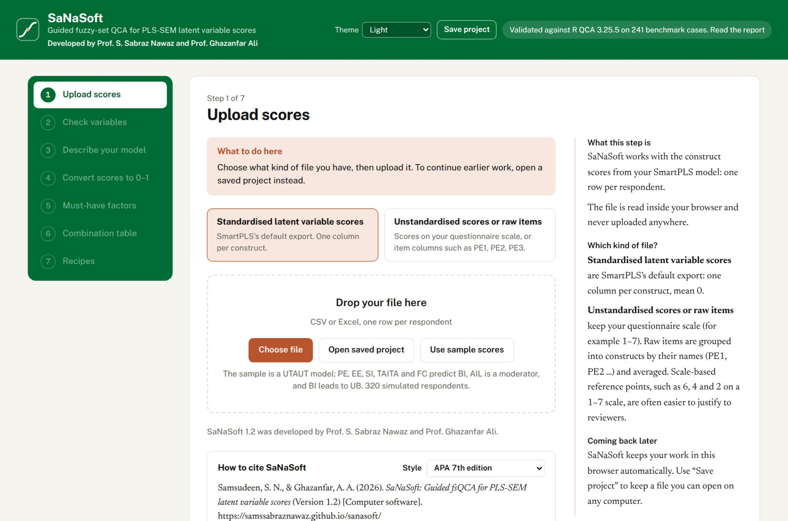
The start screen of SaNaSoft 1.2.
First, choose what kind of file you have:
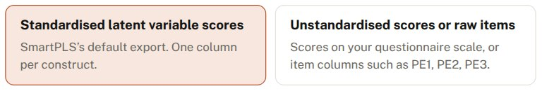
The two kinds of file SaNaSoft accepts.
- Standardised latent variable scores: SmartPLS’s default export, one column per construct. Choose this for Book1.csv.
- Unstandardised scores or raw items: scores on your questionnaire scale, or item columns such as PE1, PE2, PE3. See section 12.

Then click Choose file (or drag the file onto the dashed box) and select Book1.csv. SaNaSoft confirms 378 respondents and 4 constructs. A row-number column or a SmartPLS moderation term such as “AIGM x HAIC” would be left out automatically.
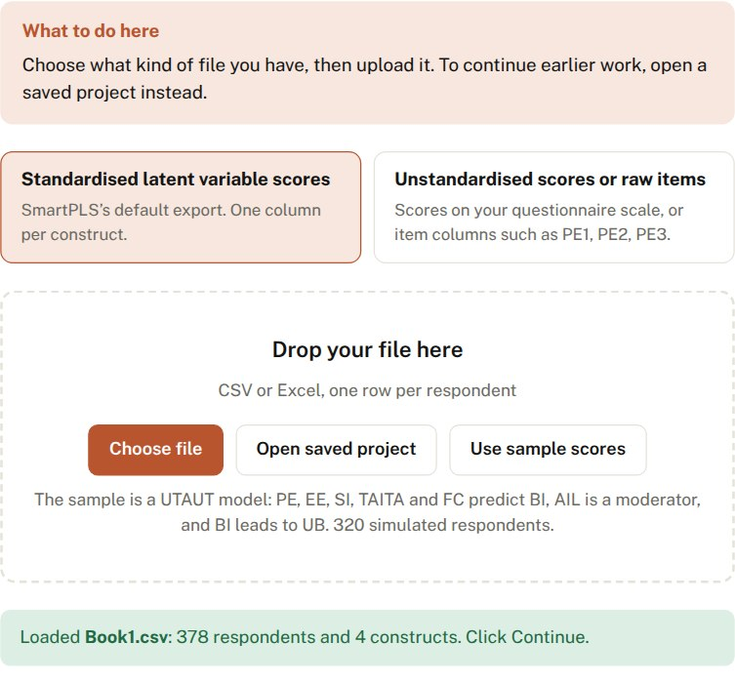
After uploading: a green message confirms the file and shows its first rows.
Below the upload box, SaNaSoft shows who developed it and how to cite it. Choose a reference style and click Copy citation to paste it into your paper.
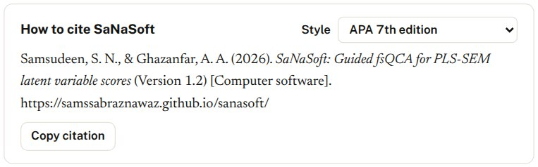
The “How to cite SaNaSoft” box. The style menu offers APA 7th, Harvard, Emerald, Chicago author-date, IEEE and Vancouver.

2. Check the variables
Each construct should have a mean of 0 and a standard deviation of 1, which confirms the scores are standardised. Yours are. Nothing needs changing, so click Continue.
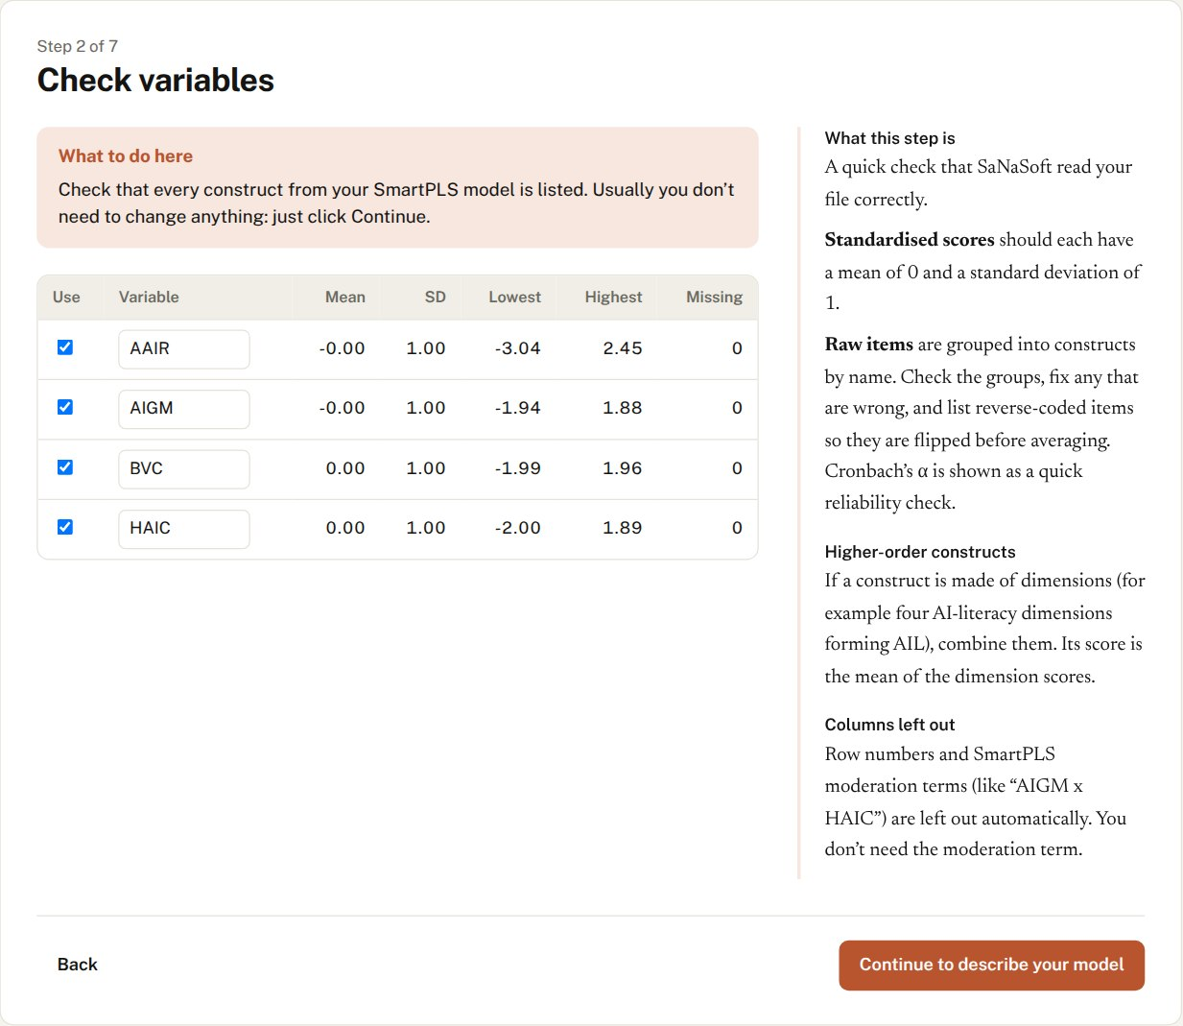
All four constructs have mean 0.00 and SD 1.00, with no missing values.

3. Describe your model
This is the only step that needs real input. Look at your SmartPLS diagram and choose each variable’s role from the drop-down list:
- Set BVC to Dependent variable.
- Set HAIC to Mediator. Its arrow goes to BVC, which SaNaSoft ticks automatically.
- Set AAIR to Independent variable. Leave both BVC and HAIC ticked, because AAIR has arrows to both.
- Set AIGM to Moderator. Its dotted arrow points at the HAIC → BVC arrow, which is an arrow going into BVC, so keep BVC ticked and untick HAIC.

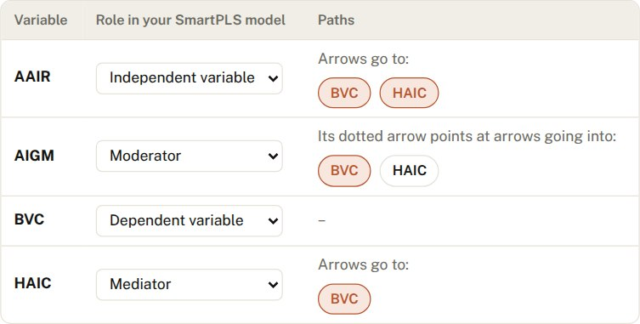
The model described in SaNaSoft. AIGM’s arrow is ticked for BVC only.
What about AIGM’s direct arrow to BVC? It makes no difference. Whether AIGM moderates an arrow into BVC or predicts BVC directly, fsQCA uses it the same way: as a factor for BVC. If AIGM matters, it appears in the recipes together with the factors it strengthens.
SaNaSoft now suggests two analyses based on your arrows:
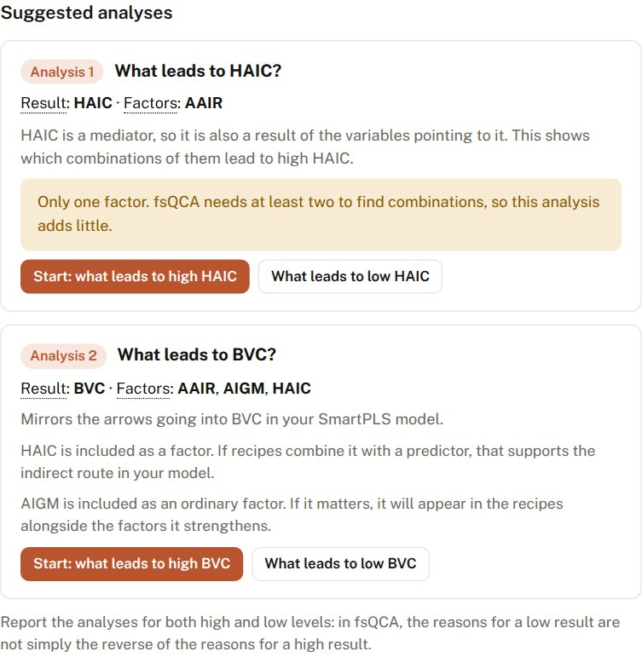
The suggested analyses. Analysis 2 (BVC) is the main one.
- Analysis 1, what leads to HAIC? Only AAIR points to HAIC, so this analysis has a single factor. SaNaSoft warns that fsQCA adds little with one factor.
- Analysis 2, what leads to BVC? This uses AAIR, AIGM and HAIC, mirroring every arrow into BVC. Click Start: what leads to high BVC.

4. Convert scores to 0–1
fsQCA asks how much each respondent belongs to the “high” group for each variable, from 0 (clearly low) to 1 (clearly high). For standardised scores SaNaSoft fills in the recommended reference points: the 95th, 50th and 5th percentiles of your data.
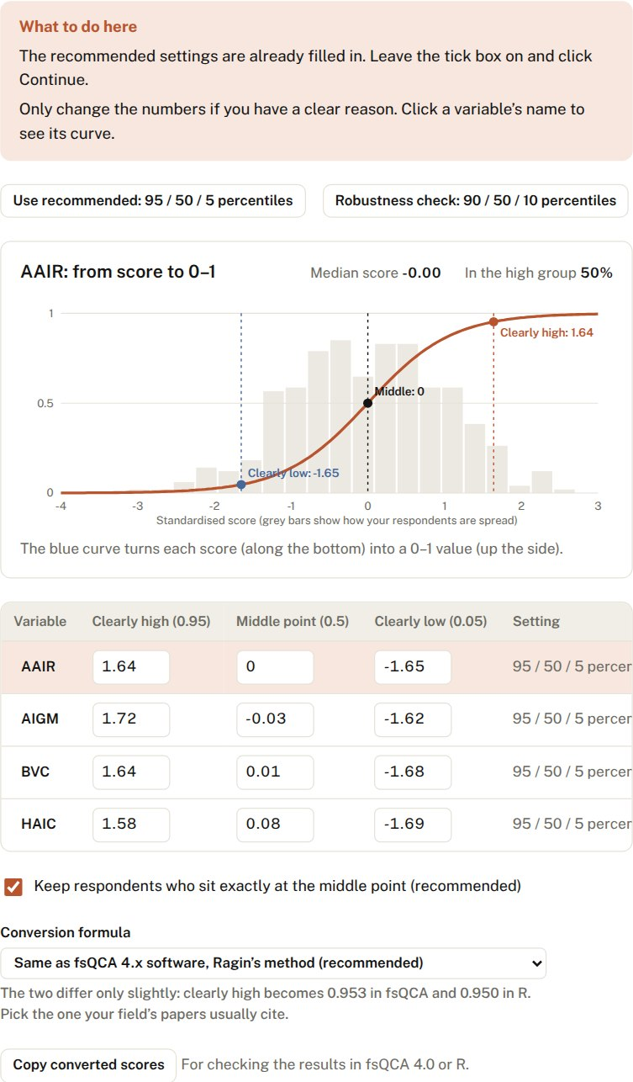
The blue curve shows how each BVC score becomes a 0–1 value; the grey bars show how respondents are spread.
What to do: nothing. Keep the recommended settings and the tick box on, and click Continue. The “Conversion formula” menu lets you match either fsQCA 4.x (the default) or the R QCA package.

5. Must-have factors
SaNaSoft checks whether high BVC ever occurs without a particular factor. None of your factors reaches the 0.90 benchmark (the highest is high AAIR at 0.771), so none is a must-have. This is common with survey data; report it in one sentence.
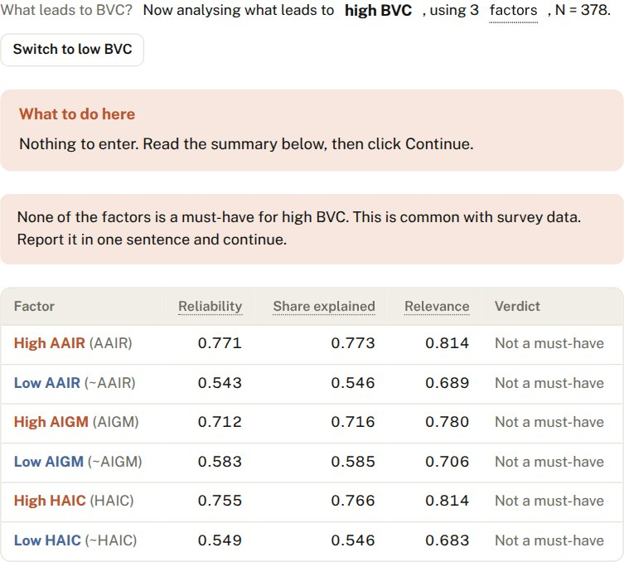
None of the factors is a must-have for high BVC.

6. Combination table
Every respondent has a pattern of high and low values. With three factors there are eight possible patterns. SaNaSoft counts the respondents in each and checks whether the pattern reliably goes with high BVC.
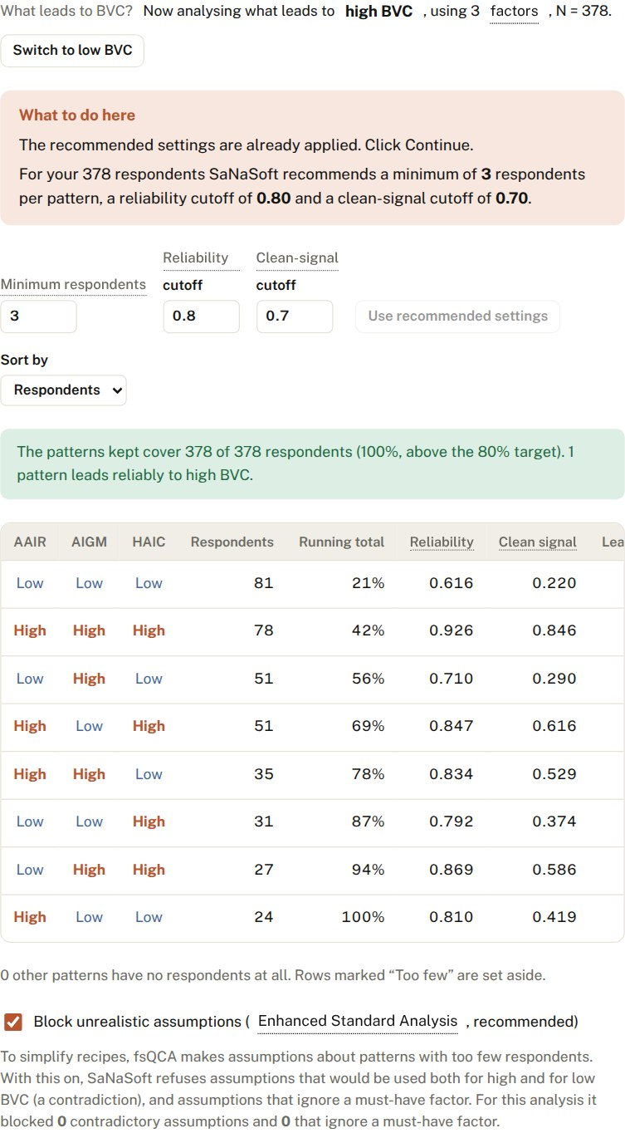
The combination table. Only one pattern, high AAIR with high AIGM and high HAIC (78 respondents, reliability 0.926), is marked “Yes”.
What to do: nothing; the recommended settings are applied. For 378 respondents that means at least 3 respondents per pattern (keeping 100% of respondents), a reliability cutoff of 0.80 and a clean-signal cutoff of 0.70.
Notice the pattern with high AAIR, low AIGM and high HAIC: its reliability is 0.847 but its clean-signal score is only 0.616, so it does not count. It reappears in the robustness check. At the bottom, Block unrealistic assumptions (Enhanced Standard Analysis) is on; for this data it found nothing to block.

7. Read your recipes
At the top of the Recipes step, say what your theory expects. All SmartPLS paths into BVC are positive, so keep Helps when high for every factor.
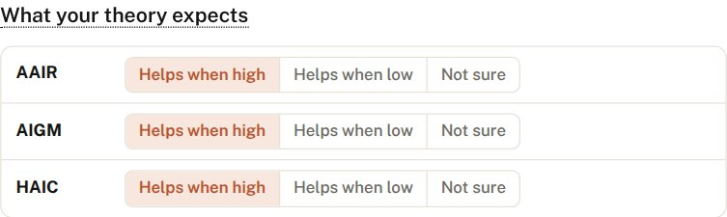
Theory expectations. Change a factor to “Helps when low” only if its SmartPLS path was negative.
The recipe chart shows one recipe for high BVC, and SaNaSoft explains it in plain words:
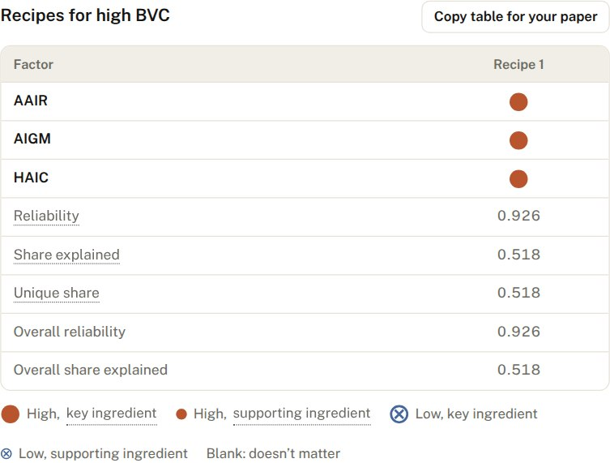
Recipe 1: high AAIR, high AIGM and high HAIC, all key ingredients (large dots).
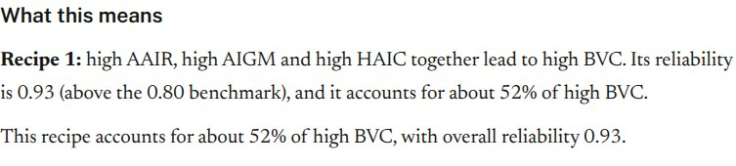
The same result in a sentence you can adapt for your paper.
In other words, high BVC occurs when AAIR, AIGM and HAIC are all high together. The recipe is highly reliable (0.93, well above 0.80) and accounts for about half of all high-BVC membership (0.52).
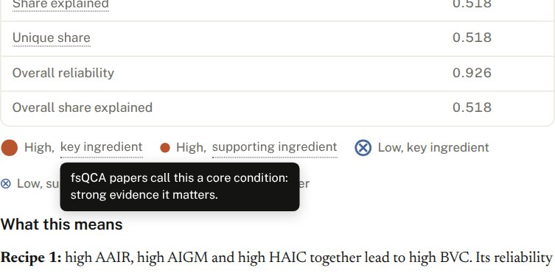
Point at any dotted word to see its technical name: “key ingredient” is what papers call a core condition.
Further down, SaNaSoft shows which respondents follow the recipe, and an XY plot of the fit:
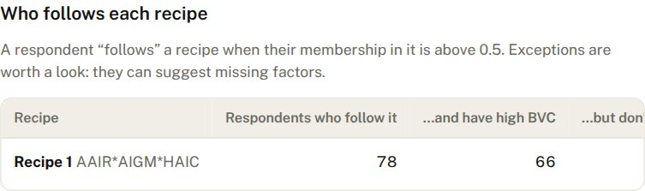
Respondents who follow the recipe and have high BVC, and exceptions who follow it but don’t.
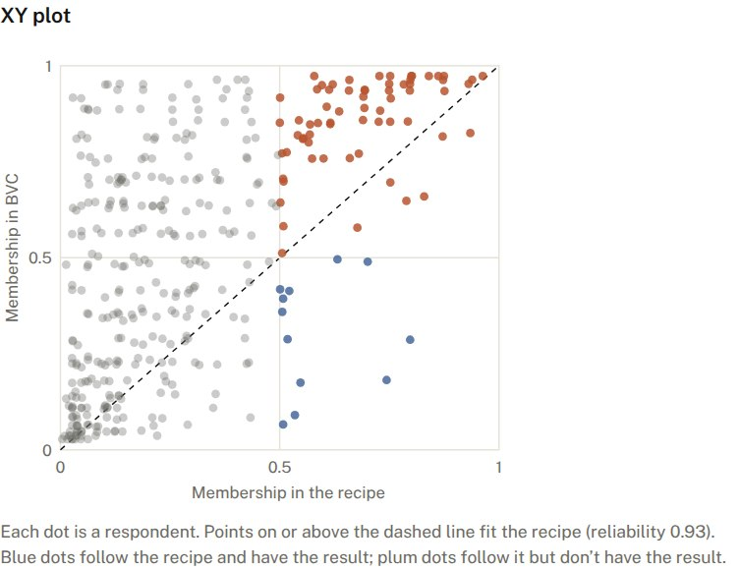
Each dot is a respondent. Dots on or above the dashed line fit the recipe.

8. Check robustness and predictive validity
Click Run robustness check. SaNaSoft reruns the analysis with other reference points, cutoffs and minimum numbers of respondents.
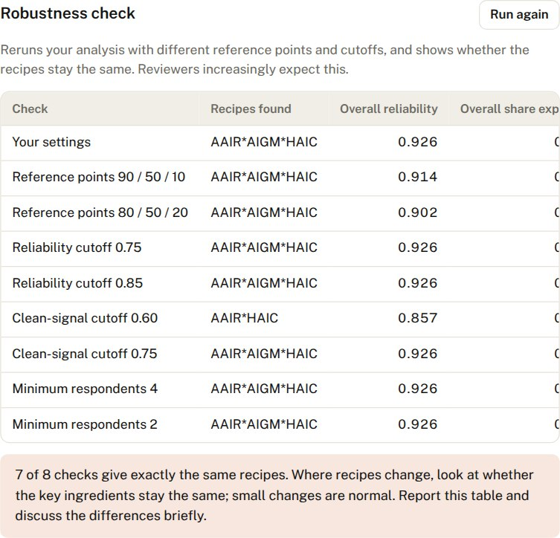
7 of 8 checks give exactly the same recipe.
The one change is instructive. With a lower clean-signal cutoff (0.60), the recipe becomes AAIR·HAIC without AIGM. So the robust core is that AAIR and HAIC together lead to high BVC, and AIGM completes the recipe under the stricter, recommended setting.
Then click Run predictive test. SaNaSoft finds the recipe in a random half of the respondents and tests it on the other half.
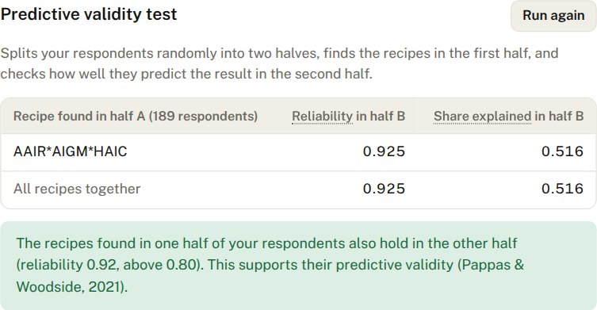
The recipe holds in the unseen half (reliability 0.925, share explained 0.516).

9. Download your results
The Download your results section turns everything into files for your paper. Choose the paper size, the reference style (APA 7th, Harvard, Emerald, Chicago author-date, IEEE or Vancouver) and the font, tick what to include, then download.
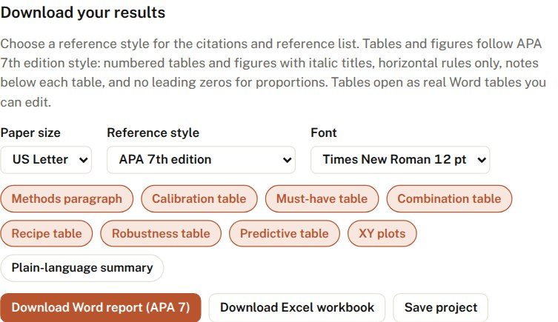
The download section. Robustness and predictive tables become available once those checks have been run.
Word report (APA 7). Tables and figures follow APA 7th edition style: numbered, with italic titles, horizontal rules only, notes below and no leading zeros for proportions. They are real Word tables you can edit. Citations and the reference list follow the style you chose, and SaNaSoft is cited automatically.
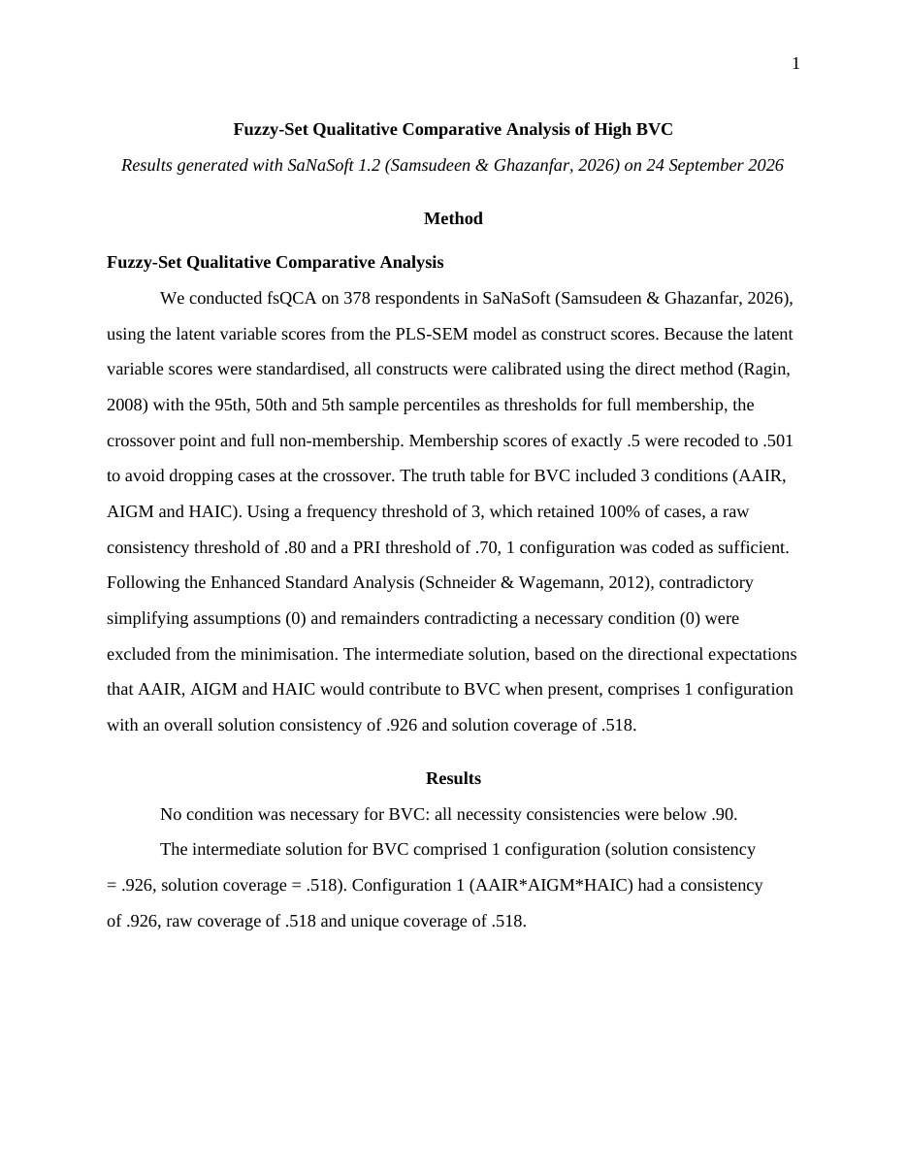
Page 1 of the Word report: the methods paragraph citing SaNaSoft and the results summary.
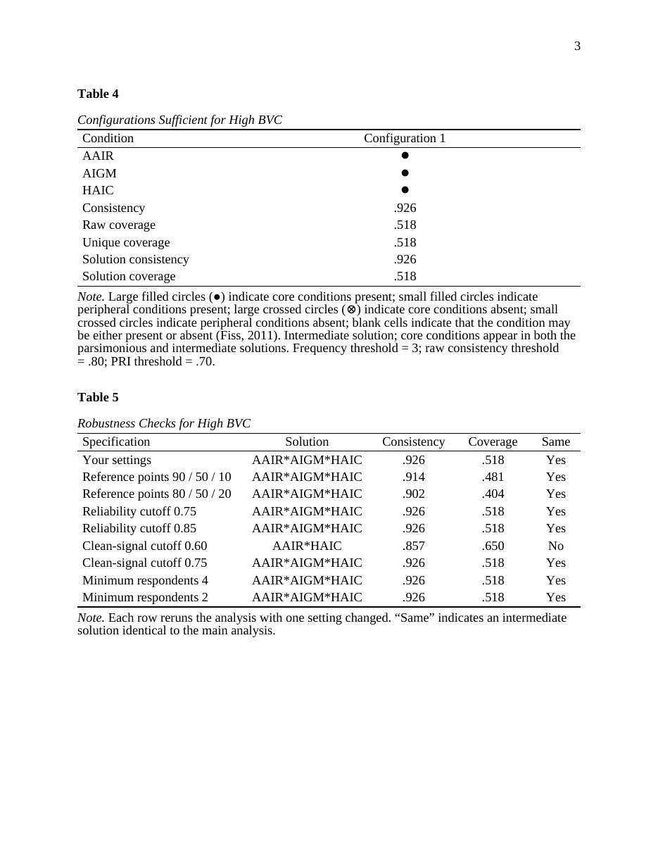
Page 3 of the Word report: the configuration table and robustness checks in APA 7 format.
Excel workbook. Nine sheets: settings and anchors, calibrated data, necessity, truth table, all three solutions, configuration chart, respondents per recipe, robustness and predictive validity.
Methods paragraph. The Recipes step also shows a ready-to-edit methods paragraph with its references in your chosen style. Copy paragraph copies the references too.
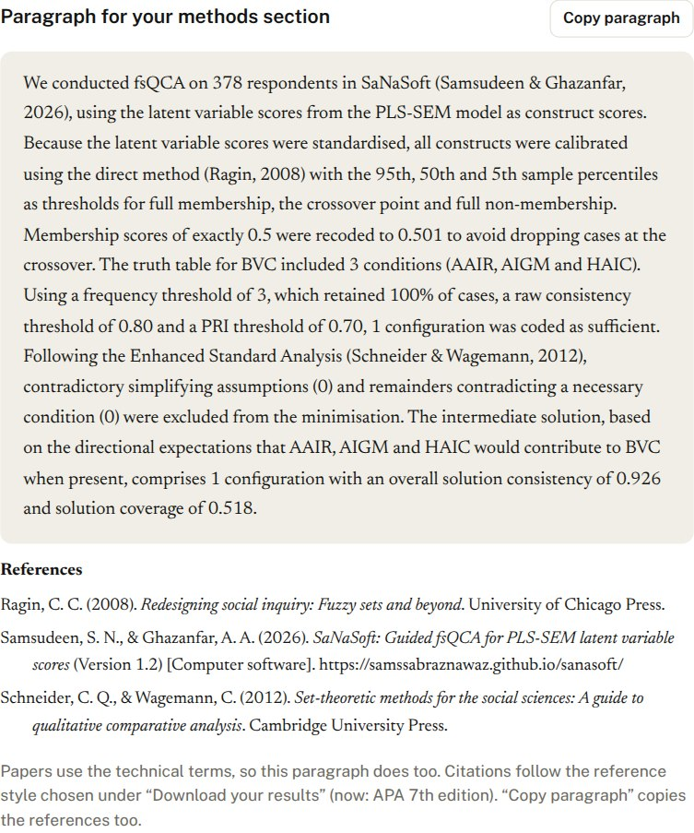
The methods paragraph, citing SaNaSoft and the methodological sources in APA style.
Every download is numbered so nothing is ever overwritten:
File | First download | Next download
Word report | SaNaSoft_1_Report_Book1_high_BVC.docx | SaNaSoft_2_Report_Book1_high_BVC.docx
Excel workbook | SaNaSoft_1_Results_Book1_high_BVC.xlsx | SaNaSoft_2_Results_Book1_high_BVC.xlsx
Project | SaNaSoft_1_Project_Book1.sanasoft.json | SaNaSoft_2_Project_Book1.sanasoft.json

10. Save your project and come back later
Click Save project in the green bar (or in the download section) at any time. The project file keeps your data, model, settings and choices, and it opens on any computer: on the first screen click Open saved project and choose the file. SaNaSoft returns to the step where you saved, with identical results.
The green bar: Theme menu, Save project and the link to the validation report.
SaNaSoft also keeps your work in the browser automatically. If you close or reload the page, the first screen offers to continue:

After reloading, SaNaSoft offers to continue where you left off.

11. Run the remaining analyses
At the bottom of the Recipes step, buttons run your other analyses with the same settings.
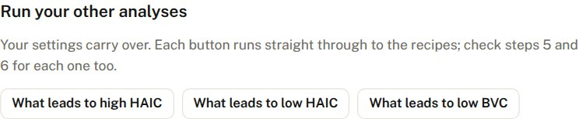
Your other analyses: low BVC, and high and low HAIC.
Low BVC. The recipe is the mirror image: low AAIR, low AIGM and low HAIC together lead to low BVC (reliability 0.868, share explained 0.507).
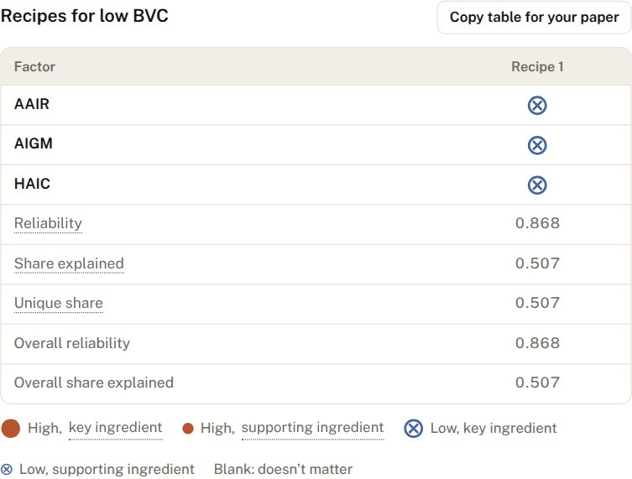
The recipe for low BVC. Crossed circles mean the factor must be low.
HAIC. With AAIR as its only factor, no pattern passes the settings, so SaNaSoft reports no recipe for high HAIC. That is a legitimate finding: AAIR alone does not reliably produce high HAIC. Report it rather than lowering the cutoffs to force a result.

12. If you have raw items instead
If your file holds questionnaire items (for example HAIC1 to HAIC4 on a 1–7 scale) or unstandardised scores, choose Unstandardised scores or raw items in step 1. SaNaSoft then:
- groups items into constructs by name and averages them, showing Cronbach’s α;
- flips reverse-coded items that you list;
- builds higher-order constructs, for example AAIR from its dimensions;
- uses scale-based reference points, such as 6 (agree), 4 (neutral) and 2 (disagree) on a 1–7 scale.

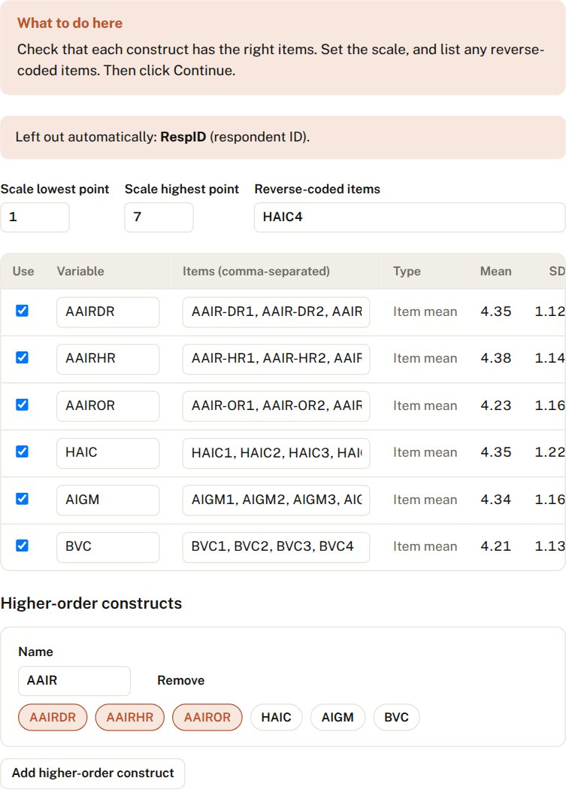
Step 2 with an example raw-item file: HAIC4 is reverse-coded, and AAIR is built from three dimensions.
The rest of the analysis works exactly as described above, and the methods paragraph describes the scale-based calibration.

Writing up the findings
Here is how the results could be reported alongside the PLS-SEM findings. Adapt the wording to your paper.
fsQCA was conducted in SaNaSoft (Samsudeen & Ghazanfar, 2026). No single condition was necessary for high BVC (all consistencies below .90). The intermediate solution contained one configuration: high AAIR combined with high AIGM and high HAIC, all as core conditions (consistency = .926, coverage = .518). The negated outcome showed the reverse configuration, with low AAIR, low AIGM and low HAIC leading to low BVC (consistency = .868, coverage = .507). The solution was stable across alternative calibration anchors, consistency thresholds and frequency thresholds (7 of 8 robustness checks); with a PRI threshold of .60, AIGM dropped out, leaving AAIR*HAIC (consistency = .857, coverage = .650). A holdout test supported predictive validity (consistency = .925 in the holdout subsample).
What it adds to the PLS-SEM results:
- Mediation. AAIR and HAIC appear together in every recipe, consistent with AAIR working through HAIC. High AAIR on its own is not enough.
- Moderation. AIGM completes the recipe for high BVC, the configurational counterpart of AIGM strengthening the HAIC → BVC path.
- Asymmetry. With only three factors, the recipe for low BVC mirrors the one for high BVC. Say so, because it shows you checked.

How to cite SaNaSoft
SaNaSoft was developed by Prof. S. Sabraz Nawaz and Prof. Ghazanfar Ali. Please cite it in any work that uses it, for example:
Samsudeen, S.N. and Ghazanfar, A.A. (2026), “SaNaSoft: Guided fsQCA for PLS-SEM latent variable scores”, Version 1.2, available at: https://samssabraznawaz.github.io/sanasoft/
The “How to cite SaNaSoft” box on the first screen gives the citation in six reference styles, and every report SaNaSoft produces includes it automatically.

Checklist before you submit
- Calibration anchors reported, with the .501 adjustment
- Necessity results reported, even if no condition was necessary
- Frequency, consistency and PRI thresholds reported, with the share of cases retained
- Configuration table with core and peripheral conditions, consistency and coverage
- Negated outcome analysed and reported
- Robustness table in an appendix; predictive validity test mentioned
- SaNaSoft cited in your chosen reference style

SaNaSoft 1.2 was developed by Prof. S. Sabraz Nawaz and Prof. Ghazanfar Ali. It is validated against R QCA 3.25.5. Tutorial updated September 2026.

