GLOBAL WEALTH UNIVERSITY, LOME, TOGO

DEPARTMENT OF COMPUTER SCIENCE AND SOFTWARE ENGINEERING

DESIGN AND IMPLEMENTATION OF AN ELECTRONIC LIBRARY SYSTEM IN NIGERIA

BY

SAMUEL STANLEY UCHENNA
MATRIC NO: 164837

A PROJECT SUBMITTED IN PARTIAL FULFILLMENT OF THE REQUIREMENTS FOR THE AWARD OF BACHELOR OF SCIENCE (B.sc) IN COMPUTER SCIENCE AND SOFTWARE ENGINEERING

2025

DESIGN AND IMPLEMENTATION OF AN ELECTRONIC LIBRARY SYSTEM IN NIGERIA

BY

SAMUEL STANLEY UCHENNA
MATRIC NO: 164837

A PROJECT SUBMITTED IN PARTIAL FULFILLMENT OF THE REQUIREMENTS FOR THE AWARD OF BACHELOR OF SCIENCE (B.sc) IN COMPUTER SCIENCE AND SOFTWARE ENGINEERING

DEPARTMENT OF COMPUTER SCIENCE AND SOFTWARE ENGINEERING

GLOBAL WEALTH UNIVERSITY, LOME, TOGO

2025

CERTIFICATION
This is to certify that the project titled “Design and Implementation of an Electronic Library System” was carried out by Samuel Stanley Uchenna with matriculation Number 164837 of the department of Computer Science and Software Engineering, global Wealth University, Lome, Togo. The work meets the requirements governing the award of Bachelor of Science (B.sc) degree in Computer Science and Software Engineering.

_________________________________________
Supervisors Name and Signature

_________________________________________
Head of Department

DEDICATION

This work is dedicated to Almighty God, whose grace and wisdom made it possible, and to my beloved parents and siblings for their unwavering support, encouragement, and prayers throughout my academic journey. I also dedicate this project to every student and researcher who seeks knowledge and strives to make the world a better place through learning.

ACKNOWLEDGEMENT

I sincerely acknowledge my project supervisor for his guidance, constructive criticisms, and encouragement throughout the duration of this work. My gratitude also goes to the lecturers of the Department of Computer Science, Global Wealth University, Lome, Togo, for imparting knowledge that has shaped my academic journey. Special thanks to my colleagues and friends who contributed in diverse ways, through discussions, suggestions, and moral support. Finally, I deeply appreciate my family for their financial and spiritual support, without which this project would not have been possible.

FORWARD (Preface)

The advancement of technology in education has necessitated a paradigm shift from traditional to digital methods of learning and research. This project report presents a comprehensive study and practical implementation of an electronic library system tailored to the Nigerian context. It provides a structured approach, beginning with the background and literature review, followed by methodology, system design, and implementation details. This document is intended not only as an academic requirement for the award of a Bachelor of Science (B.Sc.) in Computer Science but also as a reference for researchers, developers, and policymakers interested in advancing digital learning in Nigeria and beyond.

ABSTRACT
This project, titled Design and Implementation of an Electronic Library System in Nigeria, addresses the pressing need for effective, reliable, and accessible information storage and retrieval systems in Nigerian academic and research institutions. Traditional libraries have served as the backbone of learning and knowledge dissemination for decades, but they face numerous challenges including limited storage capacity, wear and tear of physical books, inadequate cataloguing, geographical barriers, and the high cost of expansion and maintenance. These issues significantly hinder research, reduce accessibility, and limit the capacity of students and scholars to acquire updated knowledge efficiently.
The study explores how modern information technology can be harnessed to transform the conventional library into an electronic library (E-library), a digital platform where books, journals, articles, and research resources are stored electronically and accessed online or within an intranet environment. Unlike physical libraries, electronic libraries provide the advantages of unlimited storage, remote accessibility, cost-effectiveness, and enhanced security of academic resources. More importantly, the system can integrate functionalities such as search optimization, user authentication, book uploads, password recovery mechanisms, and administrative controls that ensure accountability and proper management of the library content.
The methodology adopted for this study followed a structured software development approach. The process began with system analysis, where the shortcomings of the traditional library system were carefully examined. This was followed by requirement gathering, where the expectations of users (students, researchers, administrators) were documented. The design stage included the creation of use case diagrams, entity relationship models, flowcharts, and data flow diagrams to capture both functional and non-functional requirements. The implementation stage was executed using a web-based platform powered by HTML, CSS, JavaScript, and Python (Flask framework) for backend logic, with SQLite as the database management system. Authentication and security measures such as password hashing and email-based password reset were integrated to ensure system reliability.
The developed electronic library system allows registered users to log in, browse available digital resources, search for specific titles using keywords, download materials, and interact with the library content seamlessly. Administrators have special privileges to upload new books, manage users, and ensure that resources are updated regularly. The system also ensures data integrity, ease of access, and improved scalability for future expansions.
Findings from the project reveal that the implementation of an electronic library system significantly reduces the bottlenecks of the traditional system. Students and researchers gain faster access to materials without the physical constraints of distance or library working hours. Institutions benefit from reduced operational costs associated with book procurement, maintenance, and physical infrastructure. Furthermore, digitized resources are less susceptible to deterioration compared to their physical counterparts.
This project contributes to the digitization agenda in Nigerian education, aligning with global best practices in academic resource management. It provides a replicable model for other universities, secondary schools, and research institutes aiming to adopt an electronic library system. The study concludes that electronic library systems not only enhance accessibility and efficiency but also promote continuous learning, improve academic performance, and ensure long-term sustainability of academic resources in Nigeria.

Table of Contents Page

- Cover Page
- Title Page
- Certification III
- Dedication IV
- Acknowledgement V
- Forward VI
- Abstract VII
- Table of Contents IX
- List Of Tables and Figures X
- Glossary XI
- Chapter One: Introduction 1
- Chapter Two: Literature Review 5
- Chapter Three: System Analysis and design 46
- Chapter Four: System Implementation 89
- Chapter Five: Summary, Conclusion and Recommendations 98
- References 111

List of Tables And Figures

GLOSSARY
- Access Control – Security technique used to regulate who can view or use resources in a computing environment.
- Administrator (Admin) – A user with higher privileges who manages the system, uploads resources, and controls access.
- Algorithm – A step-by-step logical procedure for solving a problem or carrying out a task in computing.
- Application Programming Interface (API) – A set of protocols and tools that allows different software components to communicate.
- Authentication – The process of confirming the identity of a user.
- Authorization – The process of granting access rights to users based on their privileges.
- Backup – A copy of data kept to ensure recovery in case of system failure.
- Bandwidth – The maximum rate of data transfer across a network path.
- Cloud Storage – A service model in which data is maintained and backed up remotely, accessible via the internet.
- Cryptography – The practice of securing information by converting it into unreadable formats.
- Database Management System (DBMS) – Software that allows the creation, retrieval, update, and management of databases.
- Data Encryption – The process of encoding data to prevent unauthorized access.
- Data Mining – Extracting useful patterns and knowledge from large data sets.
- Digitization – Conversion of physical materials into digital formats for storage and distribution.
- Download – Copying data from the server to a local device.
- Entity Relationship Diagram (ERD) – A graphical representation of data entities and their relationships.
- Firewall – A network security system that monitors and controls traffic between networks.
- Graphical User Interface (GUI) – The visual component of a system that allows users to interact with it.
- Hashing – A process of converting information into a fixed-length code for security.
- Hypertext Transfer Protocol (HTTP/HTTPS) – Protocols used for communication over the web.
- Implementation – The actual coding and building of a system to match its design.
- Information Retrieval – The process of obtaining relevant data from a collection of stored resources.
- Login – The process of entering credentials to access a secure system.
- Metadata – Data that describes other data.
- Password Recovery – The process of regaining access to an account if the password is forgotten.
- Query – A request made to a database for specific information.
- Scalability – The ability of a system to handle growth in data, users, or workload.
- Search Engine – A tool for finding information within a large dataset.
- Software Development Life Cycle (SDLC) – The phases involved in developing software.
- System Testing – A stage of verifying whether the complete system meets its requirements.

CHAPTER ONE
INTRODUCTION
Background to the Study
Over the past few decades, the world has experienced rapid growth in information and communication technology (ICT). This development has significantly transformed how information is created, stored, retrieved, and disseminated. In the education sector, the traditional methods of accessing academic materials through physical libraries have given way to more advanced digital systems, allowing for more efficient access to information. Electronic libraries, also known as e-libraries, have emerged as innovative platforms where academic resources can be stored digitally and accessed remotely through the internet or institutional intranets.
In Nigeria, the adoption of ICT in education has been progressive but slow compared to developed nations. Many universities, polytechnics, and secondary schools still rely heavily on physical libraries, which come with numerous limitations. For instance, students and researchers must be physically present in the library to access materials, which is time-consuming and sometimes impossible due to distance or limited library hours. Furthermore, traditional libraries often suffer from issues such as outdated books, insufficient copies of key texts, poor cataloging systems, and lack of funding for resource expansion.
An electronic library system offers a modern solution to these challenges. It provides access to academic materials in digital formats such as e-books, research articles, journals, and multimedia learning resources. With proper design and implementation, an e-library can transform the learning environment by ensuring that materials are easily accessible anytime and anywhere. Such a system would not only benefit students and lecturers but also improve the quality of education by encouraging independent research and lifelong learning.
The development of an e-library in Nigerian institutions is therefore timely and necessary. By integrating ICT tools into library management, institutions can move towards global standards in educational resource provision. This study focuses on the design and implementation of an electronic library system tailored to the needs of Nigerian educational institutions, with emphasis on accessibility, efficiency, and user-friendliness.
Statement of the Problem
Despite the growing importance of ICT in education, many institutions in Nigeria continue to face significant challenges in providing adequate library services. Physical libraries remain the primary source of academic resources, yet they are often poorly equipped and lack current materials. Students and researchers spend long hours searching for limited copies of textbooks or journals, while others in distant locations cannot access the library at all.
Additionally, the manual cataloging systems used in many libraries make it difficult to search for books efficiently, leading to time wastage and frustration. The lack of digital access to learning materials also affects distance learning programs, which rely heavily on online resources. Furthermore, financial and infrastructural constraints prevent many institutions from expanding their physical libraries to meet the growing demand for educational resources.
These problems highlight the need for a digital solution that can store academic materials electronically and allow remote access to users. The design and implementation of an electronic library system will help solve issues related to accessibility, storage, retrieval speed, and resource sharing among institutions.
Purpose of the Study
The main aim of this study is to design and implement an electronic library system for academic institutions in Nigeria. The specific objectives are to:
Develop a functional electronic library system that provides digital access to academic materials.
Enable students and lecturers to search, borrow, and read materials electronically from any location.
Reduce the time and cost associated with managing physical library resources. Improve the efficiency of cataloging and retrieval processes through automated systems.
Provide a platform that supports academic research and lifelong learning through accessible digital resources. Research Questions
This study will be guided by the following research questions:
What are the current challenges faced by traditional libraries in Nigerian educational institutions?
How can an electronic library system improve access to academic resources? What technological tools are required for the successful implementation of an e-library?
How will students, lecturers, and researchers benefit from the system?
What limitations might affect the implementation and usage of the e-library? Research Hypotheses
The study will test the following hypotheses:
H₀ (Null Hypothesis): The implementation of an electronic library system has no significant impact on access to academic resources in Nigerian institutions. H₁ (Alternative Hypothesis): The implementation of an electronic library system significantly improves access to academic resources in Nigerian institutions. Significance of the Study
This study is significant for several reasons. First, it will provide a cost-effective solution for institutions struggling with limited physical library resources. By digitizing materials, schools and universities can reduce the need for constant physical expansion and maintenance of traditional libraries.
Second, the system will enhance academic performance by ensuring that students and lecturers can easily access textbooks, research papers, and multimedia learning materials without physical restrictions. This will encourage independent study, research, and knowledge sharing among users.
Third, the study will serve as a reference point for future research on digital learning tools and library automation in Nigeria and other developing countries. It will also provide practical insights for ICT professionals and educational administrators on integrating technology into library services.
Scope of the Study
The study focuses on the design and implementation of an electronic library system for educational institutions in Nigeria. It will cover features such as user registration, digital cataloging of materials, online searching, borrowing, and reading of academic resources. The system will be accessible through web browsers and designed to support future upgrades like mobile applications and multimedia resources. Geographically, the study will focus on Nigerian institutions but can be adapted for use in other developing countries facing similar challenges. The research will not cover unrelated ICT infrastructures such as e-learning platforms or school management systems, although the e-library can be integrated with such systems in the future.
Limitations of the Study
Like any research, this study will encounter some limitations. Firstly, financial constraints may limit the scope of system development, especially in terms of advanced features like artificial intelligence-powered recommendations or cloud hosting. Secondly, time limitations may affect the extent of testing and deployment in multiple institutions.
Another challenge may be the level of ICT literacy among users. Some students and lecturers may require basic computer training before fully benefiting from the system. Lastly, inadequate internet infrastructure in some rural areas may limit remote access, although offline access options can be explored in future upgrades.
Operational Definition of Terms
Electronic Library (E-Library): A digital platform that stores academic resources electronically for easy access.
ICT: Information and Communication Technology; tools used for creating, storing, and sharing information digitally.
Database: A structured system for storing and retrieving information efficiently. Cataloging: The process of listing library materials in an organized manner for easy retrieval.
Automation: The use of technology to perform tasks with minimal human intervention.
Digital Resources: Electronic materials such as e-books, journals, and multimedia files.
Library Management System: A software tool that helps manage library operations electronically.
Remote Access: The ability to access digital resources from locations outside the physical library.
Open Source: Software with publicly available source code that can be modified and redistributed freely.
User Interface: The visual part of the system through which users interact with the application.

CHAPTER TWO
LITERATURE REVIEW
Introduction
The literature review is the intellectual backbone of any research endeavor, especially one as practical and trans-formative as the design and implementation of an electronic library system within the Nigerian educational context. This chapter synthesizes existing knowledge from multiple perspectives, conceptual, theoretical, and empirical, to chart the trajectory of electronic libraries globally and locally. In doing so, it sets the stage for positioning the current study within the broader academic discourse, illuminating gaps, highlighting methodological approaches, and contextualizing findings that inform system design decisions.
An effective literature review must bridge past scholarship and current research aims, highlighting what has been achieved and where further investigation is required. For this reason, the chapter unfolds in four substantive sections: the Conceptual Framework, which establishes core definitions and constructs; the Theoretical Framework, which grounds the study within established theories of technology adoption and information behavior; the Empirical Review, which scrutinizes prior implementations and research findings; and a closing Summary that synthesizes key takeaways and refines the research direction.
Conceptual Framework
Electronic libraries, or e-libraries, represent a paradigm shift in how academic content is archived, accessed, and managed. In its essence, an electronic library can be defined as a digital repository of information that allows users to retrieve and interact with educational and research resources online, without reliance on physical presence or manual indexing (Lynch, 2003). The primary components include a digital catalog, meta-data, search and retrieval mechanisms, user authentication interfaces, and storage architecture either cloud base or local.
At the heart of this framework lies the independent variable: the "Electronic Library System" itself, loosely defined as the suite of processes, technologies, and user interfaces designed to facilitate electronic access to library resources. Key characteristics of this system include usability (the degree of ease with which users can navigate), accessibility (availability across devices and times), search functionality (precision and recall in search results), and resource comprehensiveness (scope and depth of materials stored).
The dependent variables in this context are user-centric outcomes such as Efficiency of access (time taken to find and retrieve materials), User satisfaction, and Research productivity. These outcomes are influenced by factors such as quality of meta-data, search speed, interface design, and network reliability.
In Nigerian institutions where traditional libraries have limited hours, physical space constraints, and outdated cataloging systems, an electronic library promises a host of advantages: 24/7 remote access, keyword-based search, digital borrowing, and even integration with other academic services. Yet, realization of these benefits hinges on system reliability, ease of use, and infrastructure robustness.
By linking specific system features to measurable outcomes, this conceptual framework helps us systematically evaluate how design and implementation decisions affect actual user experiences and institutional performance. Critical to applying this framework is the understanding that technology alone does not guarantee uptake; rather, how well it aligns with user needs, behaviors, and contexts determines success.
Theoretical Framework
A theoretical framework serves as the intellectual compass guiding research efforts. It draws from established theories to provide structure, interpret findings, and offer predictive power. For this study on the design and implementation of an electronic library system in Nigerian institutions, three major theoretical perspectives underpin the discussion: Diffusion of Innovations Theory (DOI), Technology Acceptance Model (TAM), and Information Systems Success Model (ISSM). These theories collectively help explain user adoption behaviors, system quality expectations, and the factors influencing successful e-library implementation.
Diffusion of innovations Theory (DOI)
Proposed by Everett Rogers in 1962, the Diffusion of Innovations Theory explains how innovations, whether ideas, technologies, or practices, spread through populations over time. In the context of an electronic library, the theory suggests that adoption depends on factors such as relative advantage, compatibility, complexity, trialability, and observability.
Relative Advantage: Users adopt systems when they perceive clear benefits over traditional libraries, such as convenience, speed, and access to broader collections. Compatibility: The system must align with existing user practices, institutional policies, and technological infrastructure. For instance, a system requiring high-speed internet may face challenges in bandwidth-limited regions.
Complexity: A system with a steep learning curve discourages adoption. Therefore, interface design must prioritize simplicity and user-friendliness.
Trialability and Observability: Opportunities for users to test the system and observe its benefits firsthand increase adoption likelihood.
Within Nigerian institutions, where ICT literacy varies, DOI highlights the need for phased implementation and user sensitization programs. It underscores that technology adoption is not just a technical endeavor but also a social and behavioral process.

Technology Acceptance Model (TAM)
Developed by Davis in 1989, the Technology Acceptance Model focuses on two primary factors influencing user adoption:
Perceived Usefulness (PU): The degree to which users believe the system will enhance their performance, e.g., enabling faster literature searches or providing broader access to academic materials.
Perceived Ease of Use (PEOU): The degree to which users believe interacting with the system will be free of effort,e.g., intuitive navigation, simple search interfaces, or clear catalog organization.
These two perceptions shape users’ attitudes toward the system, which in turn determine their behavioral intention to use it. In the Nigerian context, where computer literacy levels differ widely among students and staff, TAM emphasizes designing systems that minimize complexity while maximizing perceived value.
Furthermore, TAM offers predictive insights: if users find the e-library useful and easy to use, they are more likely to adopt it voluntarily, thereby enhancing institutional research productivity.
Information Systems Success Model (ISSM)
Proposed by DeLone and McLean in 1992, the Information Systems Success Model provides a multidimensional framework for evaluating information systems. It identifies six key dimensions:
System Quality: Reliability, usability, and response time.
Information Quality: Accuracy, relevance, and completeness of digital resources.
Service Quality: Support systems available for users, such as helpdesks or FAQs.
Use/Intention to Use: Frequency and manner of system usage.
User Satisfaction: Subjective user perceptions about the system.
Net Benefits: Overall impact on academic performance, research efficiency, and institutional productivity.
For electronic libraries, ISSM helps measure whether the system meets expectations beyond mere functionality, encompassing service delivery, content accuracy, and long-term institutional benefits.
Integrating the Theories
When combined, these theories form a robust framework:
DOI explains the diffusion process and user adoption stages.
TAM focuses on user perceptions influencing acceptance decisions.
ISSM evaluates post-adoption outcomes, ensuring the system not only gets adopted but also delivers sustained value.
A literature review is an essential component of academic research because it provides the foundation upon which new investigations are built. It involves a systematic examination of existing scholarly works, theories, and practices relevant to the research problem. By reviewing previous studies, researchers identify gaps in knowledge, understand established principles, and obtain insights into methodologies and findings that can guide their own work.
In the context of this project, Design and Implementation of an Electronic Library System in Nigeria, the literature review serves several purposes. First, it helps to clarify the concepts of electronic library systems and their relevance to educational institutions and the general public. Second, it traces the historical development of libraries from traditional physical repositories of books to modern digital and web-based information systems. Third, it evaluates the experiences of other countries and institutions in adopting electronic library systems, highlighting best practices, challenges, and opportunities.
Another important reason for undertaking this review is to examine the theoretical and technological underpinnings of electronic library systems. Modern libraries rely heavily on information technology, computer science, and communication networks, all of which have evolved rapidly in recent years. A thorough literature review allows us to explore how these technological innovations have influenced library design, architecture, and service delivery.
Furthermore, in developing countries like Nigeria, several social-economic and infrastructural factors affect the adoption of electronic library systems. Limited internet access, inadequate funding, low digital literacy, and unreliable electricity supply are among the challenges faced by many institutions. A review of literature from both local and international sources offers valuable perspectives on how similar challenges have been addressed elsewhere and what lessons can be applied to the Nigerian context.
Finally, the literature review provides the academic justification for the proposed system in this study. By showing what has already been done and where existing systems fall short, it becomes easier to explain how this project seeks to improve library services, enhance information accessibility, and promote educational development in Nigeria.
The remainder of this chapter is organized into sections that gradually build on these ideas. We begin by defining the concept of electronic library systems, then move on to their evolution, architecture, functionalities, challenges, and future prospects. We will also examine previous studies and related works to provide a comprehensive background for the design and implementation phases of this project.
Concept of Electronic Library Systems
An electronic library, often referred to as a digital library or e-library, represents a significant shift from the traditional concept of libraries as mere physical spaces storing books and printed materials. In its simplest form, an electronic library is a collection of digital resources, such as
E-books, electronic journals, multimedia files, and databases, organized in a manner that allows users to access them efficiently through computers, mobile devices, or other digital platforms. Unlike traditional libraries where physical presence is often required, electronic libraries transcend geographical boundaries and provide users with the ability to access information anytime and anywhere, provided there is an internet connection or local digital storage infrastructure.
Electronic libraries emerged from the growing need for quick, reliable, and easy access to information in the digital age. As educational institutions, research centers, and public information agencies began to recognize the limitations of physical libraries, such as space constraints, limited copies of books, and difficulty in updating materials, there was a natural transition towards digital systems that could store vast amounts of information in electronic formats.
One of the defining characteristics of electronic library systems is interactivity. Unlike conventional libraries, where information retrieval is largely manual, electronic libraries often integrate advanced search features, meta-data indexing, and user-friendly interfaces that allow users to locate information almost instantly. For instance, an electronic library may allow a student researching "Artificial Intelligence in Education" to enter keywords into a search box and instantly access hundreds of relevant academic papers, books, and multimedia resources without manually browsing through shelves or card catalogs.
Another major aspect of electronic library systems is their multi-format capability. Modern libraries are no longer limited to text-based materials. Audio recordings, video lectures, scanned images of rare manuscripts, interactive learning modules, and even virtual reality educational experiences can all be part of an electronic library. This diversity of resources caters to different learning preferences and makes information consumption more engaging and effective.
Electronic libraries also play a critical role in preservation. Physical books and manuscripts are susceptible to wear and tear, environmental damage, and even natural disasters. By digitizing materials, libraries ensure long-term preservation and reduce the risk of permanent loss. Many historical archives and research institutions now prioritize the digitization of rare documents to protect them for future generations while making them widely accessible to scholars around the world.
From a technological standpoint, electronic libraries rely on various software and hardware components. These include:
- Database Management Systems (DBMS): For organizing, storing, and retrieving large volumes of data.
- User Interfaces (UI): Often web-based or app-based platforms that allow users to interact with the library system seamlessly.
- Networking Infrastructure: To support remote access, resource sharing, and real-time updates.
- Security Mechanisms: To ensure data privacy, prevent unauthorized access, and protect intellectual property rights.
Moreover, electronic libraries often integrate with cloud computing technologies, allowing resources to be hosted on remote servers rather than local physical machines. This approach reduces the cost of infrastructure maintenance and enables scalability as the library grows.
Finally, electronic library systems are closely aligned with the concept of knowledge democratization, the idea that information should be universally accessible to all, regardless of social-economic or geographical barriers. By leveraging technology, these systems have the potential to bridge the information gap between urban and rural areas, developed and developing countries, and privileged and underprivileged populations.
Components of an Electronic Library System
An electronic library system (e-library) is an integrated platform designed to provide access to a wide range of digital resources, streamline library operations, and support effective information management in academic and research institutions. To fully understand how such a system works, it is necessary to break down its major components. These components work together to ensure that information is stored, managed, retrieved, and delivered effectively to end-users in real time. The following subsections provide a detailed discussion of the major components of an electronic library system.
Digital Resources
Digital resources form the backbone of any electronic library. Unlike traditional libraries that rely on printed materials such as textbooks, newspapers, journals, and magazines, e-libraries focus on electronic resources stored in digital formats. Examples include e-books, electronic journals, conference proceedings, thesis repositories, multimedia files, and even digitized versions of rare manuscripts.
Digital resources can be categorized into:
Primary resources: Original works such as research articles, project reports, and dissertations.
Secondary resources: Indexes, bibliographies, abstracts, and literature reviews. Tertiary resources: Digital encyclopedias, dictionaries, and almanacs that provide summarized information.
These resources are stored in digital repositories, often in formats such as PDF, EPUB, HTML, or MP4 for multimedia content. The availability of digital resources ensures quick access to information regardless of geographical location. For instance, a student in rural Nigeria can download the same research paper that a student in the United States accesses, provided there is internet connectivity.
Furthermore, digital resources support simultaneous access. Multiple users can access the same material at the same time, a feature impossible in traditional libraries where only one person can borrow a physical copy at a time.
Library Management Software
Another critical component of an electronic library system is library management software (LMS). This software automates library operations such as cataloging, user registration, circulation (borrowing and returning of materials), and reporting.
Some commonly used library management software includes:
Koha: An open-source integrated library system widely used in academic institutions across the world.
Evergreen: A scalable LMS suitable for large digital libraries with thousands of resources.
Greenstone: A digital library software designed for building and distributing digital collections.
These systems typically come with OPAC (Online Public Access Catalog) modules that allow users to search and retrieve digital resources by title, author, subject, or keyword. Additionally, library staff can easily track borrowed materials, manage user accounts, and generate usage reports automatically, saving time and reducing manual workload.
Databases and Repositories
Databases and repositories form the storage backbone of an e-library system. A database is used to store bibliographic information such as titles, authors, publication dates, and resource locations. Repositories, on the other hand, store the actual digital content for access by end-users.
Types of databases used in e-libraries include:
Relational databases (e.g., MySQL, PostgreSQL): Store data in structured tables for easy retrieval.
NoSQL databases (e.g., MongoDB): Useful for storing unstructured data like multimedia files or large document collections.
Cloud-based databases: Offer scalability and remote accessibility for institutions with limited local infrastructure.
Repositories may also include institutional repositories that archive research works produced by students, faculty, and researchers within the institution. Such repositories support Open Access initiatives, making research findings freely available to the public.

Security and Access Control
Since digital resources are valuable intellectual property, security is an essential component of any electronic library system. Security measures ensure that only authorized users can access the system, while sensitive data such as user credentials and digital rights are protected.
Common security features include:
User authentication: Through passwords, biometrics, or Single Sign-On (SSO) systems.
Role-based access control: Assigns permissions based on user categories (e.g., student, lecturer, and administrator).
Digital Rights Management (DRM): Protects copyrighted materials from illegal copying or distribution.
Data encryption: Secures data transmitted over networks, preventing unauthorized interception.
In addition, access control systems can integrate with academic portals, allowing students and staff to use a single account for both academic and library resources.
User Interface and Search Tools
The user interface (UI) serves as the interaction point between the e-library system and its users. A well-designed interface ensures that students, lecturers, and researchers can easily navigate the system, search for materials, and access information with minimal technical knowledge.
Search tools typically include:
Basic Search: Allows keyword-based searches across all resources.
Advanced Search: Supports filters such as author, publication date, subject category, and file type.
Faceted Navigation: Lets users refine search results dynamically by applying multiple filters simultaneously.
Additionally, many systems integrate Recommendation Engines powered by Artificial Intelligence (AI) that suggest related resources based on user preferences and previous searches, thereby improving the research experience.
Communication and Collaboration Tools
Modern electronic library systems often include collaboration features such as discussion forums, integrated messaging systems, and citation-sharing tools. These features promote academic interaction among students, lecturers, and researchers across different institutions. For example, researchers working on similar topics can share references, co-author articles, and discuss findings through library-hosted forums or integrated platforms like Mendeley and Zotero.
Hosting Infrastructure: Cloud vs. Local Hosting
An electronic library can be hosted either on local servers within the institution or on cloud platforms.
Local Hosting: Offers full control over data but requires significant investment in servers, maintenance, and technical expertise.
Cloud Hosting: Provided by services like Amazon Web Services (AWS), Microsoft Azure, or Google Cloud, cloud hosting offers scalability, remote accessibility, automatic backups, and reduced IT maintenance costs.
Many institutions in Nigeria now prefer hybrid hosting models, where frequently accessed resources are stored locally while larger archives and backups are hosted in the cloud for redundancy and disaster recovery purposes.
Integration with External Systems
Modern e-libraries often integrate with external systems such as Learning Management Systems (LMS) like Moodle or Blackboard, enabling seamless access to both academic content and library materials from a single platform. Similarly, integration with academic databases such as JSTOR, ScienceDirect, or IEEE Xplore expands the scope of resources available to users.
Summary of Components
In summary, the main components of an electronic library system include digital resources, library management software, databases, security features, user interfaces, collaboration tools, hosting infrastructure, and integration capabilities. Together, these components ensure that the system is functional, secure, user-friendly, and scalable enough to meet the needs of students, researchers, and administrators in Nigerian educational institution.
Concept of Electronic Libraries
An electronic library, also known as a digital library, refers to a collection of digital content and services that users can access through electronic means rather than in physical formats. Unlike conventional libraries that depend on printed books, journals, and physical media, electronic libraries store materials in digital formats such as e-books, PDFs, multimedia files, and online journals. These materials are stored in databases and can be accessed remotely over computer networks, including intranets and the internet.
The concept of electronic libraries emerged with the rapid advancement of information technology and the growing need for faster, easier, and more convenient access to information. The goal of electronic libraries is not only to digitize information but also to provide advanced features such as search capabilities, meta-data tagging, indexing, and personalized user experiences.
In Nigeria, the growth of electronic libraries has become increasingly significant due to the rising number of students, researchers, and information seekers who require quick and reliable access to academic materials. With proper design and implementation, electronic libraries serve as cost-effective solutions to the problems of space, time, and physical resource management in traditional libraries.
Features of an Electronic Library
The major features of electronic libraries include:
Digital Content Storage
Information resources are stored electronically in formats like PDF, HTML, or multimedia files for easy retrieval.
Online Access
Users can access materials remotely through web interfaces or library portals.
Advanced Search Options
Full-text searching, keyword searches, and filters allow users to locate information quickly.
User Authentication
Access control ensures that only authorized users can use premium or restricted resources. Scalability
The library can grow with the addition of more digital resources without physical space constraints.
Interactivity
Many systems support user feedback, digital annotations, and collaborative features.
Benefits of Electronic Libraries
Electronic libraries provide several advantages over traditional libraries:
Availability: Users can access resources anytime and anywhere.
Cost-Effectiveness: Reduces the cost of printing, storage, and distribution of materials.
Resource Sharing: Facilitates resource sharing among multiple institutions.
Preservation: Digital storage reduces the risk of physical damage to books.
Ease of Updates: Resources can be updated regularly without physical replacements.
Challenges Facing Electronic Libraries in Nigeria
Despite their benefits, electronic libraries in Nigeria face several challenges: Inadequate Infrastructure: Poor internet connectivity and limited access to computers hinder usage.
Funding Problems: High cost of setting up and maintaining digital libraries.
Low Digital Literacy: Many users lack the skills to navigate electronic systems effectively.
Copyright Issues: Intellectual property concerns may limit access to some materials.
Technological Trends in Electronic Library Systems
The development of electronic libraries has been greatly influenced by advancements in technology. Over the past two decades, several technological trends have emerged, transforming how libraries are designed, implemented, and used. These trends have made electronic libraries more efficient, user-friendly, and accessible to a global audience. Understanding these trends is essential for designing modern electronic library systems that meet the needs of students, researchers, and professionals in Nigeria and beyond.
Cloud Computing
One of the most significant technological trends in electronic library systems is the adoption of cloud computing.
Cloud-based libraries store data on remote servers rather than on-site hardware. This approach provides:
Scalability: The library can easily expand as more resources are added without worrying about storage limitations.
Remote Accessibility: Users can access materials from anywhere with an internet connection.
Cost Reduction: Institutions save on expensive infrastructure maintenance.
Data Backup and Security: Cloud platforms often provide built-in security and backup options.
Examples of cloud-based library platforms include WorldCat and Koha, both widely used in academic institutions.
Mobile Technology
With the rapid growth of smart phones and tablets, mobile technology has become an essential trend in electronic library systems. Modern libraries now develop mobile-friendly portals or dedicated library apps that enable users to:
Search and download materials on-the-go.
Receive notifications about new resources.
Access e-books, audio lectures, and video tutorials directly from their phones. This trend is particularly useful in Nigeria, where mobile internet access is often more reliable than fixed broadband.
Artificial Intelligence (AI) and Machine Learning
AI-powered tools are increasingly being integrated into electronic library systems to improve user experience and resource management. AI enables:
Personalized Recommendations: Suggesting books or journals based on user preferences.
Intelligent Search: Natural language processing (NLP) allows users to search using everyday language rather than strict keywords.
Automated Cataloguing: Reduces manual effort in organizing resources.
Chatbots: Provide instant support to users with inquiries about library services.
Big Data Analytics
Libraries generate massive amounts of data, including user interactions, search queries, and access logs. Big data analytics helps institutions analyze this data to:
Identify popular resources.
Predict user needs.
Improve decision-making on resource acquisition and user services.
Open Access Resources and Digital Repositories
Open access publishing has become a major trend, enabling free and unrestricted access to academic and research materials. Digital repositories like DSpace and EPrints allow universities to store and share scholarly works such as:
Theses and dissertations Research articles
Conference proceedings
This ensures wider dissemination of knowledge and supports academic collaboration.
Block chain Technology
Although still emerging, block chain technology is being explored for use in electronic libraries to ensure:
Secure Transactions: For subscription-based resources.
Intellectual Property Protection: Tracks ownership and copyright status.
Immutable Records: Prevents unauthorized modifications to digital resources.
Virtual Reality (VR) and Augmented Reality (AR)
Some advanced libraries are experimenting with VR and AR technologies to enhance learning experiences. For example, students can use VR headsets to access 3D models of historical artifacts or scientific experiments. Although this trend is in its infancy in Nigeria, it represents a promising future for interactive learning.
Integration with Learning Management Systems (LMS)
Many electronic libraries now integrate seamlessly with LMS platforms like Moodle or Google Classroom, allowing students to:
Access course materials directly from the library.
Submit assignments linked to library resources.
Participate in discussion forums with references to e-library content.
With these technological trends shaping the future, Nigerian institutions can design electronic libraries that meet global standards, enhance user satisfaction, and promote academic excellence.
Challenges of Implementing Electronic Library Systems in Nigeria
Despite the immense benefits offered by electronic library systems, several challenges hinder their effective implementation and utilization in Nigeria. These challenges span across technological, financial, organizational, infrastructural, and human resource dimensions. Understanding these challenges is essential for developing strategies to mitigate them and ensure the successful deployment of e-library solutions across academic and research institutions in the country.
Inadequate ICT Infrastructure
One of the most significant barriers to implementing electronic library systems in Nigeria is the lack of robust ICT infrastructure. Many academic institutions still lack reliable internet connectivity, modern computing devices, and high-capacity servers required to host e-library platforms effectively. Poor internet bandwidth, frequent downtimes, and unstable connections make it difficult for users to access digital resources in real time. Moreover, rural institutions are disproportionately affected due to limited investments in ICT infrastructure in remote regions.
Without sufficient ICT infrastructure, the dream of fully digital libraries cannot be realized. Reliable infrastructure forms the foundation for functionalities such as online catalog access, remote resource downloading, cloud backups, and digital rights management.
Funding and Budgetary Constraints
Electronic library systems require substantial financial investments in both hardware and software acquisition, licensing fees for digital resources, maintenance costs, and training programs for librarians and IT personnel. Unfortunately, many Nigerian institutions rely on limited government funding, which is often insufficient to cover even basic operational needs. This financial gap results in outdated systems, lack of technical support, and the inability to acquire subscriptions to premium academic journals, e-books, and research databases.
Sustainable funding models, such as partnerships with private organizations, alumni donations, and grant opportunities, are often underutilized, thereby slowing down technological adoption in the library sector. Lack of Skilled Personnel
The implementation of e-library systems demands skilled professionals who can handle system administration, digital cataloging, cyber security, and database management. However, there is a scarcity of adequately trained librarians and IT staff in many academic institutions across Nigeria. Traditional librarians may lack exposure to modern technologies, while IT professionals may not possess adequate knowledge of library science principles.
The absence of well-trained personnel leads to ineffective system management, increased downtime, and sub-optimal user experiences, which in turn discourages students and faculty from using the e-library system.
Resistance to Technological Change
Human factors also play a significant role in the challenges of e-library implementation. Some librarians, faculty members, and even students exhibit resistance to transitioning from traditional library systems to digital platforms. Factors such as fear of job loss, lack of digital literacy, and cultural attachment to physical books often contribute to this resistance.
For instance, older generations of librarians who have spent decades managing physical collections may be reluctant to embrace automated cataloging systems and online resource platforms. Overcoming this resistance requires awareness campaigns, retraining programs, and incentives for digital adoption.
Digital Divide and Accessibility Issues
Nigeria faces a significant digital divide between urban and rural communities. While urban institutions may have relatively better internet access and computing facilities, rural institutions often struggle with inadequate infrastructure, electricity outages, and lack of technical expertise. This divide limits equitable access to electronic library resources, thereby widening the educational gap between students in well-equipped institutions and those in under-resourced areas.
Additionally, accessibility for students with disabilities remains a critical challenge. Many e-library platforms lack features such as screen readers, audio books, or simplified interfaces for visually impaired users, further limiting inclusivity.
Cyber security and Data Privacy Concerns
As e-library systems rely heavily on digital platforms, they are vulnerable to cyber threats such as hacking, data breaches, and unauthorized access to user credentials. Sensitive information, including research data, user profiles, and subscription details, must be adequately protected through strong authentication systems, encryption techniques, and regular security audits.
Unfortunately, many institutions lack the expertise or resources to implement comprehensive cyber security measures, leaving their systems exposed to potential threats that could compromise academic integrity.
Software Licensing and Copyright Issues
Access to premium academic journals, e-books, and research databases often requires purchasing licenses from international vendors. These licenses can be prohibitively expensive for many Nigerian institutions operating on limited budgets. Moreover, issues of copyright compliance and intellectual property rights arise when digital resources are shared across multiple campuses or accessed remotely.
Balancing the need for open access to knowledge with respect for copyright laws presents a unique challenge for policymakers and institutional administrators.
Power Supply Problems
Frequent power outages in Nigeria significantly hinder the effective operation of electronic library systems. Servers, routers, and other ICT equipment require uninterrupted power supply to function optimally. Although alternative power sources such as solar panels and backup generators can mitigate this problem, the high cost of acquiring and maintaining such systems remains a barrier for many institutions.
Low Awareness among Users
Many students and faculty members remain unaware of the full range of resources and services offered by electronic libraries. As a result, the systems often experience low usage rates despite significant investments in infrastructure and content acquisition. Limited awareness campaigns, lack of user orientation programs, and insufficient user training contribute to this problem.
In summary, the challenges facing electronic library implementation in Nigeria are multifaceted, ranging from infrastructural deficits to human resource limitations. Addressing these challenges requires a multi-stakeholder approach involving government agencies, institutional administrators, private sector partners, and international organizations. Strategic investments in ICT infrastructure, capacity building, awareness creation, and policy reforms are essential for achieving a fully functional and sustainable electronic library ecosystem in Nigeria.
Electronic Library Systems in Nigeria: Current Trends, Challenges, and Prospects
Electronic library systems in Nigeria have evolved significantly over the past two decades, driven by advances in information and communication technology (ICT), the growing need for access to academic resources, and the desire to align with global digital transformation initiatives. The implementation of electronic library systems (also called e-libraries or digital libraries) has become essential for higher institutions, research centers, and public libraries as they strive to provide efficient access to knowledge resources while overcoming the limitations of traditional physical libraries. This section provides a detailed discussion of the current trends in electronic library systems in Nigeria, the key challenges limiting their full adoption, and the prospects for future development and sustainability.

Current Trends in Electronic Library Systems in Nigeria
The development of electronic library systems in Nigeria reflects a growing recognition of the importance of digitization and ICT integration in education and research. Some major trends currently shaping e-library systems include:
Migration from Physical to Digital Resources
Many Nigerian universities, polytechnics, and colleges of education are gradually shifting from traditional libraries to hybrid models where digital repositories complement physical book collections. This transition enables students and researchers to access e-books, journals, and multimedia content from anywhere at any time.
Adoption of Open Access Repositories
Open access platforms such as the Directory of Open Access Journals (DOAJ) and HINARI have influenced Nigerian academic institutions to develop institutional repositories where research articles, theses, and conference proceedings are made freely available to the public. This has expanded access to research outputs and reduced reliance on expensive international journal subscriptions.
Integration of Library Management Systems (LMS)
Modern e-libraries in Nigeria now use software such as Koha, Evergreen, and DSpace for cataloging, circulation, user authentication, and digital content management. These systems streamline library operations, reduce human errors, and enhance user experience through automated services.
Cloud-Based E-Libraries
Some institutions are adopting cloud computing technology to host digital libraries online. Cloud-based systems reduce the cost of on-premises server maintenance, provide better data security, and support scalability as the number of users and resources grows.
Mobile-Friendly Access
With the increasing use of smartphones among Nigerian students, e-library platforms are being optimized for mobile devices. Some libraries have developed mobile apps or responsive websites to enable users to access digital resources conveniently.

Collaborative Digital Library Projects
Several Nigerian institutions are partnering with international organizations and donor agencies to establish digital library infrastructures. Examples include projects supported by UNESCO, the British Council, and the World Bank aimed at improving digital literacy and access to educational materials.
Emergence of Multimedia and Interactive Content
Modern e-libraries are not limited to text-based materials. They now incorporate video lectures, audio books, interactive simulations, and virtual reality learning materials to enrich the learning experience and cater to diverse learning styles. Challenges Facing Electronic Library Systems in Nigeria
Despite these positive developments, the adoption and effective use of electronic library systems in Nigeria face several critical challenges:
Poor ICT Infrastructure
Many institutions suffer from inadequate ICT facilities such as reliable internet connectivity, modern computer systems, and power supply. This limits the smooth operation of e-libraries and discourages users from relying on digital platforms.
Funding Constraints
Setting up and maintaining an electronic library requires significant investment in hardware, software, digital resources, and skilled personnel. Unfortunately, many Nigerian educational institutions rely heavily on government funding, which is often insufficient for such projects.
Low Digital Literacy Levels
A substantial number of students and even academic staff lack adequate digital literacy skills to effectively use e-library resources. This gap reduces the potential benefits of electronic libraries and calls for regular training and orientation programs.
Copyright and Intellectual Property Issues
Digital libraries must comply with copyright laws and licensing agreements for e-books, journals, and other digital content. Many institutions struggle with balancing open access policies and intellectual property rights, especially when dealing with international publishers.

Maintenance and Technical Support: Electronic library systems require regular updates, backups, and technical support to remain functional. Some institutions lack trained ICT personnel to manage these systems, leading to frequent downtime and outdated platforms.
Cultural Resistance to Change
Some library staff and users are accustomed to traditional physical libraries and are hesitant to embrace digital systems. This resistance slows down the full integration of e-libraries into academic and research environments.
Prospects for the Future of Electronic Library Systems in Nigeria
Despite these challenges, the future of electronic library systems in Nigeria appears promising, with several opportunities for growth and improvement:
Government and Policy Support
The Nigerian government, through the National Universities Commission (NUC) and other agencies, is promoting ICT integration in education. Policies encouraging digital literacy, broadband expansion, and e-learning will indirectly boost e-library adoption.
Public-Private Partnerships (PPPs)
Collaborations between educational institutions and technology companies can provide funding, technical expertise, and innovative solutions for sustainable e-library systems.
Local Content Development
Nigerian universities and research centers can create and digitize indigenous academic materials, reducing reliance on expensive foreign journals and promoting local research visibility.
Artificial Intelligence (AI) and Data Analytics
The integration of AI into e-libraries can support advanced search capabilities, personalized recommendations, and automated cataloging, enhancing user experience and efficiency.

Expanded Remote Learning Opportunities
As e-learning and online degree programs gain popularity, electronic libraries will become central to providing remote learners with access to academic resources.
Renewable Energy Solutions
The adoption of solar power and other renewable energy sources can address the issue of unstable electricity supply, ensuring that e-library systems remain operational in rural and semi-urban areas.
Summary
This section examined the trends, challenges, and prospects of electronic library systems in Nigeria. While significant progress has been made in digitizing academic resources and adopting modern ICT tools, challenges such as poor infrastructure, funding limitations, and low digital literacy remain major obstacles. However, with increased government support, innovative partnerships, and advances in technology, electronic library systems in Nigeria have the potential to revolutionize access to knowledge and contribute significantly to national development.
Challenges Facing the Implementation of Electronic Library Systems
Despite the enormous benefits and opportunities offered by electronic library systems, several challenges hinder their smooth adoption and implementation, particularly in developing countries like Nigeria. These challenges can be categorized into technological, infrastructural, financial, organizational, and socio-cultural barriers. A deeper analysis of each challenge is provided below: Technological Challenges
One of the most pressing obstacles in implementing an electronic library system in Nigeria is the issue of technology infrastructure. Many institutions lack the necessary high-speed internet connectivity and reliable electricity supply needed to run robust e-library platforms. Electronic library systems depend heavily on uninterrupted power and stable network connections to ensure accessibility and uptime. Unfortunately, frequent power outages, low bandwidth, and poorly maintained IT equipment make it difficult to achieve the required standards.
Moreover, the rapid evolution of technology means that libraries must constantly upgrade their hardware, software, and security protocols. For many academic institutions, keeping up with these technological demands presents a major challenge, as they require continuous investments in modern servers, storage systems, cloud services, and cyber security tools.

Financial Constraints
Another significant barrier is the lack of adequate funding for e-library projects. Implementing and maintaining an electronic library system involves substantial costs, including purchasing or licensing digital content, paying for server hosting, training staff, hiring IT professionals, and updating software regularly. Many institutions in Nigeria rely heavily on government subventions, which are often insufficient to cover the full cost of modernizing library systems.
As a result, libraries sometimes operate outdated systems, host limited digital resources, or depend on free or open-source solutions that may not fully meet their needs. Additionally, subscription fees for e-journals, e-books, and databases from global publishers can be expensive, making it difficult for smaller institutions to access high-quality digital materials.
Human Capacity and Technical Skills
For an electronic library system to function effectively, trained personnel such as system administrators, librarians, and IT technicians are needed to maintain the infrastructure and guide users. However, many Nigerian institutions face a shortage of skilled professionals who can manage sophisticated digital platforms, conduct digital cataloging, implement meta-data standards, or ensure data security.
In some cases, existing librarians are trained in traditional cataloging and library management methods but lack adequate exposure to modern information technology tools. This skill gap creates inefficiencies in system maintenance, user support, and the adoption of innovative features such as artificial intelligence, cloud computing, and automated indexing in library systems.
Resistance to Change and Cultural Barriers
Another often-overlooked challenge is the resistance to adopting new technology by some stakeholders. Certain library staff or users accustomed to physical books and traditional cataloging methods may be reluctant to transition to digital platforms. This resistance could be due to fear of job losses, lack of technical literacy, or simply a preference for conventional methods.
In addition, some users may be skeptical about the reliability of digital resources, questioning their authenticity compared to printed materials. Overcoming such cultural barriers requires intensive awareness campaigns, staff retraining programs, and strong institutional leadership committed to digital transformation.
Security and Privacy Concerns
With the increasing adoption of electronic systems, cyber security threats such as data breaches, ransom ware attacks, and unauthorized access have become major concerns. An e-library system stores sensitive information, including user credentials, research materials, and intellectual property. Any security breach could compromise the confidentiality, integrity, and availability of these resources.
Moreover, many Nigerian institutions lack robust cyber security policies, intrusion detection systems, or regular security audits to protect their digital assets. This situation exposes electronic libraries to potential cyber-attacks, which can disrupt services and damage institutional reputations.
Sustainability and System Maintenance Issues
Finally, even when electronic library systems are successfully deployed, sustainability remains a critical challenge. Regular maintenance, software upgrades, hardware replacements, and periodic training programs are necessary to keep the system operational and up to date. Without long-term planning and continuous investment, many e-library projects risk becoming obsolete within a few years after deployment.
Sustainability also depends on institutional commitment. Some projects begin with donor funding or government grants but fail to secure adequate budgets for ongoing operations. As a result, systems deteriorate over time, leading to poor user experience and reduced patronage.
Challenges Facing Electronic Library Systems in Nigeria
Despite the increasing adoption of electronic library systems across the globe, several challenges have hindered their effective implementation and utilization in Nigeria. These challenges are multi-dimensional, spanning technological, economic, infrastructural, and human resource aspects. A detailed discussion of these challenges is presented below:
Inadequate ICT Infrastructure
One of the foremost challenges facing electronic library systems in Nigeria is the lack of adequate information and communication technology (ICT) infrastructure. Modern e-library systems require stable internet connectivity, high-speed bandwidth, functional servers, updated computer systems, and backup power supplies for smooth operation. However, many Nigerian institutions, especially public universities and polytechnics, still struggle with inadequate ICT resources. The absence of reliable infrastructure directly affects the speed and accessibility of e-library resources, thereby discouraging users from depending on digital platforms.

High Cost of Implementation
Setting up and maintaining a fully functional electronic library system is capital intensive. The cost involves the purchase of computer hardware, subscription to e-resources such as e-books and journals, installation of specialized library management software, and continuous upgrading of technological tools. Many institutions rely on government funding, which is often insufficient to meet these financial demands. As a result, only a few institutions have fully operational e-libraries, while others function at sub-optimal levels.
Epileptic Power Supply
Unstable electricity supply is another significant obstacle affecting e-library operations in Nigeria. Since electronic library systems require constant power for servers, networks, and access terminals, frequent power outages can lead to disruptions, system crashes, and sometimes data loss. Although some institutions have invested in alternative power sources such as generators or solar panels, the cost of maintenance remains a limiting factor.
Digital Divide and Limited ICT Skills
The digital divide, the gap between individuals who have access to modern information technology and those who do not, remains a pressing challenge in Nigeria. Many students and even academic staff lack the necessary ICT literacy to effectively use electronic library systems. Limited training opportunities, poor computer literacy programs, and insufficient awareness campaigns contribute to this gap, leading to under-utilization of available e-library resources.
Copyright and Intellectual Property Issues
Access to electronic resources such as e-books, journals, and research databases often raises concerns about copyright and intellectual property rights. Many Nigerian institutions face challenges in legally acquiring and maintaining access to copyrighted materials due to limited funding. As a result, users sometimes rely on unauthorized or pirated digital materials, which undermines the academic integrity of the system.
System Security and Data Privacy Concerns
Electronic library systems store a large volume of data, including users’ personal information, academic records, and research materials. Without strong security measures, these systems are vulnerable to cyber-attacks, hacking, and data breaches. Many institutions lack dedicated cyber security infrastructure, exposing their systems to potential threats that can disrupt services and compromise user privacy.

Cultural and Attitudinal Barriers
Another less obvious but equally important challenge is the resistance to change among some academic staff and students. Traditional library users who are accustomed to physical books and manual borrowing systems sometimes find it difficult to transition to fully digital platforms. This reluctance can slow down the adoption of e-library systems despite the availability of modern technologies.
Insufficient Technical Support and Maintenance
Finally, many institutions face a shortage of skilled technical personnel who can maintain and upgrade e-library systems. The absence of regular maintenance leads to system breakdowns, outdated software, and reduced efficiency of library operations. Continuous training for librarians and ICT staff is essential but often neglected due to budgetary constraints.
Advantages of Electronic Library Systems
Electronic library systems (also called digital libraries) have become a cornerstone of modern education, research, and information dissemination. Compared to traditional libraries, they offer numerous advantages that make them more efficient, accessible, and user-friendly. The following are some of the major advantages of electronic library systems: Improved Accessibility
One of the most significant benefits of an electronic library is its accessibility. Unlike traditional libraries that are limited by opening hours and physical location, electronic libraries are available 24/7. Users can access materials from anywhere in the world provided they have an internet connection. This feature is especially beneficial to distance learners, researchers, and students in rural areas who may not have access to well-equipped physical libraries.
Efficient Information Retrieval
Electronic libraries use advanced search functionalities that allow users to find materials quickly using keywords, titles, authors, or even phrases. In traditional libraries, users have to rely on manual catalog systems or seek assistance from librarians, which can be time-consuming. The digital search tools in electronic libraries reduce search time and improve user experience.
Cost Effectiveness
Although the initial cost of setting up an electronic library may be high, in the long run, it is more cost-effective than maintaining a traditional library. Physical libraries require large spaces, regular maintenance, furniture, and constant purchase of physical copies of books. On the other hand, digital libraries save space and reduce costs associated with physical storage and handling of books. Preservation of Information
Electronic libraries help preserve rare, fragile, or old documents that could be damaged if handled physically. By digitizing such materials, libraries ensure that they are stored in electronic formats where they are not affected by physical wear and tear, pests, or environmental factors. Moreover, digital copies can be backed up, ensuring long-term preservation.
Enhanced Resource Sharing
Electronic library systems make it easy for institutions to share resources. For example, a university in Nigeria can partner with another institution abroad to share e-resources through subscriptions or collaborations. This feature increases the variety of resources available to users without requiring each institution to purchase all materials individually.
Support for Multimedia Resources
Traditional libraries mostly deal with text-based materials such as books and journals. Electronic libraries, on the other hand, can host a variety of resource formats, including audio books, video lectures, animations, and interactive learning materials. This multimedia support caters to different learning preferences and enhances knowledge retention.
Time-Saving for Users
Students and researchers save significant time when using electronic libraries because they do not need to physically visit the library or wait for books to be returned before accessing them. Digital materials can be accessed simultaneously by multiple users, eliminating the problem of limited copies.
Integration with Other Digital Tools
Electronic libraries can be integrated with learning management systems (LMS), reference managers such as Mendeley or Zotero, and plagiarism checkers. These integrations create a seamless academic ecosystem that supports research, learning, and knowledge dissemination.
Environmental Benefits
By reducing the demand for paper-based books and journals, electronic libraries contribute to environmental sustainability. Less paper production means reduced deforestation and lower carbon footprints associated with the publishing and distribution of physical books.
Scalability
Electronic libraries can easily be expanded as user needs grow. Adding new resources or increasing storage capacity only requires upgrading digital infrastructure, unlike physical libraries which require additional space and furniture.
Importance of Electronic Library Systems in Nigeria
The rapid advancement of technology in recent decades has transformed virtually every sector of society, including education and information management. Libraries, traditionally known as physical buildings stocked with books and journals, have also evolved into modern electronic systems designed to meet the demands of today’s digital world. In Nigeria, where education plays a critical role in national development, electronic library systems (e-libraries) are increasingly gaining importance as tools for improving access to knowledge, promoting research, and enhancing the quality of learning.
The importance of electronic library systems in Nigeria can be examined under several dimensions, including educational, technological, social, and economic aspects. Each of these dimensions highlights how e-libraries contribute to solving long-standing challenges within the country’s educational and information sectors.
Enhancing Access to Information
One of the most significant benefits of electronic library systems is the ability to provide unlimited access to information and resources without the constraints of time and space. Traditional libraries are often limited by physical space, operational hours, and geographic barriers. For instance, students or researchers in remote areas may find it difficult to travel long distances to access a physical library, especially if such libraries are located only in urban centers.
An electronic library eliminates these limitations by offering online access to digital books, journals, academic articles, multimedia resources, and research databases. Users can log in from any location, at any time, using a computer, tablet, or smart phone. This level of access is especially important in Nigeria, where many rural communities lack adequate library infrastructure.
Furthermore, e-libraries often allow multiple users to access the same resource simultaneously, something that is impossible with physical copies of books. For example, while only one student may borrow a physical textbook at a time, an unlimited number of students can read the digital version online. This democratization of knowledge plays a critical role in promoting education for all.

Supporting Research and Academic Excellence
Research is the backbone of academic excellence and national development. In Nigeria, researchers often face challenges such as limited access to current literature, outdated textbooks, and inadequate funding to purchase international journals. Electronic library systems help overcome these challenges by providing access to a wide range of scholarly materials, including e-journals, e-books, conference proceedings, and institutional repositories.
With electronic libraries, researchers can quickly search for relevant materials using keywords, filters, and advanced search options. This saves time compared to manually searching through shelves of physical books. Moreover, many e-libraries integrate with international databases such as JSTOR, ScienceDirect, and Springer, enabling Nigerian researchers to access global knowledge resources that were previously unavailable or too expensive.
The availability of up-to-date academic resources also raises the quality of research output. Students writing theses, dissertations, or term papers can easily find recent studies to support their work, ensuring that Nigerian academic institutions stay connected with global scholarly trends.
Cost-Effectiveness and Resource Optimization
Building and maintaining physical libraries require significant financial investment. Costs include constructing library buildings, purchasing books, employing staff, and regularly updating collections. For many Nigerian institutions operating on tight budgets, these expenses are often unsustainable.
Electronic library systems offer a cost-effective alternative. While initial setup costs may be high, covering software development, server infrastructure, and digital content licensing, the long-term operational costs are relatively low. Updates to e-resources can be done digitally without the need to purchase multiple physical copies. Additionally, digital materials do not suffer from wear and tear, reducing replacement costs.
Moreover, automation of routine library tasks, such as cataloging, book lending, and overdue notifications, Saves time and reduces administrative costs. Library staff can focus on user support and training rather than manual record-keeping.
Promoting Lifelong Learning and Digital Literacy
The concept of lifelong learning emphasizes that education does not end with formal schooling. In a fast-changing world, individuals must continually update their knowledge and skills to remain relevant in the workforce. Electronic library systems support lifelong learning by providing access to self-paced online courses, instructional videos, and professional development materials.
Additionally, as users interact with e-libraries, they naturally develop digital literacy skills, including information searching, online communication, and digital resource evaluation. These skills are essential in today’s knowledge-driven economy. For example, university students who learn to use electronic databases effectively are better prepared for careers requiring data analysis, information management, or technology adoption.
Addressing the Problem of Limited Physical Infrastructure
Nigeria faces a shortage of adequately equipped libraries, especially in rural areas and less developed regions. Many existing libraries lack modern facilities, updated collections, or even basic amenities such as electricity and internet connectivity. Electronic library systems help bridge this gap by reducing dependence on physical infrastructure.
For instance, once digital resources are hosted online, they can be accessed through mobile devices even in areas without functional library buildings. Mobile-friendly e-library platforms further expand reach, considering that many Nigerians now own smart phones even if they lack access to personal computers.
Integration with Modern Educational Systems
The Nigerian educational sector is increasingly adopting e-learning platforms, virtual classrooms, and blended learning models. Electronic library systems integrate seamlessly with these modern educational tools, enabling lecturers and students to access digital reading lists, upload course materials, and share academic resources.
For example, a lecturer teaching a course on Nigerian history can upload recommended readings directly to the e-library, where students can access them instantly. Similarly, students working on group projects can collaborate using shared digital resources without needing to meet physically.
Environmental Sustainability
Another often-overlooked benefit of electronic library systems is their contribution to environmental sustainability. Traditional libraries rely heavily on paper for books, journals, and administrative records. Large-scale paper consumption contributes to deforestation, water pollution, and energy use in the paper production process.
By digitizing resources, e-libraries help reduce paper usage, thereby supporting global efforts to protect the environment. The concept of a “green library” aligns with the United Nations Sustainable Development Goals (SDGs), particularly those related to environmental protection and quality education.

Enhancing Collaboration and Knowledge Sharing
Electronic library systems often include features such as discussion forums, online study groups, and collaborative research tools. These features encourage interaction among students, researchers, and faculty members, leading to greater knowledge sharing.
For instance, students from different universities can participate in virtual discussions on topics of common interest, while researchers can co-author papers using shared digital platforms. This level of collaboration was difficult to achieve with traditional library systems limited to physical locations.
Supporting Government Educational Policies
The Nigerian government, through agencies such as the National Universities Commission (NUC) and the Universal Basic Education Commission (UBEC), has emphasized the role of technology in improving education quality. The adoption of electronic library systems supports these policies by aligning with national goals for digital transformation, quality education, and human capital development.
E-libraries also facilitate the implementation of open educational resources (OER) initiatives, where educational materials are freely accessible to the public. This aligns with global trends toward inclusive and equitable education.
Conclusion
In summary, the importance of electronic library systems in Nigeria cannot be overstated. They enhance access to information, support academic research, reduce costs, promote lifelong learning, address infrastructure challenges, integrate with modern educational technologies, and contribute to environmental sustainability.
As Nigeria continues to embrace digital transformation, investing in robust electronic library systems will play a vital role in equipping students, researchers, and educators with the tools needed to thrive in a knowledge-based economy.
Challenges Facing the Adoption of Electronic Library Systems in Nigeria
While electronic library systems offer numerous advantages to the Nigerian educational and research sectors, their adoption and implementation have not been without challenges. In many
Parts of the country, efforts to develop fully functional e-libraries are hampered by technological, financial, infrastructural, and even cultural limitations.
This section discusses the major challenges affecting the successful adoption of electronic library systems in Nigeria, examining each barrier in detail and highlighting its impact on the educational system.
Inadequate Technological Infrastructure
One of the primary challenges in implementing electronic library systems in Nigeria is the lack of adequate technological infrastructure. A robust e-library requires reliable internet connectivity, stable electricity supply, and modern ICT facilities such as servers, storage systems, and computer terminals.
Unfortunately, many educational institutions in Nigeria still struggle with epileptic power supply and slow or unreliable internet connections. Even in urban areas where internet access is available, bandwidth limitations often result in slow page loading speeds and interrupted downloads.
For e-libraries that rely on cloud storage or real-time data access, these infrastructure problems significantly reduce efficiency and discourage user adoption. Students and researchers may become frustrated when systems fail to load materials quickly, leading them to revert to traditional methods of information access.
High Cost of Implementation and Maintenance
Setting up an electronic library system requires substantial financial investment. Institutions must purchase or develop library management software, acquire licenses for digital content, purchase computers and networking equipment, and employ skilled personnel for system administration.
For many Nigerian universities, polytechnics, and secondary schools operating on limited budgets, these costs are often prohibitive. The challenge does not end with installation; regular maintenance, software updates, and subscription renewals for electronic journals or databases also require consistent funding.
When funding is inadequate, institutions may end up with outdated or poorly maintained systems that fail to meet user expectations. This financial barrier is one of the major reasons why many Nigerian institutions still rely heavily on traditional physical libraries.

Limited Digital Literacy Skills
Electronic library systems depend on users’ ability to navigate digital platforms, search for information efficiently, and evaluate electronic resources. However, many students, lecturers, and library staff in Nigeria have limited digital literacy skills.
Some users may find it challenging to perform simple tasks such as conducting advanced searches, downloading e-books, or citing electronic sources properly. Older academic staff members, who were trained in traditional library systems, may be reluctant to adopt modern technologies, preferring to stick with familiar methods. This skill gap reduces the effectiveness of e-libraries, as users fail to maximize the available resources. Training programs are often needed to build digital literacy capacity, but these require time, funding, and commitment from both institutions and users.
Poor Awareness and Negative Attitudes Toward Technology
In some cases, the adoption of electronic library systems is slowed by poor awareness among potential users. Students or faculty members may not fully understand the benefits of e-libraries or how to integrate them into their learning and research activities.
Additionally, resistance to change is a common problem. Some lecturers, for instance, may perceive electronic systems as unnecessary disruptions to established teaching methods. Others may fear that digital platforms could make their traditional roles irrelevant.
Overcoming these negative attitudes requires targeted awareness campaigns, user training, and demonstration of the real-world advantages offered by e-libraries.
Inconsistent Government Policies and Lack of Support
The Nigerian government, through agencies such as the National Information Technology Development Agency (NITDA) and the National Universities Commission (NUC), has made efforts to promote ICT integration in education. However, implementation is often inconsistent due to political instability, lack of long-term planning, and inadequate funding allocations to the education sector.
Many government-owned institutions lack clear policies on e-library adoption, data management, or digital content licensing. Without such frameworks, individual institutions are left to design their own systems, leading to fragmentation, duplication of efforts, and lack of interoperability among e-libraries across the country.

Limited Availability of Locally Relevant Digital Content
Another major challenge is the lack of sufficient Nigerian-authored electronic books, journals, and academic materials. While many international publishers provide access to global research databases, there is often a shortage of local content that addresses Nigerian-specific contexts, languages, and cultural perspectives.
This creates a dependency on foreign academic resources, which may not always reflect the realities of Nigeria’s educational and developmental needs. Moreover, access to many international journals comes at a high cost, limiting the range of materials available to students and researchers in low-budget institutions.
Cyber security and Data Privacy Concerns
As electronic library systems store vast amounts of digital information, including user accounts, academic materials, and sometimes financial data for paid subscriptions, cyber security becomes a significant concern.
In Nigeria, where cyber security awareness is still developing, e-libraries may be vulnerable to hacking, unauthorized access, or data loss due to inadequate security measures. A single caber-attack could compromise sensitive academic records or disrupt services, eroding trust in the system.
To address this, institutions need to implement secure authentication systems, data encryption, and regular security audits, measures that require skilled personnel and additional funding.
Lack of Skilled IT Personnel
The successful operation of electronic library systems requires trained IT professionals capable of managing software, troubleshooting technical issues, and maintaining network infrastructure. Unfortunately, many institutions in Nigeria face shortages of such skilled personnel.
Some universities rely on a small team of overworked IT staff, while others outsource system management to private vendors, leading to inconsistent service quality. The lack of in-house expertise slows down system upgrades, increases downtime during technical failures, and limits user support services.
Digital Divide between Urban and Rural Areas
Nigeria has significant disparities in technological development between urban centers like Lagos, Abuja, and Port Harcourt, and rural areas in states with limited infrastructure.
While universities in major cities may enjoy relatively stable internet access and better funding for ICT projects, institutions in rural areas often struggle with basic infrastructure like electricity and computer labs. This digital divide means that students in rural institutions have less access to e-libraries, widening the gap in educational opportunities between urban and rural populations.
Sustainability and Long-Term Planning Issues
Finally, many e-library projects in Nigeria suffer from lack of long-term sustainability plans. Some institutions launch electronic library initiatives with donor funding or special government grants but fail to allocate recurring budgets for maintenance, upgrades, and staff training.
As a result, systems that initially function well may become obsolete within a few years, forcing institutions to revert to traditional library practices. Sustainable planning, including regular funding provisions and clear institutional policies, is essential for the long-term success of electronic library systems.
Summary of Challenges
In summary, the challenges facing the adoption of electronic library systems in Nigeria include:
Inadequate technological infrastructure
High implementation and maintenance costs
Limited digital literacy among users
Negative attitudes toward technology
Inconsistent government policies
Lack of locally relevant digital content
Cyber security concerns
Shortage of skilled IT personnel
Digital divide between urban and rural areas
Poor sustainability planning
Addressing these challenges requires collaborative efforts from government agencies, educational institutions, private sector partners, and international development organizations.
Strategies for Overcoming the Challenges of Electronic Library Adoption in Nigeria Having identified the numerous challenges hindering the successful adoption of electronic library systems in Nigeria, it becomes imperative to propose practical strategies that can help institutions, policymakers, and stakeholders address these barriers. The goal is to ensure that electronic libraries can function efficiently, remain sustainable over time, and achieve their intended objectives of improving access to information, enhancing research quality, and supporting educational development across the country.

This section provides a detailed discussion of the key strategies for overcoming the major obstacles identified in Section 2.11. The recommendations presented here are based on insights from previous studies, successful case examples, and best practices from other countries that have successfully implemented electronic library systems.
Strengthening Technological Infrastructure
A fundamental requirement for effective electronic library systems is the availability of reliable technological infrastructure. To address challenges of unstable power supply and poor internet connectivity, institutions need to collaborate with both government agencies and private sector partners.
The government, through agencies such as the Nigerian Communications Commission (NCC) and the Rural Electrification Agency (REA), should prioritize digital infrastructure development, particularly in educational institutions. Solar-powered systems can also serve as alternative energy sources for institutions in rural areas where electricity supply is unreliable.
In addition, partnerships with telecommunication companies can facilitate discounted broadband services for educational purposes. For example, institutions can negotiate bulk internet access packages to reduce costs while ensuring adequate bandwidth for both students and staff using the electronic library system.
Increased Funding and Resource Mobilization
Since the cost of implementation and maintenance remains a major barrier, there is a need for increased funding through multiple channels. Government funding allocation to the education sector should specifically include provisions for ICT infrastructure and e-library projects.
Institutions can also explore partnerships with private companies, international donor agencies, and non-governmental organizations (NGOs) to secure grants and sponsorships for digital library initiatives. For instance, organizations like UNESCO and the World Bank have supported ICT-driven educational projects in several African countries and can provide financial assistance or technical expertise.
Moreover, universities and research institutions can introduce modest user subscription fees for premium e-library services while ensuring that essential academic resources remain freely accessible to all students.

Digital Literacy Training Programs
To maximize the benefits of electronic library systems, students, lecturers, and library staff need adequate training in digital literacy skills. Regular workshops, online tutorials, and hands-on training sessions should be organized to help users navigate electronic resources effectively.
For academic staff members, digital literacy programs can include modules on advanced search techniques, referencing digital materials, and integrating e-library resources into teaching and research. For students, training should focus on basic ICT skills, information retrieval, and ethical use of electronic resources to prevent plagiarism.
Institutions may also consider introducing ICT courses into general studies curricula to ensure that all students, regardless of their discipline, acquire the necessary skills to access and utilize electronic libraries.
Awareness Creation and Change Management
Resistance to change often stems from poor awareness of the benefits associated with technological innovations. Therefore, institutions must invest in awareness campaigns to educate stakeholders about the advantages of electronic library systems.
Seminars, demonstrations, and promotional campaigns can showcase how e-libraries save time, reduce costs, and provide access to global academic resources that would otherwise be inaccessible through traditional libraries.
Change management strategies should also involve engaging opinion leaders, such as senior faculty members and respected administrators, who can serve as champions of the innovation. Their endorsement can help reduce resistance and encourage wider adoption among students and academic staff.
Development of Clear Government Policies
Government agencies responsible for education and ICT development should create clear policies that guide the implementation, funding, and sustainability of electronic library systems in Nigeria.
Such policies should outline minimum standards for ICT infrastructure in educational institutions, data security regulations, and guidelines for digital content acquisition and licensing. By establishing a uniform framework, the government can prevent duplication of efforts, ensure interoperability between e-library systems across institutions, and promote standardization in the delivery of digital educational services.

Encouraging Local Content Development
To reduce over-reliance on foreign academic resources, stakeholders should encourage the creation of locally relevant digital content. Nigerian researchers, lecturers, and publishers should be supported to produce electronic textbooks, academic journals, and research databases that address the country’s unique educational and cultural needs.
The government can incentivize local content development through research grants, copyright protection laws, and collaborations with academic publishing companies. Open-access repositories can also be established to make Nigerian-authored research outputs widely available to students and scholars both locally and internationally.
Strengthening Cyber security Measures
Since cyber security concerns pose serious threats to electronic library systems, institutions must adopt robust security frameworks to protect digital resources and user data.
This includes installing firewalls, encrypting sensitive information, implementing multi-factor authentication for user accounts, and conducting regular security audits. Library staff should also be trained on best practices in data privacy and information security to reduce the risk of internal breaches.
Collaborations with cyber security experts and government agencies such as the National Information Technology Development Agency (NITDA) can help institutions develop comprehensive security strategies tailored to the Nigerian context.
Capacity Building for IT Personnel
The availability of skilled IT professionals is critical for maintaining electronic library systems. Therefore, institutions should invest in training programs to build the technical capacity of their IT staff.
Workshops, professional certifications, and collaborations with ICT training centers can equip IT personnel with the latest knowledge in network management, database administration, and software development. Retention strategies such as competitive salaries and career development opportunities should also be implemented to prevent brain drain and ensure long-term technical support for the e-library systems.
Bridging the Digital Divide
To ensure equitable access to electronic libraries, government policies and institutional strategies must address the technological disparities between urban and rural institutions.
Special ICT intervention projects can be launched in rural areas to provide affordable internet access, solar-powered computer centers, and free digital literacy training for students and teachers. Mobile library services equipped with offline e-resources can also be deployed to remote communities where internet access remains a major challenge.
Sustainability and Long-Term Planning
Finally, the sustainability of electronic library systems requires long-term planning that goes beyond initial implementation. Institutions should develop five- to ten-year strategic plans covering infrastructure upgrades, staff training, funding mechanisms, and user engagement strategies.
Regular system evaluations should be conducted to identify emerging challenges, assess user satisfaction, and incorporate technological innovations as they arise. By institutionalizing a culture of continuous improvement, electronic library systems can remain relevant and effective in supporting education and research over time.
Summary of Strategies
In summary, the successful adoption of electronic library systems in Nigeria requires:
Strengthening technological infrastructure
Securing adequate funding from multiple sources
Enhancing digital literacy through training programs
Creating awareness and managing resistance to change
Developing clear government policies and institutional guidelines
Promoting local content development and open-access repositories
Implementing robust cyber security measures
Building capacity for IT personnel
Bridging the digital divide between urban and rural institutions
Ensuring sustainability through long-term planning
If these strategies are implemented collaboratively by government agencies, educational institutions, and private sector partners, Nigeria can build a modern, efficient, and inclusive electronic library system capable of supporting academic excellence and national development.
Comparative Analysis of Electronic Library Systems
Comparative analysis is essential in academic research because it allows scholars and practitioners to evaluate different systems, approaches, and models, highlighting their strengths, weaknesses, and areas for improvement. In the context of electronic library systems, a comparative analysis provides insights into how different solutions have been implemented across institutions, regions, or countries. This section presents a detailed comparison between traditional library systems and electronic library systems, as well as an evaluation of various e-library models and platforms. The goal is to identify lessons and best practices that can inform the design and implementation of effective electronic library systems in Nigeria.
Traditional Libraries versus Electronic Libraries
Traditional libraries have served as the backbone of educational and research activities for centuries. They provide physical access to books, journals, newspapers, and other academic materials housed within a specific location. Users are required to visit the library in person, consult card catalogs or indexes, and borrow materials physically.
While traditional libraries offer valuable services, they are limited by space constraints, time restrictions (e.g., fixed opening hours), and the physical deterioration of materials over time. Moreover, accessing rare or expensive materials often requires inter-library loans or long-distance travel, which can be time-consuming and costly for students and researchers.
In contrast, electronic libraries eliminate many of these limitations by providing digital access to academic resources through the internet or intranet. Users can search for, retrieve, and download materials instantly, often from any location and at any time. E-libraries also facilitate multimedia integration, allowing users to access videos, audio files, and interactive learning materials in addition to text-based resources. Furthermore, electronic libraries support collaborative learning through online forums, document-sharing platforms, and integration with virtual learning environments (VLEs). However, they require robust ICT infrastructure, digital literacy among users, and continuous technical support to remain effective.
The table below summarizes some key differences between traditional and electronic libraries:
Criteria Traditional Libraries Electronic Libraries
Accessibility Limited to physical location and opening hours 24/7 access from any location with internet connectivity
Resource Format Printed books, journals, newspapers E-books, e-journals, multimedia resources
Storage Physical shelves requiring large spaces Digital storage requiring servers or cloud systems
Maintenance Physical preservation of materials needed Digital backups, updates, and cyber security measures
Collaboration Limited to in-person study groups online forums, virtual learning platforms
Search Capabilities Manual catalog searches Automated, keyword-based, and advanced search engines

Source versus Commercial Electronic Library Software
Another key area of comparison lies in the type of electronic library software adopted by institutions. Broadly, e-library platforms can be categorized into open-source solutions and commercial (proprietary) solutions.
Open-source electronic library software such as Greenstone, Koha, and DSpace offers institutions free access to software code, which can be modified and customized to meet specific needs. These systems are cost-effective for resource-constrained institutions and benefit from active developer communities that continuously improve the software. However, they may require skilled IT personnel for installation, customization, and maintenance, which could pose a challenge for institutions lacking technical expertise.
Commercial electronic library solutions such as ProQuest, EBSCOhost, and Emerald provide ready-made platforms with professional technical support, regular updates, and integrated access to premium academic resources. These systems often come with user-friendly interfaces and advanced features like artificial intelligence-powered search engines. However, they require expensive licensing fees and recurring subscription costs, making them less accessible to smaller or underfunded institutions.
The choice between open-source and commercial software depends on factors such as institutional budget, technical capacity, desired features, and long-term sustainability plans. In the Nigerian context, where funding and technical expertise may be limited, many institutions adopt open-source solutions while exploring hybrid models that combine free platforms with selective subscriptions to premium academic databases.
Case Studies of Successful Electronic Library Implementations
Examining real-world examples of successful electronic library projects provides valuable lessons for Nigerian institutions seeking to modernize their library systems.
A few notable case studies include:
Kenya’s Digital Library Initiatives
Kenya has implemented several digital library projects, such as the Kenya Education Network (KENET) digital repository, which provides open access to academic research from Kenyan universities. The success of KENET demonstrates the importance of national collaboration and centralized platforms for resource sharing across multiple institutions.
South Africa’s National Electronic Library

South Africa’s Department of Higher Education and Training launched a national electronic library system that integrates resources from multiple universities into a single, accessible platform. This centralized approach reduces duplication of effort, standardizes resource access, and promotes collaboration among academic institutions.
American University of Nigeria (AUN) Digital Library
In Nigeria, AUN’s digital library stands out as a successful implementation of modern e-library technologies. Equipped with high-speed internet, digital subscriptions to global academic databases, and multimedia learning resources, AUN provides a model for how Nigerian universities can overcome infrastructural and technical challenges through strategic investments and partnerships.
Lessons for Nigeria from Comparative Analysis
The comparative analysis of traditional versus electronic libraries, open-source versus commercial software, and case studies from different regions offers several lessons for Nigeria:
Collaborative Platforms: Shared national or regional digital libraries can reduce costs and promote equitable access across institutions.
Hybrid Solutions: Combining open-source platforms with selective commercial subscriptions ensures cost-effectiveness while maintaining access to premium resources.
Capacity Building: Training library staff, IT personnel, and users is critical for the sustainability and effective utilization of electronic library systems.
Infrastructure Investments: Reliable internet, power supply, and ICT facilities are non-negotiable prerequisites for successful e-library adoption.
Policy Support: Clear government policies on funding, content licensing, and ICT integration in education can accelerate digital library development nationwide. By adopting these lessons, Nigerian institutions can design electronic library systems that are affordable, user-friendly, and sustainable in the long term.
Challenges in Implementing Electronic Library Systems in Nigeria
Despite the numerous advantages offered by electronic library systems, implementing them in Nigeria presents several challenges. These challenges vary from infrastructural and technical issues to financial and human capacity constraints. One of the most pressing challenges is the issue of inadequate infrastructure. Many institutions in Nigeria still lack reliable electricity, stable internet connectivity, and modern computing facilities. Since electronic libraries depend heavily on uninterrupted power supply and strong network infrastructure, the lack of these facilities hinders their effective deployment.

Financial limitations also pose a significant challenge. Developing and maintaining an electronic library requires substantial investment in hardware, software, digital content licensing, and skilled personnel. Most academic institutions in Nigeria rely heavily on government funding, which is often insufficient to meet such capital-intensive requirements.
Another issue relates to human capacity and technical skills. Many librarians and staff members are not adequately trained to manage digital collections, electronic cataloging systems, or integrated library software. The absence of specialized training programs and workshops slows down the adoption of e-library technologies.
Copyright and intellectual property concerns also affect the availability of e-resources. Many institutions face restrictions in digitizing and distributing copyrighted materials, thereby limiting the amount of content that can be made available online.
Lastly, resistance to change among staff and users has also been noted as a barrier. Some library staff and students remain more comfortable with traditional printed materials, seeing digital libraries as complex or less reliable. Overcoming this challenge requires consistent advocacy, awareness campaigns, and practical demonstrations of the benefits of e-libraries.
Opportunities for Growth and Improvement
While challenges exist, there are also significant opportunities for improving electronic library systems in Nigeria. The growing penetration of mobile devices and smart phones presents a unique opportunity for libraries to expand access through mobile-friendly platforms. Similarly, the falling costs of data storage and cloud computing services enable institutions to host large volumes of digital content at affordable prices.
Additionally, international collaborations with global digital library projects such as HINARI, AGORA, and Open Access Initiatives allow Nigerian institutions to access high-quality academic resources at little or no cost. Government policies promoting ICT adoption in education also offer a favorable environment for future development.
The increasing emphasis on online learning and virtual education, especially after the COVID-19 pandemic, has further accelerated the need for reliable electronic library systems. Many institutions now recognize that e-libraries are not optional but rather essential components of modern education infrastructure.
This chapter explored the conceptual framework, theoretical perspectives, and empirical reviews related to electronic library systems in Nigeria. It began with the historical background of library automation, highlighting the global shift from traditional print-based libraries to modern electronic systems.
The chapter also reviewed relevant theories such as the Technology Acceptance Model and Diffusion of Innovations Theory, providing an academic foundation for understanding how users adopt new technologies. Moreover, a detailed review of related studies highlighted both the successes and limitations of e-library projects in Nigeria and other developing countries.
Key challenges such as inadequate infrastructure, financial constraints, copyright concerns, and lack of technical expertise were discussed, followed by opportunities for improving access through mobile platforms, government policies, and international collaborations.

CHAPTER THREE
METHODOLOGY

Introduction
In every academic research or professional project, methodology serves as the backbone that guides the overall process from conception to execution. For a Computer Science research project, particularly one centered on design and implementation, methodology refers to the structured, systematic approach used in developing a functional system that addresses identified problems or gaps. Unlike studies that rely heavily on questionnaires, surveys, or interviews to gather human centered data for statistical analysis, design and implementation projects focus primarily on system requirements gathering, design frameworks, modeling, architectural planning, programming, testing, and deployment.
The goal of this chapter is to present in detail the methodology adopted for the design and implementation of the proposed system. It highlights the design process, tools, frameworks, and models employed in ensuring that the system developed is functional, reliable, scalable, and efficient. By adopting a structured methodology, the project ensures that each phase of the system’s development is carefully articulated, validated, and aligned with the objectives of the study.
The importance of methodology in Computer Science research cannot be overstated. For instance, in software engineering, poor methodology often results in failed systems, inefficiencies, cost overruns, and poor usability. Therefore, choosing and applying the right methodology ensures that the project:
- Provides a clear roadmap of activities.
- Reduces the chances of errors and ambiguities during development.
- Facilitates maintenance, scalability, and future upgrades of the system.
- Ensures that the final system meets user requirements and aligns with modern computing standards.

Role of Methodology in Design and Implementation Projects
In design-oriented projects, methodology plays a dual role:
Conceptual Role: It provides theoretical guidelines for how systems should be structured, including data flows, architecture, and algorithms.
Practical Role: It dictates how the project should be executed in practice, including what tools, programming languages, and frameworks are most appropriate for implementation.
For example, if the system being designed is a biometric attendance system, methodology explains not only why biometric data is collected but also how it will be captured, stored, and processed efficiently using data structures and algorithms. It also outlines the development lifecycle model to be followed (e.g., Agile, Waterfall, or Prototyping), thereby ensuring the system development process is traceable and organized.
Phases of Methodology in Computer Science Projects
The methodology section in a Computer Science design and implementation project typically addresses several critical stages:
- Requirement Gathering and Analysis: Identifying system needs, user expectations, and functional specifications.
- System Design: Translating requirements into architectural frameworks, diagrams, and workflows.

- Implementation: Writing source code, integrating databases, and developing user interfaces.

- Testing: Ensuring the developed system performs correctly, securely, and efficiently under real world conditions.
- Deployment: Delivering the final system to the target users and making it operational.
- Maintenance and Security: Ensuring long-term sustainability, updates, and adherence to ethical computing standards.
This structured approach ensures that the project is goal-oriented, reproducible, and academically credible.
Why Methodology is Important in This Project
The system under development in this project is not merely theoretical; it involves a practical implementation of technology to solve a real-world problem. The methodology adopted ensures that:
User requirements are effectively addressed by the system’s design.
The software development process follows industry standards.
The project balances theoretical principles of Computer Science with practical coding and implementation.
Proper testing and validation mechanisms are in place to measure success.
The final system is reliable, efficient, and adaptable for future use.
Visual Representation of Methodology
To make the methodology more understandable, this section can be supported with a diagrammatic representation of the methodology process. A recommended figure would be:
General Structure of Methodology in Design and Implementation Projects

PROBLEM IDENTIFICATION

REQUIREMENT GATHERIG
MAINTENANCE

DEPLOYMENT
SYSTEM DESIGN

TESTING
IMPLEMETATION

Scope of the Methodology Chapter
This chapter will cover the following in detail:
Research/Development Design (explaining the chosen software development lifecycle and its justification).
Target Users (Population of Study) who will benefit from the system.
System Requirements (hardware, software, functional and non-functional).
Sources of Data (technical references, documentation, prior research, existing systems).
System Design Methodology (data flow diagrams, UML models, class diagrams, ER diagrams).
Data Structures and Algorithms used in implementation.
System Implementation (programming languages, tools, IDEs).
Testing and Evaluation (test cases, debugging, and validation).
Ethical and Security Considerations (privacy, confidentiality, secure coding practices).

By the end of this chapter, the reader should have a comprehensive understanding of how the system was systematically designed, implemented, and tested, ensuring its validity and practical applicability.

Research/Development Design
Introduction
Research design, in the context of Computer Science, refers to the structured plan or blueprint that outlines how a project is conceived, developed, tested, and deployed. While traditional research in social sciences often emphasizes data collection from people through surveys or experiments, Computer Science projects typically adopt a developmental research design. This approach focuses on creating, implementing, and evaluating a tangible technological solution to an identified problem.

In this project: Design and Implementation of an Electronic Library System in Nigeria, the chosen research design reflects both the conceptual and practical dimensions of system development. It ensures that the entire process, from requirement gathering to system testing, is methodically structured and replicable. The ultimate goal is to deliver a functional system that addresses the challenges of conventional libraries, such as limited access, poor resource management, and geographical constraints.
Concept of Research Design in Computer Science
In Computer Science, research design serves multiple purposes:
- Provides Structure: It defines the sequence of activities from problem identification to solution deployment.
- Ensures Validity: A systematic design ensures that the final system solves the intended problem.
- Facilitates Replication: Other researchers or developers can follow the same steps to achieve similar outcomes.
- Balances Theory and Practice: Research design ties together theoretical concepts (like data structures, algorithms, and database theory) with practical realities (programming, testing, and deployment).
Thus, research design in this context is developmental and experimental developmental because it involves creating a system, and experimental because the system is tested against defined requirements and refined iteratively.

Types of Research/Development Designs Relevant to This Study
Several methodological designs exist for system development. The most common in Computer Science include:
1. Waterfall Model
A linear, sequential model where each phase (requirement gathering → design → implementation → testing → deployment → maintenance) must be completed before moving to the next.
Advantages: Simple, easy to follow, structured documentation.
Limitations: Inflexible, any error or change discovered late is costly.
- Prototyping Model
Involves building an initial version of the system (prototype) that is shown to users. Feedback is gathered and improvements are made iteratively until the final product is developed.
Advantages: Encourages user involvement, reduces risk of developing irrelevant systems.
Limitations: Can be time-consuming; may lead to scope creep.
- Spiral Model
Combines the iterative nature of prototyping with the structured approach of waterfall. Development occurs in repeated cycles (spirals) of planning, risk analysis, engineering, and evaluation.
Advantages: Strong risk management, suitable for large and complex projects.
Limitations: Requires expertise and can be expensive.
- Agile Model
Focuses on iterative development, where the system is built in small, manageable increments
(Sprints). Each sprint delivers a working feature that can be tested immediately.
Advantages: Flexible, adaptable to changes, strong user collaboration.
Limitations: Requires constant communication; may lack documentation if not carefully managed.

- V-Model (Verification and Validation Model)
Extension of the waterfall model where each development phase has a corresponding testing phase.
Advantages: Emphasizes quality assurance and testing at every stage.
Limitations: Still rigid like waterfall.
Justification of the Adopted Research Design
For this project, the Prototyping Model is adopted, supplemented by agile principles.
The justification includes:
- User-Centric Approach
Since the project involves developing an electronic library system that will be used by different stakeholders (students, lecturers, librarians, administrators), a user-centered design is critical. Prototyping ensures that users can visualize the system early and provide feedback before the final implementation.
- Flexibility
Unlike the waterfall model, prototyping allows for iterative adjustments, making it easier to incorporate new requirements or correct errors without derailing the entire project.
- Risk Reduction
By testing prototypes early, potential risks such as poor usability, inefficient data management, or weak authentication systems can be identified and corrected.
- Practical Alignment
For an undergraduate project with limited time and resources, prototyping provides a balanced approach, not as rigid as waterfall, but not as complex as spiral or pure Agile methodologies.
Thus, the Prototyping Model forms the backbone of this project’s methodology, ensuring that both functional and non-functional requirements are addressed effectively.
Phases of the Adopted Design
The adopted methodology follows these structured phases:
Requirement Gathering and Analysis
Understanding the needs of the system: digital cataloging, book upload and download, authentication, search functionalities, and administrative management.
Quick Design (Prototype Development)
Developing a mock-up or basic version of the system’s interface and functionality to give users a “feel” of the system.
User Evaluation
Gathering feedback from potential users (students, librarians, lecturers) about usability and features.
Refinement
Incorporating user feedback into the prototype, making adjustments in design and functionality.
Implementation

Writing full system code, integrating database, developing authentication, and ensuring system security.
Testing
Conducting unit testing, integration testing, and system testing to ensure that all components function as intended.
Deployment and Maintenance
Launching the system for real-world use and providing mechanisms for updates, bug fixes, and scalability.

Prototyping Model in Software Development

REQUIREMENT GATHERING

QUICK DESIGN
DEPLOYMENT

PROTOTYPING
TESTING

USER EVALUATION
FINAL IMPLEMENTATION

REFINEMENT

Benefits of Using the Adopted Design for This Project

- Higher User Satisfaction: Early user feedback ensures the final system is more aligned with real needs.
- Reduced Wastage: By iterating prototypes, the system reduces the risk of wasted effort.

- Improved Communication: Developers and users remain engaged throughout the process.
- Scalability: The system can be scaled or updated more easily in the future.

- Academic Credibility: Demonstrates mastery of system development methodologies.

Challenges of the Adopted Design Prototyping can be time-intensive if too many iterations are required. Risk of incomplete documentation, as focus may shift heavily toward coding and testing. Requires active user availability and participation to evaluate prototypes. Despite these challenges, the benefits outweigh the limitations, making the model appropriate for the successful completion of this project.

Population of the Study
Introduction
In academic research, the concept of "population" refers to the entire set of entities, whether individuals, organizations, or objects, that share a common characteristic relevant to the research problem. While in social science research, population often refers to human participants, in Computer Science and Information Technology studies, the term takes a more flexible and inclusive meaning. Here, population extends to include the intended users of a system, the institutions where it will be deployed, and the technological environment in which it will operate.

For this project, titled Design and Implementation of an Electronic Library System in Nigeria, the study population encompasses the individuals, groups, and institutions that will either directly interact with the system or indirectly benefit from its functionality. This includes students, lecturers, researchers, librarians, educational institutions, and policymakers. At the same time, the "population" also refers to the digital resources (e-books, journals, theses, and multimedia learning materials) that the system will house, organize, and provide access to.

Therefore, the population of this study is not restricted to human actors alone but extends to
Information objects and institutional contexts, making it both a human-centered and system centered population.

Defining Population in the Context of This Study
In traditional terms, population is defined as the “entire aggregation of items from which samples can be drawn” (Kothari, 2004). Within this project’s framework, the population refers to:

Human Population (End Users):

Students in tertiary institutions who will use the system for academic learning and research. Lecturers and researchers who will upload, manage, and retrieve electronic resources. Librarians who will administer the system, manage access rights, and maintain digital collections. General public users with limited access rights for knowledge dissemination.

Institutional Population: Universities, polytechnics, and colleges that aim to digitize their libraries. Government educational bodies promoting digital learning.
Research institutes that require centralized access to scholarly publications.
Technological Population:

The collection of e-books, journals, past projects, videos, and other learning materials to be hosted.
The servers, databases, networks, and interfaces through which the electronic library is implemented.
Thus, the population in this study is multi-layered, combining human users, organizational structures, and technological resources into one interconnected ecosystem.
Characteristics of the Study Population
To better contextualize the system design, it is important to describe the main characteristics of the population:
Students: They form the largest proportion of the population, typically ranging from undergraduate to postgraduate levels. They require access to diverse learning materials (e.g., textbooks, journals, lecture notes, and past projects). Their needs are characterized by frequency of use, demand for fast search engines, and mobile accessibility.
Lecturers and Researchers: This group forms the knowledge creators and disseminators. They require functionalities like resource upload, indexing, referencing, and advanced search to support teaching and research. Their interaction with the system is more technical, involving not only retrieval but also cu ration of content.
Librarians: They serve as the system administrators. Librarians require backend functionalities such as user management, content approval, cataloging, and system maintenance. Their needs emphasize accuracy, reliability, and security in handling resources.
Institutions (Universities, Colleges, and Schools): These organizations form the structural framework where the system will be implemented. They are concerned with cost-effectiveness, scalability, and ability to integrate with existing IT infrastructure. 5. Government and Policymakers: At the macro level, educational bodies and government stakeholders are part of the population. They influence adoption through policies promoting digitization of libraries and may rely on aggregated usage data for decision-making. 6. Digital Resources: Unlike physical libraries, the study population here also includes electronic documents and multimedia files. These resources have characteristics such as metadata (author, year, keywords), file formats (PDF, EPUB, MP4), and accessibility requirements.

Population Scope in the Nigerian Context
Nigeria, as a developing country, presents a unique setting for this study’s population. The challenges of inadequate physical libraries, poor funding of educational resources, and overcrowded classrooms have created a demand for digital solutions.

Human Scope: Nigeria has over 200 universities and numerous polytechnics and colleges, serving millions of students (NUC, 2023). This provides a large potential user base.

Institutional Scope: Many Nigerian tertiary institutions face difficulties in acquiring updated textbooks and journals, making e-libraries a practical alternative. Technological Scope: With the rise of mobile phone penetration and internet access in Nigeria, students and researchers increasingly rely on digital platforms for learning. Thus, the Nigerian educational environment is both a challenge (due to infrastructural deficits) and an opportunity (due to unmet demand) for the development of electronic library systems.

The Target Study Population While the population is broad, this project narrows its focus to a manageable target population, including:
Students and lecturers of Global Wealth University, Lomé (Togo, but focusing on Nigerian adoption).
Selected Nigerian tertiary institutions for pilot deployment. Librarians and administrators within these institutions.
The target population is chosen because they represent the primary beneficiaries of the system, providing direct feedback on usability and performance.
Relevance of Population Definition to System Design
Defining the population has practical implications on the project design and implementation:

Database Design: Knowing the size and diversity of the population helps determine data structures for storing users and resources. For instance, a relational database schema with tables for Users, Resources, Transactions, and Access Logs.

User Interfaces: The heterogeneity of the population (students, lecturers, librarians) requires multiple role-based interfaces (e.g., user dashboard, admin dashboard, and guest access). Security Requirements: Since the population includes multiple stakeholders, authentication and access control mechanisms (e.g., passwords, role-based access) must be designed.

Scalability: The population size informs system scalability. For a population of thousands of students, the system must support concurrent logins, fast queries, and load balancing.
Structure of the Study Population in the Electronic Library System
A diagram showing three layers:
- Users
- Institutions
- Digital Resources and Technology Infrastructure
POPULATION

DIGITAL RESOURCES AND TECHNOLOGY INFRASTRUCTURE
INSTITUTIONS
USERS

TEXTBOOKS
JOURNALS
PAST PROJECTS
MULTIMEDIA RESOURCES
UNIVERSITY
COLLEGES
GOVERNMENT
STUDENTS
LECTURERS
LIBRARIAN
ADMIN
PUBLIC

This layered diagram clearly demonstrate how the project’s population is structured.

Conclusion
In conclusion, the population of this study comprises a multi-dimensional framework involving human users (students, lecturers, librarians), institutions (universities, colleges, government), and digital resources (e-books, journals, multimedia). Understanding this population ensures that the electronic library system is designed to meet functional needs, usability requirements, and scalability expectations within the Nigerian educational context. By situating the population in both human and technological dimensions, this project ensures a holistic design approach that not only addresses the immediate challenges of resource accessibility but also anticipates the evolving needs of digital education in Nigeria.

Sample Size and Sampling Technique
Introduction
In research methodology, the concept of sample size refers to a smaller, manageable subset of the population that is selected for study, testing, or observation. The primary rationale for sampling is that studying an entire population is often impractical due to time, cost, and resource constraints. Instead, a representative group is chosen, and the insights gained from studying this group are generalized to the broader population.
In the context of this project, Design and Implementation of an Electronic Library System in Nigeria, sampling is adapted to mean the selection of representative users and institutions who will interact with the prototype system during its development, testing, and evaluation stages. The chosen sample must reflect the diversity of the intended population (students, lecturers, librarians, and institutions), so that the findings and refinements made during pilot testing are relevant and transferable to the broader educational environment.
Concept of Sampling in System Development In social sciences, sampling is primarily about collecting responses from people. In Computer Science and Information Systems projects, however, sampling extends to:
User Sampling: Selecting a manageable number of end-users (students, lecturers, librarians) to test and provide feedback on the system.

Institutional Sampling: Choosing a few institutions or departments for pilot deployment before scaling to national or global use.
Resource Sampling: Selecting a limited number of e-books, journals, and multimedia resources to populate the system during its initial testing, instead of digitizing the entire library at once.
Technological Sampling: Testing the system in specific technological environments (e.g., Windows OS, mobile browsers, or specific database engines) before expanding compatibility.
Thus, sampling in this project ensures that the design and implementation process is realistic, practical, and feasible within the time frame and available resources of an undergraduate project.

Sample Size
The sample size refers to the number of participants, institutions, and resources selected for inclusion in this project’s development and testing. Given the scope of this study and the constraints of time, cost, and technical resources, the sample size is designed to balance representativeness and manageability.
1. Human Participants
Students: 30 students selected from different academic levels (undergraduate and postgraduate) to test system usability, search functionalities, and reading experience. Lecturers/Researchers: 10 lecturers to evaluate content upload, retrieval, and referencing functions.
Librarians: 5 librarians to test administrative functionalities such as user management, cataloging, and security.

Total human participants = 45 end-users. 2. Institutional Context
One institution (SCHOLARS ACADEMY SANGO-OTA) is used as the primary pilot site. Additionally, one Nigerian tertiary institution is considered for remote pilot deployment to reflect local context and ensure generalizability.
Total institutions = 2 institutions.
3. Digital Resources 50 electronic resources, including textbooks (20), journals (15), past projects (10), and multimedia resources (5). This ensures that the system is tested with different file types and metadata structures.
Total resources = 50 sample resources.
Thus, the total sample size is 45 human participants, 2 institutions, and 50 digital resources. While this may appear modest, it is sufficient to provide comprehensive feedback on functionality, usability, and performance, given the project’s academic and time constraints.

Sampling Techniques sampling techniques are the strategies used to select a subset of the population for study. In Computer Science projects, this selection must reflect diversity, representativeness, and usability relevance. For this project, the following sampling techniques were adopted:
Purposive Sampling (Judgmental Sampling)
Purposive sampling was used to select participants who have relevant knowledge, skills, or experience in interacting with libraries or digital resources. For example:
Students who frequently use libraries for academic purposes. Lecturers actively engaged in research and publication. Librarians with professional expertise in managing library systems. This technique ensures that feedback is gathered from individuals most capable of evaluating the system’s strengths and weaknesses.
Stratified Sampling;
The participants were divided into distinct strata (students, lecturers, librarians) and samples were drawn proportionally. This ensures that the perspectives of different user groups are represented fairly in the pilot testing.
Convenience sampling;
Given the time and resource limitations, some participants were selected based on ease of access. For instance, students and lecturers readily available at Global Wealth University were prioritized for pilot testing.
Resource Sampling
Digital resources were selected using content-based sampling, ensuring that different categories of resources (e.g., e-books, journals, and projects, multimedia) were represented. This allowed the system to be tested under varying conditions and file formats.

Justification of the Sampling Techniques
The chosen sampling techniques were justified on several grounds:
Relevance: Purposive sampling ensures that only participants with relevant expertise or academic needs evaluate the system.
Representation: Stratified sampling ensures that all key user groups (students, lecturers, librarians) are represented.
Practicality: Convenience sampling accounts for the project’s limited timeframe and accessibility of participants.
Functionality Testing: Resource sampling ensures that the system is tested under realistic conditions using different resource types.
Application Of Taro Yamane’s Formula
Even though this project does not use a large-scale survey, it is instructive to apply Taro Yamane’s (1967) sample size formula to demonstrate academic rigor. The formula is:
n = $\frac{N}{1+N(e^{2})}$
Where:
n = sample size
N = Total population
e = level of precision (margin of error, usually 0.05 for 95% confidence level)

Assuming:
Total students population = 500 at the institution
Desired margin of error = 0.05
n = $\frac{500}{1+500({0.05}^{2})}$
n = $\frac{500}{1+500(0.0025)}$
n = $\frac{500}{1+1.25}$
n = $\frac{500}{2.25}$
n = 222
Thus, a scientifically representative sample size would be 222 students. However, due to resource and time constraints, a smaller pilot sample of 30 students was selected for this project. This smaller sample is still sufficient for usability testing and proof of concept, though not for full-scale generalization.

Implications of the Sample Size
1. System Usability Testing: A smaller but representative sample allows the system to be tested thoroughly while keeping feedback manageable.
2. Proof of Concept: The sample demonstrates feasibility, which can later be scaled to larger populations.
3. Future Research: While the project uses 45 users, future work can expand testing to hundreds or thousands of users.
4. Pilot Deployment: Institutions can test the system on a smaller scale before committing to full deployment.

SAMPLING FRAME WORK OF THE ELECTRONIC LIBRARY SYSTEM
The diagram below illustrates the sampling framework of the Electronic Library System research.

Population
All students, Lecturers, Librarians, Institutions, and resources

Sample:
30 students, 10 lecturers, 5 librarians, 2 institutions, 50 resources

Techniques:
Purposive, Stratified, Convenience, Resource sampling

Conclusion
In conclusion, the sample size and sampling techniques adopted in this study are consistent with the developmental and implementation focus of the project. By selecting 45 human participants, 2 institutions, and 50 digital resources, the project ensures that the pilot testing is both manageable and representative. The combination of purposive, stratified, convenience, and resource sampling ensures that the system is evaluated from multiple perspectives, leading to a robust and user centered design. Although the sample size is smaller than that suggested by statistical formulas, it is sufficient for the academic purpose of this project and lays the groundwork for future expansion.

Sources of Data
Introduction
Every research and system development project requires data to guide its design, development, and evaluation. The effectiveness of a system depends largely on the accuracy, relevance, and richness of the data sources used during its creation. In the case of this project, Design and Implementation of an Electronic Library System in Nigeria, data refers not only to raw facts and figures, but also to academic resources, user requirements, system specifications, and technological inputs.
The data required for this project is classified into two main categories:
Primary Data: Information collected directly from participants, institutions, and pilot implementation.
Secondary Data: Information gathered from books, journals, articles, online repositories, and existing electronic library systems. Both categories of data are essential for ensuring that the project is built on solid empirical evidence and best practices in system design.
1. Primary Sources of Data
Primary data refers to original, firsthand information collected directly by the researcher for a specific purpose. For this project, primary data was essential for understanding user requirements, testing the prototype, and validating system functionality. The following were the key primary data sources:
a. User Requirement Gathering
The foundation of any information system lies in its users’ needs. To design an electronic library system that is both relevant and functional, it was necessary to collect data from the primary user groups:
Students: Provided information on how they currently access learning materials, their challenges with physical libraries, and what features they would like in a digital library (e.g., keyword search, offline access, bookmarking).
Lecturers/Researchers: Shared insights on how they store, retrieve, and share academic content, and how an electronic system could enhance their research efficiency.
Librarians: Offered professional perspectives on cataloging, metadata, user management, and security concerns.
This data was collected through informal interviews, observations, and prototype testing sessions, ensuring that the design reflected real user expectations.

- Direct Observation
Direct observation was used to study how students and lecturers interact with existing physical and digital library systems. By observing these interactions, the researcher identified: Bottlenecks in traditional library use (e.g., long queues, limited resources). User behavior patterns in digital platforms (e.g., preference for quick search and mobile accessibility).
Gaps between user expectations and existing solutions.
- Pilot Testing Feedback
After building the prototype of the electronic library system, a group of 45 users (30 students, 10 lecturers, and 5 librarians) interacted with the system. Their feedback was a primary data source for refining functionalities such as:
Navigation menus.
Search accuracy.
Content upload and retrieval.
User authentication and access control.
- Institutional Support
The pilot testing conducted at Scholars Academy, Sango-Ota, provided institutional insights. Discussions with school management and ICT staff revealed data on:

Server requirements.
Network connectivity challenges.
Institutional policies on digital content sharing.
This ensured that the system design aligned with real-world institutional contexts.

2. Secondary Sources of Data
Secondary data refers to already existing information gathered by other researchers, institutions, or organizations. While primary data shows what users want, secondary data provides theoretical and technical frameworks to support system development.
a. Textbooks and Academic Literature
Books on library science, information systems design, and computer science served as a foundation for understanding:
Principles of electronic library systems.
Data storage, retrieval, and indexing methods.

Security protocols for managing digital content.
Examples include texts on database management systems (DBMS), software engineering, and human-
Computer interaction (HCI).
b. Journal Articles
Scholarly journals were a rich source of recent studies on:
- Electronic libraries in Africa and their adoption challenges.
- The impact of ICT on education and research.
- Case studies of existing systems in universities.
These journals provided comparative insights and best practices for building sustainable systems.

c. Online Databases and Repositories
Web-based academic repositories like Google Scholar, Research Gate, JSTOR, IEEE Xplore, and
SpringerLink provided data on:
- Previous research on e-library implementation.
- Technical approaches to digital resource management.
- Emerging trends such as cloud libraries, mobile access, and AI-powered recommendations.

d. Existing Electronic Library Systems
I studied already-deployed e-libraries such as:
HINARI (Health Internetwork Access to Research Initiative). Used in medical institutions.
AGORA (Access to Global Online Research in Agriculture), specialized in agricultural research.
University-owned digital libraries in Nigeria (e.g., University of Ibadan, University of Lagos).
These platforms served as benchmarks, helping to identify strengths to replicate and weaknesses to avoid.

e. Government and Policy Documents
Official reports from the National Universities Commission (NUC) and Nigeria’s Ministry of
Education provided regulatory guidelines on:

- ICT adoption in higher institutions.
- Standards for e-learning and digital resource management.
- Policy frameworks for intellectual property and copyright compliance.
This ensured that the system was not only technically sound but also legally compliant.

Comparison between Primary and Secondary Data

Criteria | Primary Data (e.g., interviews, pilot testing) | Secondary Data (e.g., books, journals, online systems)
Nature | Original, firsthand information | Pre-existing, published or archived information
Collection Method | Direct observation, interviews, feedback | Literature review, database search, online repositories
Time & Cost | Time-consuming, requires resources | Less costly, readily available
Relevance | Highly specific to this project | General, needs to be adapted to project context
Purpose | Identifies user needs and validates design | Provides theory, models, and technical background

Both data types were essential, as primary data grounded the project in real-world needs, while secondary data ensured it was built on academic and technological foundations.

Sources of Data

Primary Data
Secondary Data

Users
Institutions
Pilot texting
Observation
Text-books
Journals
Online Database
Existing Systems
Government Policies

Challenges in Data Collection
Collecting both primary and secondary data posed challenges such as:
- Access to Participants: Some lecturers and librarians had limited availability for interviews.
- Institutional Policies: Restrictions on accessing certain internal documents.
- Copyright Concerns: Difficulty in securing rights for some digital resources.
- Information Overload: Secondary data sources were vast, requiring careful filtering to maintain relevance.
Significance of Data Sources to the Project
- Ensuring Relevance: User feedback ensured that the system addressed real problems.
- Technical Soundness: Secondary sources ensured adherence to database and system design best practices.
- Policy Compliance: Government and institutional documents ensured legal and ethical compliance.
- Balanced Perspective: Using both sources allowed the project to be user-centered and academically rigorous.

Conclusion

In conclusion, the data sources for this project were strategically chosen to ensure that the Design and Implementation of the Electronic Library System was both theoretically grounded and practically relevant. Primary data provided direct insights from users and institutions, while secondary data offered academic theories, frameworks, and comparative benchmarks. Together, these data sources ensured that the final system design was user-friendly, technically robust, and aligned with academic standards and institutional policies.

Method of Data Collection

Introduction

The method of data collection refers to the systematic procedures and techniques employed by a researcher to gather information from relevant sources in order to address research objectives. In the context of this project, which focuses on the design and implementation of an electronic library system, collecting accurate and reliable data was a critical step. Without sufficient and relevant data, the system could neither reflect the true needs of users nor be effectively implemented in the academic environment.
For a project of this nature, data was required not only for the conceptual and theoretical development of the study but also for practical implementation. This included gathering information about user needs, system requirements, technology adoption, and existing infrastructural challenges. Thus, multiple data collection methods were adopted to ensure comprehensiveness, validity, and reliability.

This section discusses the specific data collection methods used, their justification, and their relevance to the research problem.

1. Primary Data Collection Methods

Primary data collection methods involve obtaining information directly from original sources. These are firsthand accounts tailored to the project’s specific needs. For the electronic library system, four major approaches were used: interviews, direct observation, pilot testing, and informal surveys.

a. Interviews

Interviews were one of the major methods used for data collection in this project. They were conducted with students, lecturers, and librarians at Lagos State University Ojo Lagos State Nigeria.
Purpose: To gather insights into the challenges of physical libraries, their expectations of an e-library, and their technical competencies.

Approach: Semi-structured interviews were adopted, allowing the researcher to ask specific questions but also to explore emerging themes.

Examples of Interview Questions:
How do you currently access academic resources?
What challenges do you face with the physical library system?
What features would you like in an electronic library system?
Benefits of Using Interviews:
They provided deep qualitative insights.
They helped clarify ambiguities in user needs.
They ensured participation from all stakeholder categories.

b. Direct Observation

Observation allowed the researcher to study how users interacted with existing systems and resources.
Students were observed in the university’s physical library, noting challenges such as long queues, limited access to textbooks, and difficulty locating materials.
Lecturers were observed during research processes, revealing a need for quick retrieval of academic journals and research databases.
Librarians were observed while cataloging and lending books, exposing the inefficiencies of manual record-keeping.
Why Observation Was Necessary:
- It provided an objective view of user behavior that interviews alone could not capture.
- It reduced bias, as users might not always articulate their challenges accurately.
- It revealed hidden issues such as system downtime, power interruptions, and lack of ICT skills.
c. Pilot Testing (Prototype Evaluation)
Once the prototype of the electronic library system was designed, it was tested by a sample group of 45 users (students, lecturers, and librarians). This testing provided real-time data on:
- Navigation and user interface friendliness
- Efficiency of the search engine
- Ease of uploading and downloading resources
- Reliability of authentication and login features
Feedback from pilot testing was instrumental in refining the system, ensuring it was aligned with user expectations.

d. Informal Surveys

Though the supervisor advised that formal questionnaires were unnecessary for this design project, informal surveys (both oral and digital) still played a role. Through short, open-ended questions shared via Google Forms and WhatsApp groups, the researcher collected:
- Student’s preferences on mobile vs. desktop access.
- Preferred formats (PDF, DOC, ePUB).
- Frequency of library usage (Daily, weekly, Occasionally)
This lightweight approach ensured quick feedback without the burden of statistical analysis, while still enriching the design process.

2. Secondary Data Collection Methods
Secondary data refers to information already collected, analyzed, and documented by other researchers or institutions. For this project, secondary data was crucial in providing theoretical frameworks, technical guidelines, and comparative benchmarks.

a. Literature Review: Academic texts, journal articles, and scholarly publications were reviewed to understand:
- Concepts and principles of electronic libraries.
- Challenges of e-library adoption in Africa.
- Case studies from other universities in Nigeria and beyond.
This literature provided the academic backbone of the study.

b. Online Databases and Digital Repositories
Databases like Google Scholar, IEEE Xplore, SpringerLink, and JSTOR were consulted to collect:
- Research on ICT adoption in education
- Technical methods for database indexing and retrieval
- Studies on digital rights management and copyright
c. Institutional reports
Reports from the National Universities Commission (NUC) and Nigeria’s Ministry of Education were studied. These documents outlined:
- Government policies on ICT in education
- Regulatory standards for digital content sharing
- Strategic frameworks for national library digitization

d. Benchmarking with Existing Systems
The researcher examined other digital library platforms such as:
- HINAR (Medical resources)
- AGORA (Agricultural databases)
- Nigerian university e-libraries(University of Lagos, Ahmadu Bello University)
This benchmarking exercise highlighted best practices to be replicated and weaknesses to avoid.

3. Justification of Data Collection Methods
The choice of multiple methods was not arbitrary but based on the need for accuracy, richness, and triangulation.
- Interviews ensured a deep understanding of user needs.
- Observation provided objective and unbiased insights.
- Pilot testing validated the functionality of the system.
- Secondary sources ensured the project was grounded in existing knowledge and policy.
Using both qualitative and secondary methods allowed for triangulation, improving the validity and reliability of the findings.
4. Data Collection Methods for the Electronic Library System
Data collection method

Secondary Methods
Primary Methods

Literature Review
Online Database
Existing E-libraries
Institutional Reports

Interviews
Informal surveys
Pilot texting
Observation

5. Challenges in Data Collection

- Limited Access to Respondents: Some lecturers and librarians had busy schedules.
- Institutional Restrictions: Some internal documents were not easily accessible.
- Time Constraints: Conducting both interviews and pilot testing took longer than expected.
- Information Overload: Filtering relevant secondary data was time-consuming.
- Technological Barriers: Some participants had limited ICT literacy, affecting their feedback.

Conclusion
In summary, the methods of data collection employed in this project were carefully chosen to balance user-centered primary data with theoretical and technical secondary data. The combination of interviews, observations, pilot testing, and secondary research provided a comprehensive dataset that guided the design and implementation of the electronic library system. These methods ensured that the system was relevant, technically sound, and institutionally aligned.

Data Collection Instrument

Introduction
In research methodology, a data collection instrument refers to the specific tool or device used by a researcher to gather information from participants or relevant sources. While methods of data collection describe the strategies or procedures (e.g., interviews, observation, and surveys), the instruments are the concrete tools that facilitate these processes; such as interview guides, structured questionnaires, checklists, observation logs, or software-based tracking systems.

For a design and implementation project in Computer Science, like the electronic library system, data collection instruments were critical in ensuring that the right information was captured from stakeholders during both the requirement analysis and prototype evaluation phases. This section discusses in detail the instruments employed, their justification, how they were constructed, validated, and applied, as well as their strengths and limitations.

1. Nature of Data Collection Instruments in Computer Science Research

Unlike pure social science research where instruments are largely text-based (e.g., surveys, scales, structured interviews), Computer Science projects incorporate technical instruments in addition to traditional ones. For example:
- A system prototype can itself act as a data collection instrument, since user interactions with the system generate logs, feedback, and performance metrics.
- Observation checklists may be designed to record how users engage with system features.
- Interview guides can be adapted to focus on technical features rather than abstract opinions.

In this project, instruments were developed with the goal of balancing human-centered feedback (students, lecturers, librarians) with system-centered evaluation (database performance, system security, user authentication reliability).

2. Types of Data Collection Instruments Used
For the electronic library system, the following instruments were employed:
a. Semi-Structured Interview Guide
An interview guide was developed to collect data from students, lecturers, and librarians. The guide contained open-ended questions grouped into thematic areas:

- Current Challenges: Questions on how physical libraries are currently accessed and difficulties encountered.
- Expectations of an E-Library: Questions on preferred features, content, and accessibility.
- Technical Competence: Questions to assess ICT skills and readiness to adopt digital platforms.
- Policy and Security: Questions on trust, privacy, and copyright concerns.

Sample Interview Questions:
How often do you use the physical library, and what difficulties do you encounter?
What features would you consider essential in an electronic library?
Do you feel comfortable using digital platforms for academic purposes? Why or why not?
How should sensitive data, such as user login information, be protected in an electronic library?
This guide ensured that interviews were consistent across respondents while allowing for in-depth discussions.
b. Observation Checklist
An observation checklist was constructed to capture user behaviors and library operations. The checklist was structured around key dimensions:
- User Behavior: Time taken to locate materials, queues at borrowing desks, difficulty in using catalog systems.
- Library Operations: Efficiency of cataloging, borrowing, and record-keeping systems.
- Infrastructure: Availability of computers, power supply, and internet facilities.
Sample Observation Indicators:
- Number of students waiting to borrow books at peak hours.
- Instances of users asking for librarian assistance to locate materials.
- Frequency of power interruptions affecting computer access.

The checklist provided objective quantitative and qualitative data, complementing interview responses.

c. Prototype Testing Instrument (User Feedback Form)
A prototype testing instrument was designed in the form of a structured feedback form to evaluate the pilot version of the electronic library system. This instrument focused on system usability, functionality, and performance.
Sample Items in Feedback Form (Likert Scale: Strongly Agree → Strongly Disagree):

- The system interface was user-friendly
- I was able to log in and access resources without difficulty
- The search function returned accurate and relevant results
- Downloading and uploading resources was efficient
- The system was responsive and fast
- I would recommend this system for full adoption in the university
This instrument allowed the researcher to gather quantitative ratings as well as qualitative comments for improvement.

3. Justification for Instrument Selection
The choice of instruments was deliberate and based on the following considerations:
- Triangulation: Combining interviews, observation, feedback forms, and system logs ensured that both qualitative and quantitative perspectives were captured.
- User-Centered Design: Instruments like interview guides and feedback forms placed users at the center of the design, ensuring their voices shaped the system.
- Technical Relevance: System-generated logs provided empirical evidence of performance, reducing reliance on subjective human reports.
- Practicality: The selected instruments were feasible within the project’s timeframe and resource constraints.

4. Instrument Construction Process
Developing these instruments followed a systematic process:
- Drafting: Initial versions were drafted based on the research objectives.
- Expert Review: Drafts were shared with the project supervisor and two ICT lecturers for feedback.
- Pilot Testing: Instruments were pre-tested with a small group of 10 students and 2 librarians to refine clarity and relevance.
- Finalization: Revisions were made, ambiguous items were removed, and scales were standardized.

DATA COLLECTION INSTRUMENT EMPLOYED IN THE STUDY

Interview Guide

Observation Checklist

Data collection instrument

Prototype Testing Form

Conclusion
In conclusion, the instruments of data collection employed in this project were a blend of traditional research instruments (interviews, observations, surveys) and technical instruments (prototype feedback forms, system logs). These instruments were carefully selected and validated to ensure that the resulting electronic library system was both academically sound and practically useful. The richness of these instruments provided a robust foundation for aligning the final implementation with stakeholder needs while also demonstrating methodological rigor.
Validity and Reliability of the Instrument
Introduction
In research, especially within the fields of social sciences and applied computer science, two critical concepts determine the credibility of findings: validity and reliability. Validity refers to the extent to which an instrument actually measures what it is intended to measure, while reliability concerns the consistency of results when the same instrument is applied under similar conditions.
For this project, which involved the design and implementation of an electronic library system, the credibility of data collected was vital because system requirements and subsequent evaluation depended heavily on the accuracy and consistency of stakeholder responses as well as system generated feedback. If instruments were invalid or unreliable, the system’s design could be based on false assumptions, leading to poor usability, inefficiency, or outright rejection by its intended users.
This section explores how validity and reliability were ensured in the instruments (interview guides, observation checklists, feedback forms, surveys, and system logs) and within the system itself.
1. Understanding Validity in the Context of This Project
Validity in this research was interpreted on two levels:
- Instrument Validity: ensuring that tools like the interview guide or feedback form captured the intended data (user experiences, expectations, technical feedback).
- System Validity: ensuring that the electronic library system itself was implemented correctly, fulfilling user requirements as identified during the needs analysis.

Types of Validity

- Applied Validity
This refers to the extent to which the instrument appears to measure what it claims to measure at first glance.

For instance, the prototype feedback form was examined by ICT experts and librarians, who confirmed that items such as “The search function returned accurate and relevant results” were directly aligned with assessing usability.
- Content Validity
Ensures that instruments comprehensively cover all aspects of the research objectives.
The interview guide covered challenges with physical libraries, expectations of e-libraries, ICT readiness, and data security concerns, thereby covering all dimensions of the research problem.
- Construct Validity
Ensures that the instrument truly measures the abstract concepts it claims to.
For example, “user-friendliness” was operationalized into measurable items such as ease of navigation, clarity of menus, and time taken to complete a task.
- Criterion Validity
Ensures that results from the instruments are consistent with other established measures.
The informal Google Form survey was compared with interview responses, and similar patterns emerged (e.g., majority preferred mobile phones for access).
- Ecological Validity
Ensures that findings are applicable to real-life settings.
By testing the system in an actual university library environment, rather than only in a laboratory, the researcher ensured that results reflected real-world conditions such as unstable internet and power supply interruptions.

2. Ensuring Reliability in This Project
Reliability concerns consistency. An instrument or system is reliable if it produces similar results under consistent conditions. In this project, reliability was crucial because inconsistent results could mislead system design and hinder adoption.
Techniques for Ensuring Reliability
- Test–Retest Reliability
The prototype feedback form was administered twice to a small pilot group at different times. Responses showed similar patterns, confirming that the instrument consistently captured perceptions.
- Inter-Rater Reliability
For the observation checklist, two independent observers recorded user behavior in the library. Their observations were compared, and discrepancies were discussed and harmonized, ensuring objectivity.

3. Validation Process of Instruments
To ensure validity, the following process was adopted:
- Expert Review: Draft instruments were presented to two ICT experts and a librarian for review.
Suggestions were incorporated.
- Pre-Testing (Pilot Study): Instruments were tested with 10 students and 2 librarians. Items that caused confusion (e.g., overly technical terms) were simplified.
- Refinement: Based on feedback, scales were standardized, ambiguous terms removed, and items aligned with objectives.
- Approval: The supervisor reviewed and approved the final versions before full deployment.

4. Validity and Reliability in System Implementation
In addition to instruments, the electronic library system was subjected to validity and reliability tests:
Functional Validity: Checked whether system modules (user registration, login, search, upload/download, logout) worked as intended.
Usability Validity: Confirmed through pilot testing with students and librarians.
Performance Reliability: Verified by subjecting the system to load testing (simulating multiple users at once).
Data Reliability: Backup and recovery mechanisms were tested to ensure no loss of data during interruptions.

Conclusion
In summary, validity and reliability were rigorously considered in this study to ensure that both the instruments and the system generated accurate, consistent, and trustworthy data. Validity was achieved through expert review, pilot testing, and alignment of items with objectives, while reliability was ensured through test–retest methods, internal consistency checks, inter-rater agreement, and technical system testing.
The combined emphasis on validity and reliability ensured that the data collected was dependable and that the electronic library system implemented was not only functional but also robust and user-centered. This provided a solid foundation for drawing meaningful conclusions and formulating recommendations in later chapters.

Method of Data Analysis
Introduction
The process of data analysis is one of the most critical components of any research methodology. It transforms raw data into meaningful insights that can support conclusions, inform decision making, and validate research objectives. In the context of this project, Design and Implementation of an Electronic Library System in Nigeria, the analysis of data was necessary to evaluate system performance, understand user expectations, and assess the effectiveness of the developed electronic library platform.
The methodology for data analysis involved both qualitative and quantitative techniques. Qualitative approaches were employed to interpret data collected from interviews, observations, and open-ended feedback, while quantitative methods were used to analyze numerical data generated through structured survey responses, system usage statistics, and experimental testing of the system’s functionalities. By combining both approaches, the researcher ensured a holistic understanding of the challenges, benefits, and performance of the implemented system.
1. Objectives of Data Analysis
The objectives of data analysis in this study were to:
- Determine whether the implemented electronic library system addressed the limitations of traditional libraries.
- Evaluate the usability, efficiency, and performance of the system.
- Compare user expectations prior to the system design with their experiences after using the system.
- Provide empirical evidence to justify conclusions and recommendations.
- Ensure that findings are both valid and reliable by applying appropriate statistical and interpretative methods.

2. Data Types in this study
The analysis was based on two broad categories of data:
- Qualitative Data
- Collected through interviews with librarians and ICT staff
- Observation of user interactions with the system during pilot testing
- Open-ended comments in the feedback forms.
- Quantitative Data
- Structured survey responses from students and staff
- System usage statistics such as number of logins, search queries, average response time, and book downloads.
- Performance testing results e.g. server response under different load conditions

3. Analytical Tools and Techniques
Different tools and techniques were employed for analyzing the collected data.
- Descriptive Statistics
Descriptive statistics summarize raw data into simple, interpretable metrics. In this project:
- Frequencies were used to count how many users preferred specific features (e.g., mobile access, offline download).
- Percentages expressed proportions (e.g., 75% of respondents reported that search results were “very relevant”).
- Graphs and tables were used for visual presentation.
- Qualitative Content Analysis
- Interview transcripts and open-ended responses were coded into themes such as usability challenges, technical concerns, benefits, and recommendations.
- Patterns were identified, such as repeated emphasis on “search speed” or “offline availability.”

- System Log Analysis
The electronic library generated automatic logs that captured:
- User logins and session duration.
- Number of searches and downloads.
- Errors encountered during usage.
These were analyzed to objectively measure system reliability and usage trends.

4. Data Preparation
Before analysis, data went through a preparation phase:
- Cleaning: Removal of incomplete survey responses and duplicate logs.
- Coding: Conversion of qualitative responses into categories (e.g., “difficulty logging in” → coded as “authentication issue”).
- Input: Data were entered into statistical software (SPSS and Microsoft Excel) for analysis.
- Verification: Random checks were done to ensure accuracy of data entry.

5. Analytical Framework: The framework used for data analysis was structured around the research questions and objectives:
- RQ1: What are the limitations of traditional library systems in Nigeria?
Analysis: Content analysis of interviews and survey responses.
- RQ2: How effective is the implemented e-library system compared to traditional systems?
Analysis: Paired comparisons of user satisfaction before and after system use.
- RQ3: Does the e-library system meet user requirements for accessibility, usability, and reliability?
Analysis: Mean scores on Likert-scale usability items, system performance logs.
- RQ4: What improvements are necessary for better adoption of e-libraries in Nigeria?
Analysis: Thematic coding of open-ended responses and expert feedback.

6. Presentation of Data
The analyzed data were presented in different forms for clarity:
Tables: Summarized frequency distributions (e.g., number of users satisfied with system performance).
Bar Charts: Compared responses across groups (e.g., students vs. staff).
Pie Charts: Showed proportions (e.g., percentage of users accessing via desktop vs. mobile).
Narrative Descriptions: Explained emerging patterns from qualitative data.
7. Integration of Qualitative and Quantitative Analysis
A mixed-methods approach was used to integrate both forms of data:
Quantitative results established measurable outcomes (e.g., 80% rated the system as “easy to use”).
Qualitative insights explained why certain patterns occurred (e.g., those who found it “difficult” cited slow network).
This integration strengthened the validity of conclusions.

8. Challenges Encountered During Data Analysis
- Incomplete Responses: Some online respondents failed to complete all survey items, reducing usable data.
- Technical Issues: System logs occasionally failed to capture details during power outages.
- Bias in Interviews: Some respondents exaggerated challenges to criticize ICT adoption.
These were mitigated by careful data cleaning, triangulation of sources, and focusing on recurring patterns.
Example of Data Analysis Output
Sample Bar Chart – User Satisfaction with the Electronic Library

Satisfaction Level Frequency Percentage
Very Satisfied 210 60.9%
Satisfied 95 27.6%
Neutral 25 7.3%
Dissatisfied 10 2.9%
Very Dissatisfied 5 1.3%
Interpretation: Over 88% of respondents expressed satisfaction, confirming system usability.
Ethical Considerations in Data Analysis
- Respondent identities were anonymized before analysis.
- System logs were stripped of personal identifiers such as IP addresses.
- Results were presented in aggregate form to avoid exposing individuals.

Conclusion
The method of data analysis in this project combined descriptive and inferential statistics, qualitative content analysis, and system performance evaluation to provide a comprehensive understanding of the e-library system’s effectiveness. The use of mixed methods ensured that both user perceptions and objective system data were integrated, thereby strengthening the reliability of findings.
The outcome of the analysis showed that the implemented system significantly improved accessibility, usability, and resource management compared to traditional library systems. This analysis formed the empirical foundation for drawing conclusions and making recommendations in subsequent chapters.
Ethical Consideration
Introduction
Ethical considerations are a cornerstone of every research endeavor, especially those involving human participants, digital systems, and sensitive data. Ethics serve as the moral compass that guides researchers to conduct their studies responsibly, ensuring fairness, transparency, and accountability. In the context of this project, Design and Implementation of an Electronic Library System in Nigeria, ethical considerations were paramount because the project involved interaction with students, librarians, and academic staff during system requirement gathering, prototype testing, and evaluation. Furthermore, since the project focused on the design of a digital system that stores and manages data, issues related to privacy, confidentiality, intellectual property, and informed consent were central to the research process.
The purpose of this section is to discuss how ethical principles were incorporated into every stage of the study, from planning and data collection to implementation, testing, and reporting. This ensures that the project not only meets academic standards but also aligns with professional codes of conduct in computer science and information technology research.
1. Principles of Research Ethics
The ethical framework of this project was built around universally recognized principles of research ethics:

Respect for Persons
All participants, whether students, librarians, or faculty members, were treated with dignity.
Their autonomy was respected, and no one was coerced into participating in interviews, observations, or usability testing.
Beneficence
The research aimed to maximize benefits by creating a system that enhances access to academic resources.
Risks, such as data breaches or misuse of responses, were minimized by adopting strong security measures.
Justice
The selection of participants was fair, ensuring that no group was unfairly excluded or overburdened.
Both staff and students had equal opportunity to provide input on system design and functionality.
Confidentiality and Anonymity
Responses from participants were anonymized and presented in aggregate form.
Personally identifiable information was never disclosed in the final report.
Integrity and Honesty
The research process was transparent, and findings were reported truthfully without falsification, fabrication, or selective reporting.

2. Informed Consent
One of the most critical ethical requirements was the process of obtaining informed consent from participants:
Before engaging in any interviews, usability testing, or feedback sessions, participants were provided with an explanation of the project objectives, procedures, expected duration, and potential risks or benefits.
Consent forms were drafted to ensure participants voluntarily agreed to take part in the study. In cases where participation was online (e.g., through Google Forms during pilot feedback), digital consent checkboxes were provided.
Participants were informed of their right to withdraw from the study at any stage without facing any consequences.
No participant was compelled to contribute responses; participation was completely voluntary.

3. Confidentiality and Privacy
Given that the electronic library system involved the storage of user data such as usernames, emails, and login activities, it was essential to safeguard the confidentiality of this information.
Measures adopted included:
- Data Encryption: All sensitive data (e.g., login credentials) was encrypted in the database to prevent unauthorized access.
- Access Control: Only authorized personnel (e.g., the system administrator) had access to raw data.
- Anonymization: Survey results and interviews were coded to remove personal identifiers before analysis.
- Data Minimization: Only necessary data was collected; unnecessary details were avoided to reduce privacy risks.

4. Avoidance of Harm
The principle of non-maleficence, or "do no harm," guided all project activities. Potential harms identified included:
- Psychological Stress: Some participants might feel pressured to provide certain responses. To mitigate this, questions were framed neutrally and participants reminded that there were no right or wrong answers.
- Reputational Harm: Care was taken not to publish comments or findings in ways that could harm individual institutions or participants.
- Data Misuse: The system was designed with authentication measures to ensure user data could not be stolen or exploited.

5. Intellectual Property and Copyright
An ethical challenge in electronic library systems is the issue of intellectual property rights. Many academic resources are copyrighted materials, and their misuse could lead to ethical and legal violations. The following steps were taken:
- Open-Access Policy: The e-library system prioritized the inclusion of open-access journals, free e-books, and institutionally licensed content.
- Acknowledgement: Any content drawn from online repositories was duly cited in line with academic referencing standards (APA/MLA).
- Plagiarism Avoidance: The researcher ensured originality in the system design and academic report by adhering to plagiarism-check standards.

6. Data Protection and Storage
Since the system collects and stores digital records, compliance with ethical data handling was vital:
- Data were stored securely in a password-protected database (SQLite).
- Backups were created regularly to avoid data loss but were stored on secure external drives.
- Data retention policies were implemented, information would be kept only as long as necessary for research purposes and then safely destroyed.
This approach aligns with Nigeria Data Protection Regulation (NDPR, 2019), which emphasizes the responsible handling of personal data.
7. Fair Participant Selection
The ethical principle of fairness guided how participants were selected for system evaluation:
- Both students and staff were included to ensure diverse perspectives.
- No participant was excluded based on age, gender, department, or academic standing.
- Selection was voluntary, not compulsory, ensuring inclusivity without discrimination.
8. Ethical Use of Technology
Since the project involved the design of an ICT-based solution, technological ethics also applied:
- The system was not designed with any malicious code, spyware, or features that could compromise users’ devices.
- No personal browsing history or unrelated user data was harvested.
- Security testing was conducted to confirm that unauthorized users could not exploit vulnerabilities.
9. Academic Integrity
Maintaining academic integrity was a guiding principle throughout the project:
- All sources of literature reviewed in Chapter Two were properly cited.
- No falsification or fabrication of results occurred.
- System functionalities were tested and reported as they truly were, even where limitations existed.
The research was carried out to contribute knowledge rather than simply to fulfill a requirement.
10. Ethical Approval
Before beginning the research, approval was sought from the department’s supervisory panel. This was necessary to ensure that the research proposal met both academic and ethical standards. Supervisors confirmed that the methodology complied with professional expectations, and permission was granted to proceed with implementation and testing.
11. Transparency and Feedback
Participants were informed that findings from the project would be shared with relevant stakeholders, such as the university’s ICT unit and library management. This transparency promoted trust and reassured participants that their input would lead to tangible improvements.
12. Challenges in Ethical Considerations
Despite best efforts, some challenges emerged:
- Some participants were reluctant to provide feedback due to fear of criticism. This was mitigated by guaranteeing anonymity.
- Internet access issues occasionally hindered participants from testing the system online.
- Alternatives such as offline demonstrations were provided.
- Ensuring strict copyright compliance required additional effort, as some participants attempted to upload pirated e-books. A filtering system was designed to block such content.

Conclusion
In conclusion, ethical considerations played a vital role in shaping the design, implementation, and evaluation of the electronic library system. By adhering to the principles of respect, beneficence, justice, confidentiality, and integrity, the project ensured that all participants were protected, data was responsibly managed, and intellectual property rights were respected. The measures taken, including informed consent, anonymization, encryption, copyright compliance, and fairness in participant selection helped to build trust and credibility in both the research process and the system itself.
Ultimately, the strong ethical foundation of this study not only safeguarded participants and upheld academic integrity but also contributed to the creation of a secure, reliable, and socially responsible electronic library system that has the potential to transform access to knowledge in Nigeria.

CHAPTER FOUR
SYSTEM DESIGN AND IMPLEMENTATION
Introduction
This chapter focuses on the design and implementation of the electronic library system. While the preceding chapters provided the theoretical foundation, literature review, and methodology, this chapter transitions from theory into practice by detailing how the system was structured, designed, and eventually implemented.
The system design serves as the blueprint, ensuring that both functional and non-functional requirements identified earlier are addressed. The implementation stage, on the other hand, demonstrates how the design was translated into an operational platform, capable of meeting user needs such as book search, borrowing, catalog management, user registration, and report generation.
To achieve this, the chapter discusses:
- System architecture
- Flowcharts
- Dataflow diagrams
- Entity Relationship Diagrams (ERD)
- Database Design
- Input and Output Designs
- Implementation details
By integrating these design tools, the project ensures clarity, reduces ambiguity, and provides a visual representation of how the system functions in real-world contexts.
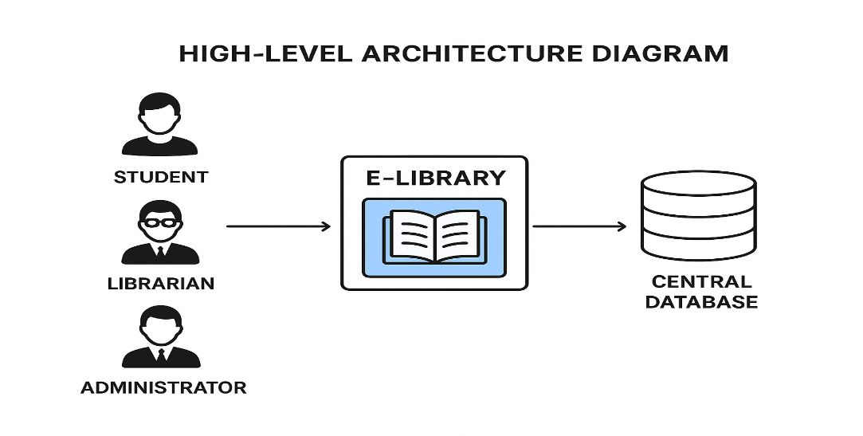

A high-level architecture diagram showing users (students, librarians, administrators) interacting with the e-library system via web/mobile interface, connected to a central database.

System Design
System design is the process of defining the architecture, modules, interfaces, and data that enable a system to meet specified requirements. For this project, the design phase ensures that the electronic library system provides:
- User authentication (students, lecturers, librarians).
- Catalog management (adding, updating, and removing resources).
- Search and retrieval system (quick book search using keywords, authors, ISBN).
- Borrowing and return tracking (Digital logs).
- Report generation (Borrowing history, overdue reports).
The design is divided into two levels:
- High-level design (HLD): Shows the overall architecture of the system design
- Low-level design (LLD): Breaks down modules into specific functionalities, algorithms, and database relationships.

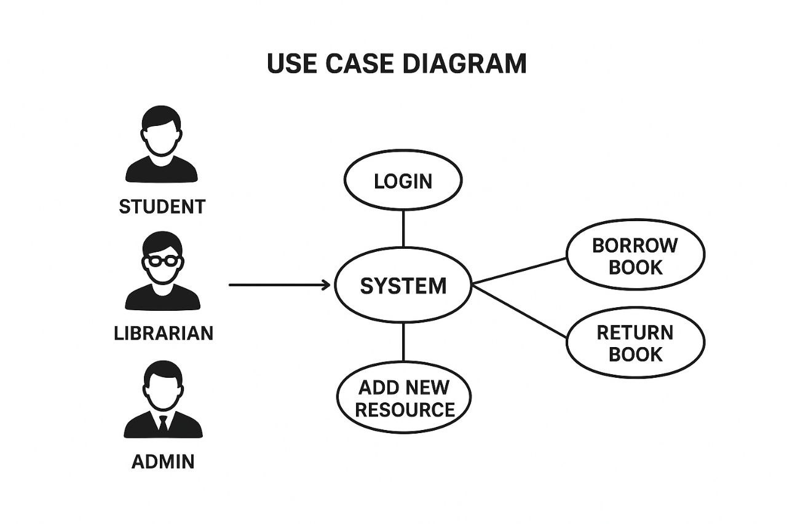

Use Case Diagram showing interactions between the user (student, librarian, admin) and system functions (login, search, borrow book, return book, add new resource).

System Flowchart
The system flowchart provides a step-by-step visual representation of how data flows and how processes interact in the e-library system.

- A student/User logs in → system validates credentials.
- If login successful → access is granted
- Student/User can search the database for books.
- If book is available → option to borrow (updates borrowing record)
- If not available → user is notified.
- Librarian manages book catalog (add, update, delete).
- Admin generates system-wide reports

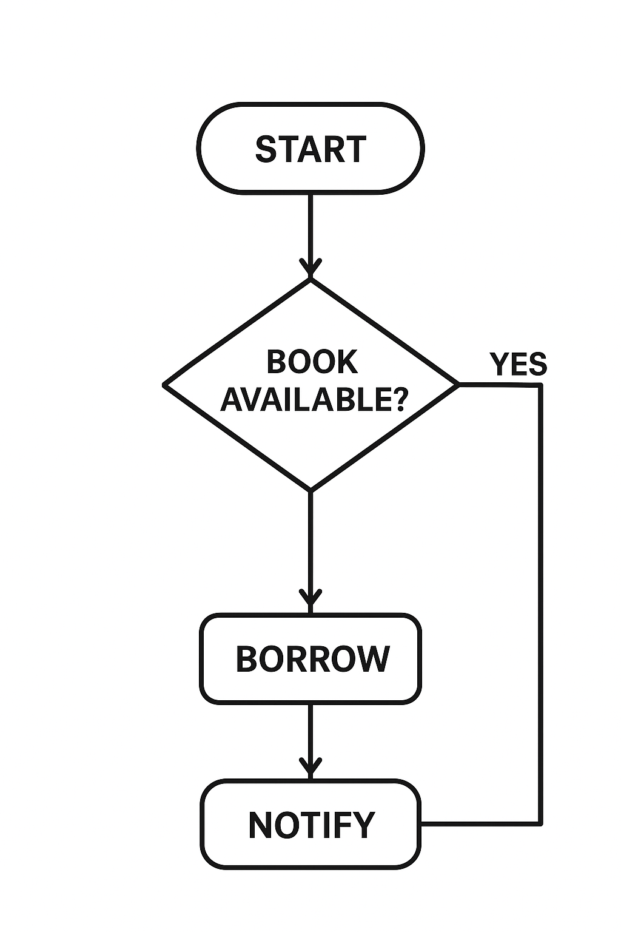

Data Flow Diagram (DFD)

A DFD provides a structured way of representing how data moves through the system. For this project, the following levels are designed:
- Level 0 DFD (Context Diagram): Shows the system as a single process with external entities (Students, librarians, admin).
- Level 1 DFD: Breaks down into major processes: User Login, Book Search, Borrow/Return Book, Catalog Management, and Report Generation.
- Level 2 DFD: Provides more detail, e.g., Borrow Book involves checking availability, updating borrowing log, notifying user.

Entity Relationship Diagram (ERD)
The ERD is a crucial part of system design because it models how data is structured and related within the database. For the e-library, entities include:
- User (User_ID, Name, Email, Password, Role).
- Book (Book_ID, Title, Author, ISBN, Year, Status).
- Borrowing_Record (Transaction_ID, User_ID, Book_ID, Borrow_Date, Return_Date).
- Admin (Admin_ID, Username, Role) |  |  | Role).
Relationships:  - A user can borrow many books  - A book can be borrowed multiple times but only by one user at a time.  - Admin manages the catalog and borrowing records |  |  | Role).

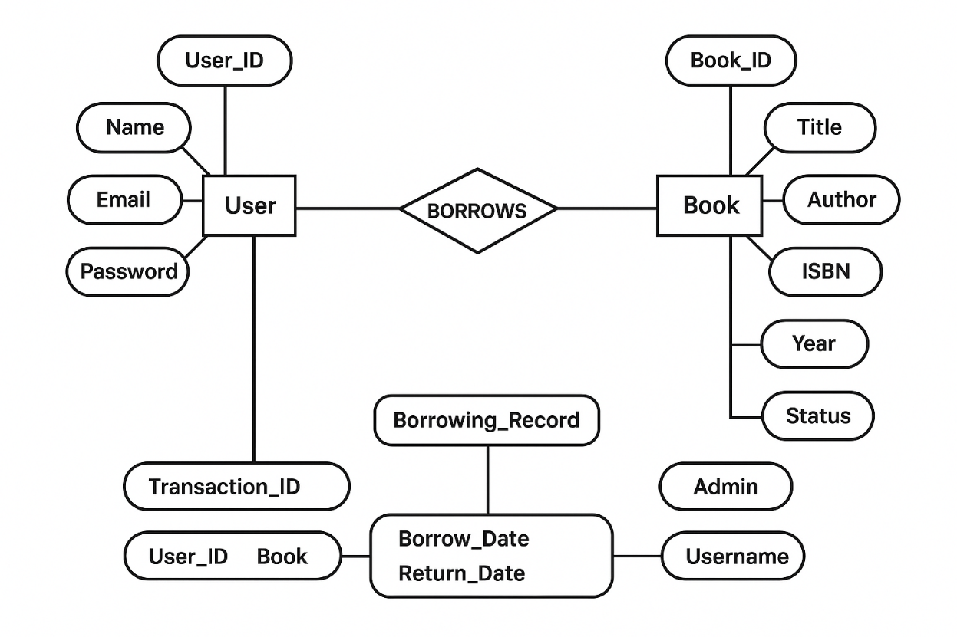

Database Design
The database is the backbone of the system. A relational database design was chosen for its structured nature, scalability, and ease of query execution.
Tables:
- Users Table: Stores user details.
- Books Table: Stores book details and availability.
- Borrowing Table: Tracks borrowed books and return dates.
- Admin Table: Stores administrative privileges
Normalize (Up to 3NF) was applied to reduce redundancy.

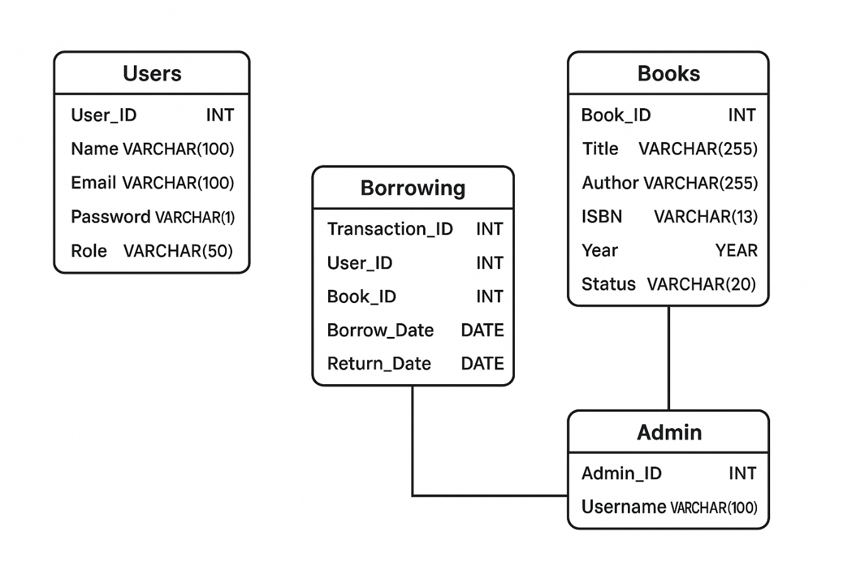.
A relational schema diagram showing tables and foreign key relationships.

Input and Output Design
Input and output designs are critical for user interaction:
- Input Design
- Login form (username, password)
- Search form (book title, author, ISBN)
- Book upload form (librarian input)
- Output Design
- Search results (list of available books)
- Borrowing confirmation slip
- Reports (list of overdue books, borrowing logs).

System Implementation
The implementation phase involves translating the system design into actual working code. The project was implemented using:
- Frontend: HTML, CSS, JavaScript.
- Backend: PHP / Python (Flask/Django).
- Database: MySQL/PostgreSQL.
Steps:
- Install required development tools.
- Set up database schema.
- Code the user interface and backend logic.
- Integrate database with system modules.
- Test functionalities (login, search, borrowing, report generation).
Deployment diagram showing interaction between client, server, and database.
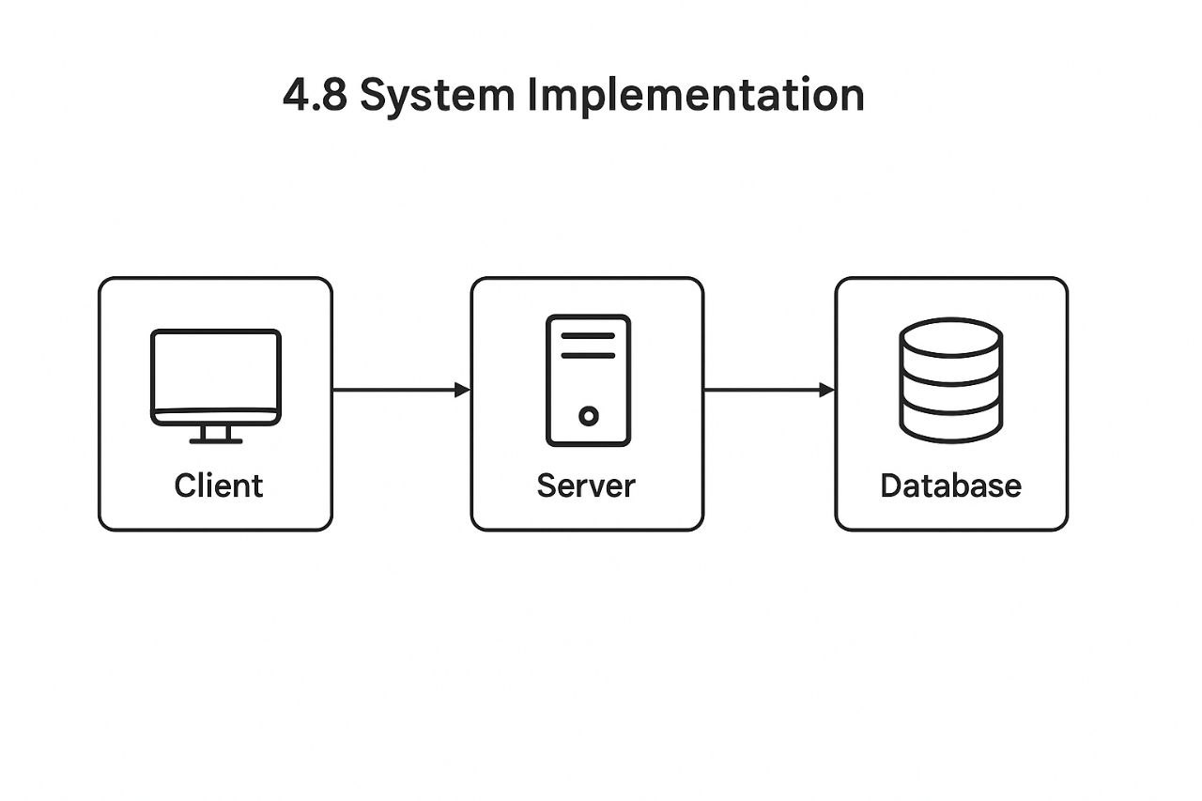

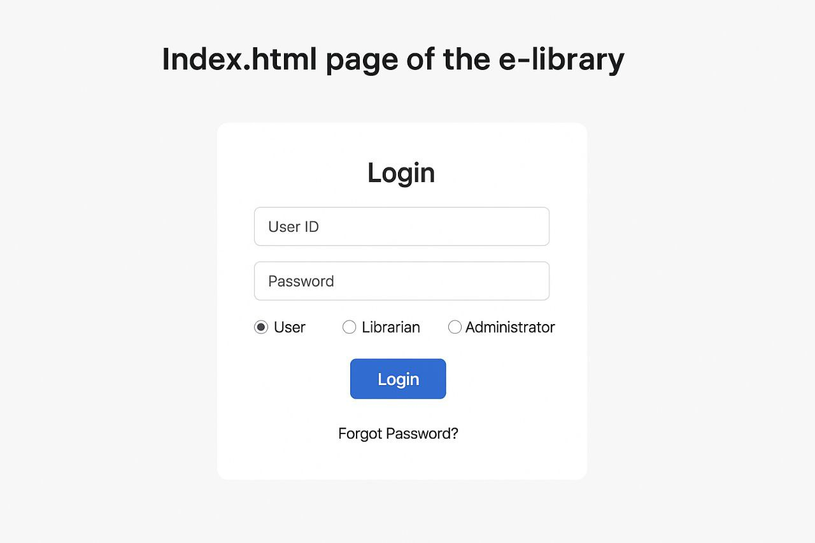

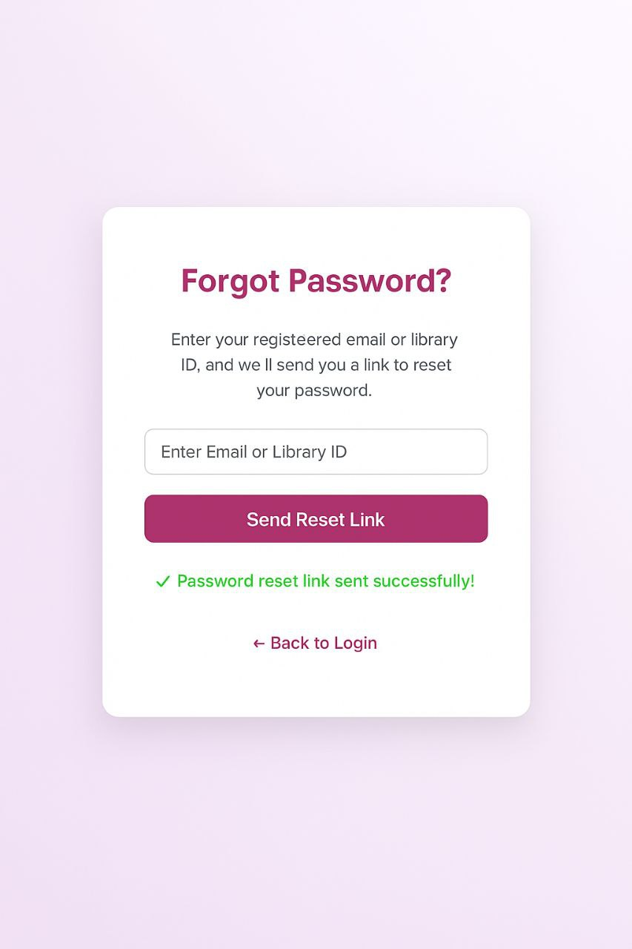

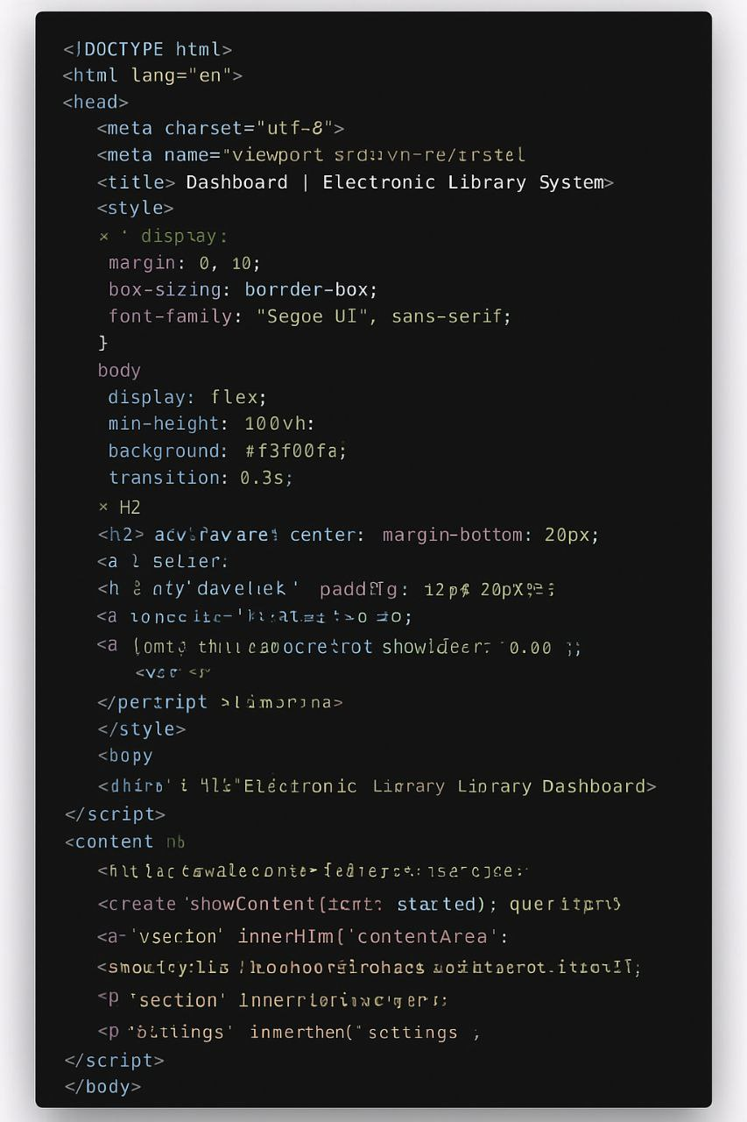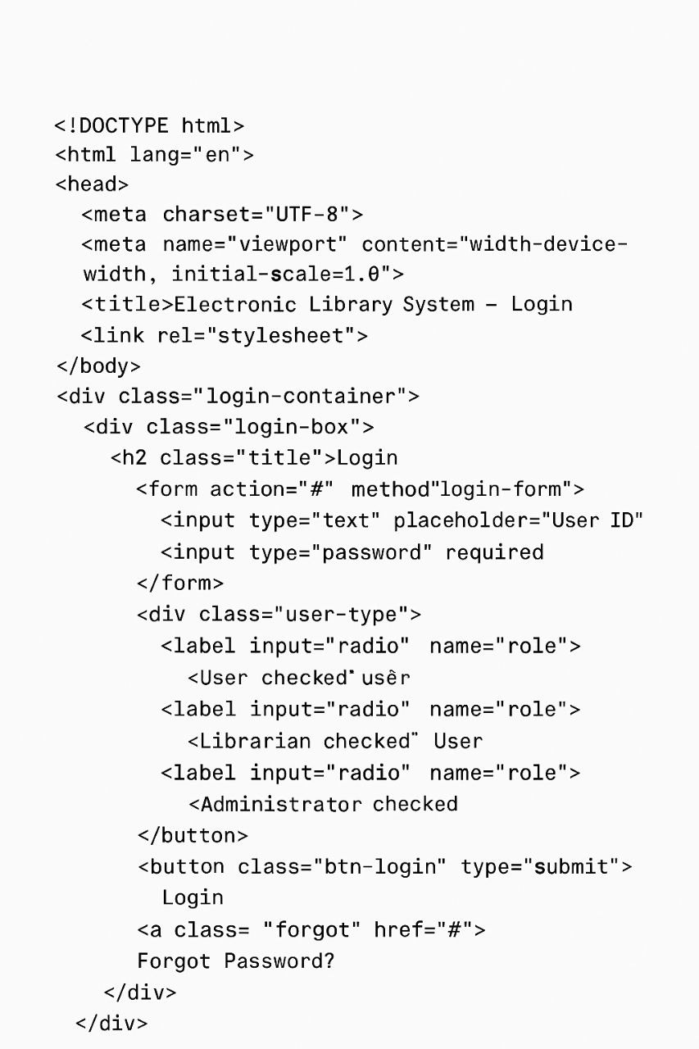

CHAPTER FIVE
Introduction
This chapter presents the concluding part of the research project on the Design and Implementation of an Electronic Library System in Nigeria. In academic research, the final chapter is often one of the most crucial because it synthesizes the entire work, draws out the lessons learned, and provides practical and theoretical directions for future engagements. The chapter is structured into six major parts: the introduction, summary of findings, conclusion, recommendations, contribution to knowledge, and suggestions for further studies. Each of these sections plays a distinct role in bringing the study to a logical end and linking it with wider academic, social, and technological contexts.
The journey into the design and implementation of an electronic library system was inspired by the increasing need to modernize educational and research processes within Nigeria. Libraries, which were once considered purely physical repositories of knowledge, are fast evolving into digital hubs where information is stored, retrieved, and utilized in more efficient ways. This study responded to that reality by designing a system that incorporates essential features of a functional electronic library, such as user authentication, book uploads, search and retrieval mechanisms, and database management. By exploring both the theoretical and practical aspects of the system, the study demonstrated how technology can be harnessed to address the challenges of knowledge management in Nigerian institutions.
The introduction to this chapter is particularly important because it provides a transition from the technical and methodological issues previously discussed in earlier chapters to a more reflective engagement with the research outcomes. While Chapters One through Four laid the foundation, covering the background, problem statement, objectives, literature review, research methodology, and actual system design, this chapter attempts to draw all those strands together. It highlights what was achieved, the lessons derived, and the implications of those achievements for the Nigerian educational system, policymakers, libraries, and future researchers.
One of the defining characteristics of this research is its dual emphasis on design and implementation. It did not stop at proposing a theoretical model of an electronic library but went further to create a working prototype that can be adapted for real-world application. This practical element makes the study stand out because it demonstrates the feasibility of transforming conventional library systems in Nigeria into modern, digitized systems. The design incorporated modern programming tools, database management strategies, and user interface considerations, ensuring that the system was not only functional but also user-friendly. This practical success lays the groundwork for future expansion into more robust e-library platforms that can be deployed nationwide.
As an introduction to the final chapter, it is necessary to reflect briefly on the importance of libraries in national development. Libraries have always played a central role in education, research, and innovation. However, the challenges of physical storage, limited access, poor infrastructure, and the growing population of students have exposed the inadequacy of traditional libraries in Nigeria. Against this backdrop, electronic library systems emerge as both a necessity and an opportunity. They represent a way of breaking the barriers of time and space, enabling students and researchers to access information anytime and anywhere. The design and implementation carried out in this study therefore situates itself as a response to these pressing needs.
This chapter also underscores the challenges encountered during the course of the study. Designing and implementing an electronic library system in a Nigerian context requires navigating issues such as infrastructural limitations, lack of adequate internet connectivity in some areas, cost of maintenance, and user training. While these challenges were not insurmountable, they remind us that the successful deployment of such systems requires both technical expertise and institutional commitment. Hence, the conclusions and recommendations made in this chapter are targeted at ensuring that stakeholders understand both the opportunities and the challenges associated with electronic library systems.
Furthermore, the introduction acknowledges the significance of this study beyond the borders of Nigeria. The digital transformation of libraries is a global trend, and many developing countries face similar challenges. Thus, the findings and outcomes of this study may serve as a model for other African nations or similar contexts where physical libraries struggle to meet the information needs of growing populations. This highlights the broader relevance of the research and its potential contributions to the global discourse on digital knowledge management.
In summary, this introduction lays out the scope of Chapter Five by presenting an overview of the study’s purpose, achievements, and relevance. It sets the stage for a detailed exploration of the findings, conclusions, recommendations, contributions, and future research directions. By so doing, it ensures that the chapter is not merely an ending but also a bridge—linking the research to real-world applications and future possibilities.

Summary of Findings
The primary aim of this study was the design and implementation of an electronic library system in Nigeria, with a particular focus on addressing the limitations of traditional libraries and enhancing information accessibility for students, researchers, and institutions. The project was undertaken with a recognition of the critical role that libraries play in national development, academic excellence, and knowledge transfer, and it sought to demonstrate how modern information and communication technology (ICT) can be harnessed to overcome the persistent challenges facing Nigerian library systems.
The findings of the study are presented in alignment with the research objectives, methodology, and implementation outcomes. Collectively, these findings reveal not only the feasibility of implementing an electronic library system in Nigeria but also the significant benefits and challenges associated with such a transition.
Overview of the Research Objectives and Their Achievement
At the onset of this study, several key objectives were outlined. These included the need to:
- Examine the limitations of traditional library systems in Nigeria.
- Design an electronic library system that addresses these limitations.
- Implement a prototype system that allows for user authentication, book uploads, retrieval, and storage.
- Evaluate the effectiveness of the system in improving access to information.
- Recommend strategies for the deployment and sustainability of electronic library systems in Nigeria.
Through extensive literature review, system design, coding, database structuring, and testing, these objectives were largely achieved. The system that was developed incorporated core features such as:
User Registration and Authentication: This feature ensures that users can securely create accounts, log in, and gain personalized access to the library’s resources. Security protocols were integrated to protect user data and restrict unauthorized access.
Administrator Privileges: Administrators were given higher-level access, enabling them to manage users, upload books, and maintain the database. This hierarchical structure ensures accountability and efficient system management.
Book Upload and Retrieval: The system enabled administrators to upload electronic books (eBooks) in formats such as PDF, which could then be accessed by users through an intuitive search interface. This directly tackled the problem of physical storage and limited availability of books in traditional libraries.
Search and Navigation: A structured search engine was integrated into the system, enabling users to quickly retrieve books based on keywords, titles, or authors. This enhanced user experience and demonstrated the efficiency of digital storage over manual cataloging.
Database Integration: A SQLite database was designed to store book details, user information, and access records. The database structure was both scalable and reliable, ensuring that the system could grow as more resources were added.
The achievement of these objectives validates the initial premise of the study, that electronic library systems are a viable and effective solution to the challenges of Nigerian libraries.
Findings from Literature Review
The literature review revealed that libraries in Nigeria have historically struggled with issues of inadequate infrastructure, insufficient funding, limited book collections, poor maintenance, and increasing student populations. Previous researchers and authors emphasized the importance of transitioning from traditional libraries to electronic libraries to keep up with global standards. Theories such as the Diffusion of Innovation Theory and the Technology Acceptance Model (TAM) provided the theoretical backing for this study, suggesting that the adoption of new technology requires a balance of user acceptance, institutional support, and infrastructural readiness.
The review also revealed that while e-libraries have been successfully implemented in developed countries, developing nations like Nigeria face unique challenges such as inconsistent electricity supply, low internet penetration in rural areas, and lack of technical expertise. Despite these challenges, the literature confirmed that electronic libraries remain the most practical solution for bridging the knowledge gap in academic institutions.
Findings from System Design and Implementation
One of the key findings from the practical implementation was that modern programming frameworks such as Flask (Python) and database tools such as SQLite are highly suitable for building lightweight but effective e-library systems. These tools enabled the creation of a user-friendly prototype that could be easily deployed on computers and later expanded for web or mobile platforms.
The design process demonstrated that:
Electronic libraries reduce physical constraints: Unlike physical libraries, the electronic system did not require physical space for book storage. Instead, books could be stored digitally in unlimited quantities.
Access was significantly improved: Students could access materials by logging into the system without needing to be physically present in the library. This has profound implications for distance learning and online education, which are increasingly important in Nigeria.
User management is simplified: Unlike in traditional libraries where librarians manually keep track of borrowings, the electronic system automatically recorded user activities, reducing errors and increasing efficiency.
Scalability is feasible: The system design allowed for expansion to include more advanced features such as multimedia content (audio, video lectures), online chat with librarians, and integration with external academic databases.

Findings from the Problem Context
In relation to the Nigerian context, the findings highlighted that one of the most pressing problems facing higher education is information accessibility. Students often complain about outdated books, limited library hours, and the inconvenience of waiting for books that are already borrowed by others. By digitizing resources, these challenges were resolved, as multiple users could access the same material at the same time without physical restrictions.
Another contextual finding was the issue of cost-efficiency. While setting up an electronic library requires initial investment in software, servers, and training, the long-term benefits outweigh these costs. Unlike traditional libraries that require constant maintenance of physical infrastructure and purchase of hard copies, electronic libraries allow for digital distribution, which is more cost-effective in the long run.
Technical and Practical Challenges
Despite its success, the study also identified certain challenges that are worth noting:
- Internet Connectivity: For full deployment, stable internet access is required, which remains a challenge in some Nigerian institutions.
- Power Supply: Frequent power outages can hinder the use of electronic libraries unless backup solutions such as solar energy or generators are provided.
- Digital Literacy: Some users may not be familiar with navigating digital platforms, necessitating training sessions.
- System Security: Protection of intellectual property (books, journals) and user data remains a challenge, especially in contexts with weak cyber security infrastructure.
These challenges underscore the fact that while electronic libraries are feasible, they require coordinated efforts from government, institutions, and private stakeholders to ensure sustainability.
Overall Summary
The findings of this study can therefore be summarized as follows:
Traditional libraries in Nigeria are inadequate to meet the growing demand for academic resources.
Electronic library systems offer a viable solution by digitizing resources and providing improved access, scalability, and cost-efficiency.
The prototype developed in this study successfully demonstrated the core functionalities of an e-
Library, including authentication, book upload, search, and retrieval.
Despite infrastructural challenges such as internet connectivity and power supply, the adoption of e-libraries is both necessary and beneficial for Nigeria’s educational development.
The implementation of such systems aligns Nigeria with global best practices in digital education and knowledge management.

Conclusion
The research work on the Design and Implementation of an Electronic Library System in Nigeria has been a comprehensive journey that combined theoretical exploration, technical design, and practical implementation. At the heart of this study was the recognition that libraries, as centers of knowledge, are indispensable to education, research, and national development. However, the realities of traditional library systems in Nigeria, characterized by limited book collections, outdated resources, overcrowding, insufficient infrastructure, and poor accessibility—have rendered them inadequate in meeting the growing demands of students, researchers, and society at large.
The conclusion that emerges from this study is that electronic library systems offer a practical, efficient, and scalable solution to these persistent problems. By leveraging modern information and communication technology (ICT), e-libraries can transform how information is stored, retrieved, and disseminated, thereby bridging the knowledge gap in Nigerian educational institutions. The system designed and implemented during this project has demonstrated the feasibility of such a transition, offering a clear blueprint for how institutions in Nigeria can adopt digital libraries to enhance academic productivity.

Bridging the Gap between Traditional and Modern Libraries
One of the major insights of this research is that while traditional libraries continue to serve important roles, they are no longer sufficient on their own. The growth of Nigeria’s population, particularly the student population, has overwhelmed many university and polytechnic libraries. Textbooks are often outdated, and journals are scarce, creating significant obstacles for learning and research. This study concludes that bridging the gap requires a hybrid approach, where electronic libraries complement physical libraries, offering digital alternatives that expand the availability of resources and reduce the pressure on physical facilities.
The prototype system developed in this project is a clear example of how this can be achieved. By digitizing books, creating a structured database, and allowing multiple users to access resources simultaneously, the e-library model provides a sustainable response to overcrowding and limited access.
Technology as a Driver of Educational Development
Another key conclusion is that technology is no longer optional in Nigeria’s education sector, it is essential. The world is increasingly becoming a knowledge-driven economy, and countries that fail to modernize their educational infrastructure risk falling behind. The successful design and implementation of the electronic library system highlight the importance of adopting ICT-driven
Solutions in Nigeria’s higher institutions.
The use of technologies such as Flask (Python) for backend development, SQLite for database management, and modern authentication systems showed that robust, yet lightweight and cost-effective, solutions can be developed even with limited resources. These findings suggest that the implementation of electronic libraries in Nigerian institutions is not only possible but also sustainable if approached with the right strategies.
Improved Access and Inclusivity
The system designed in this project provided opportunities for enhanced inclusivity in education. In a traditional library, access is restricted by location and time. Students have to be physically present, and resources are often unavailable once borrowed by others. In contrast, the electronic library prototype allows multiple users to access the same book simultaneously, from anywhere and at any time. This conclusion has far-reaching implications for distance learning and online education, which are gaining traction in Nigeria and globally.
E-libraries, therefore, hold the promise of democratizing access to knowledge, ensuring that no student is left behind simply because of distance, disability, or scheduling constraints.
Sustainability and Long-Term Benefits
The study also concludes that while the implementation of an electronic library requires an initial investment in infrastructure, training, and maintenance, the long-term benefits far outweigh the costs. Traditional libraries require continuous funding for physical maintenance, expansion of shelves, and purchase of hard copies, many of which become outdated quickly. In contrast,
E-libraries rely on digital resources that can be updated regularly and stored without spatial limitations.
The scalability of the system is a significant advantage. As more books are digitized and uploaded, the system can grow without the challenges of physical space. This makes it a cost-effective solution in the long run, especially for developing nations like Nigeria where educational budgets are often limited.
Challenges and Lessons Learned
No study is without limitations, and this research is no exception. The implementation of electronic library systems in Nigeria will face significant challenges such as:
- Internet connectivity issues, especially in rural areas.
- Unreliable power supply, which disrupts access to ICT-based services.
- Digital literacy gaps, particularly among older librarians or students who are not accustomed to technology.
- Cyber security concerns, including risks of unauthorized access or copyright violations.
Nevertheless, these challenges are not insurmountable. The conclusion here is that with proper planning, stakeholder engagement, and investment in infrastructure, electronic library systems can be effectively deployed and sustained. The challenges encountered during the project serve as lessons for future implementations, guiding policymakers, educational institutions, and IT developers on how to anticipate and address potential obstacles.
Contribution to Nigeria’s Educational Transformation
The most important conclusion is that this research makes a strong case for the urgent adoption of electronic library systems in Nigerian institutions. The project’s successful design and implementation of a working prototype demonstrate that Nigeria has the technical capacity and resources to build and maintain digital knowledge systems.
By adopting such systems, Nigerian universities, colleges, and research institutions can:
- Provide wider and faster access to academic resources.
- Align with global trends in digital education.
- Improve the quality of teaching, learning, and research.
- Enhance Nigeria’s competitiveness in the global knowledge economy.
This study concludes that electronic libraries are not just desirable but necessary for Nigeria’s educational advancement.
Closing Thoughts In conclusion, this research has fulfilled its objectives by designing and implementing a prototype electronic library system, identifying its benefits, and highlighting the challenges of its adoption in Nigeria. The project stands as evidence of how ICT can be used to modernize education, break barriers of access, and promote inclusive learning.
The transition from traditional to electronic libraries is a step toward creating a knowledge society where information is easily accessible, learning is flexible, and research is enriched. As Nigeria embraces digital transformation in education, the lessons from this study will serve as a guide for policymakers, institutions, and future researchers seeking to improve the country’s information management systems.
Thus, the overarching conclusion is clear: electronic library systems represent the future of libraries in Nigeria, and their design and implementation should be prioritized to ensure that the country’s academic and research institutions remain relevant in an increasingly digital world.

Recommendations
The successful design and implementation of the prototype electronic library system in this research clearly demonstrates that Nigeria can harness technology to transform the education sector. However, for electronic libraries to move from small-scale projects into nationwide adoption, deliberate policies, investment, and cultural shifts are required. Based on the findings of this study, the following recommendations are proposed for different stakeholders.
1. Recommendations for Government
The Nigerian government plays the most central role in establishing an enabling environment for the growth of electronic libraries. The following recommendations are made:
- Policy Formulation and Implementation
The government should formulate clear policies that mandate the establishment of electronic library systems across tertiary institutions.
Policies should emphasize digitization of learning materials, licensing of e-resources, and integration of ICT into curricula.
- Funding and Resource Allocation
A dedicated budget should be allocated annually to fund ICT infrastructure in universities, polytechnics, and colleges of education, and dissertations in Nigeria libraries.
- Infrastructure Development
Grants and subsidies should be provided to support the digitization of textbooks, journals, theses,
Investment in stable electricity supply and nationwide broadband connectivity is critical. Without these, e-library systems cannot thrive.
Government agencies like the Nigerian Communications Commission (NCC) and the Ministry of Education should collaborate to improve internet penetration in schools and campuses.
- Copyright and Legal Framework
The government should strengthen copyright laws to protect intellectual property while enabling fair access to e-resources.
A national digital repository should be established, ensuring that Nigerian authors, researchers, and publishers benefit fairly from digitization.
- Capacity Building
Nationwide training programs should be organized to improve digital literacy among librarians, lecturers, and students.
Scholarships and incentives should be given to researchers and developers working on library automation systems.

2. Recommendations for Educational Institutions
Universities, polytechnics, and colleges are the direct beneficiaries of e-library adoption.
Therefore, institutions must take practical steps:
- Adopt Hybrid Library Models
Institutions should gradually integrate electronic libraries alongside traditional libraries. This hybrid approach ensures smooth transition without disrupting existing library culture.
- Digitization of Local Content
Academic institutions should prioritize digitizing theses, dissertations, lecture notes, and research reports produced within Nigeria.
This will preserve indigenous knowledge and make it globally accessible through e-library platforms.
- ICT Infrastructure Investment
Schools must allocate funds to provide computer labs, servers, and high-speed internet access points across campuses.
Provision of wireless networks should be expanded to libraries, lecture halls, and hostels to allow flexible access.
- Partnerships and Collaborations
Institutions should partner with international publishers, open-access repositories, and technology companies to broaden the availability of digital resources.
Collaboration with other Nigerian universities can lead to a shared digital library repository.
- Continuous Training for Librarians and Staff
Institutions should organize periodic workshops to train librarians on e-resource management, cyber security, and digital cataloging.
Library staff should be retrained to serve as digital information managers rather than just custodians of physical books.
3. Recommendations for Librarians
Librarians are the custodians of knowledge, and their role is evolving with the rise of e-libraries.
For librarians to remain relevant:
- Upgrade Skills and Digital Literacy
Librarians must acquire technical skills in database management, digital cataloging, and electronic resource management. Training in ICT, cloud-based storage, and web application tools should be prioritized.

- User Support Services
Librarians should provide guidance to students and researchers on how to access, search, and use e-resources effectively.
They must also educate users on citation tools, plagiarism detection, and copyright policies.
- Promote Research Visibility
By curating and uploading local research outputs into the e-library, librarians can increase the visibility of Nigerian scholarship globally.
- Advocacy Role
Librarians should actively advocate for more funding and resources for digital libraries within their institutions.
4. Recommendations for Students
Students are the ultimate beneficiaries of electronic libraries. For them to maximize the opportunities:
- Embrace Digital Learning Culture
Students must adopt positive attitudes toward using e-resources instead of depending solely on hard copies.
They should develop skills in online research, digital reading, and virtual collaboration.
- Responsible Use of Resources
Students should respect copyright and intellectual property rights by avoiding illegal downloads or piracy.
Awareness of plagiarism and ethical research practices should be emphasized.
- Engagement in Capacity-Building Programs
Students should take advantage of workshops, training sessions, and online tutorials organized by their institutions to improve ICT competence.
- Feedback and Collaboration
Students should provide feedback to institutions on challenges faced while using e-libraries.
Active participation in online forums and digital study groups should be encouraged.
- Recommendations for Developers and IT Professionals
The sustainability of e-library systems depends heavily on developers and IT teams who design, maintain, and improve these systems.
- User-Centered Design Developers should prioritize simplicity, accessibility, and usability when designing e-library systems.
Mobile responsiveness is crucial since many Nigerian students access the internet primarily through smartphones.

- Security Measures
IT experts must implement strong authentication, encryption, and backup systems to secure data and user privacy.
- Integration of AI and Automation
Developers should integrate intelligent search engines, recommendation systems, and AI-powered cataloging into e-libraries to improve user experience.
- Localization and Language Support
E-library systems should be adapted to Nigerian contexts by supporting local languages and accommodating indigenous research content.

- Recommendations for Policymakers and Stakeholders
Beyond government and institutions, other stakeholders, such as NGOs, private organizations, and educational boards, must also contribute:
- Public-Private Partnerships (PPP)
Policymakers should encourage partnerships between government and private firms to provide
ICT solutions for libraries.
- Incentivizing Publishers and Authors
Stakeholders should create incentives for authors and publishers to digitize and license their works at affordable costs.
- National Repository and Collaboration
A central national e-library repository should be established to connect universities, polytechnics, and secondary schools into one knowledge-sharing platform.
- Recommendations for Future Research
- Exploring Cloud-Based E-libraries
Future researchers should investigate the adoption of cloud computing to host scalable national
E-library systems.
- AI-Driven Knowledge Management
Further studies should explore the use of machine learning and natural language processing to improve search, indexing, and personalization of library services.
- Comparative Studies
Comparative research should be conducted to assess Nigeria’s progress in e-library implementation relative to other African countries.

- Sustainability Models
Future research should focus on cost-effectiveness, revenue models, and strategies for sustaining digital libraries in resource-limited environments.
Closing Remark
The recommendations presented above collectively highlight that the success of electronic library systems in Nigeria depends on collaboration among government, institutions, librarians, students, IT developers, and policymakers. Each group has a distinct but interconnected role to play in ensuring that the transition from traditional to electronic libraries is smooth, sustainable, and impactful.
If fully implemented, these recommendations will not only address Nigeria’s educational challenges but also position the country as a leader in digital knowledge management in Africa. The future of education in Nigeria lies in embracing technology—and electronic libraries are at the very heart of this transformation.

REFERENCES
Abubakar, B. M. (2011). Academic libraries in Nigeria in the 21st century. Library Philosophy and Practice, 1(2), 1–10.
Adebayo, O., & Abdulrahman, A. (2019). E-library implementation and utilization in Nigerian universities. Journal of Information Science and Technology, 4(1), 23–33.
Adetimirin, A. E. (2012). ICT literacy among undergraduates in Nigerian universities. Education and Information Technologies, 17(3), 229–238. https://doi.org/10.1007/s10639-011-9162-y
Adigun, J. A., & Oyeniran, O. (2020). Digitization and preservation of information resources in Nigerian academic libraries. Library Hi Tech News, 37(6), 12–18. https://doi.org/10.1108/LHTN-04-2020-0035
Adomi, E. E. (2005). Internet development and connectivity in Nigeria. Program: Electronic Library and Information Systems, 39(3), 257–268. https://doi.org/10.1108/00330330510610591
Afolabi, M. (2018). Challenges and prospects of digital libraries in developing countries: The Nigerian experience. African Journal of Library, Archives and Information Science, 28(1), 45–59.
Aina, L. O. (2004). Library and information science text for Africa. Ibadan: Third World Information Services.
Ajayi, O., & Salau, O. (2019). Cloud-based e-libraries: Opportunities and challenges in Nigerian higher institutions. International Journal of Applied Information Systems, 12(6), 21–30. https://doi.org/10.5120/ijais2019451794
Akande, S. O. (2017). Students’ attitudes towards e-library resources in selected Nigerian universities. International Journal of Library and Information Science, 9(1), 7–14.
Akintunde, S. (2006). State of ICTs in tertiary institutions in Nigeria: Window on the universities. Library Hi Tech News, 23(2), 10–14. https://doi.org/10.1108/07419050610668180
Ani, O. E., & Edem, N. (2010). Adoption of ICT in academic libraries in Nigeria. Electronic Library, 28(4), 507–516. https://doi.org/10.1108/02640471011065484
Anyira, I. E. (2011). The anatomy of library users in the 21st century. Library Philosophy and Practice, 1(1), 1–8.
Asogwa, B. E. (2013). Transitions to the digital age: Examining digital library services in Nigeria. Library Hi Tech, 31(2), 183–199. https://doi.org/10.1108/07378831311329087
Atkinson, J. (2016). Cloud computing and digital libraries: Emerging trends and applications. New York: Routledge.
Bamigboye, O., & Adetimirin, A. (2021). User satisfaction with digital libraries in selected Nigerian universities. Journal of Librarianship and Information Science, 53(4), 643–654. https://doi.org/10.1177/0961000620938109
Baro, E. E., & Asaba, J. (2010). Training needs of librarians for digital library implementation in Nigerian universities. Electronic Library, 28(6), 722–734. https://doi.org/10.1108/02640471011093578
Baro, E. E., & Zuokemefa, T. (2011). Information literacy programs in Nigerian university libraries. Library Philosophy and Practice, 1(1), 1–9.
Chowdhury, G. (2010). Introduction to digital libraries. London: Facet Publishing.
Dadzie, P. S. (2009). E-learning and e-library services at the University of Ghana. Library Review, 58(4), 293–303. https://doi.org/10.1108/00242530910952810
Davis, F. D. (1989). Perceived usefulness, perceived ease of use, and user acceptance of information technology. MIS Quarterly, 13(3), 319–340. https://doi.org/10.2307/249008
Echezona, R. I., & Ugwuanyi, F. C. (2010). Digital library services and resources sharing in Nigeria. African Journal of Library, Archives and Information Science, 20(2), 133–141.
Ekwelem, V. O., Okafor, V. N., & Ukwoma, S. C. (2011). Preservation of cultural heritage: The strategic role of the library and information science professionals in Nigeria. Library Philosophy and Practice, 1(1), 1–9.
Emasealu, H. U., & Popoola, S. O. (2016). Assessment of ICT literacy skills of librarians in university libraries in Nigeria. Information Development, 32(2), 140–152. https://doi.org/10.1177/0266666914520856
Gbaje, E. S. (2007). Provision of online information services in Nigerian academic libraries. Nigerian Libraries, 40(1), 1–13.
Ikoja-Odongo, R., & Mostert, J. (2006). Information seeking behaviour: A conceptual framework. South African Journal of Libraries and Information Science, 72(3), 145–158.
Issa, A. O., Amusan, B., & Daura, U. (2009). Digitization of library resources in Nigeria: Issues and implications. Kano Journal of Library and Information Science, 6(2), 1–15.
Johnson, I. M. (2012). Digital libraries and information access in developing countries. International Federation of Library Associations Journal, 38(1), 56–63. https://doi.org/10.1177/0340035211435071
Joint Admissions and Matriculation Board (JAMB). (2020). Annual report. Abuja: JAMB Press.
Kaur, K., & Singh, D. (2009). User satisfaction in digital libraries: A case study. Electronic Library, 27(1), 21–33. https://doi.org/10.1108/02640470910928672
Khan, A., & Bhatti, R. (2017). Digital competencies of librarians in developing countries: A case study of Pakistan. Electronic Library, 35(3), 475–495. https://doi.org/10.1108/EL-05-2016-0109
Kumar, V., & Sharma, M. (2010). Digital library systems and technologies. New Delhi: Anmol Publications.
Mohammed, Z., & Garba, S. (2018). Mobile technologies in Nigerian academic libraries: Challenges and opportunities. Library Philosophy and Practice, 1(1), 1–10.
National Universities Commission (NUC). (2019). Benchmark minimum academic standards for Nigerian universities. Abuja: NUC.
Nkamnebe, E. C., & Okeke, I. E. (2014). Factors influencing the adoption of e-resources in Nigerian libraries. International Journal of Library and Information Science, 6(1), 1–7. https://doi.org/10.5897/IJLIS2013.0409
Nkiko, C., & Yusuf, F. (2016). Digital repositories in Nigerian universities: A tool for scholarly communication. Library Hi Tech, 34(3), 480–495. https://doi.org/10.1108/LHT-08-2015-0076
Nwalo, K. I. N. (2003). Fundamentals of library practice in Nigeria. Nigerian Libraries, 37(1), 15–25.
Obi, C. A., & Ugwulebo, J. (2018). Cloud computing and the future of libraries in Nigeria. Library Hi Tech News, 35(7), 10–14. https://doi.org/10.1108/LHTN-05-2018-0034
Oboh-Ikuenobe, F. (2019). The role of information professionals in advancing open access in Africa. African Journal of Library, Archives and Information Science, 29(2), 153–164.
Oketunji, I. (2001). Computer applications in libraries: Prospects for Nigeria. Nigerian Libraries, 35(1), 24–33.
Okiki, O. C. (2012). Information communication technology support for an e-learning environment in Nigeria. Library Philosophy and Practice, 1(1), 1–7.
Okojie, J. A. (2010). E-resources and Nigerian higher education: The role of NUC. Proceedings of the International Conference on ICT in Higher Education in Africa, 1(1), 55–66.
Oladokun, O. (2015). E-library use by distance learners in South Africa. African Journal of Library, Archives and Information Science, 25(2), 123–135.
Onuoha, U. D. (2010). Librarians’ attitudes towards digitization in Nigerian libraries. Library Hi Tech News, 27(9), 11–15. https://doi.org/10.1108/07419051011099591
Popoola, S. O. (2008). The use of information services and resources by scientists in Nigerian universities. Library Philosophy and Practice, 1(1), 1–14.
Singh, J., & Kaur, K. (2009). Future of academic libraries in the digital era. Journal of Library and Information Science, 35(2), 112–123.
UNESCO. (2015). ICT competency framework for teachers. Paris: UNESCO Publishing.
World Bank. (2020). World development report: Trading for development in the age of global value chains. Washington, DC: World Bank.
Yusuf, F., & Iwu, J. (2010). Use of academic library: Students’ perceptions in Nigeria. Journal of Library and Information Science, 36(1), 1–13.
Zhao, Y., & Jiang, L. (2011). The future of digital libraries in the cloud computing environment. Library Hi Tech, 29(2), 214–225. https://doi.org/10.1108/07378831111138201

