1. Give an advantage of a binary search tree structure over:

a. A linked list structure Much faster overall since each decision has two choices and cuts off half of the remaining keys.

b. A stack A stack is specifically LIFO. The main advantage of a tree is the ability to do all four of the main operations. This is impossible for a Stack.

c. An array-based structure One can implement a binary search tree as an array. The Delete method for such a structure requires an extra field in the TreeNode class. That same delete method is simpler than the Delete for the binary search tree, however.

d. A hashed structure Hashed structures are really fast at insert and lookup. They do not easily produce sorted lists of nodes. Producing a sorted list is easy from a binary search tree.

2. Define the terms:

a. Root node This is the node with no parent.

b. Binary tree A tree with no more than two child nodes for each node. Binary because there are two choices when moving down the tree.

c. Parent For a given node, the parent is the one which it is connected to it and closer to the root.

d. Leaf node The "topmost" nodes. When drawn the leaf nodes are usually at the bottom of the drawing. These are the nodes with no "children".

e. Level 0 of a tree Level 0 is the "lowest" point on the tree, when drawn it looks like the "highest" point on the tree. Also called "the root node".

f. Highest level of a tree The level containing only leaf nodes.

g. Balanced tree A tree where the size of the subtree to the left of the root is about equal to the subtree on the right of the root.

h. Complete tree A tree where every node in every level is full.

i. Left-balanced I had a hard time finding a definition of this that makes sense. There isn't one in the book that I could find. It is a binary tree in which every level except the leaf level is full and the leaves are added from left to right. It requires careful choices about what order to fill it in to make this happen. This could be important when one is using the array based approach to a binary tree.

3. What is the *maximum* number of nodes that can be stored in a binary tree with 10 levels?

1023

4. What is the *minimum* number of levels in a binary tree containing 6023 nodes?

13

5. What is the *maximum* number of levels in a tree containing 6023 nodes?

6023

6. What is the *maximum* number of nodes that can be stored in level 16 of a binary tree?

65536

7. If there are *nl* nodes in level *l* of a balanced binary tree, give an expression for the number of nodes at level *l* + 1 (assuming level *l*+ 1 is not the highest level of the tree).

We know we are on a mid-level of a balanced tree. That means it is full which means that

nl = 2l. So for level (l+1) we know that it is also full. Thus: nl+1 = 2(l+1) = 2(2l) = 2nl

8. True or false:

a. The highest level of a complete binary tree contains more nodes than all of the other levels combined.

True (by one). For instance, level two has four nodes and levels zero and one combined have three.

b. The root node is always at the highest level of the tree. False

c. Level 9 is the highest level in a 10 level tree. True

9. State the significance of the word binary in the term binary tree (i.e., why is a *binary* tree called a *binary* tree?).

Each node has a maximum of *two* children. If it were limited to three children for each node it would be a ternary tree.

10. Define the term “binary search tree.”

At every node of the binary search tree all the keys to the nodes in the left subtree are less than the key of the node of interest and all of the keys in the right subtree are larger than the key of the node of interest.

11. Draw the binary search tree resulting from inserting the nodes with the integer key values: 68, 23, 45, 90, 70, 21, and 55 into the tree. Assume key 68 is inserted first, then key 23, etc.

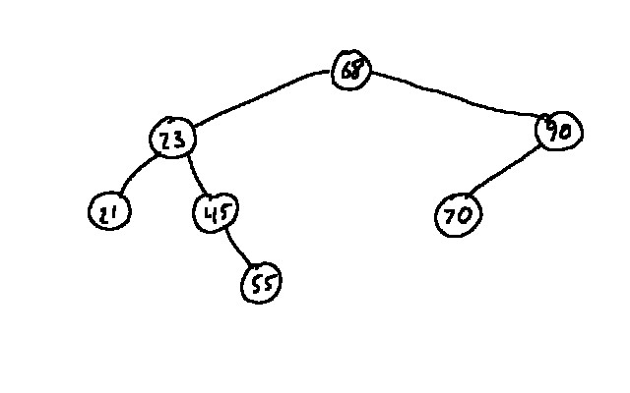

12. The client objects inserted into a Binary Search Tree structure are not actually stored in a binary tree, true or false?

The question is stated as a negative. The correct answer is that the nodes contain a pointer to the actual memory location of the client objects. That would make the statement True.

13. Give the data members of the class TreeNode defined in this chapter and state what is stored in each data member.

Listing node; // node contains a pointer to a member of the "Listing" class.

TreeNode rc; // rc contains a pointer to the "right child" TreeNode.

TreeNode lc; // lc contains a pointer to the "left child" TreeNode.