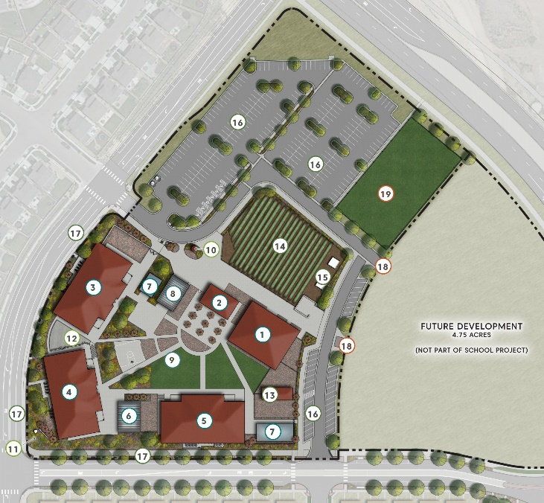
The STEAD School
Commerce City, CO

Project Details
Description: 64,000 sf charter high school
Owner: STEAD School Building Corporation
Architect: DLR Group
General Contractor: Saunders Construction
Budget: $40MM
Completion: Anticipated 2027

Project Description
The STEAD School is a new charter high school with a project-based learning curriculum centered around Science, Technology, Environment, Agriculture, and system Design thinking. At full build out, the 8.5-acre campus will house 660+ students in a variety of building types, including four pre-engineered metal academic buildings, two greenhouses, two “quanset hut” lab buildings, indoor and outdoor athletic facilities, a one-acre farm, and an Animal Sciences Center. Construction of the first phase of development, which included academic building began in December 2020 and completion of the final phase of construction is expected in 2027. The campus has been developed in partnership with DLR Group and Saunders Construction, who were engaged during the early concepting stage to assist with programming and project delivery planning of the campus. As of Q3 2025, 80% of the facilities (by square footage) are occupied and Phase 5 of the development, which includes the Athletic Field, Animal Sciences Center and internal roadways, will be completed by the end of the year. Phase 6, which includes The Barn (the school’s indoor athletic center) and the second phase of the parking lot, is currently in design.
Scope of Services
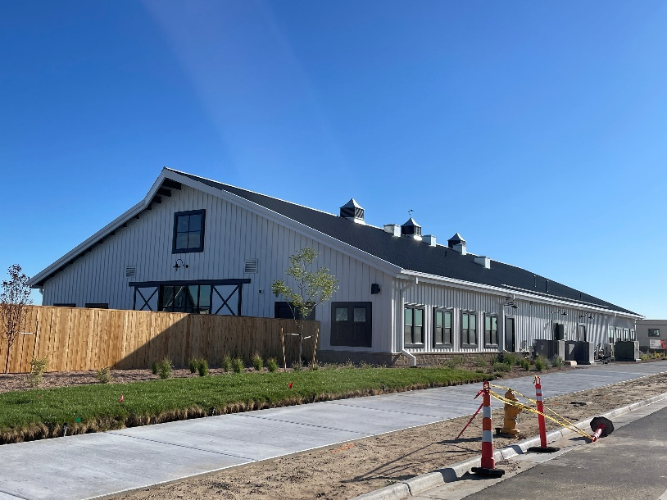
SII was engaged during the preliminary planning phase and has been involved in every aspect of the design, construction, financing and entitlement of the campus. Eric Shafran serves as Project Executive, Chris Landry served as the Project Director, and Cord Green is the Project Controls Manager. SII was engaged in a full-scope capacity, and is responsible for the following:
- Negotiation and management of phased contracts with DLR Group and Saunders Construction; ongoing management of design, preconstruction, permitting activities, and construction of all facilities
- Phased budget development and daily management, including invoice processing, exposure tracking, contingency administration, cash flow reforecasting, and lender relationship management
- Lead value engineering exercises with Saunders and DLR at each phase
- Management of design, procurement, permitting and construction of specialty buildings, including two greenhouses, two quanset huts, stables and sheds
- Coordination of all FF&E selection, procurement, assembly and installation from dozens of primary and secondary vendors
- Engage utilities and direct delivery of new services to all buildings
- Solicit, negotiate, and finalize all necessary additional professional service contracts including survey, geotechnical investigation, construction and material testing, Audio-Visual and low voltage contractor, signage design, fabrication and installation, and others; manage delivery of all services and deliverables
- Overall responsibility for project delivery, including quality control, schedule management, resolution of vendor issues, building handoff and startup coordination with School staff

