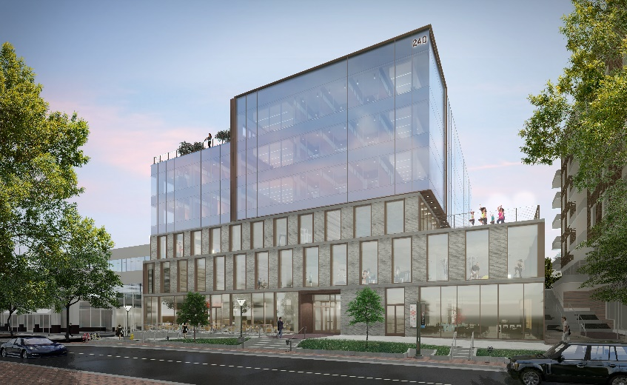
Tenere Capital
Denver, CO

Project Details
Description: 2,927 sf Tenant Improvement
Owner: Tenere Capital
Architect: Open Studio
General Contractor: Taurus Builders
Budget: $1.1M
Completion: Mar 2022

Project Description
The Tenere Capital project is a ~3,000 sf tenant improvement at the Cherry Creek office building 240 St. Paul St in Denver, CO. Open Studio designed the core and shell of the main office building as well as the Suite 600 interior for Tenere. Interior buildout included a kitchen, four private offices, conference room, copy room, reception area, and trading floor.
Scope of Services
Eric Shafran serves as Project Executive for the duration of the design and construction of the office buildout, overseeing and managing virtually all aspects of the project over its design phase and approximately 6-month construction period. Cord Green was Project Manager on the project. SII was engaged for a full suite of oversight responsibilities, including:
- Ongoing development and management of the complete project budget, including cash flow projection
- Hands-on management of the design process, ensuring coordination between all design professionals
- Coordination with all contractors and consultants to ensure accurate and timely delivery of work product and construction
- Preparation of monthly pay application packages to facilitate payment to vendors
- Tracking of change orders, budget transfers, and contingency usage
- Building and managing a project schedule to track project progress
- Oversight of the entitlements and permitting process
- Management of procurement and installation of furniture, fixtures, and equipment
- Selection, negotiation and contracting of general contractor; ongoing construction management, pay application review, change order negotiation, construction inspection and review
- Management of low voltage contractors, including security, data, and audio/visual

