Mikvah of East Denver
Denver, CO

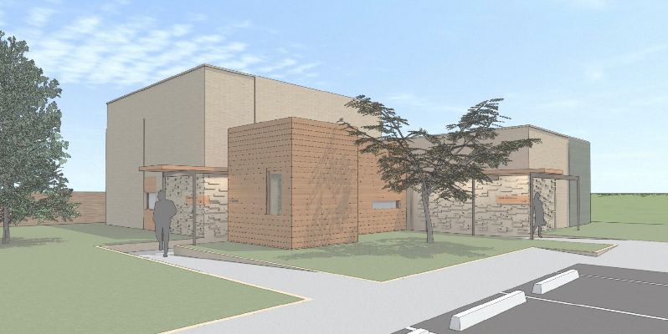
Project Details
Description: 2,608 sf Mikvah Construction
Owner: Mikvah of East Denver
Architect: Vega Architecture
General Contractor: Spectrum General Contractors
Budget: $3.0M
Completion: Feb 2021

Project Description
The Mikvah of East Denver is a 2,608 sf Jewish ritual bath in Denver, CO. The bathhouse includes separate men’s and women’s changing and bathing areas, as well as a Keilim Mikvah for ritual cleansing of kitchenware. The design and construction conform to strict Jewish law. Mikvaot (immersion pools) are built with a monolithic concrete pour to facilitate durability of the pits used to hold the water.
Scope of Services
Eric Shafran served as Project Executive for the duration of the design and construction of the mikvah, overseeing and managing virtually all aspects of the project over its design phase and approximately 10-month construction period. Cord Green was Project Controls Manager on the project. SII was engaged for a full suite of oversight responsibilities, including:
- Ongoing development and management of the complete project budget, including cash flow projection
- Oversight of the entitlements and permitting process, including zone lot amendments, parcel reconfigurations and several administrative modifications and variances
- Management of an RFQ-P process for architecture and engineering services
- Hands-on management of the design process, ensuring coordination between all design professionals including Rabbinic oversight and compliance of the design with Jewish law
- Coordination with all contractors and consultants to ensure accurate and timely delivery of work product and construction
- Preparation of monthly pay application packages to facilitate payment to vendors
- Tracking of change orders, budget transfers, and contingency usage
- Assisting the capital campaign team with fundraising via site tours, meetings with community leaders and donors
- Building and managing a project schedule to track project progress
- Management of procurement and installation of furniture, fixtures, and equipment
- Selection, negotiation and contracting of general contractor; ongoing construction management, pay application review, change order negotiation, construction inspection and review

