MULTI-VENDOR ECOMMERCE SITE
DOCUMENTATION
- WHY LARAVEL 13?
-> Laravel is one of the most powerful and widely used PHP frameworks for web development.
Also, Laravel 13 is great for building e-commerce site because it offers improved security, better API support, and enhanced database queries for faster performance.
- What is a multi-vendor E-commerce Website?
->A multi-vendor e-commerce platform allows multiple sellers to register and sell their product on a single website.
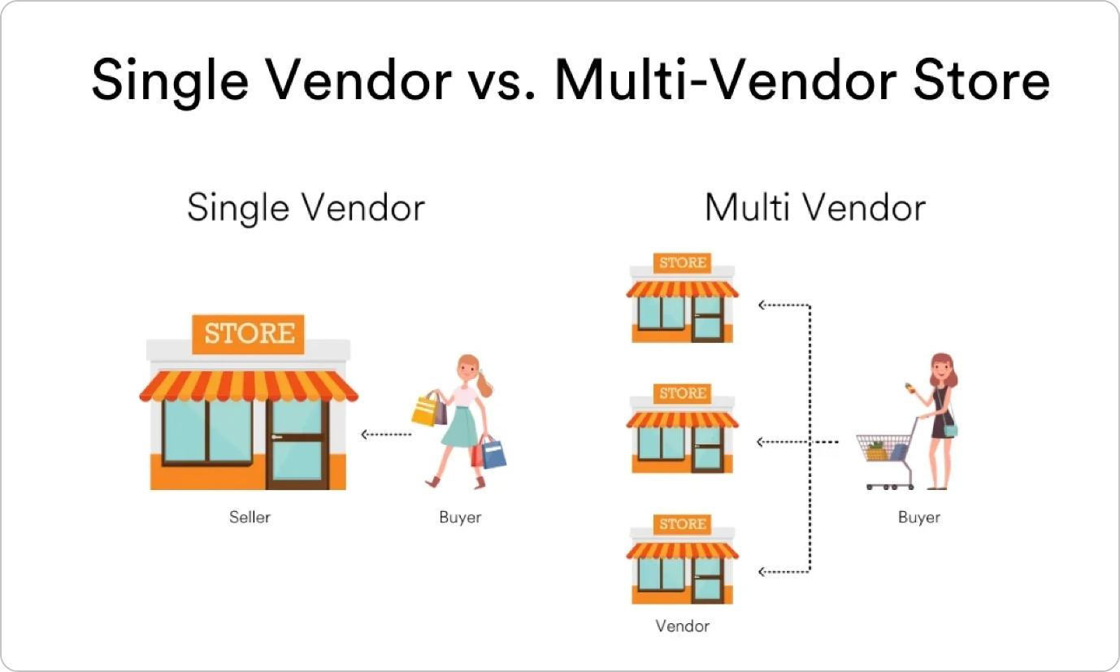
- Example : Amazon, ebay, daraz,flipcart etc
- Key Features of the Multi-vendor e-commerce site:-
i. user and vendor registration :- user register to buy product and vendors register to sell product.
ii. Product management :- vendors can list, edit and manage their product.
iii. Commission System:- Admin can charge a commission on each sale.
iv. Order and payment process :- payment integration :- esewa, khalti, connect-ips, fonepay,stripe, paypal
v. shipping and delivery management :- shipping charge according their location.
- Admin-> manage their vendors, monitor, approved and disapproved vendors products, role permission etc and customer order manages.
- Vendor -> seller dashboard, product list, track earning, transactions, coupon or discount.
- User-> register and purchase product and manage their order.
1. Composer
2. Laragon / xampp
3. Vscode
4. Multi-vendor site installation steps:-
i. Laravel new project_name in terminal.
ii. Project install completed.
github repo
https://github.com/samsuddeen/multi-vendor-ecommerce

