**Address Book Management Solutions**

The solution can be executed in the following ways:

1. Clone the repository (<https://github.com/samsudhir6/AddressBook.git> ) to your local and run the application from your IDE.

If there is any compilation Error or Error while running Unit Tests, please include the Junit.jar and Hamcrest.jar to the project build path. The Jars can be downloaded from the repo (<https://github.com/samsudhir6/util-commons.git> )

1. Clone the repo on [https://github.com/samsudhir6/util-commons.git and run the AddressBook.jar](https://github.com/samsudhir6/util-commons.git%20and%20run%20the%20AddressBook.jar)

Command for executing the Standalone : **java –jar AddressBook.jar**

Note : Please Ensure that Java version 8 is available on the system in which the above are executed.

Unit Test cases are available for reference and can be executed after importing / cloning projects in eclipse or any other IDE

Below are some of the scenarios for testing the developed solutions

**Create New Address Book**

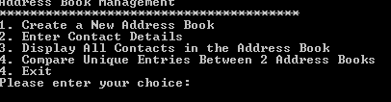

1. Enter option 1.
2. Contact Details cannot be added without creating a new address book

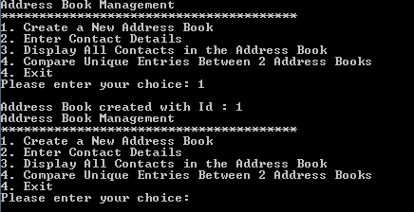

**Create Entries in Address Book**

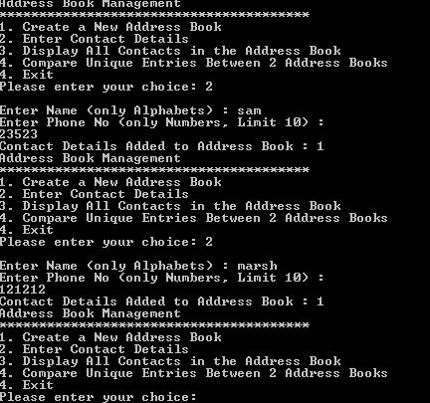

1. Choose Option 2
2. Enter Name and Phone Number.
3. Contact Details will be added to the address book.
4. The list of options will be shown again.
5. Choose option 2 once again to add contacts to the same address book.
6. Enter Name and Phone Number to add details to the address book.
7. Data can be added to the same address book as mentioned above.

**Create a new Address Book and Add Entries to it**

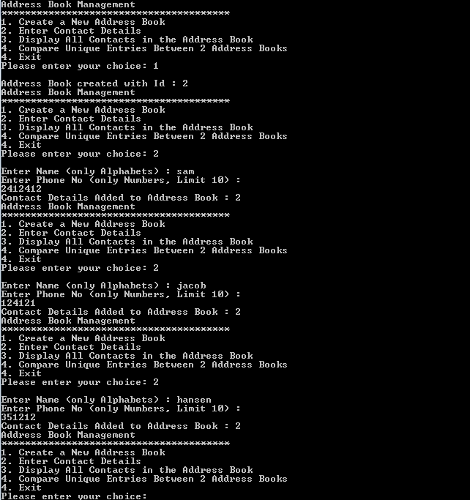

1. Enter option 1. A new address book with Id 2 is created
2. Choose Option 2
3. Enter Name and Phone Number.
4. Contact Details will be added to the address book.
5. The list of options will be shown again.
6. Choose option 2 once again to add contacts to the same address book.
7. Enter Name and Phone Number to add details to the address book.

**View Entries in Each Address Book**

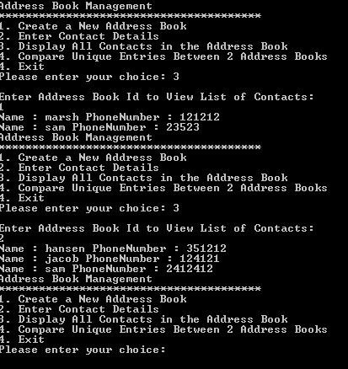

1. Enter option 3
2. You will be prompted to enter the Id of the Address Book.
3. The contact details will be displayed once the input is provided

**Compare and Filter Unique Contacts from 2 different Address Books**

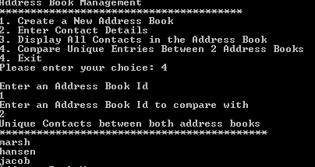

1. Choose option 4
2. Provide the IDs of the Address Books which need to compared after you are prompted for the input
3. The Unique contacts between both address Books are displayed.