**Date Range Calculator**

The solution can be executed in the following ways:

1. Clone the repository (<https://github.com/samsudhir6/DateRangeCalculator.git> ) to your local and run the application from your IDE.

If there is any compilation Error or Error while running Unit Tests, please include the Junit.jar and Hamcrest.jar to the project build path. The Jars can be downloaded from the repo (<https://github.com/samsudhir6/util-commons.git> )

1. Clone the repo on [https://github.com/samsudhir6/util-commons.git and run the DateRangeCalculator.jar](https://github.com/samsudhir6/util-commons.git%20and%20run%20the%20DateRangeCalculator.jar)

Command for executing the Standalone : **java –jar DateRangeCalculator.jar**

Note : Please Ensure that Java version 8 is available on the system in which the above are executed.

Unit Test cases are available for reference and can be executed after importing / cloning projects in eclipse or any other IDE

Below are some of the scenarios for testing the developed solutions

1. Provide Start and End Date Ranges in the Proper Formats. The output provides the details of the number of days and Months between the dates provided.

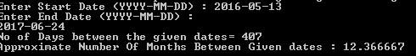

1. Providing data in improper format will cause an exception to be thrown

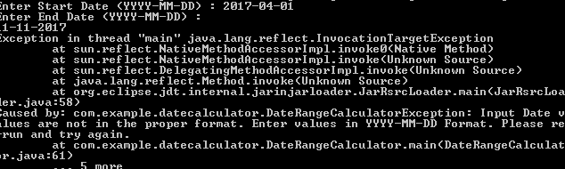

1. Another exception is thrown if the start data range is more than the end date Range

