Now, we definitely aren't advocating for smoking cigarettes (or many of Draper's [health choices](https://www.thrillist.com/culture/how-long-would-don-draper-live-don-draper-mad-men-life-expectancy)). But fictional or not, you can't deny the memorability and catchiness of that tagline.

**[Download our free guide here for tips to become a better writer.](https://cta-service-cms2.hubspot.com/ctas/v2/public/cs/c/?cta_guid=d2f809f1-9d66-4cd1-a05f-33193f57325d&placement_guid=ee0cc5c1-3c55-49d3-b456-cecf55bd3d6e&portal_id=53&canon=https%3A%2F%2Fblog.hubspot.com%2Fmarketing%2Fgood-copywriting-practices-list&redirect_url=APefjpGZZVW3_QCJjqyS3uJ_31QQLbd6CvpkbAaaaQ5Am3XI4i0Ta4dEe0mRJpkSAHHHkg38VBrOzyvWnOURI3r9D3xdjIDXDsC2h6zywxhiWdPbs-ZyhgRlg_Xu-NTIc26GMrDWlpJBIW3zLn-rQZHzn_fZdBJjmg&click=30f4c8b4-106c-465f-8585-45beb2e5381d&hsutk=61b498fbab9fd995d9c20b783ceedd8d&utm_referrer=https%3A%2F%2Fwww.google.com%2F&__hstc=20629287.61b498fbab9fd995d9c20b783ceedd8d.1536076330873.1536076330873.1536076330873.1&__hssc=20629287.1.1536076330874&__hsfp=1334811812" \o "Download our free guide here for tips to become a better writer. " \t "_blank)**

It's easy to recognize good copywriting when you see it, but there are actually several characteristics that really separate outstanding writing from the rest of the pack. Want to know them? Read on below to find out.

**What Is Copywriting?**

Copywriting is one of the most critical elements of any and all forms of marketing and advertising. Copywriting consists of the words, either written or spoken, marketers use to try to get people to take an action after reading or hearing them.

Copywriting is like a call-to-action, but on a bigger scale: Copywriters are trying to get people to feel, think, or respond -- or, ideally, to Google the slogan or brand to learn more about the campaign. And where a blog post like this one has the luxury of hundreds of words with which to make a case, copywriters only have a few words to make their case.

But short and sweet isn't the only characteristic of good copywriting. Keep reading to learn more characteristics of truly memorable copy.

**6 Traits of Good Copywriting**

**1) It tilts your perspective.**

Sometimes, all a message needs to break through is a slight shift in angle. We've grown so accustomed to blocking out marketing messages, we don't even see them anymore. One of the most powerful things a copywriter can do is break down a reader's guard with an unexpected approach. Every story has a myriad of angles -- your job as a copywriter is to find the one that resonates.

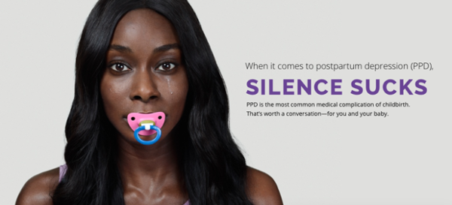

Source: [*Silence Sucks*](https://ppdsilencesucks.com/)

This ad from Sage Therapeutics pressing the importance of talking about postpartum depression works because instead of asking readers to care about something they don't know, it puts them in the position of experiencing the struggle that mothers suffering do. Did they miss some readers who quickly passed by the ad thinking it was for adult pacifiers? Most definitely. But the ad resonated that much more thoroughly with those who read it.

The next time you sit down to write, try out this approach. Don't take the topic head on. Instead, ask yourself why it matters. Each time you write down an answer, challenge yourself to push it further. Find the larger story happening behind your message.

**2) It finds connections.**

In 1996, Steve Jobs let the cat out of the bag. He was [speaking with a journalist from *Wired* on the topic of creativity](http://www.wired.com/wired/archive/4.02/jobs.html?person=steve_jobs&topic_set=wiredpeople) and explained:

"Creativity is just connecting things. When you ask creative people how they did something they feel a little guilty because they didn't really do it, they just saw something. It seemed obvious to them after awhile."

Let's say you have to write an ad for a new pair of sneakers. You could take the assignment head on. You could write about the elasticity of the shoe's sole or the lightweight design. Indeed, many have. Or you could put all of that aside and instead draw the connection between the product and the experience it evokes.

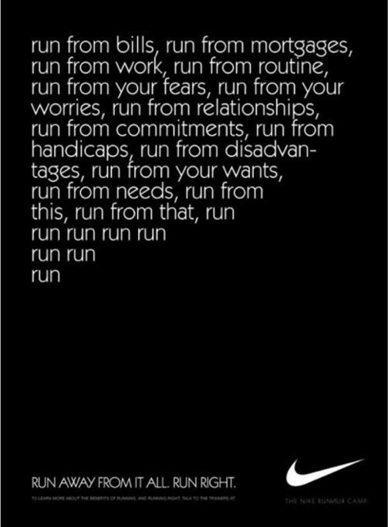

Source: [*Pinterest*](https://www.pinterest.com/pin/401242648028519555/)

Two things are happening in this ad. First, the copy recognizes that for many, running isn't about running at all -- it's about solitude, peace, and restoring sanity to an otherwise hectic life. Second, not only does Nike connect the ad to the experience of running, it actually connects to the sound that those shoes make as they hit the pavement.

This ad is about the complexity of one's life fading away and being replaced by simplicity and clarity. As the copy progresses, the sentences simplify and the copy's complexity is slowly replaced by the simple and rhythmic pounding of words: run, run, run, run. The same rhythm one hears when all but their footsteps have faded away. *That's* connection.

**3) It has a stunning lead.**

The following are all headlines or leading sentences from [Urban Daddy](http://www.urbandaddy.com/home/bos), an email-based magazine drawing attention to new products, experiences, and eateries.

* "Six days. That’s how long you have until 65% of your body is turkey."
* "There are 8,760 hours in a year. And just one hour in which a stand will be dispensing gratis latkes with homemade applesauce and sour cream in Harvard Square. Yeah, it’s not fair. But 60 minutes is 60 minutes."
* "Ewoks. Talk about living."

What's common among each of these leads? They make us want to read the next line. I mean, seriously, how much do you want to know [where that Ewok thing is headed](http://www.urbandaddy.com/bos/leisure/13450/Tree_Spa_at_Hidden_Pond_Getting_Massaged_in_a_Maine_Treehouse_Boston_BOS_Service)?

There's an adage in copywriting that's loosely credited to copywriter and business owner Joe Sugarman, which roughly states that the purpose of the headline is to get you to read the first line. The purpose of the first line is to get you to read the second line, and so on. In short, if your first line doesn't enthrall your readers, all is lost.

**4) It is born out of listening.**

Seeing its plans to launch yet another gym in the greater Boston region, an outsider might have called the Harrington family a wee bit crazy. The market was already flush with gyms, including a new breed of luxury ones that seemed to be in an arms war for the flashiest perks. Gyms across the region were offering massage services, smoothie bars, and fleets of personal trainers. And GymIt wouldn't have any of that.

What did [GymIt](http://www.gymit.com/about/) have? An understanding of its core audience. Before launching its new gym, the brand did a ton of listening to its primary market of gym-goers. For many in GymIt's target market, the added benefits associated with luxury gyms were nice to have, but came with a lot of baggage -- namely expensive rates and overly complex contracts.

GymIt decided to simplify the gym-going experience for people who predominately cared about getting in and working out. The copy in its launch campaign and across its marketing materials reflects that understanding.

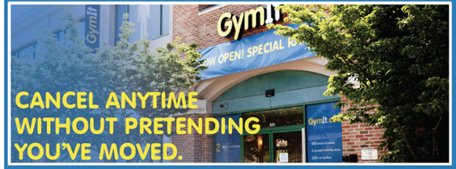

In [an older blog post](http://www.copyblogger.com/listen-carefully/), *Copyblogger*'s Robert Bruce put this nicely. "Humble yourself and truly serve your audience, listen to their needs and desires, listen to the language they use," he said. "If you listen carefully, your audience can eventually give you everything you need, including much of your copy. Get out of their way."

**5) It avoids jargon and hyperbole.**

Groundbreaking. Revolutionary. Business Solutions. Targetable Scale. Ideation. Evidence-based approaches. Industry-wide best practices.

Have I lost you yet?

When writers struggle to convey what is truly special about their company, product, or service, they sometimes fall back on jargon or hyperbole to underscore their point. The truth is, good copywriting doesn't need dressing up. Good copywriting should speak to the reader in human terms.

This isn't to say you should never celebrate awards or achievements. Just be direct in the way you *explain* that achievement. This homepage from [Basecamp](https://basecamp.com/) does a nice job of highlighting its popularity in concrete terms.

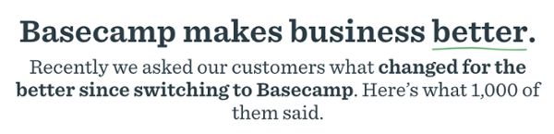

**6) It cuts out excess.**

Good writing gets to the point -- and that means cutting out excessive phrases, and rewording your sentences to be more direct. In an ad celebrating its "academic" readership, [*The Economist*](https://www.economist.com/) playfully demonstrates this below.

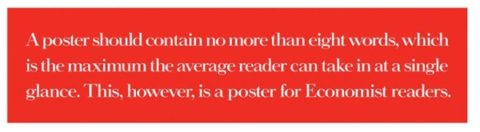

How do you rid excess words from your writing? It's half practice, half knowing where to cut. This [article from *Daily Writing Tips*](http://www.dailywritingtips.com/10-techniques-for-more-precise-writing/) is one of the most effective summaries I've found on precise writing. Included in its tips:

* **Reduce verb phrases:** For instance, turn "The results are suggestive of the fact that" to "The results suggest."
* **Reduce wordy phrases to single words:** You can change "in order to" into "to." Another example: Turn "Due to the fact that" into "because."
* **Avoid vague nouns:** Phrases formed around general nouns like "in the area of" or "on the topic of" clutter sentences.
* [Read the full list of brevity tips here](http://www.dailywritingtips.com/10-techniques-for-more-precise-writing/).

In general, if you can afford to cut without losing the meaning of a sentence, do so. Push yourself to strip down your word count. Turn 50-word homepage copy into 25, then push yourself again to make that 25-word sentence into 15 words. It's not about brevity so much as it is about making sure every word counts in your writing.

Since my last point was about getting to the point, I'll keep this brief: *Words matter*. Every time you sit down to write an ad, web page, video script, or other content for your company, you have the opportunity to break through to people. Find those opportunities in your marketing and make sure that you've made the most of them.

E-mail marketers use many strategies to improve the effectiveness of their campaigns, but one area often overlooked is what fills the page--the copy you write.

Whether you're a seasoned writer or a novice, it's always important to strengthen your editorial skills and make sure your e-mail marketing communications contain valuable information. Good copy helps your readers understand your offer--and how to respond. The following copywriting tips are ones that pros know well. Keeping these "commandments" in front of you when you write will help you create compelling copy that engages your readers, conveys your business message and creates effective calls for action.

**Commandment #1: Know your audience.**  
Who is this e-mail going to? Picture the average person on your list. Give them a name, even. Think about what their day is like. Think about what's important to them. What are they passionate about? How old are they? What products or services have they purchased from you in the past and why? The more you know about the audience you're writing for, the more targeted and relevant your copy will be.

**Commandment #2: Determine your value proposition.**  
Know the answers to these questions: Why should your customer buy your product or service? What's in it for them? Why is your product better than the one down the street? What are your key differentiators?

**Commandment #3: Find a unique selling proposition.**  
The more your offer stands out from the competition, the better your chances of getting a response. Rosser Reeves, author of *Reality in Advertising*, defines the unique selling proposition as a promotion that offers "something that competitors do not, or will not, offer." He also says, "The proposition must be strong enough to pull new customers to the product."

**Commandment #4: Establish an objective.**  
What's the purpose of this e-mail? What action are you trying to get the reader to take? You need to be clear on this before you start writing. If the answer isn't clear to you, it certainly won't be clear to your reader.

**Commandment #5: Use a compelling subject line.**  
The subject line is what gets your e-mail opened, so don't write something quickly just before sending. You have to convince your readers that they really need to open your e-mail. The best word you can use to get the reader's attention is *you*. The word *you* says that the message is about them. Other great words for subject lines (and headlines) include *new, exciting, exclusive* and *introducing*. Also, try to keep your subject line to 50 characters or less, including spaces.

**Commandment #6: Write a great headline.**  
If the subject line gets your reader to open the e-mail, then the headline gets them to read further. Consider using some of the buzzwords mentioned in commandment #5 in the headline so it'll grab readers with an obvious "What's in it for me?" message. Here's a question to ask yourself: What if my customers only read the headline? Will they know enough about you and what you offer?

Tip: Write five to 10 different subject lines and five to 10 different headlines to see what works best. Also, you may find that it's easier to write a subject line and headline after you've written the body copy.

**Commandment #7: Avoid weasel words.**  
When writing headlines, subheads and body copy, don't use words that avoid a direct command, aka weasel words. These include *may, maybe, hope, wish, try, but, could, perhaps* and *strive*. Instead, use words like *will* and *can* to describe what your product or service will or can do for your reader.

**Commandment #8: Don't use passive voice--write in the present tense.**  
Passive voice weakens your message. It's best to avoid it. Here are a few examples to help you see the difference:

* "Our company was chosen to receive an award" vs. "Our company received an award."
* "We have had 15 new products arrive" vs. "Fifteen new products arrived."
* "Ten new designs were created" vs. "We created 10 new designs."

**Commandment #9: Include a customer quote.**  
Do you have a great customer quote that you can include in your e-mail? A brief and convincing quote can add credibility to your campaign. The more real you can make the person to your readers, the better. Including their name, what city or state they live in and even a photo, if it fits your campaign, is a great way to communicate the value of your service.

**Commandment #10: Keep your copy clean and concise.**  
After you write your first round of copy, read it out loud. Also, have someone else read it to see if they understand the message and the call to action. As you edit, cut unnecessary words and consolidate ideas. See if you can get your text down to 30 to 50 percent of what you started with. Also, include bullet points and possibly subtitles to make it easy to read-and, more important, easy to scan--as most readers scan a page before deciding whether or not to read all the details.

Great copywriting is within your reach. Keeping these tips in mind when you write will greatly improve your copy, making it easier for readers to understand and respond to your e-mail campaign. Good, thoughtful writing will ultimately improve your success as an e-mail marketer.

With the constant demand for more quality content and the growing need for effective copywriting - one to attract visitors, the other to convert them to leads and customers - consistently producing powerful, high-quality copy is tough.

To help you avoid burnout, beat writer’s block, and ultimately get more results, here are 35 sure-fire copywriting tips from some of the greatest copywriters and advertisers.

#### 1. Do more research.

All the copywriting and advertising greats know the value of [research](https://writtent.com/blog/28-indispensable-research-reports-and-marketing-case-studies-for-smallbiz-strategy/). **David Ogilvy**, the Father of Advertising, said to “stuff your conscious mind with information” so you have plenty to work with. One of Ogilvy’s students, legendary copywriter [Gary Bencivenga](http://www.marketingbullets.com/bullet27.htm) (who also studied with several other great copywriters), said:

“The best copywriters are the most tenacious researchers. Like miners, they dig, drill, dynamite, and chip until they have carloads of valuable ore. John Caples advised me once to gather seven times more interesting information than I could possibly use... Research is the infallible cure for writer's block.”

The more information you have, the more possibilities you can play with.



[Image source](http://www.flickr.com/photos/thomashawk/85441961/)

#### 2. Add more interest.

When you don’t know what to write next or how to make your draft better, one copywriting hint is to add interest. As David Ogilvy once said, “Tell the truth but make truth fascinating. You know, you can’t bore people into buying your product. You can only interest them in buying it.”

So how do you make your copy more interesting and fascinating?

* Make it scannable and visually appealing
* Use your distinct personality or unique selling proposition
* Make it entertaining (as long as the humor furthers your goal)
* Incorporate controversy
* Newsjack
* Tell stories

#### 3. Inject personality.

Every writer and every brand has their own unique voice, style, and unique selling proposition (USP). Ogilvy knew that building a “sharply defined personality” is the best way (and sometimes the only way) to differentiate yourself from the competition and gain a larger market share. Before publishing anything, make sure it clearly demonstrates your [brand personality](https://writtent.com/blog/7-ways-to-infuse-your-company-website-with-brand-personality/) - including voice, style, word choice, values, and USP - as well as matches your target audience’s needs and desires.

#### 4. Refine your headline.

On the average, five times as many people read the headline as read the body copy. When you have written your headline, you have spent eighty cents out of your dollar. ~ **David Ogilvy** ~

In their books on copywriting and advertising, legends like Ogilvy and **John Caples** wrote whole chapters on crafting powerful headlines. Here are a few of the best tips on copywriting effective headlines and subject lines to get you started:

* **Copyblogger**’s [Magnetic Headlines](http://www.copyblogger.com/magnetic-headlines/) training
* Write the copy first, then pull out the strongest phrases to use as headlines and subheadings. This ensures your headlines match your copy.
* Opt for straightforward, simple headlines over tricky or clever ones.
* Remember the [4 U’s](https://writtent.com/blog/4-us-of-web-copywriting-tips-for-writing-great-headlines-copy/): Urgent, Unique, Useful, Ultra-specific.
* Give readers a benefit - then make sure you deliver in the body copy.
* Paint a vivid picture or stimulate an intense emotion. These grab attention and add interest, and they can instantly convey the most important benefit.
* Use [David Garfinkel’s Shortcut Test](http://www.davidgarfinkel.com/html/articles.html#double): If you posted the headline and a phone number as a classified ad, would it generate inquiries?

Copywriting Hall-of-Famer [John Caples divided successful headlines into three classes](http://www.makepeacetotalpackage.com/archives/great-moments-in-advertising-5-john-caples-explains-it-all/). In his experience, the third best headlines used curiosity, the second-best used news, and the best of all used the reader’s self-interest. He suggested that writers “try to get self-interest into every headline” and “avoid headlines that merely provoke curiosity... curiosity by itself is seldom enough.”

#### 5. Simplify your content.

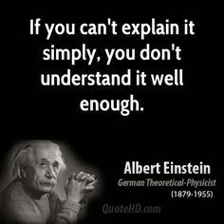

[Image source](http://www.quotehd.com/quotes/albert-einstein-physicist-never-do-anything-against-conscience-even-if-the-state)

Simplifying your copy doesn’t necessarily mean ditching the technical jargon or writing to a ninth-grader’s comprehension level.

It means making your message clear and concise so your target audience understands your offer and benefits as quickly as possible.

Famous copywriter [Eugene Scwartz](http://www.mindvalleyinsights.com/eugene-schwartzs-8-rules-of-great-copywriting/) put it this way: “Write to the chimpanzee brain - simply and directly.”

#### 6. Give your audience what they want.

Copywriter Gary Halbert tells a story about the best advantages a restaurant could have. It wasn’t great food, low prices, or a good location. The key to any restaurant’s success is the starving crowd. You start with a group of people who have demonstrated their hunger, and then you satisfy that need.

You can’t create desire; you can only stoke and channel it. Great content and copy gives your [audience](http://entreproducer.com/minimum-viable-audience/) exactly what they already want.

#### 7. Tell a story.

A 26-year-old raw copywriter sat down in 1926 to write an ad for the U.S. School of Music selling home-study courses for would-be musicians. He could have used a simple benefit headline, like **Master the Piano at Home in 30 Days - Without a Teacher!**

But he didn’t.

He dug deeper. He knew that mastering an instrument is hard work, and that the real reasons people do it is to be popular, to win their friends’ admiration and envy, and to find happiness. That copywriter realized the real product of the ad wasn’t a course or the ability to play, but popularity and happiness. With that in mind, he still could have used the classic how-to benefit headline, such as **How to Be the Most Popular Guy of Any Party!**

But he didn’t.

He knew that simply describing musicians’ popularity wouldn’t be enough. He needed the headline to resonate emotionally with prospects. He needed to create a vivid image of a buffoon--the kind of person no one ever dreamed could play - who left his friends stunned speechless by his performance.

His headline was **“They Laughed When I Sat Down At the Piano But When I Started to Play!”**

Then he used half of his entire ad space to tell the story of personal triumph, seducing prospects into reading the whole ad and giving them a vision of the possibilities.



[image source](http://www.flickr.com/photos/seriousbri/4148739768/)

That copywriter was [John Caples](http://www.makepeacetotalpackage.com/archives/great-moments-in-advertising-5-john-caples-explains-it-all/%20), who was inducted into both the Copywriters Hall of Fame and the Advertising Hall of Fame in the 1970s. That ad he wrote in the ‘20s launched his career and is still considered one of the pillars of the copywriting field.

It worked because it captured prospects’ attention, drew them into a world they desperately wanted to be part of, and left them hungry for more. The story presented the product as doing most of the hard work of learning to play and overcame the objection that you need a special talent to play (since even the buffoon could do it).

Consider these [storyselling examples from CrazyEgg](http://blog.crazyegg.com/2013/10/03/storyselling/) and these tips on [mastering storyselling from Forbes](http://www.forbes.com/sites/groupthink/2013/12/19/how-you-can-master-the-art-of-good-story-selling/).

#### 8. Make the copy visually appealing.

Successful advertiser [Leo Burnett](http://en.wikipedia.org/wiki/Leo_Burnett) developed simple icons to symbolize easy-to-understand product benefits and values (such as the Jolly Green Giant and the Pillsbury Doughboy). One of his rules of copywriting was to “make it inviting to look at” - since if the ad didn’t invite and entice the eye, no one would read it.

The same is even more true today, with the flood of content online, shrinking attention spans, and skimming readers. If your content doesn’t have what [David Garfinkel calls “eye appeal,”](http://www.davidgarfinkel.com/html/articles.html#7secrets) it won’t get read or shared.

So how do you give your copy eye appeal?

* a good typefont that’s easy on the eyes and big enough to read
* short paragraphs
* variety in the text, e.g. bolding, italicizing, underlining
* bulleted or numbered lists
* indented paragraphs or quotes
* headings and subheadings
* visual cues, i.e. arrows pointing at the form button

#### 9. Don’t be clever.

As writers and content marketers, we like to play with our words. Sometimes that’s okay, depending on your brand personality and the type of content. But most of the time, being clear and concise will return greater rewards than being clever.

As million-dollar copywriter [Gary Bencivenga](http://www.marketingbullets.com/bullet27.htm%20) said:

“Effective copywriting is salesmanship in print, not clever wordsmithing. The more self-effacing and invisible your selling skill, the more effective you are. Copywriters who show off their skills are as ineffective as fishermen who reveal the hook.”

#### 10. Break the rules.

This copywriting tip might seem counter-intuitive, but the best writers know when and how to break the rules of proper grammar, syntax, and mechanics. As [David Garfinkel said](http://www.davidgarfinkel.com/html/articles.html#7secrets), “I've advised many clients who feel compelled to use ‘proper English’ in their sales letters… to ‘fire your English teacher!’"

Speaking directly to your prospect in language they’ll easily understand is always more important than writing things by the book.

#### 11. Keep a swipe file.

One of the most well-known copywriting hints is to keep a swipe file--a collection of emails, ads, and other copy or content you love or that performed well. That way, whenever you’re stuck on a tough headline or don’t know what to try next, you can glance through your collection and jumpstart your creativity.

#### 12. Have a purpose behind everything you write.

With the content marketing boom, lots of marketers create content for content’s sake. Having a large library of content can be incredibly useful, but only if each piece has a purpose and fits in the overall plan.

As David Ogilvy said, “In the modern world of business, it is useless to be a creative, original thinker unless you can also sell what you create.” Witty, clever content by itself doesn’t do you any good. Make sure your content engages your audience, builds trust, and encourages sales first.

#### 13. Avoid distraction.

Sometimes when you’re stuck writing, the real culprit isn’t a lack of ideas or words, but not enough time to devote to the project. If you’re having trouble, try this copywriting hint and [productivity hack from Eugene Schwartz](http://www.copyblogger.com/schwartz-copywriting-system/).

First, close the door and turn off your phone. Close or sign out of email and social media. Eliminate as many distractions as possible.

Then sit your chair and set a timer for 33 minutes. The only things you can do during that half hour are think about the writing project and get to work on it.

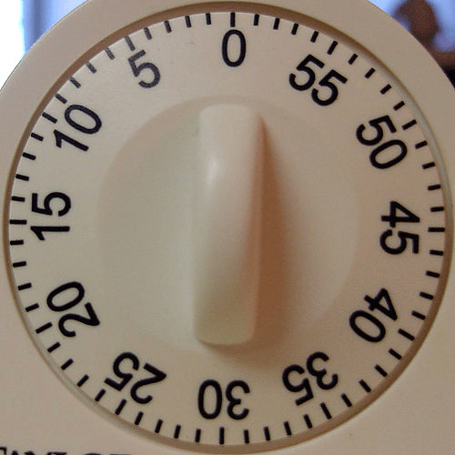

[image source](http://www.flickr.com/photos/s_v_p/5869857/)

When the timer goes off, take a 10-minute break and repeat.

With this system, Schwartz wrote about 3 hours a day, 5 days a week--and become one of the highest-paid copywriters of the 1950s and ‘60s.

#### 14. Think outside the box.

David Ogilvy said, “Talent, I believe, is most likely to be found among nonconformists, dissenters, and rebels.” Don’t be afraid to try something different and new, because it just might work. Find and form relationships with the nonconformists, dissenters, and rebels in your field and see what great ideas might spark. Unhook your rational thought process and allow your subconscious to make connections between ideas. That’s when you’ll come up with the best content and copywriting ideas.

#### 15. Speak your ideal customer’s language.

Ogilvy also said, “If you’re trying to persuade people to do something, or buy something, it seems to me you should use their language, the language they use every day, the language in which they think. We try to write in the vernacular.”

Speaking in their language helps prospects get to know, like, and trust you because they recognize themselves in your words. That helps you connect and build relationships with them, and more easily persuade them.

If you’re stuck writing, go back and make sure everything sounds the way your customers think. Put yourself in their shoes. Make yourself invisible. Not only will your copy get better for the exercise, but getting out of your own way like this can jumpstart new ideas and illuminate what should come next.

#### 16. Focus on benefits.

Every great copywriter advises other writers to emphasize benefits, not features:

* [John Caples](http://www.makepeacetotalpackage.com/archives/great-moments-in-advertising-5-john-caples-explains-it-all/) said, “The best headlines are those that appeal to the reader benefits.”
* [Eugene Schwartz](http://www.mindvalleyinsights.com/eugene-schwartzs-8-rules-of-great-copywriting/) said, “Talk about what your product ‘does’, not ‘is’ - and demonstrate this.”
* [Bob Bly](http://www.bly.com/Pages/documents/TFOPW.html) said, “Virtually all successful copy discusses benefits.”

Everybody talks about this copywriting tip because it works, and it’s a relatively easy fix if your current copy isn’t doing so well. Make every feature you mention leads to a benefit.

#### 17. Make prospects feel like they’re already getting something.

Another great tip about copywriting from Schwartz is to make gratification instantaneous. When prospects get something valuable from you just by reading, they learn to trust you and believe that you deliver what you promise. This copywriting trick gives prospects a taste so that real desire fuels their actions, not just curiosity, and it’s also one of the reasons content marketing works so well.

#### 18. Ask questions that get readers to say “yes.”

A classic persuasion technique used by Socrates and used car salesmen, this theory states that the more often you can get prospects to say “yes,” the more likely they are to say “yes” again. A-list direct-response copywriter [Parris Lampropoulos](http://www.makepeacetotalpackage.com/archives/parris-lampropoulos-with-clayton-makepeace/#sthash.nOQpxDJD.dpuf) uses this technique a different way: “In sales copy, I’ll throw in a question here and there, but more often, I’ll phrase it as a statement. You know – one of those statements that get prospects nodding their heads.”

If they’re saying “yes” and nodding their heads, you’ve hooked them.

#### 19. Appeal to emotion.

Early in his career, **Lampropoulos** saw a particular copywriting gig as his chance to make it to the big leagues, so he pulled out all the stops. In addition to packing it with proof elements, testimonials, and price justifications, he also “worked every possible emotion the reader might have.” It was one of his most successful direct-mail packages, and it mailed for four years.

The trick to incorporating emotions in your copy is to ask yourself: what is my prospect’s deepest desire right now? There are lots of emotions you can appeal to, but the key [driving emotions](http://syrupmarketing.com/direct-mail-marketing-7-key-copy-drivers/) - the strongest, deepest emotions not governed by rational thought - are:

* fear
* greed
* guilt
* exclusivity
* anger
* salvation
* flattery



[Image source](https://www.flickr.com/photos/amymctigue/3543454897/in/photolist-6Eo6A3-6p88FX-bmUKfD-82XBKu-4DVDva-77Bk1Z-29iqHy-autBvF-6QHt3o-iePj7X-4x8Tpc-77n7HT-ciC5Bs-nMmAnX-cF2LHN-6aWvjc-cFeZho-b8X5rH-3n5Rik-ce85rC-dcZ5Tp-6ez8Lv-6yppzK-fGSDaH-5dBEg5-6eDgau-cFeULs-hW6PTN-aF1vH5-cSNevY-fE6Avi-cFdgrq-cFdxM5-cFdqSS-cFf3JU-o8d1Pz-cFePU7-cFfirL-cFfp8m-bkofuU-46N8gf-4g47Cz-9f8GGL-b8yp48-cTWRXh-cF2ieo-cFfaAq-cF2mL3-bi5F9T-cF2suy)

#### 20. Try a unique angle or hook.

When asked about his process for writing stock stories and promotions for financial newsletters, [Parris Lampropoulos said](http://www.makepeacetotalpackage.com/archives/parris-lampropoulos-with-clayton-makepeace/#sthash.nOQpxDJD.dpuf):

“First, I go to Fortune, Forbes and Business Week and read every article I can find on the company being recommended. Then I do something unusual: I sit down and start writing "fascination" bullets for those articles. By doing that, I find all kinds of unexploited sales angles. Those angles lead me to the "hook" for the stock story. And once I’ve got the hook, the story almost writes itself.”

The blogs and magazines you look at may be very different, but the principle is the same: start by researching good sources, then delve deeper to find the different, interesting, unusual, or unheard-of. Those golden nuggets become the angle or hook you need to catch attention and generate interest.

#### 21. Hunt down the right words.

One of the oldest copywriting tips is to not use adjectives and adverbs to make an okay word good enough. Track down the very best word to convey the message, emotion, or imagery. It makes your copy stronger, makes you as the writer more invisible so the reader can feel or see or understand what you want to convey that much better.

As Mark Twain famously said, “The right word is the difference between lightning and lightning bug.”

#### 22. Use active voice.

Stronger and usually shorter than passive construction, active voice is easier to understand and conveys your message better and faster. Passive voice makes you sound weak, reactive, or acted upon, while active voice takes charge.

For example, the passive sentence “Over 5000 customers have been helped by our services” is much stronger in the active voice: “We have helped over 5000 customers.”

#### 23. Replace “weasel words” with imperatives and promises.

Avoiding commands and strong words like “will” and “can” are a way of protecting yourself, but it makes you sound wishy-washy and unable to deliver. Go through your copy and replace every [weasel word](http://www.entrepreneur.com/article/164812) (e.g. may, hope, could, perhaps, etc.) with the appropriate imperative or promise word (e.g. will, can, do, etc.). This strengthens your copy and makes you sound confident, which builds prospects’ trust.

#### 24. Back up your claims.

You’ll sound even more confident and build more trust and credibility when you prove your case with reliable data. Back up your benefits and other claims with proof. This wins over skeptic readers and shows that you really do know what you’re talking about. A few copywriting ideas to back up your claims might include:

* facts and statistics
* methodologies
* testimonials
* case studies
* success stories

#### 25. Use specific examples.

Resume writers and school counselors tell you to include specific numbers in your resume because they quickly convey your experience and skills. This copywriting trick works in just about everything you write, and it makes your copy stronger by attracting attention and making you seem more credible - and memorable. As [Bob Bly](http://www.bly.com/Pages/documents/TFOPW.html), one of America’s top copywriters, says: “Since so much advertising is vague and general, being specific in your copy sets it apart from other ads and creates interest.”

#### 26. Evaluate your copy’s ratio of “you” vs. “we.”

Effective content marketing and copywriting always starts with the customer. That’s why no one wants to read brochures or websites that only talk about the company - and why copy that speaks directly to the prospect gets more results. When you make sure your copy uses “you” at least twice as often as “we” or your brand name, you’ll naturally focus on your customer’s needs and desires. Your copy will be stronger, and you’ll get more traffic, leads, and sales.

Derek Halpern of Social Triggers is a great example. In his post about [creating amazing About Us pages](http://diythemes.com/thesis/amazing-blog-about-pages/), he explains why it’s important to include a benefit-driven headline... benefit-driven introduction... and social proof. To see his advice in action, check out his [Social Triggers About page](http://socialtriggers.com/social-triggers/). There’s a lot of “I” and “Social Triggers” in there--but there’s also tons of “you.” He talks directly to his audience so they know exactly what they can expect from him.

#### 27. Incorporate the fundamentals of persuasive copywriting.

According to “America’s Top Copywriter” Bob Bly, the [fundamentals of persuasive copwriting](http://www.bly.com/Pages/documents/TFOPW.html) are:

1. Gains attention
2. Focuses on the customer
3. Stresses benefits
4. Differentiates you from the competition
5. Proves its case
6. Establishes credibility
7. Builds value
8. Closes with a call to action

Depending on your product, prospect, and type of content, you may not need to use all eight. For example, established brand names might not need to worry about proof and credibility. But keeping them in mind while you write and revise can help you create stronger, more compelling copy.

#### 28. Use imagery.

Imagery helps readers instantly understand a situation or benefit (plus, it makes your copy more interesting to read). Copywriter [David Garfinkel](http://www.davidgarfinkel.com/html/articles.html#double) says one of his favorite headlines/slogans is this one for a plumbing service:

Call Roto-Rooter - that's the name -

And away go troubles, down the drain!

Describing it, he says: “Wow - is that perfection in a couple of lines, or what? You get **a call to action, company identification, and a visual description of the benefit**.”

The imagery of the drain instantly conveys the benefit. It’s also memorable, always a plus in great content.

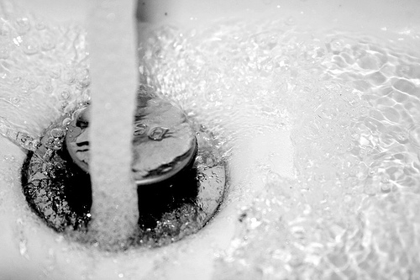

[image source](http://www.flickr.com/photos/botter/90777905/)

#### 29. Lead with your strongest point.

So many writers save their most potent points for last, when it should be the other way around. More prospects will read the beginning than the end, so putting your best idea first is more persuasive. The strongest point can often grab attention better than weaker points, making it ideal for the beginning.

#### 30. Build credibility.

Another very successful copywriter, [Steve Slaunwhite](http://www.examiner.com/article/10-powerful-copywriting-secrets-by-bob-bly), said:

“In my experience, the number one key to persuasion is this: communicate trust. If you do this well, you at least have a chance at engaging and persuading the reader. If you don’t do this well, however, no amount of fancy copywriting techniques will save you.”

You can build credibility and trust by mentioning credentials like:

* strong guarantee, return, and privacy policies
* testimonials and data about your track record
* years in business
* innovations and awards
* publications
* membership and participation in professional societies
* seals of approval
* agency ratings
* independent survey results
* media coverage

#### 31. Mention the most important point at least three times.

This is Winston Churchill’s “tremendous whack” theory, which says to not be subtle or clever about your important point. [Richard Perry says](http://www.examiner.com/article/10-powerful-copywriting-secrets-by-bob-bly%20), “Use a pile driver. Hit the point once. Then come back and hit it again. Then hit it a third time—a tremendous whack.”

Successful writers and marketers use the power of three all the time.

* [Derek Halpern](http://socialtriggers.com/leaks-cost-subscribers/) advises putting an opt-in form in three places on your About Page.
* Lots of email marketers include three links in an email to drive clicks (just look at a few of the email newsletters you get).
* Long-form landing pages often have three CTA areas.

If something’s important, say it at the beginning, again in the middle, and again at the end.

#### 32. Stress value.

America’s top copywriter [Bob Bly says](http://www.bly.com/Pages/documents/TFOPW.html), “It’s not enough to convince prospects you have a great product or a superior service. You must also show them that the value of your offer far exceeds the price you are asking for it.”

Showing the overall value is also known as the “drop-in-the-bucket” technique, where the cost of purchase is a tiny thing compared to the benefits your offer delivers. This works for email subscriptions and blog comments as well as product sales, since readers give up something they value--their time, email address, privacy--to get something of value in return.

This fundamental copywriting tip works really well in conjunction with tip #17, providing instantaneous gratification. If they already get value from your content, the value of your offer is almost certainly worth the cost.

#### 33. Include a strong call to action.

If you don’t specifically ask people to do something, chances are they won’t do it. Everything you write, from blog posts to emails to social updates to landing pages, should close with a call to action (CTA). To get the most out of your CTAs, make sure they:

* match the [buyer persona](https://writtent.com/blog/building-an-epic-buyer-persona-profile-a-totally-comprehensive-guide/) and stage of the [buying cycle](https://writtent.com/blog/how-content-marketing-fits-into-your-buying-cycle/)
* offer something of value
* offer prospects something they actually want
* reiterate your most important benefit or emotional driver

#### 34. Make it personal.

Copywriter David Garfinkel says that [successful content is personal](http://www.davidgarfinkel.com/html/articles.html#7secrets), and it doesn’t use stilted formal English or “stickler” language of a school assignment. He recommends writing in a more personal, relaxed style, as if you’re having a one-on-one conversation with your prospect.

Research indicates that [personalized emails convert better](http://emailmarketing.comm100.com/email-marketing-tutorial/personalized-email.aspx) than mass messages, and most internet marketers know that the most successful blogs employ the relaxed, personal style.

#### 35. Organize your writing with a formula.

[AIDA](http://blog.crazyegg.com/2013/09/23/aida-copywriting-formula/) is a popular sales letter format for a reason - it works. Using a framework like attention-interest-desire-action (or John Caples’ version, attention-interest-action) makes it easy to know exactly what to write next.

Here are a few other frameworks and formulas to help you get started:

* [Dan Kennedy](http://www.enchantingmarketing.com/copywriting-formulas/)’s favorite copywriting formula is PAS, or Problem-Agitate-Solution. It works because people are more likely to act to avoid pain than get gain.
* **Copyblogger** promotes a simple [1-2-3-4 framework](http://www.copyblogger.com/smart-people-1-2-3-4/) that helps you focus on the customer and incorporate the most important persuasion fundamentals.
* [Essential copywriting formulas](http://thecopybot.com/2013/04/copywriting-formulas/) and checklists to make your copy as strong and powerful as possible.

What copywriting tips and tricks do you use?We’d love to hear what works for you!