SCORA
APPLICATION OVERVIEW
Service Competency & Operational Readiness Application
One platform that turns official service performance data into visible, self-service capability development for every engineer, front-desk colleague and service partner.
ITEM | DETAIL
Project | SCORA — Service Competency & Operational Readiness Application
Entity | Samsung Electronics Egypt — Customer Service Division
Project owners | Fawzy Maher, George Samir
Category | AI Transformation (AX) — innovation delivered through AI
Coverage | Mobile Experience (MX), Digital Appliances (DA), Audio-Visual (AV)
Populations served | Field engineers · Front desk · Galaxy Consultants · Service partners
Delivery | Seven phases over seven months, continuous release
Status | Operational on the internal network
Document | Application overview — figures replace tabular detail throughout
Date | 2026-09-14

01 Purpose and Problem Definition
Samsung Electronics Egypt operates an established engineer evaluation program across Mobile Experience, Digital Appliances and Audio-Visual, alongside the Partner Quality Assessment (PQA) program for authorized service partners. Both programs are mature, governed, and continue to run through their official channels. SCORA does not alter either program — it extends how far their results travel.
Performance and quality data existed and was trusted. What was missing was a real-time, individual channel that returned that data to each engineer, front-desk colleague and partner in a form they could act on, together with the knowledge required to improve the specific KPI behind their result.
The objective followed directly: keep the established programs exactly as they are, and add a digital layer that delivers the same official outcomes to every participant in real time, links each outcome to the knowledge that improves it, and sustains that momentum continuously rather than once per cycle.
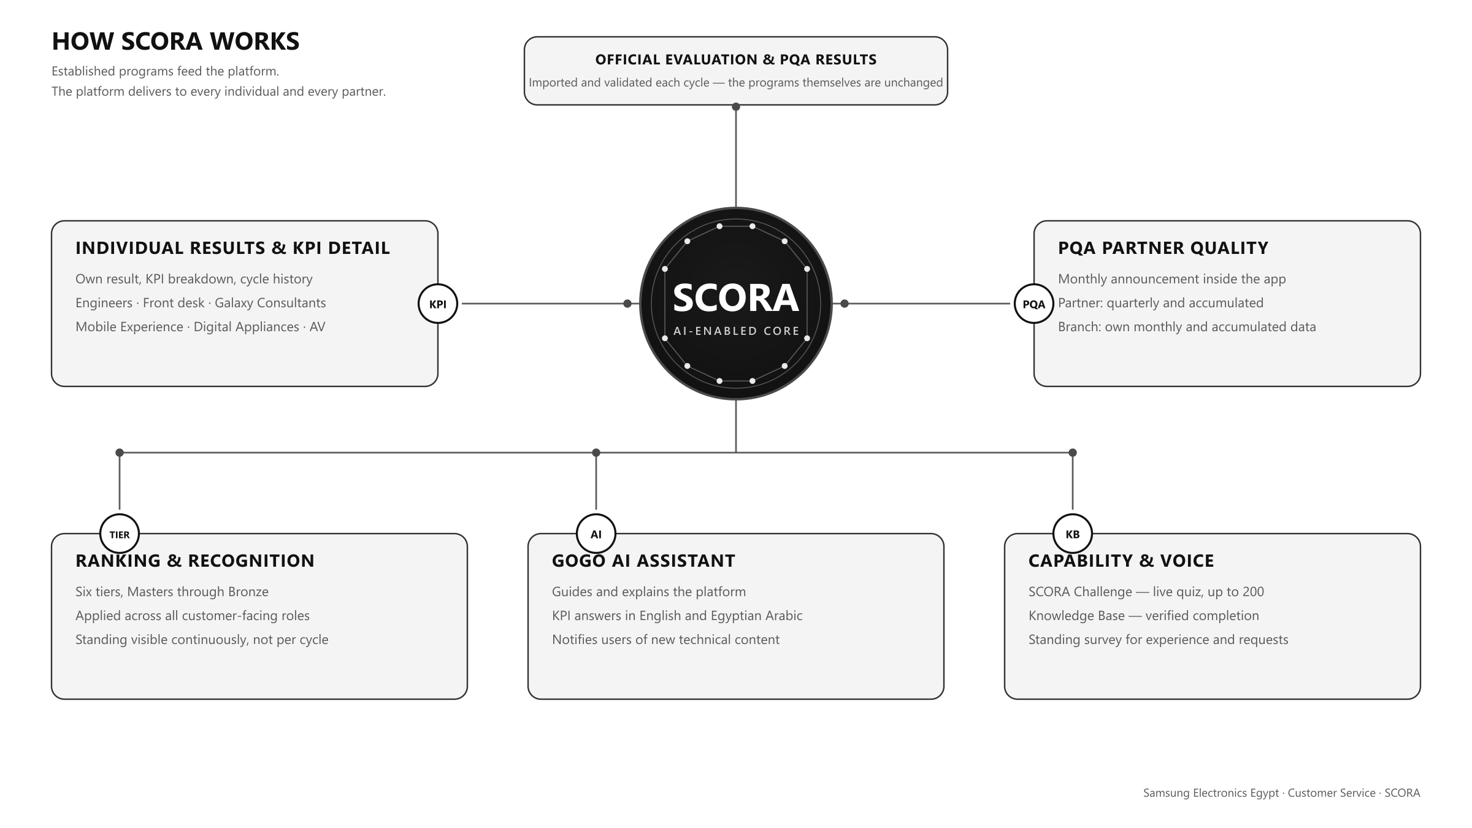
Figure 1 — How SCORA works — one validated source, five simultaneous delivery streams.

02 Improvement Goals
Six goals define the platform. Each carries a measure that the platform itself can report, so progress is observable rather than asserted.
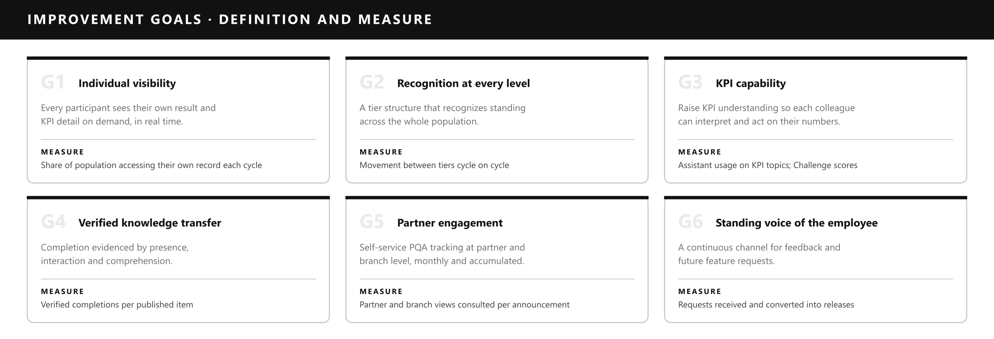
Figure 2 — The six improvement goals, each with the measure the platform reports.

03 Delivery
The platform was delivered in seven functional phases across seven months. Each phase was released to users before the next began.
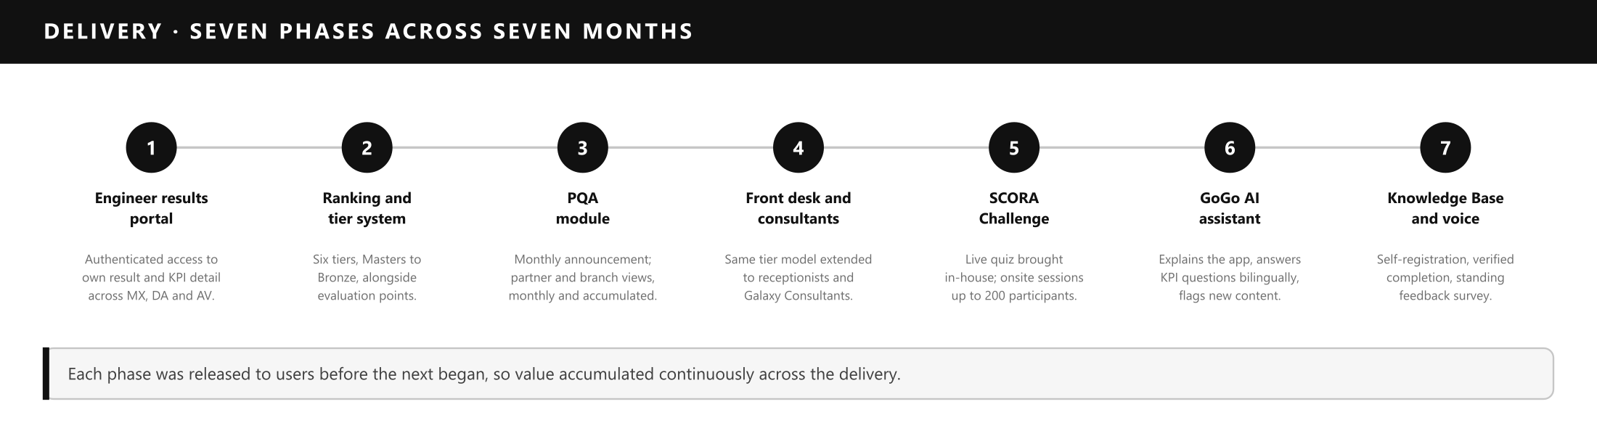
Figure 3 — Seven delivery phases, each released to users before the next began.

04 Workflow Before and After Improvement
The evaluation and PQA cycles are unchanged. The figures below describe what has been added, not what has been replaced: the same validated results enter once per cycle, then fan out to every population and partner at the same time.
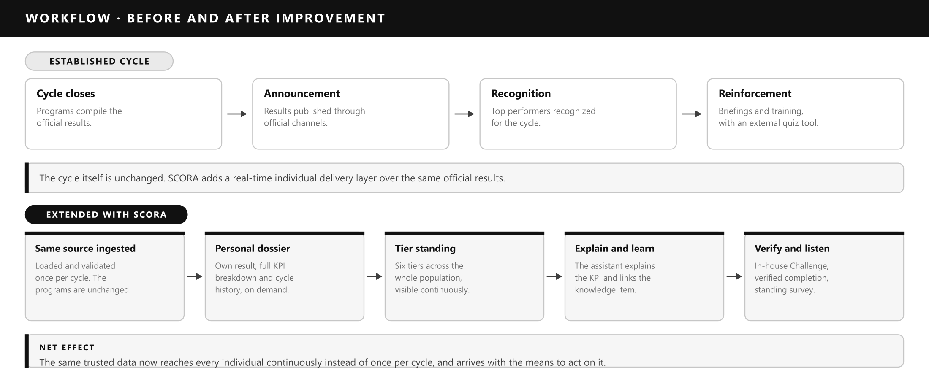
Figure 4 — Workflow before and after improvement. The established cycle is unchanged.

05 Scope of Implementation
Scope is defined by product, population, cycle and granularity. Recognition applies identically to every customer-facing role.
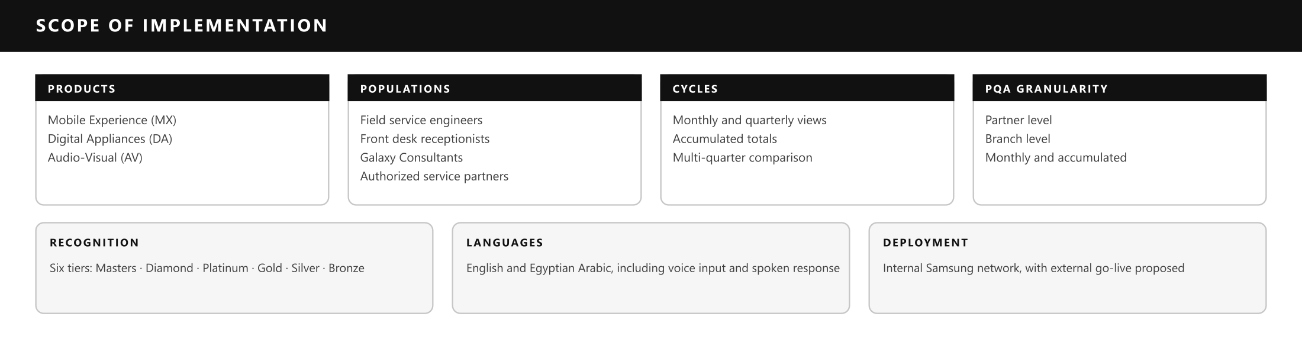
Figure 5 — Scope of implementation by product, population, cycle and granularity.
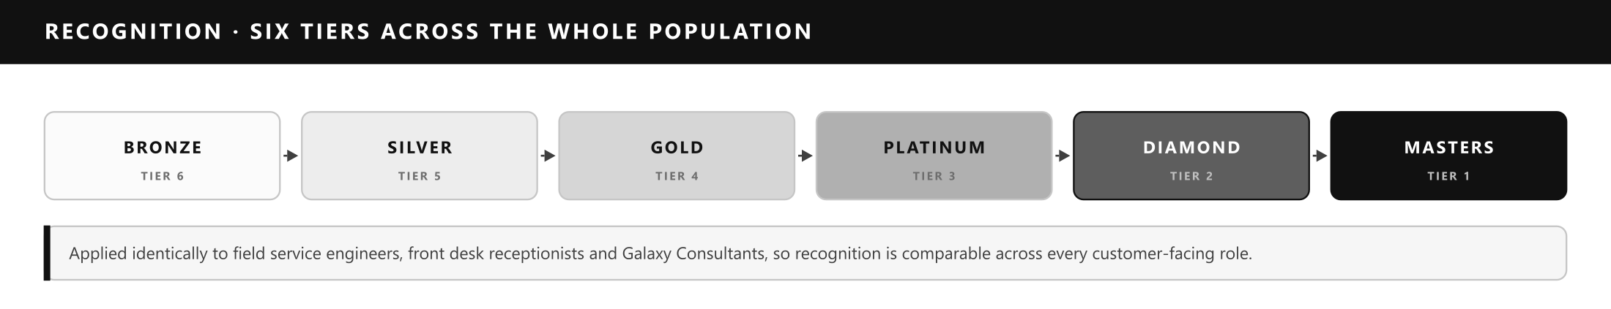
Figure 6 — Six recognition tiers, applied identically across every customer-facing role.

06 Key Function Details
Six functional modules make up the application. The KPI model is held separately per quarter, so a colleague sees both the components of their result and the outcome.
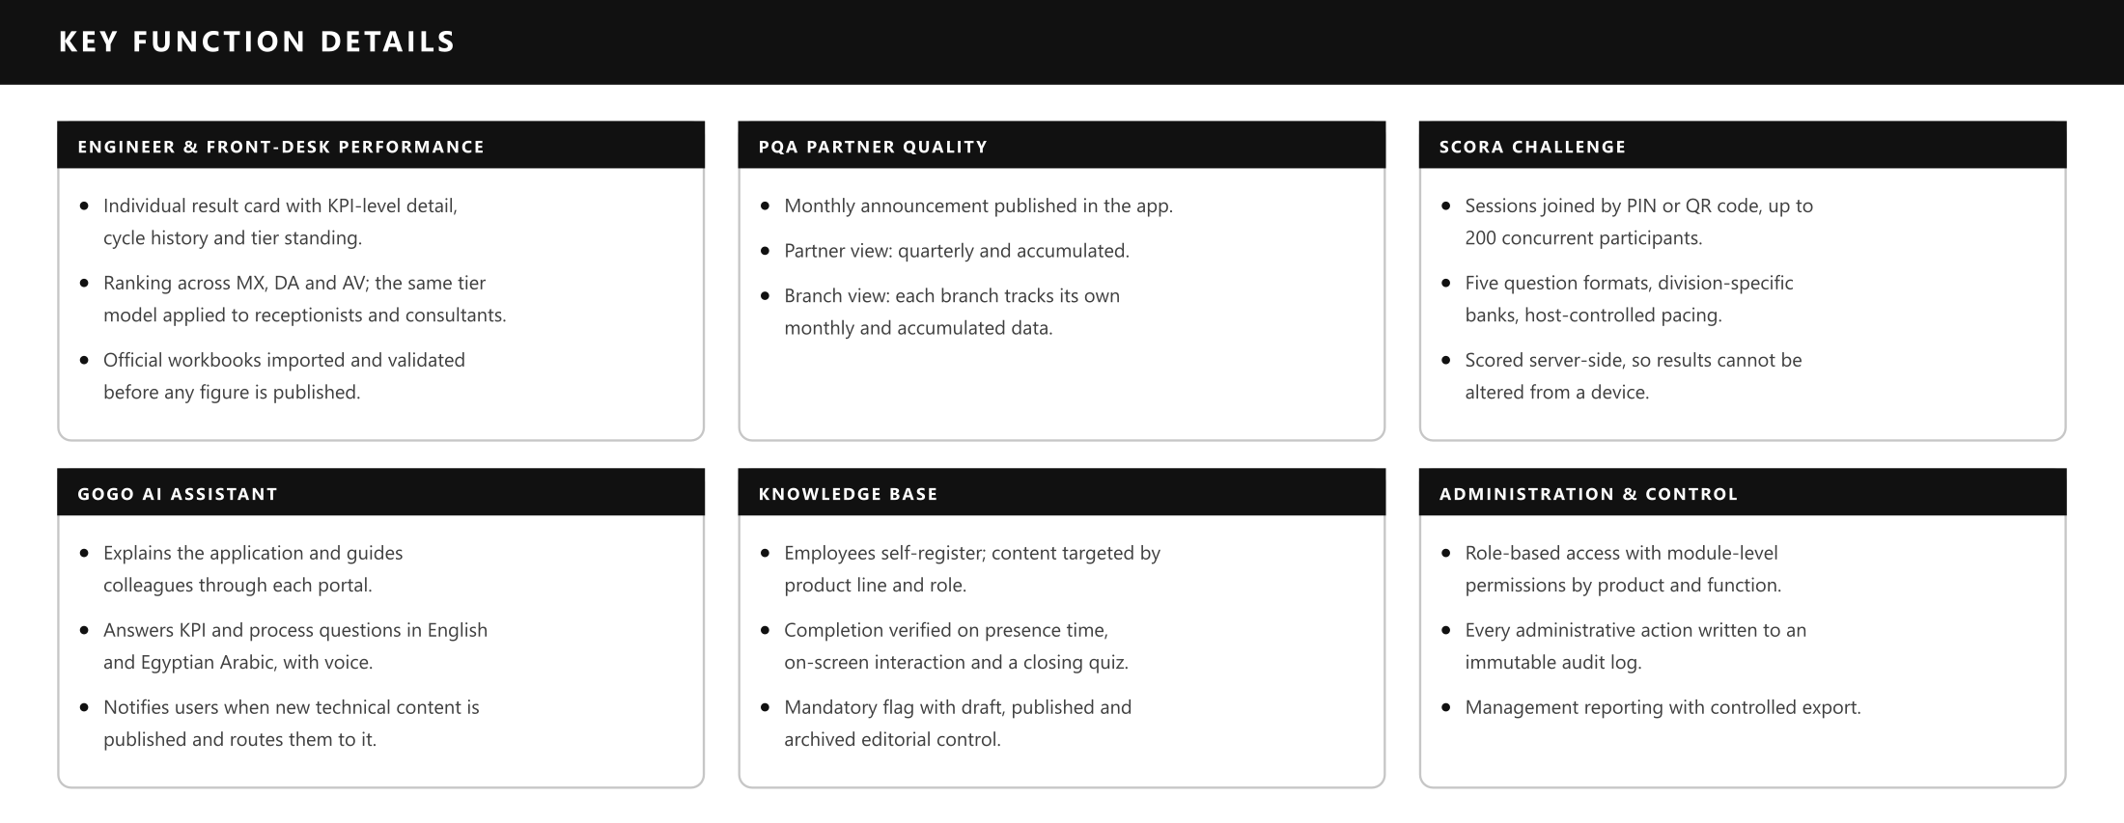
Figure 7 — The six functional modules of the application.
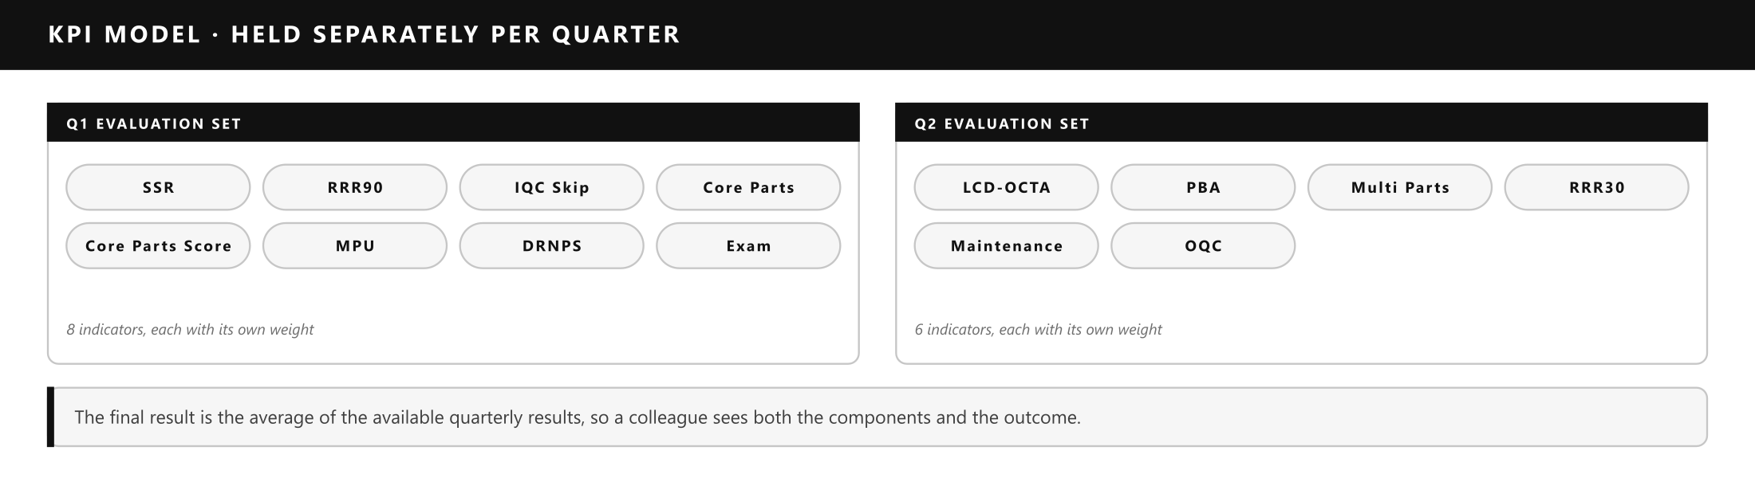
Figure 8 — The KPI model, held separately for each quarter.

07 AI and Data Utilization
SCORA was designed, built and refined using enterprise-approved AI assistants, within the internal tooling policy. This is the substance of the AX contribution: AI did not add a feature to an existing system — AI is what made a platform of this scope deliverable by the project owners in seven months, with no external development vendor and no software license cost. All generated output was reviewed, tested and released under the owners’ control.
Inside the running application, the GoGo assistant answers from curated internal content through a guided model. Because every answer originates from a verified internal item, it is attributable and auditable — an answer can be traced to its source and corrected there. This is a functional advantage, not only a control.
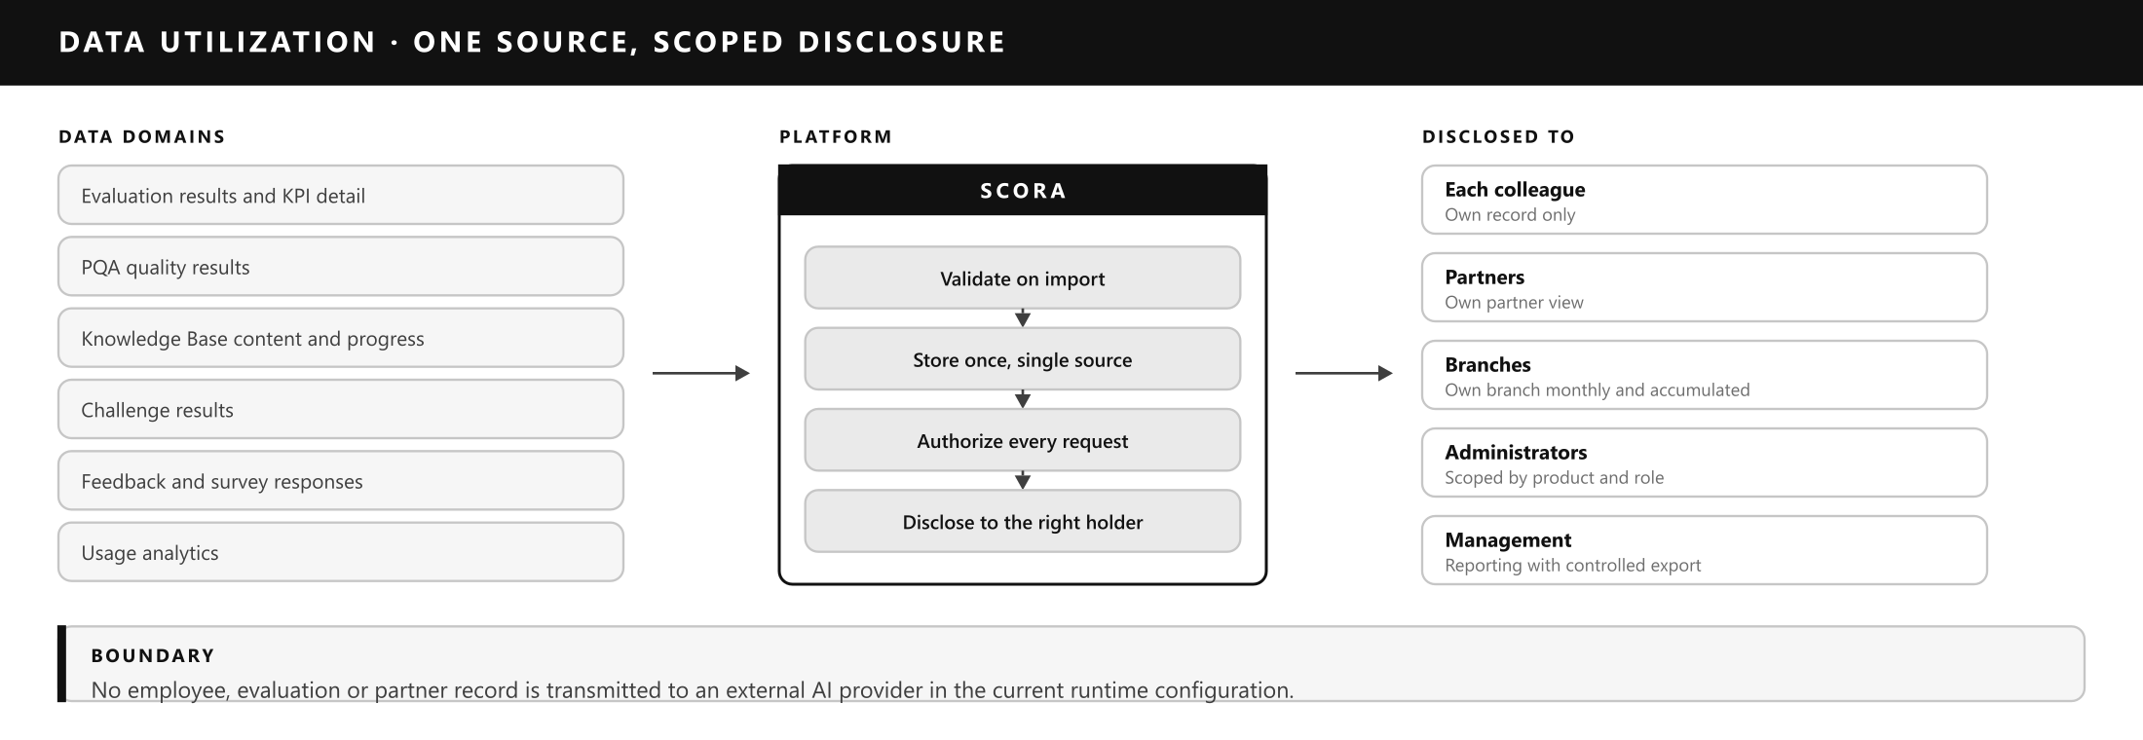
Figure 9 — Data utilization — one source, scoped disclosure, and the external boundary.

08 Return and Impact
The clearest evidence of impact is that engagement is now pulled by the population rather than pushed to it. Colleagues and partners actively seek the platform out.
- Partners seek out the platform — service partners now anticipate their onsite visit to Head Office specifically in order to review their own PQA standing.
- Colleagues request more training — engineers and front-desk colleagues ask for additional sessions so they can compete in SCORA Challenge and climb the ranking.
- Standing is a shared conversation — tier position is discussed between peers, so improvement targets are increasingly self-set rather than assigned.
- Review time goes to improvement — colleagues arrive at briefings already knowing their KPI position, so discussion moves directly to how to improve.
- New technical content is consumed quickly — because the assistant flags publication, newly issued material reaches its audience without a separate distribution effort.
- The roadmap is field-driven — requested features arrive continuously through the in-app survey, so priorities come from the people doing the work.
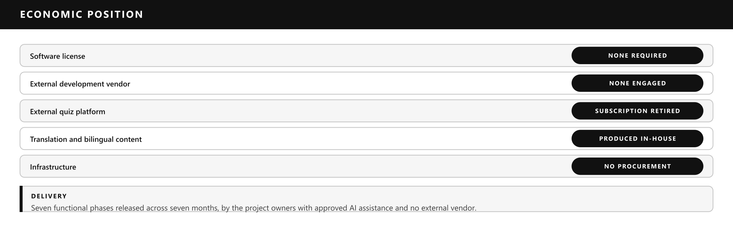
Figure 10 — Economic position: no license, no vendor, no procurement.

Indicators available for periodic reporting
- Share of population accessing their own result each cycle — reach of the transparency objective.
- Tier movement between cycles — whether visibility translates into performance improvement.
- Verified completions per published item — effectiveness of knowledge transfer.
- Challenge sessions and average score trend — retention and capability growth over time.
- Partner and branch views per announcement — partner engagement with quality outcomes.
- Feature requests received and released — responsiveness of the platform to the field.

09 Future Plan and Expansion
Three tracks are proposed. Each builds on capability already present in the platform, so none requires rebuilding what exists.

Track 1 — External go-live for live interaction
Publish the platform beyond the internal network onto a Samsung-governed server, so partners and colleagues can interact with it in real time from partner premises, at branches and in the field. Mobile installation and notification capability are already built and would activate with the external go-live, under the same authentication, role-based access and audit controls already in place.

Track 2 — Generative AI capability alongside GoGo
Integrate an approved generative AI service (for example Gemini) to operate alongside the existing GoGo assistant, so free-form questions can be answered where the curated knowledge base does not yet hold an entry. GoGo retains ownership of KPI definitions, navigation and all internal content, which keeps those answers verified and attributable; the generative layer handles open-ended language understanding only. Introduction is conditional on RHQ approval of the endpoint and on preserving the principle that employee, evaluation and partner records are not exposed to an external provider.

Track 3 — Expansion to other subsidiaries
Extend the platform to additional subsidiaries in the region. Product, role, KPI and tier models are configuration-driven, so a new subsidiary is onboarded through configuration rather than redevelopment. Each addition carries negligible marginal cost, improves the return on the original investment, and establishes a shared regional standard for competency visibility and partner quality engagement.
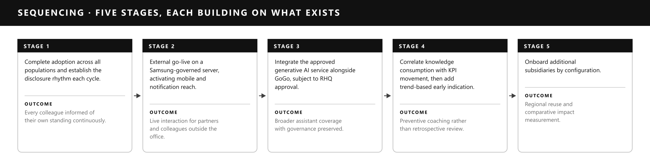
Figure 11 — Five-stage sequencing, each stage building on what already exists.
IN SUMMARY
The established programs are untouched. SCORA carries their results the last mile — to every individual and every partner, continuously, with the knowledge required to act on them.

