**Question 2:**

If the model has no constraints, especially concerning the cost per unit distance, then the model would naturally identify the minimal cost as $0. This is because, without constraints, the model assumes there is no cost associated with delivering to clients, regardless of the distance between the warehouse and customers. Therefore, in the absence of cost constraints, the model would yield a minimal cost of $0, as it would assume that all deliveries can be made for free.

**Question 4:**

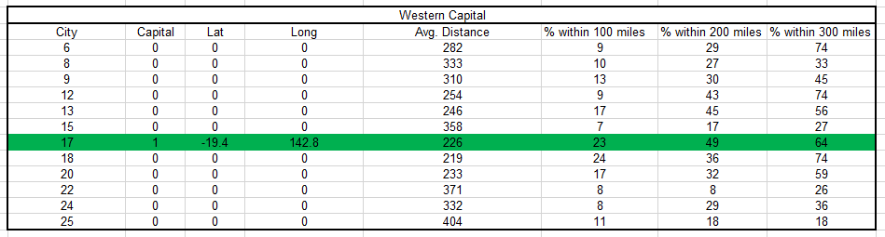

While City 18 has the lowest weighted average distance to other cities at 219 miles, City 17 is still the best choice for the capital of the western half of Logistica. Although the average distance in City 17 is slightly higher at 226 miles, it has a significant advantage in terms of accessibility for the population. Specifically, 49% of the population resides within 200 miles of City 17, compared to 36% for City 18. This greater reach makes City 17 a more centralized location for the majority of citizens, and thus, it stands out as the more suitable choice for a western capital.

**Question 5:**

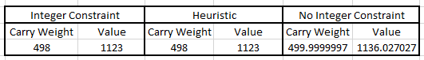

1. I created a model to maximize the total value of items chosen while not exceeding a size limit of 500 units. Solving the model gave the optimal set of items.
2. My heuristic was designed to provide a quick yet effective solution. It uses a value-to-size ratio to rank items and selects from this sorted list until the size constraint is met. However, the heuristic doesn't necessarily find the best solution. Unlike the model in 5a, which considers all possible combinations to arrive at an optimal set of items, the heuristic takes shortcuts by prioritizing items with high value-to-size ratios. This makes the heuristic less accurate but faster.
3. I removed the integer constraints to get a solution with fractional values like 0.5 for some items. While this isn't realistic (you can't take half an item), it gives an upper limit on the total value, serving as a benchmark to compare with the other methods.