Question 1 (A, B, and C all included in answer below):

Based on the optimization results and the subsequent heat map analysis, the operational strategy for managing the workforce and production levels has been successfully optimized to achieve a minimum total cost of $6,231,600.00. The solution required the workforce to fluctuate throughout the year, responding dynamically to the shipment forecast demands. For instance, the total number of workers rose from the initial 160 to 270 during peak demand months, before decreasing back down to 140 by the end of the year. This strategic hiring and laying off, coupled with an inventory management plan that adjusted production levels to meet demand, enabled the minimization of overall costs.

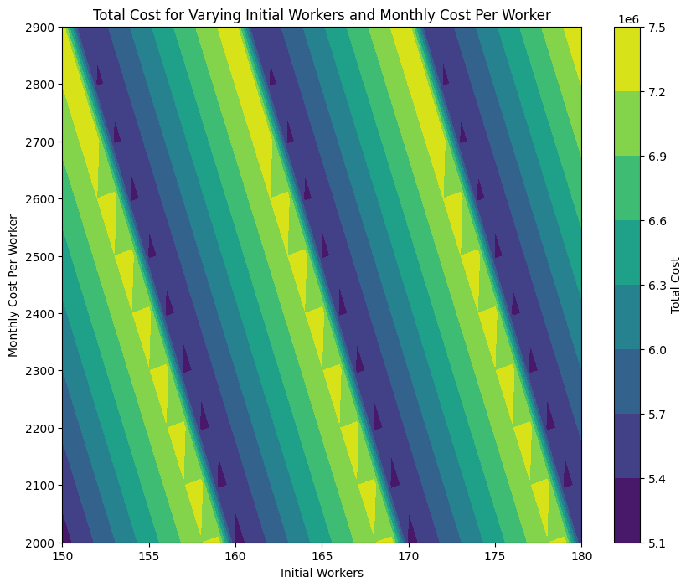

The heatmap further elucidated the sensitivity of total costs to changes in the initial number of workers and their monthly costs. It revealed that there are specific combinations of these parameters that can lead to cost efficiency, with the optimal solution falling within one of these 'sweet spots'. The visualization also showed that slight deviations from the optimal values could lead to disproportionately higher costs, highlighting the need for precise management decisions.

In conclusion, the optimization approach adopted here not only identifies the most cost-effective staffing and production plan for the given forecast but also underscores the importance of precise parameter tuning. Decision-makers are thus equipped with insights that can guide them in making informed choices to adapt to monthly demand changes while minimizing costs. This level of planning and analysis ensures the company can navigate the complexities of operational management with a clear understanding of the financial implications of their workforce strategies.

Question 2: …

Question 3: …