Earth Observation Developer/Data Scientist Challenge Task
Version 1.1

You are helping to supply data for a project located in Kurdistan, Iraq. The client is looking to build a vital water pipeline for the nearby villages. Currently you have 50 Digital Elevation Models (DEMs) that have been collected from multiple satellite platforms with different resolutions and data quality. These need to be evaluated against a reference DEM supplied to us by the client.

Good Luck!

Once completed, submit a merge request with all your code and deliverables to the supplied Github repo. Organise deliverables using a folder and naming convention: starting D1_1, D1_2... and so on.
Task #1: Estimated Time: 2-3 hours

In a rather shotgun approach, we have acquired an large number of DEM scenes over our target area from a range of commercial and government satellites. As of now we haven’t had time to check the quality of these DEMs to test whether any of them are any good. Ideally, most of them will fulfil our purpose, but the client has been clear that we must quote data accuracies as part of our final report.

In the coming weeks, 50 more images are likely to be delivered to us, so automation of this error analysis will be very valuable for time efficiency! Be aware of different Coordinate Reference Systems (CRS) and data resolutions.

Task #1 Actions:
- T1.1: Extract the files and data from EODS_Test_Data.tar.gz
- T1.2: Using whichever tools, libraries or languages you prefer, develop a script (or set of scripts) that can assess the accuracy of each supplier DEM compared to the reference DEM. Important statistical criteria include the mean error, standard deviation, and root mean squared error (RMSE).
- T1.3 Collate the error reports for each of the supplier DEMs into a single spreadsheet for easy comparison, highlighting and DEMs that appear to fail quality assurance, and perhaps why they do? Can you determine which is the best quality DEM from the error reports?
Task #1 Deliverables:
- D1.1: Well-documented code/scripts ready for review
- D1.2: DEM accuracy report (can be a simple spreadsheet)
Task #2: Estimated Time: 2-3 hours
The client has also stipulated that they want an elevation profile over a straight line transect, beginning at point “A” (44.79334 E, 35.15049 N) and ending at point “B” (44.80429 E, 35.15667 N) across the area of interest.

Task #2 Actions:
- T2.1: Using the original reference DEM as a data source, extract elevation values along the diagonal transect between points A and B. Use a script or any other means at your disposal. Save this data in a table or CSV.
- T2.2: Create a script that can plot the elevation profile in a chart, with distance along the x axis and elevation along the y axis.

Task #2 Deliverables:
- D2.1: Table or CSV containing coordinates and elevation of sample sites along transect (optional column showing relative distance from point A → B)
- D2.2: An image or PDF showing elevation between point A and B
  - Labelled axes and dimensions
  - Use a line or area plot
Appendix:
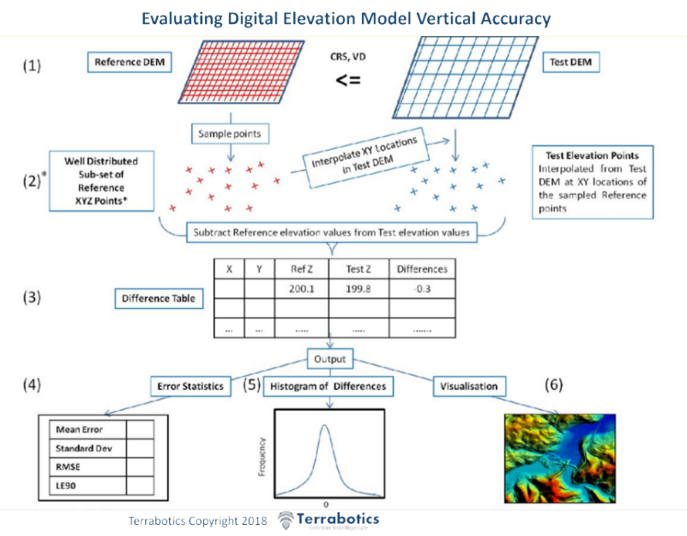
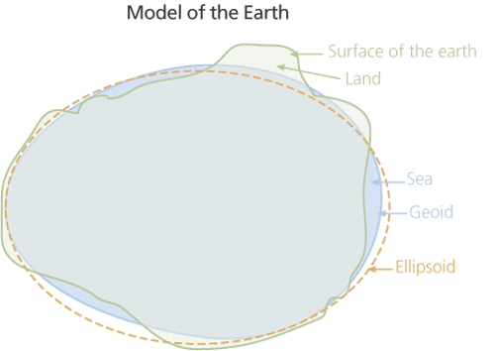

Example Elevation Profile
