*CH3: Abril, G., & Borges, A. V. (2019). Ideas and perspectives: Carbon leaks from flooded land: Do we need to replumb the inland water active pipe? Biogeosciences, 16(3), 769–784. https://doi.org/10.5194/bg-16-769-2019
- Expands on the Cole et al. 2007 to include wetlands. From their synthesis, they argue that wetlands are a carbon pump to streams delivering significant inputs. They call for the stream-pipe concept needs to replumed to include wetlands.
- 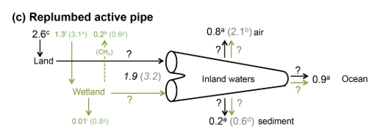
*CH3: Casson, N. J., Eimers, M. C., Watmough, S. A., & Richardson, M. C. (2019). The role of wetland coverage within the near-stream zone in predicting of seasonal stream export chemistry from forested headwater catchments. Hydrological Processes, 33(10), 1465–1475. https://doi.org/10.1002/hyp.13413
- Test the relationship between wetland proportion in catchment (a) and wetland proximity to wetland (b) versus stream chemistry (DOC, TP, NO3-N, Ca, Mg). Found wetland:catchment proportion was better indicator than wetland proximity but significance declined up dry conditions. Suggest riparian zones are instead a greater source of stream solutes during dry seasons. Call for further research to incorporate riparian zones.
Chapin, F. S., Woodwell, G. M., Randerson, J. T., Rastetter, E. B., Lovett, G. M., Baldocchi, D. D., Clark, D. A., Harmon, M. E., Schimel, D. S., Valentini, R., Wirth, C., Aber, J. D., Cole, J. J., Goulden, M. L., Harden, J. W., Heimann, M., Howarth, R. W., Matson, P. A., McGuire, A. D., … Schulze, E. D. (2006). Reconciling carbon-cycle concepts, terminology, and methods. In Ecosystems (Vol. 9, Issue 7, pp. 1041–1050). https://doi.org/10.1007/s10021-005-0105-7
- Chapin et al 2006. A great paper synthesizing carbon concept. Will be cited to calibrate the reader.
*CH1: Cole, J. J., Prairie, Y. T., Caraco, N. F., McDowell, W. H., Tranvik, L. J., Striegl, R. G., Duarte, C. M., Kortelainen, P., Downing, J. A., Middelburg, J. J., & Melack, J. (2007). Plumbing the global carbon cycle: Integrating inland waters into the terrestrial carbon budget. Ecosystems, 10(1), 171–184. https://doi.org/10.1007/s10021-006-9013-8
- A classic, well-cited publication describing how streams are not transient ‘pipes’ for terrestrial landscapes but “active pipes” that transform and source carbon as well as transport.
Harvey, J., & Gooseff, M. (2015). River corridor science: Hydrologic exchange and ecological consequences from bedforms to basins. In Water Resources Research (Vol. 51, Issue 9, pp. 6893–6922). Blackwell Publishing Ltd. https://doi.org/10.1002/2015WR017617
- A general synthesis on the river corridor. Describes shallow flow-paths within the river corridor and how to model this water flow. It also summarizes current knowledge on river corridor science.
*CH3 & CH2: Hosen, J. D., Armstrong, A. W., & Palmer, M. A. (2018). Dissolved organic matter variations in coastal plain wetland watersheds: The integrated role of hydrological connectivity, land use, and seasonality. Hydrological Processes, 32(11), 1664–1681. https://doi.org/10.1002/hyp.11519
- Great paper and should be used to model eventual FDOM data. Wetland DOM was aromatic-rich compounds. During connectivity, perennial stream-DOM resembled wetland-DOM. Topographic water shed index was a constant predictor of DOM quality.
Jin, J., Zimmerman, A. R., Moore, P. J., & Martin, J. B. (2014). Organic and inorganic carbon dynamics in a karst aquifer: Santa Fe River Sink-Rise system, north Florida, USA. Journal of Geophysical Research: Biogeosciences, 119(3), 340–357. https://doi.org/10.1002/2013JG002350
- DIC in surface waters were low during high flow. DIC may look chemically similar to marine limestone. CaCO3 will take up DOM with high molecular weights
Kalbus, E., Reinstorf, F., & Schirmer, M. (2006). Hydrology and Earth System Sciences Measuring methods for groundwater-surface water interactions: a review. In Hydrol. Earth Syst. Sci (Vol. 10). www.hydrol-earth-syst-sci.net/10/873/2006/
- Used in Lily and Kirk (2023O to model lateral Q. Essentially determine qL during low flow.
*CH2: Kirk, L., & Cohen, M. J. (2023). River Corridor Sources Dominate CO2 Emissions From a Lowland River Network. Journal of Geophysical Research: Biogeosciences, 128(1). https://doi.org/10.1029/2022JG006954
- Basically my chapter but more detailed and sampling for DOC, DIC, POC. Unconfined sites had five times more CO2 in the RC than the uplands. The opposite is true for the confined sites. Across confined and unconfined RC contributed 40 times more CO2 per unit then area than uplands. 87% of stream CO2 is sourced from the RC
- Found NEP-ER was a pretty accurate way to estimate RC CO2
*CH2: Ledesma, J. L. J., Grabs, T., Bishop, K. H., Schiff, S. L., & Köhler, S. J. (2015). Potential for long-term transfer of dissolved organic carbon from riparian zones to streams in boreal catchments. Global Change Biology, 21(8), 2963–2979. https://doi.org/10.1111/gcb.12872
- Modeled carbon stocks in riparian zones, specifically, the dominant source later (DSL) or the predominant shallow, flow path where most lateral DOC fluxes occur. Depending on the area and depth of the DSL, the DSL could maintain lateral exports from hundreds to thousands of years.
*CH2: Ledesma, J. L. J., Kothawala, D. N., Bastviken, P., Maehder, S., Grabs, T., & Futter, M. N. (2018). Stream Dissolved Organic Matter Composition Reflects the Riparian Zone, Not Upslope Soils in Boreal Forest Headwaters. Water Resources Research, 54(6), 3896–3912. https://doi.org/10.1029/2017WR021793
- Using FDOM, they parsed upland sourced from riparian sourced carbon inputs to streams. They found that stream DOM resembles DSL DOM, and as a result, DSL contributes the most to stream DOM.
*CH1: Liu, X., Lu, X., Yu, R., Sun, H., Li, Y., Qi, Z., Xue, H., Zhang, Z., Cao, Z., Liu, T., & Lu, C. (2022). Sediment and carbon dynamics during an episodic flood in an intermittent river. Ecosphere, 13(10). https://doi.org/10.1002/ecs2.4248
- Discovered post-flood events, intermittent streams had high rate of ecosystem respiration. Post-precipitation, intermittent streams emerge in the river corridor potentially delivering CO2, POC, and PIC to its stream’s waters.

*CH3: Laudon, H., Berggren, M., Ågren, A., Buffam, I., Bishop, K., Grabs, T., Jansson, M., & Köhler, S. (2011). Patterns and Dynamics of Dissolved Organic Carbon (DOC) in Boreal Streams: The Role of Processes, Connectivity, and Scaling. Ecosystems, 14(6), 880–893. https://doi.org/10.1007/s10021-011-9452-8

- Wetland-dominated streams experienced low DOC at high flow due to the dilution effect. RC-dominated streams experienced high DOC at high flow due to rising groundwater level activating the riparian soil profiles with increasing DOC concentrations near the surface. Calls for the analysis of how wetland location (flow paths) influences DOC dynamics. Occurred in higher latitudes (boreal).
Leach, J. A., Lidberg, W., Kuglerová, L., Peralta-Tapia, A., Ågren, A., & Laudon, H. (2017). Evaluating topography-based predictions of shallow lateral groundwater discharge zones for a boreal lake-stream system. Water Resources Research, 53(7), 5420–5437. https://doi.org/10.1002/2016WR019804
- Not helpful but cited in Kirk and Cohen 2023. Uses an algorithm called the deterministic 8 in GIS to estimate the UCA.
Leibowitz, S. G., Wigington, P. J., Schofield, K. A., Alexander, L. C., Vanderhoof, M. K., & Golden, H. E. (2018). Connectivity of Streams and Wetlands to Downstream Waters: An Integrated Systems Framework. Journal of the American Water Resources Association, 54(2), 298–322. https://doi.org/10.1111/1752-1688.12631
- A basic paper on wetland connectivity. Has great figures!
Li, J., Jiang, M., Pei, J., Fang, C., Li, B., & Nie, M. (2023). Convergence of carbon sink magnitude and water table depth in global wetlands. In Ecology Letters (Vol. 26, Issue 5, pp. 797–804). John Wiley and Sons Inc. https://doi.org/10.1111/ele.14199
- Modeled global wetland NEP and CO2 emissions. Measured NEP using CO2 (interesting). Found deeper water table depths= sinks while high water table depths= sources.
McLaughlin, D. L., Kaplan, D. A., & Cohen, M. J. (2014). A significant nexus: Geographically isolated wetlands influence landscape hydrology. Water Resources Research, 50(9), 7153–7166. https://doi.org/10.1002/2013WR015002
- Straw effect: more wetlands, higher water table.
Moustapha, M., Deirmendjian, L., Sebag, D., Braun, J. J., Audry, S., Ateba Bessa, H., Adatte, T., Causserand, C., Adamou, I., Ngounou Ngatcha, B., & Guérin, F. (2022). Partitioning carbon sources between wetland and well-drained ecosystems to a tropical first-order stream - implications for carbon cycling at the watershed scale (Nyong, Cameroon). Biogeosciences, 19(1), 137–163. https://doi.org/10.5194/bg-19-137-2022
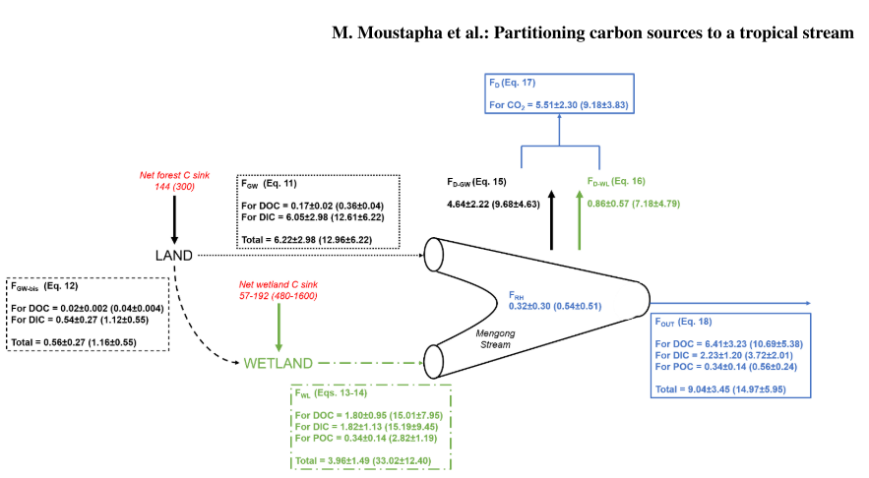
Plont, S., Riney, J., & Hotchkiss, E. R. (2022). Integrating Perspectives on Dissolved Organic Carbon Removal and Whole-Stream Metabolism. Journal of Geophysical Research: Biogeosciences, 127(3). https://doi.org/10.1029/2021JG006610
- Another well-cited, founding paper. A relevant observation is CO2 declined with stream size and groundwater inputs delivered significant concentrations of CO2.
*CH3: Solano, V., Duvert, C., Hutley, L. B., Cendón, D. I., Maher, D. T., & Birkel, C. (2024). Seasonal Wetlands Make a Relatively Limited Contribution to the Dissolved Carbon Pool of a Lowland Headwater Tropical Stream. Journal of Geophysical Research: Biogeosciences, 129(2). https://doi.org/10.1029/2023JG007556
- They verbatim, down to the methods, conducted what I wanted to for my chapter 3. Bummer. Regardless, they discovered over 75% of DOC loads was sourced from riparian sources and only 15% was sourced from connected, seasonal wetlands. This somewhat contradicts Abril and Borges 2019 publication.

(Leach et al., 2017)
Leach, J. A., Lidberg, W., Kuglerová, L., Peralta-Tapia, A., Ågren, A., & Laudon, H. (2017). Evaluating topography-based predictions of shallow lateral groundwater discharge zones for a boreal lake-stream system. Water Resources Research, 53(7), 5420–5437. https://doi.org/10.1002/2016WR019804

