**CI Assessment**

Vagrant file with port forwarding

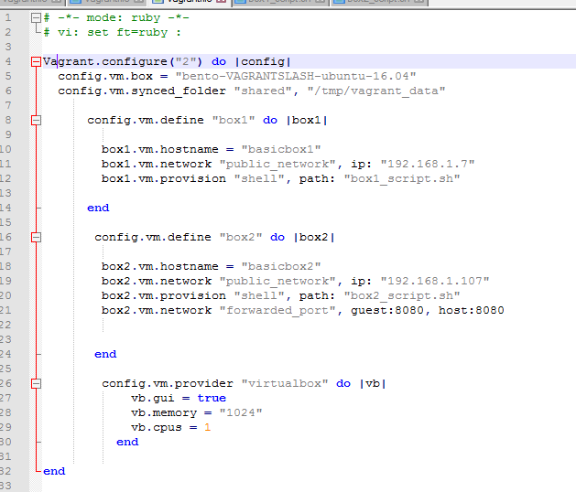

Box1_script.sh

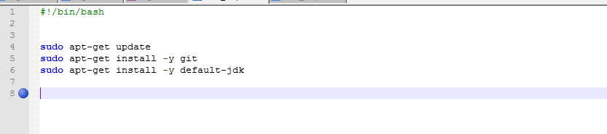

Box2_script.sh

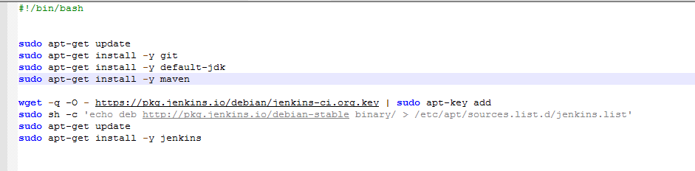

Java installed on first vm

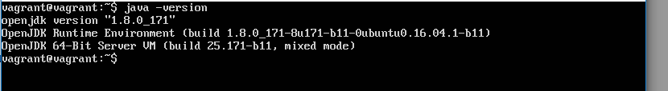

Clone java repository from github to vm

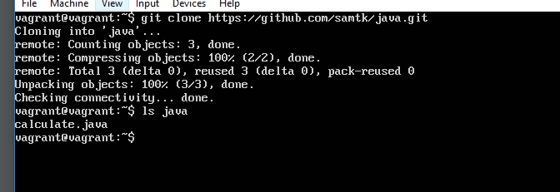

Script1 produced on vagrant virtual machine

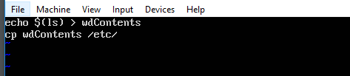

Script2 produced on vagrant virtual machine

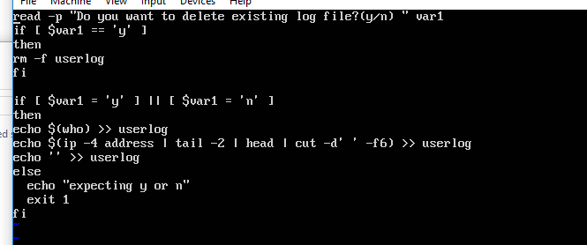

Script2 output

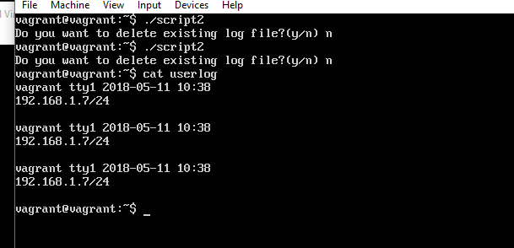

Getting the Jenkins password

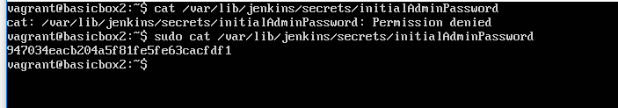

Jenkins configure build

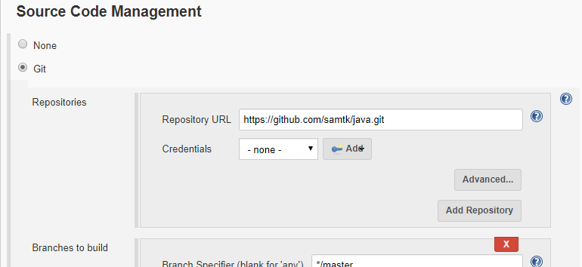

Console output of Jenkins build

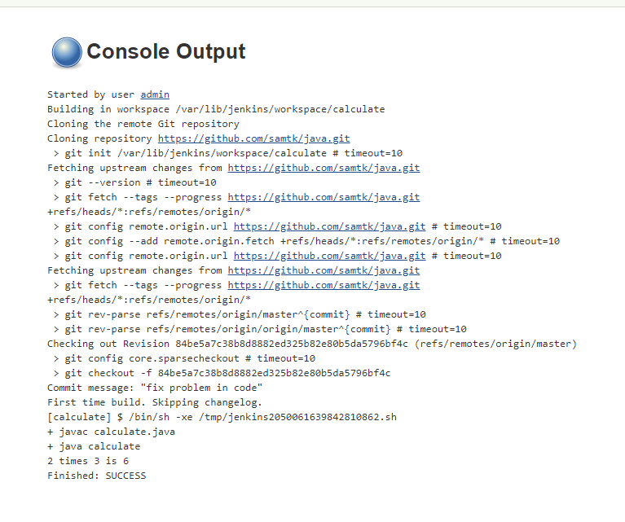

Jenkins add artefact to build

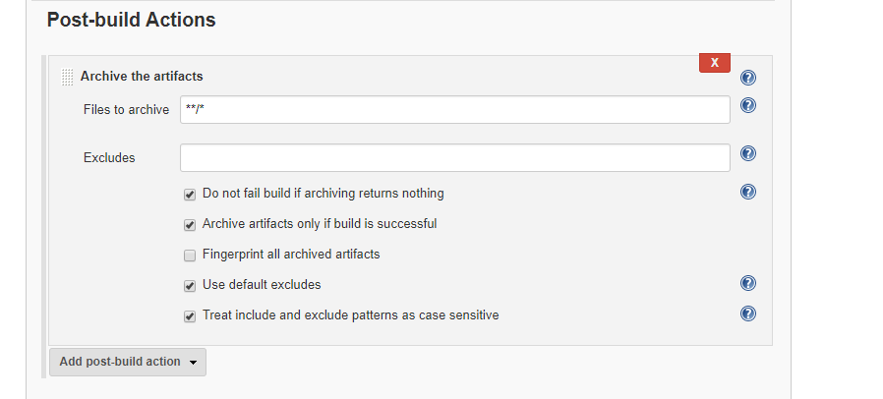

Jenkins artefact folder

