**Media Streaming with IBM Cloud Video Streaming**

**Phase – 4 Development Part 2**

**Problem Statement:**

To building the platform by integrating video streaming services and enabling on-demand playback.

**Goal:**

Integrate IBM Cloud Video Streaming services to enable smooth and high-quality video playback.

**Website Flow:**

Our website flow contains four pages.

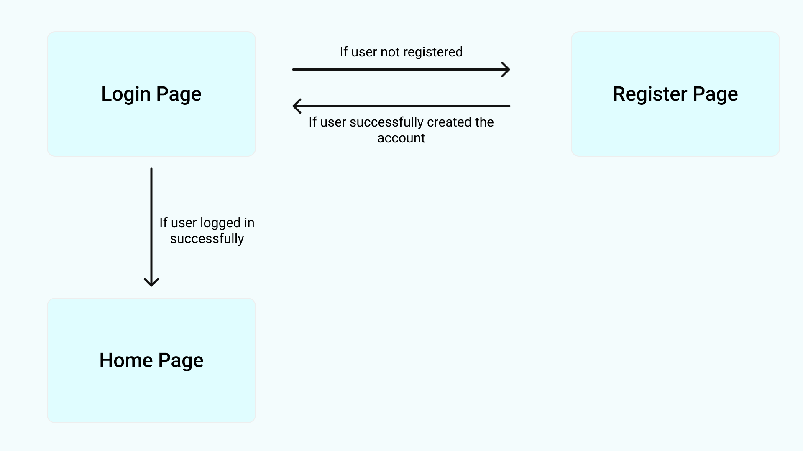



**Home Page:**

Our home page looks like



**Streaming Page:**

Our streaming page looks like

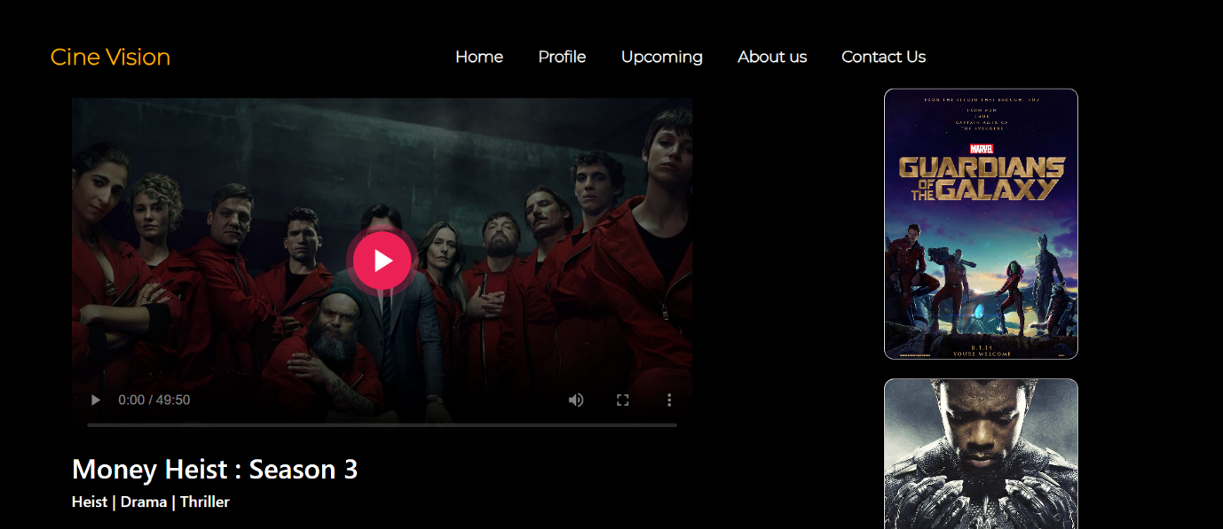

**How we implemented video streaming using IBM cloud video streaming:**

* **Set Up IBM Cloud Object Storage:** Log in to your IBM Cloud account and navigate to the IBM Cloud Object Storage service. Create a new instance if you haven't already.
* **Create a Bucket:** Within the Object Storage service, create a new bucket to store your video files. Organize the bucket structure according to your needs and access requirements.

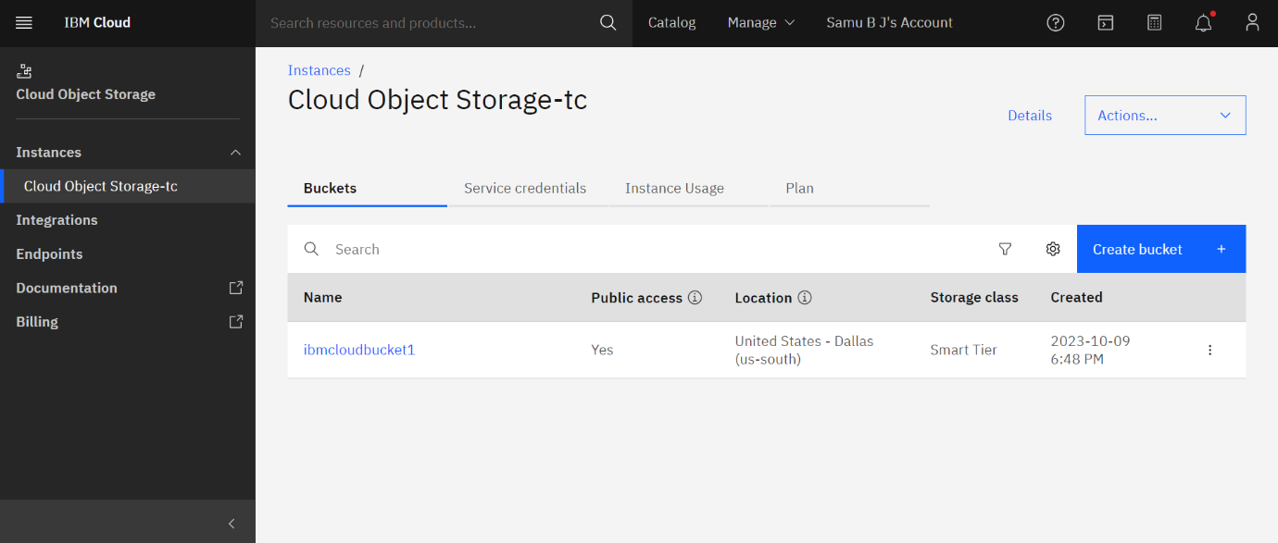

* **Upload Video Content:** Upload your video files to the designated bucket in the IBM Cloud Object Storage. Make sure to follow any specific guidelines for file formats and naming conventions.

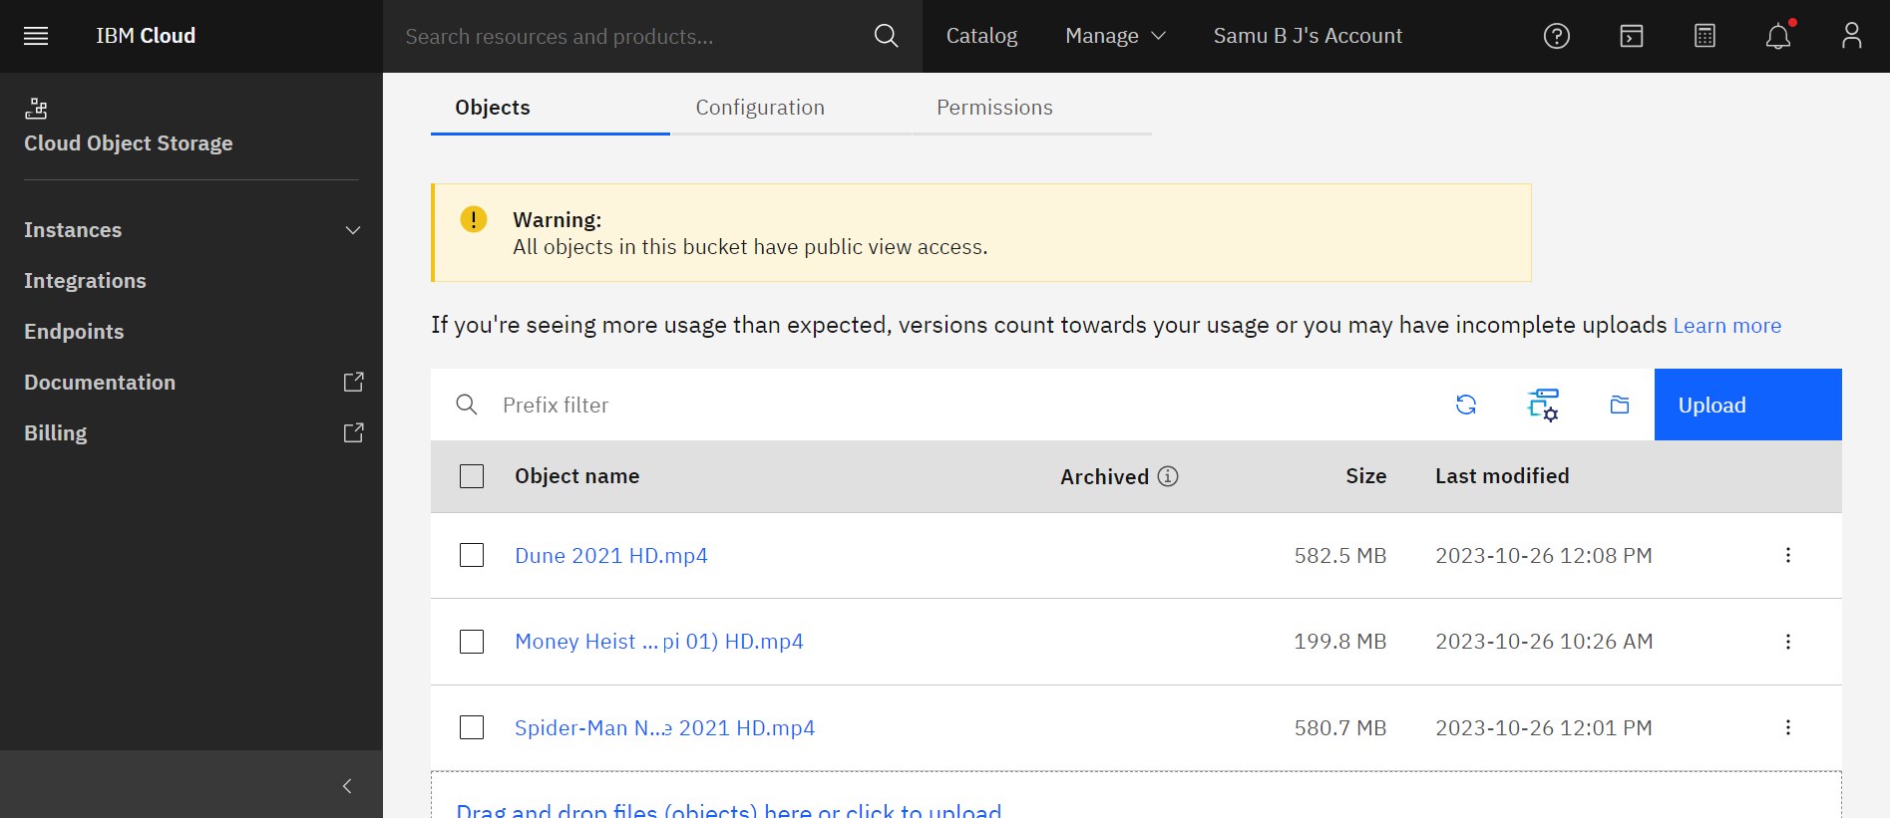

* **Configure Access Control**: Configure access control settings for your video files to ensure that they are accessible to the intended users or applications. This may involve setting up access policies, access groups, or access control lists (ACLs) depending on your specific requirements.
* **Implement Content Delivery Network (CDN):** Utilize a CDN service, such as IBM Cloud Content Delivery Network, to improve the delivery speed and performance of your video streaming content. Set up the CDN to cache and deliver your video content efficiently to users across different geographical locations.
* **Generate Streaming URLs or Embed Codes:** Generate streaming URLs or embed codes for your video files stored in IBM Cloud Object Storage. These URLs or codes will be used to integrate the video content into your website or application.

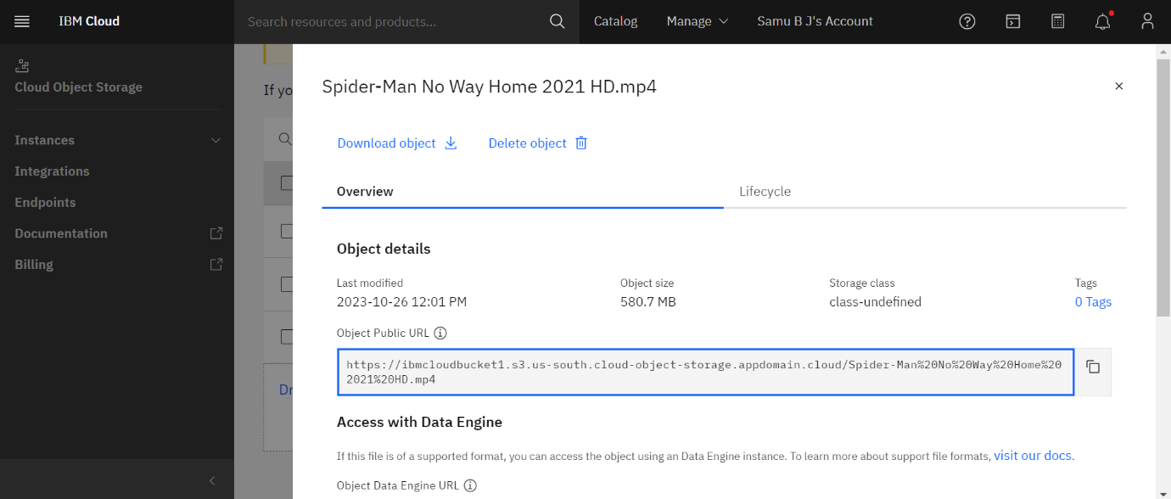

* **Test Video Playback:** Test the video playback performance across various devices and network conditions to ensure a smooth and high-quality streaming experience for your users.



**Conclusion:**

In the culmination of phase 4 development part 2, we have successfully built a robust and user-friendly platform by seamlessly integrating IBM Cloud Video Streaming services. Our emphasis on enabling on-demand playback has resulted in a high-quality video streaming experience, ensuring seamless content delivery and playback for our users. Through the utilization of IBM Cloud's advanced infrastructure and features, including customizable settings and secure streaming protocols, we have laid a strong foundation for a reliable and scalable video streaming solution. As we move forward, our focus remains on continuous monitoring, optimization, and the implementation of user-centric enhancements to further elevate the overall streaming experience.