**Media Streaming with IBM Cloud Video Streaming**

**Phase – 5 Project Documentation & Submission**

**Objective:**

To develop and implement a robust media streaming solution utilizing IBM Cloud Video Streaming services, ensuring seamless, high-quality content delivery to a global audience. This project aims to enhance user engagement, optimize video performance, and increase accessibility, thereby elevating the overall streaming experience and establishing a scalable platform for future growth and innovation.

**Design Thinking:**

Platform Definition: Virtual Cinema Platform

**User Registration and Account Management:**

* **User Registration:**

Allow users to create accounts with personal information, including name, email, and password.

* **Profile Management:**

Enable users to update and manage their profiles, including profile pictures and personal information.

**Content Management:**

* **Video Upload:**

Provide content creators with an easy-to-use interface to upload their films, specifying metadata like title, description, genre, and runtime.

* **Media Library:**

Organize uploaded videos in a user-friendly media library for easy access and management.

* **Content Verification:**

Implement a review process to ensure that uploaded content complies with platform guidelines and legal requirements.

**On-Demand Streaming:**

* **Video Playback:**

Enable viewers to stream films on-demand with options for different video quality levels (e.g., SD, HD, 4K) based on their internet connection.

* **Streaming Servers:**

Utilize robust and scalable streaming servers to ensure smooth playback, low latency, and adaptive bitrate streaming.

* **Playlist:**

Allow users to create and manage watchlists for saving films they want to watch later.

**Development Phases:**

We split our project into two main development phases. Those phases are:

* Development Phase – 1
* Development Phase – 2

**Development Phase – 1:**

In this phase, we started building our cine vision platform features like:

* User Login
* User Registration
* User Authentication

We successfully completed building the above features and stepped in into next development phase.

**Development Phase – 2:**

In this phase, we continued developing our cine vision platform features like:

* Home Page
* Movie Streaming Page
* Profile Page
* Playlist Page

**Platform Features:**

We integrated many features into our cine vision platform to enhance the user experience and easily interact with our platform. Some of the features are listed below:

* Recommendation
* Playlist
* User Profile
* Chat interface, etc.

**Recommendation:**

This feature is implemented into our cine vision platform to revolutionize the user experience by providing personalized content suggestions tailored to individual preferences and viewing history. By fostering an immersive and engaging viewing experience, this feature not only encourages extended user engagement but also amplifies content discoverability, thus enhancing customer satisfaction and retention.

**Playlist:**

This feature is implemented into our cine vision platform to enable users to add and manage the movies in the playlist. Additionally, the playlist feature enhances user engagement and retention by offering a convenient way to revisit and enjoy a collection of preferred content, thereby enriching the overall streaming experience and reinforcing customer loyalty.

**User Profile:**

This feature enables users to view the profile details like name, user id, subscription type.

**Chat interface:**

This feature enables user to chat with other users.

**User Interface Design:**

Why to create an intuitive user interface is important. Some of the reasons are given below.

* **User satisfaction:**

Intuitive interfaces are easy to understand and navigate, leading to a positive user experience. Users can quickly accomplish tasks without feeling overwhelmed or confused, leading to higher satisfaction and retention rates.

* **Reduced learning curve:**

Intuitive interfaces simplify the learning process for new users, enabling them to grasp the functionality and features of a system more rapidly. This can lead to increased adoption rates and overall user engagement.

* **Increased productivity:**

Intuitive interfaces streamline workflows and minimize the time required to complete tasks. Users can focus on their objectives rather than wasting their time to learn the platform.

* **Decreased errors:**

Intuitive interfaces reduce the likelihood of user errors and mistakes, as they guide users through processes and provide clear feedback. This can prevent frustration and the need for additional support or troubleshooting.

* **Competitive advantage:**

In today's market, user experience plays a significant role in the success of a product or service. An intuitive interface can differentiate a product from its competitors, attracting and retaining more users.

**Website Flow:**

Our website contains mainly six pages:

* + Login Page
  + Register Page
  + Home Page
  + Streaming Page
  + Playlist Page
  + Profile Page

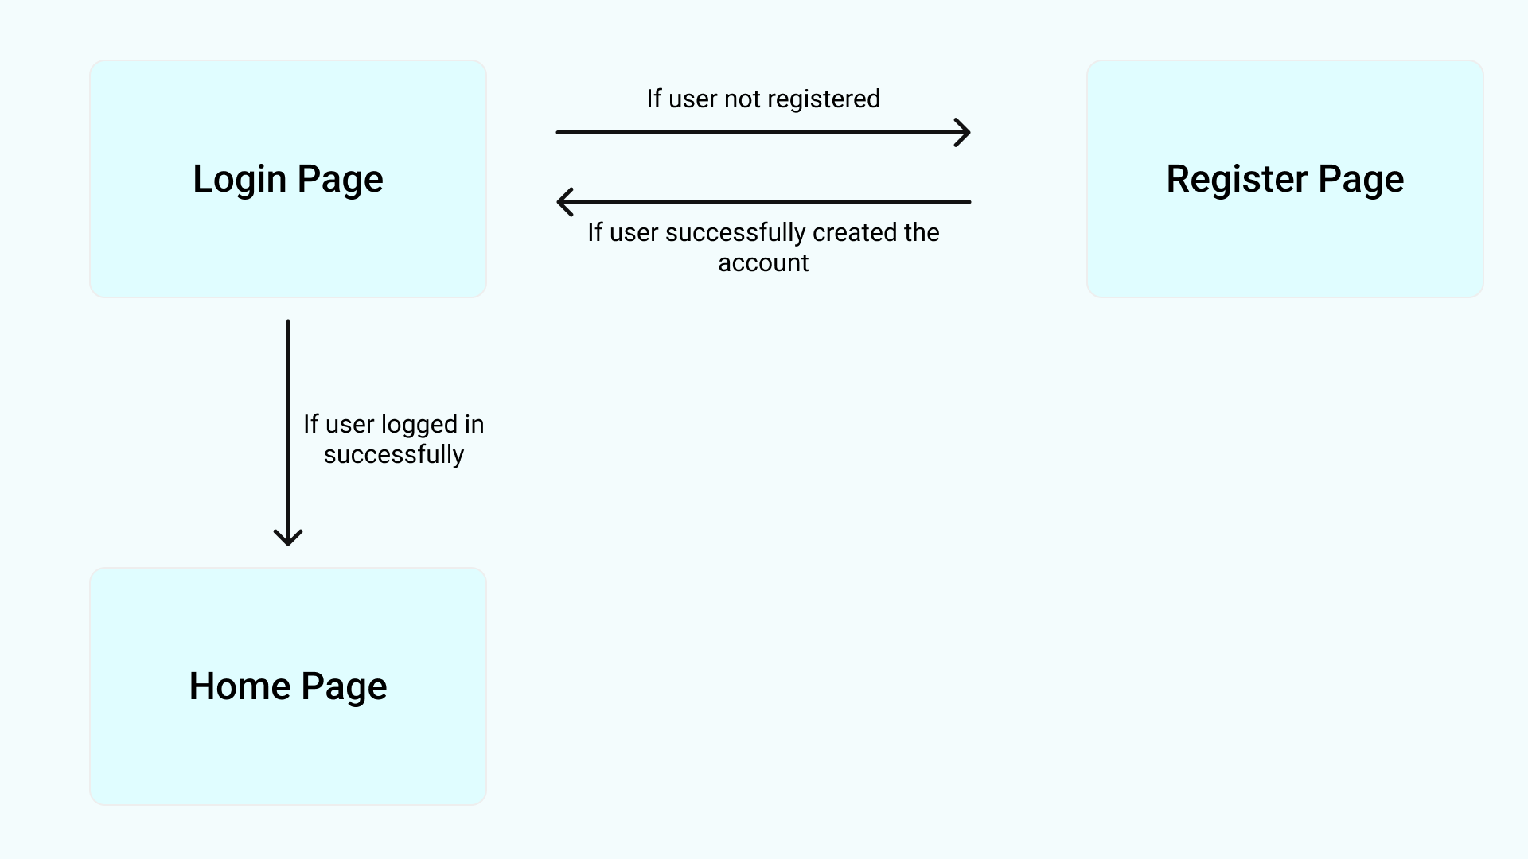

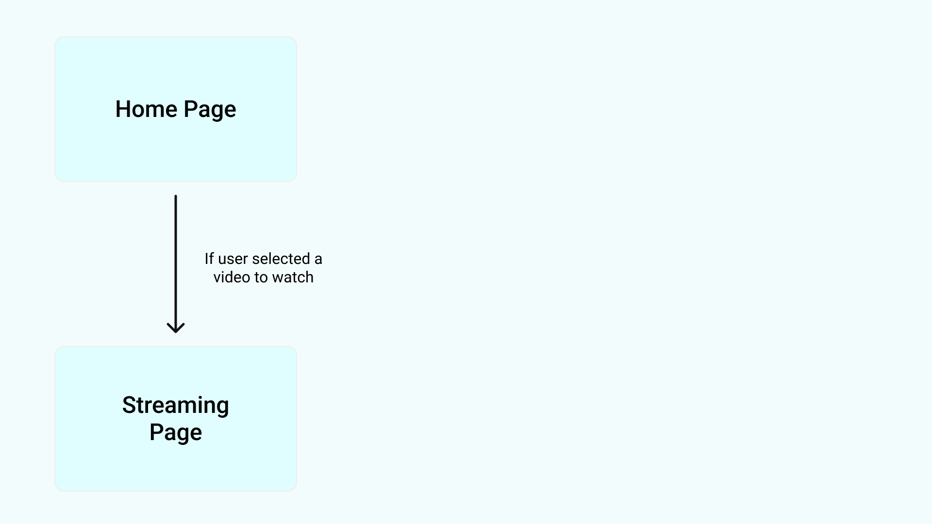

**Account Creation and Management:**

User want to provide essential details like Username, Email Id,

Password to register.

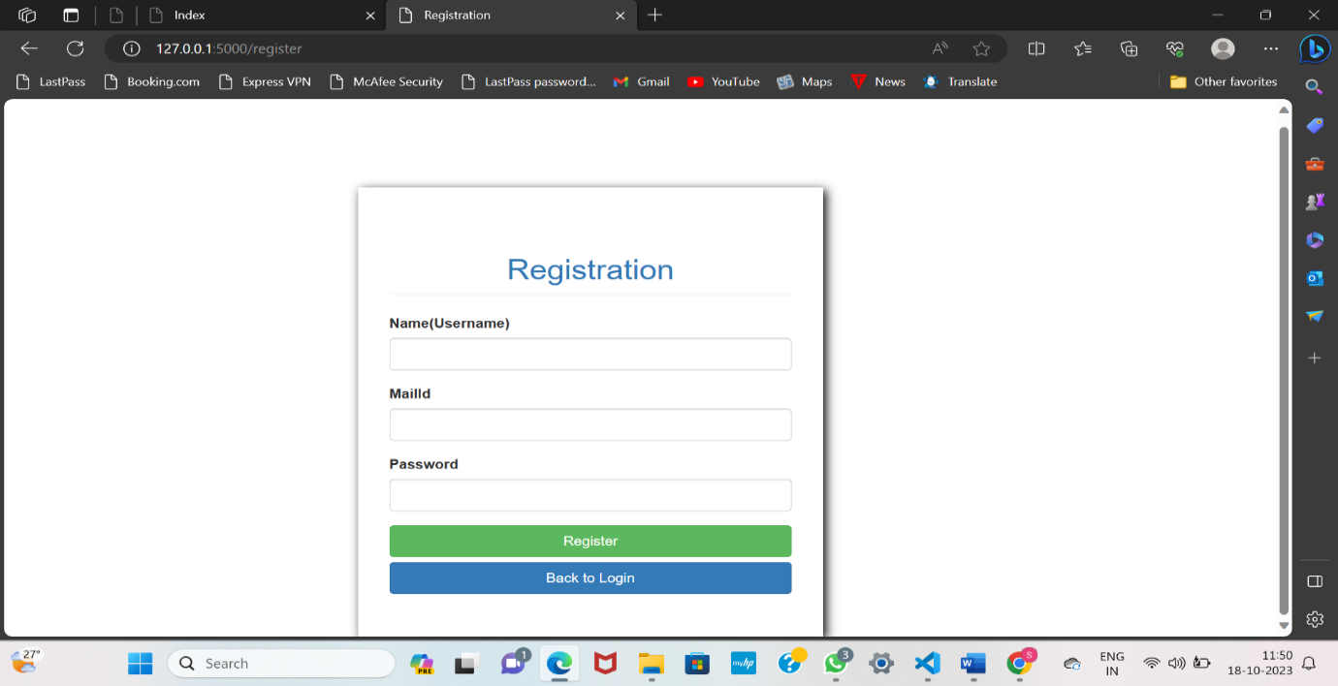

After successfully creating an account, user is automatically redirected to login page.

**Login Page:**

User wants to provide the essential account details like Username, Password to login successfully into his account.

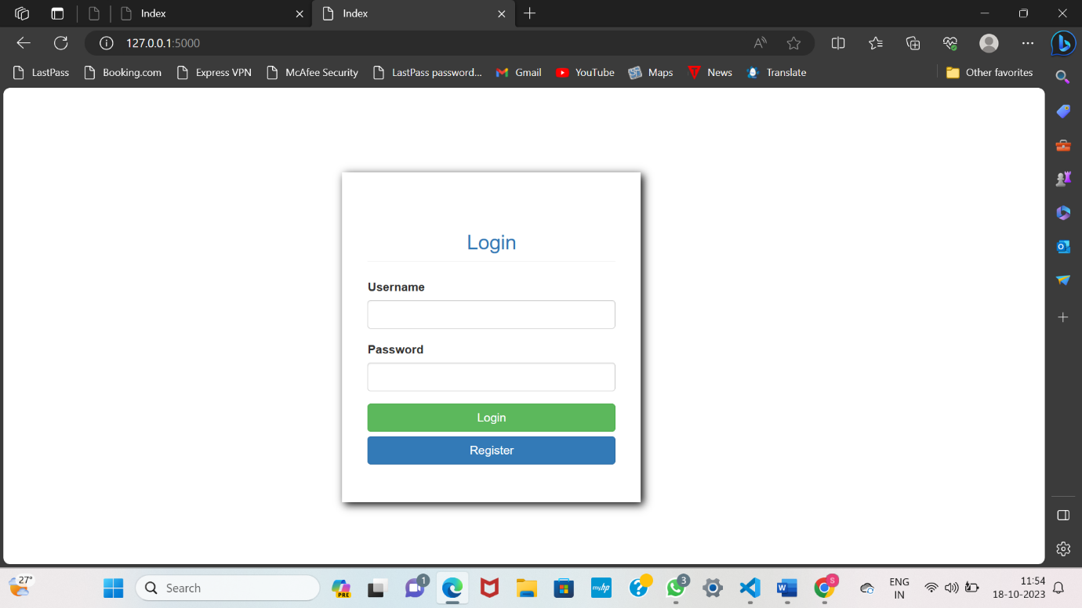

After successfully logged in to his account, user home page will be displayed.

**Home Page:**

User can access the home page of our cine vision platform once they have successfully logged in into his/her account.

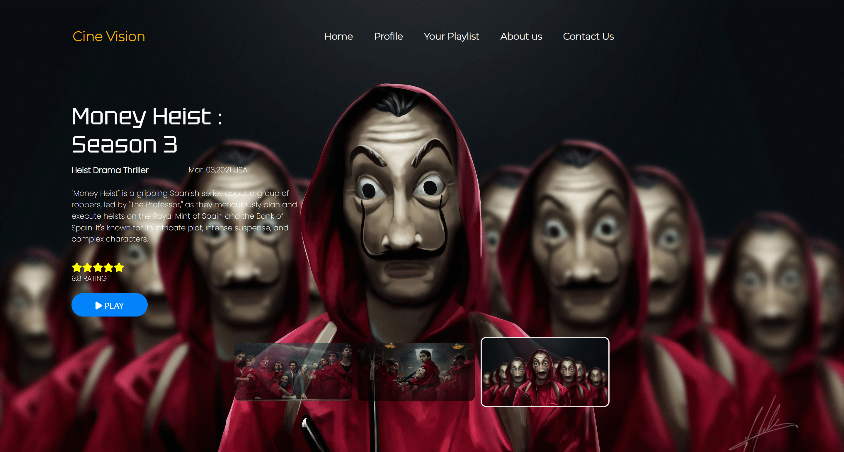

**Streaming Page:**

The video streaming page will play the movie that the user has selected, with the chat interface to chat and also shows recommended movies.

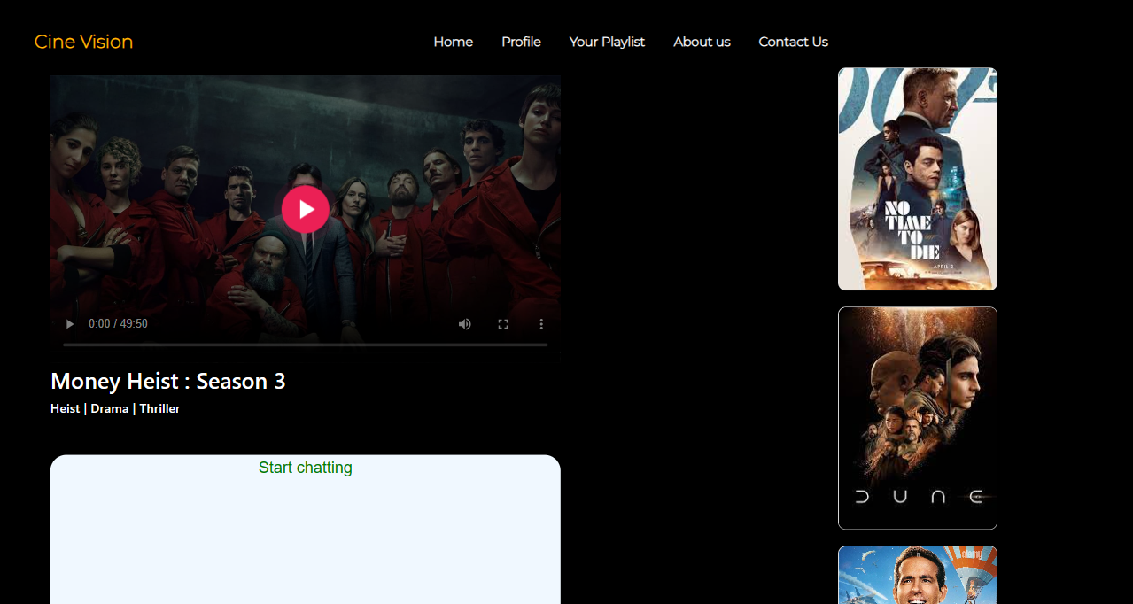

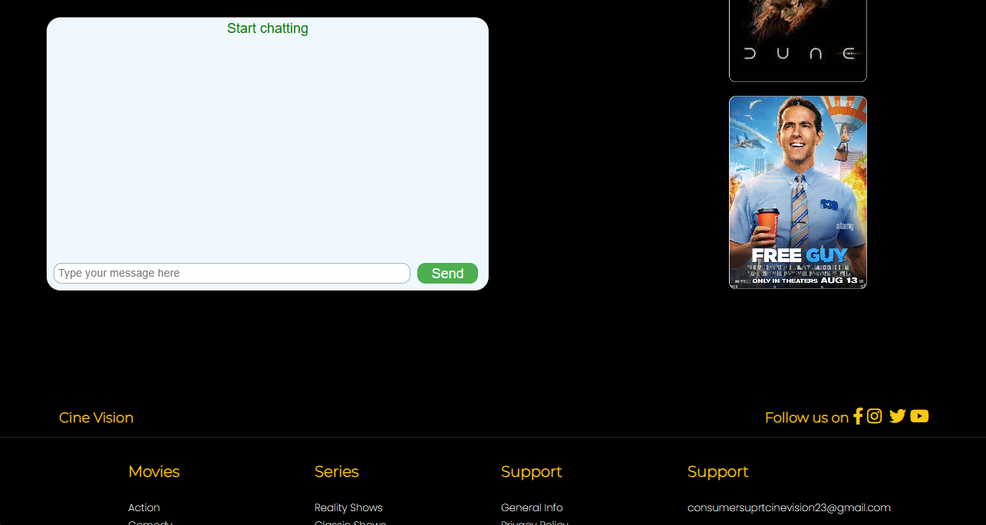

**Playlist Page:**

This page displays the user created playlist in one place to improve user engagement and retention by offering a convenient way to revisit and enjoy a collection of preferred content.

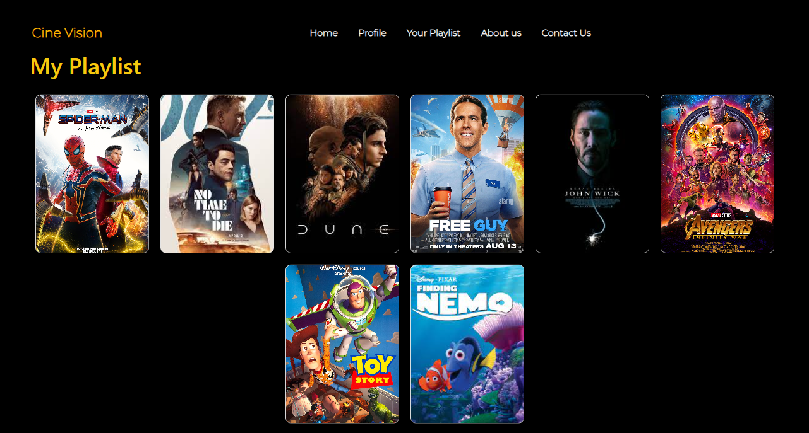

**Profile Page:**

This profile page displays the details of the user and also helps user to manage the user details easily and also helps to logout from his/her account.

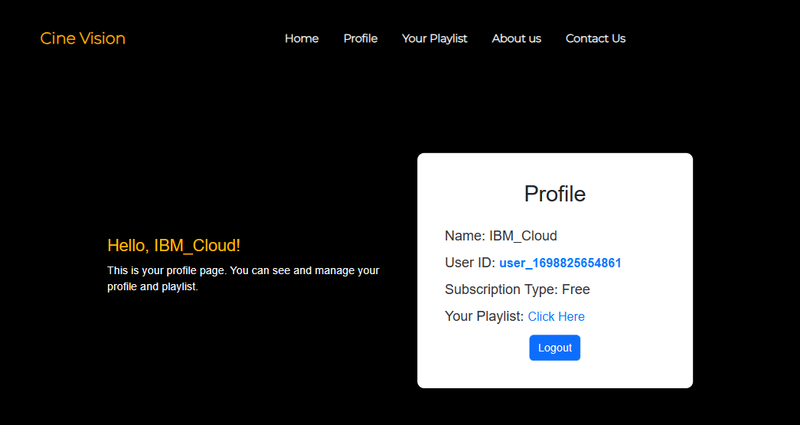

**Video Upload Process:**

Unfortunately, our recent attempt to integrate the video upload process feature into cine vision platform utilizing IBM Cloud Video Streaming has encountered unforeseen challenges, leading to a setback in the intended implementation. The integration process faced critical issues and we were not able to resolve the issues. So, we are not integrating this feature into our cine vision platform. The code that we used for trying to integrate this feature is given below:

App.py

from flask import Flask, render_template, request, redirect, url_for

from ibm_botocore.client import Config

import ibm_boto3

import os

from uuid import uuid4

app = Flask(__name__)

cos_endpoint = 'https://s3.us-south.cloud-object-storage.appdomain.cloud'

cos_api_key_id = '0zGfvsbZxFpnuwfI56kWE8Ybp1gAIudTmTJv4OQ6nQD5'

cos_service_instance_id = 'crn:v1:bluemix:public:cloud-object-storage:global:a/a11397e22def483bab284fe2e14e64ca:d377b18f-7fc9-4f1a-bdab-341ff7d9b485::'

cos_auth_endpoint = 's3.us.cloud-object-storage.appdomain.cloud'

cos_config = Config(signature_version='oauth',

                   service_name='s3',

                   endpoint_url=cos_endpoint,

                   ibm_service_instance_id=cos_service_instance_id)

cos_client = ibm_boto3.client('s3', config=cos_config, ibm_api_key_id=cos_api_key_id, ibm_service_instance_id=cos_service_instance_id)

UPLOAD_FOLDER = 'uploads'

if not os.path.exists(UPLOAD_FOLDER):

    os.makedirs(UPLOAD_FOLDER)

app.config['UPLOAD_FOLDER'] = UPLOAD_FOLDER

@app.route('/')

def index():

    return render_template('index.html')

@app.route('/upload', methods=['POST'])

def upload_file():

    if 'file' not in request.files:

        return redirect(request.url)

    file = request.files['file']

    if file.filename == '':

        return redirect(request.url)

    filename = f"{uuid4().hex}-{file.filename}"

    file_path = os.path.join(app.config['UPLOAD_FOLDER'], filename)

    file.save(file_path)

    try:

        cos_client.upload_file(file_path, 'your-bucket-name', filename)

    except Exception as e:

        print(f'Error uploading file: {e}')

        return redirect(request.url)

    os.remove(file_path)

    return redirect(url_for('index'))

if __name__ == '__main__':

    app.run(debug=True)

**Streaming Integration:**

The streaming integration for our cine vision platform with IBM Cloud Object Storage facilitates the seamless and efficient delivery of high-quality multimedia content to our global audience. The integration process optimizes content delivery, ensuring minimal latency and high performance, thereby enhancing the overall user experience and satisfaction.

* **Set Up IBM Cloud Object Storage:**

Log in to your IBM Cloud account and navigate to the IBM Cloud Object Storage service. Create a new instance if you haven't already.

* **Create a Bucket:**

Within the Object Storage service, create a new bucket to store your video files. Organize the bucket structure according to your needs and access requirements.

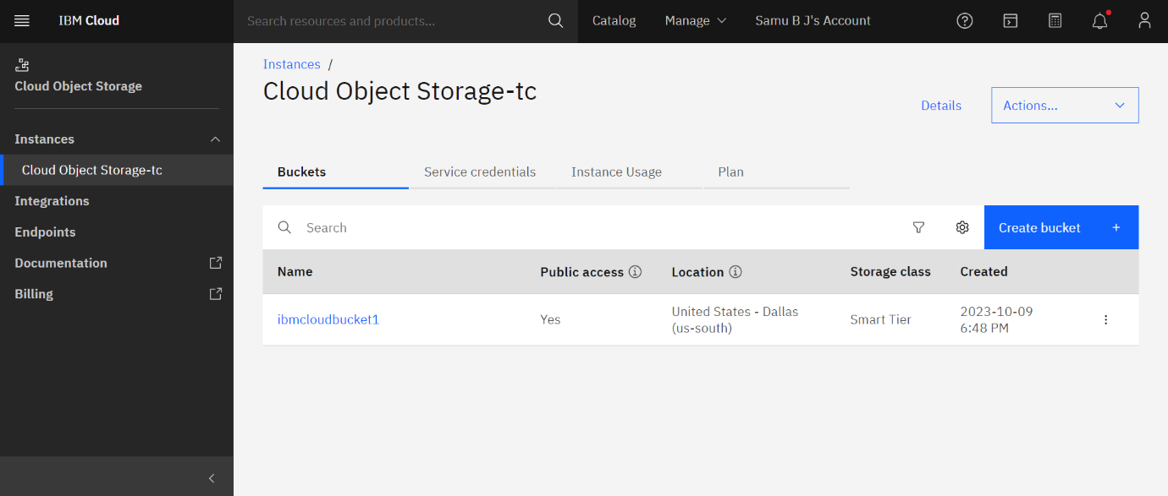

* **Upload Video Content:**

Upload your video files to the designated bucket in the IBM Cloud Object Storage. Make sure to follow any specific guidelines for file formats and naming conventions.

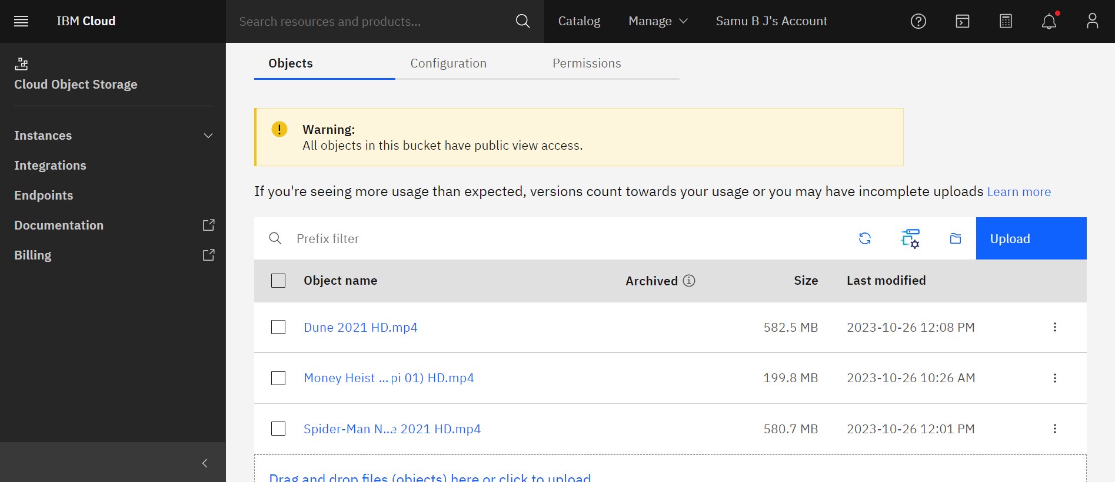

* **Configure Access Control**:

Configure access control settings for your video files to ensure that they are accessible to the intended users or applications. This may involve setting up access policies, access groups, or access control lists (ACLs) depending on your specific requirements.

* **Implement Content Delivery Network (CDN):**

Utilize a CDN service, such as IBM Cloud Content Delivery Network, to improve the delivery speed and performance of your video streaming content. Set up the CDN to cache and deliver your video content efficiently to users across different geographical locations.

* **Generate Streaming URLs or Embed Codes:**

Generate streaming URLs or embed codes for your video files stored in IBM Cloud Object Storage. These URLs or codes will be used to integrate the video content into your website or application.

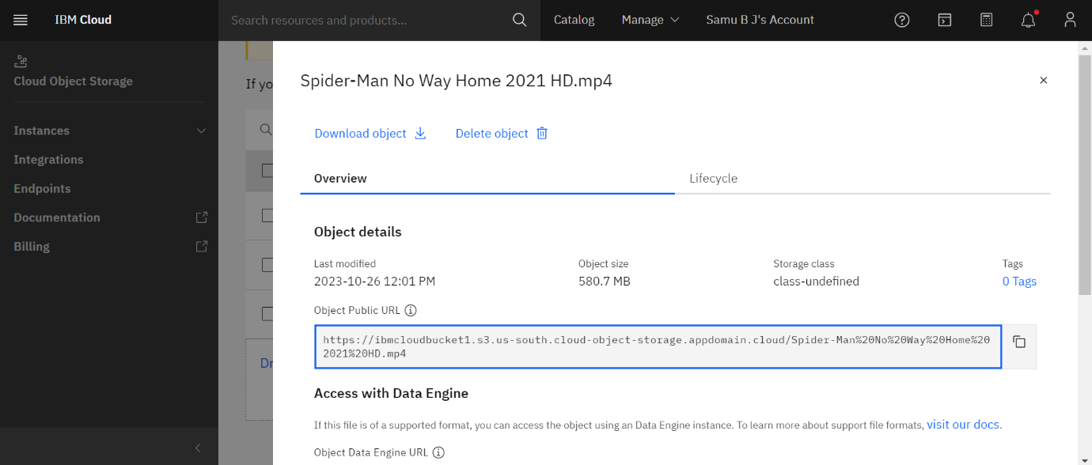

* **Test Video Playback:**

Test the video playback performance across various devices and network conditions to ensure a smooth and high-quality streaming experience for your users.

**How our platform provides a seamless and immersive movie-watching experience to our users:**

Cine Vision Media Streaming Platform is meticulously designed to provide users with a seamless and immersive movie-watching experience through a combination of cutting-edge features and intuitive user interfaces. One of the key aspects contributing to this is the platform's high-definition video streaming capabilities, ensuring that users can enjoy movies with pristine picture quality and minimal buffering interruptions.

The platform also offers a user-friendly interface that enables easy navigation, allowing viewers to effortlessly discover and access their desired movies. Cine Vision's personalized recommendation system utilizes sophisticated watch history to suggest relevant and engaging content tailored to each user's, enhancing the overall movie discovery process. Additionally, the incorporation of a comprehensive user profile feature enables users to create personalized playlist, contributing to a more customized and immersive movie-watching journey.

Furthermore, Cine Vision implements seamless cross-device synchronization, enabling users to seamlessly transition from one device to another without losing their progress, thereby ensuring a consistent and uninterrupted viewing experience. The platform also offers comprehensive subtitle and language options, making movies accessible to a diverse global audience. With robust security measures in place, Cine Vision ensures the protection of user data, thereby enhancing user trust and confidence in the platform. Collectively, these features work harmoniously to deliver an unparalleled, seamless, and immersive movie-watching experience, solidifying Cine Vision's position as a leading platform in the realm of digital movie streaming platforms.

**Conclusion:**

As we conclude the media streaming project with IBM Cloud Video Streaming, we reflect on the journey that has brought forth a comprehensive and dynamic streaming platform. Throughout the project phases, we have harnessed the powerful tools and infrastructure provided by IBM Cloud, enabling us to deliver a seamless and immersive streaming experience to our global audience.

The successful implementation of key features such as personalized recommendations, user profile, and seamless streaming integration has not only enhanced the platform's performance but has also elevated the overall user engagement and satisfaction. While we encountered challenges along the way, our team's perseverance and dedication have ensured that the project meets the highest standards of quality and functionality.

Looking ahead, we remain committed to continuous improvement and innovation, striving to stay at the forefront of the rapidly evolving landscape of digital media streaming. With a solid foundation established through this project, we are poised to adapt and expand in line with emerging technologies and changing user preferences, ensuring that our media streaming platform remains a leading destination for high-quality and captivating content.