Reference Guide
Formats and Conventions
The manual for the PLS_Toolbox uses a format consistent with that used for MATLAB. For additional information on usage see the above Functions section. The following format is used in the Reference section:
Purpose Provides short concise descriptions of a PLS_Toolbox command or function.
Synopsis Shows the input/output format of the command or function.
Description Describes what the command or function does and any rules or restrictions that apply.
Examples Provides examples of how the command or function can be used.
Options Describes advanced options of the command or function.
Algorithm Describes algorithms and routines used within the command or function.
See Also Refers to other related commands or functions in the PLS_Toolbox.
and the following conventions:
Monospace Commands, function names, and screen displays; for example, pca.
Italics Book titles, names of sections in this book, MATLAB toolbox names, and for introduction of new terms; for example, Chemometrics.
Monospace Optional input variables from PLS_Toolbox functions.
Routines in the PLS_Toolbox follow the convention of having samples in rows and variables in columns.
lmoptimize
Purpose
Levenberg-Marquardt non-linear optimization.
Synopsis

[x,fval,exitflag,out] = lmoptimize(fun,x0,options,params)
Description
Starting at (x0) LMOPTIMIZE finds (x) that minimizes the function defined by the function handle (fun) where (x) has  parameters. The function (fun) must supply the Jacobian and Hessian i.e. they are not estimated by LMOPTIMIZE (an example is provided in the Algorithm Section below).
INPUTS:
fun = function handle, the call to fun is
[fval,jacobian,hessian] = fun(x)
[see the Algorithm Section for tips on writing (fun)]
(fval) is a scalar objective function value,
(jacobian) is a x1 vector of Jacobian values, and
(hessian) is a x matrix of Hessian values.
x0 = x1 initial guess of the function parameters.
OPTIONAL INPUTS:
options = discussed below in the Options Section.
params = comma separated list of additional parameters passed to the objective function (fun), the call to (fun) is
[fval,jacobian,hessian] = fun(x,params1,params2,...).
OUTPUTS:
x = x1 vector of parameter value(s) at the function minimum.
fval = scalar value of the function evaluated at (x).
exitflag = describes the exit condition with the following values
1: converged to a solution (x) based on one of the tolerance criteria
0: convergence terminated based on maximum iterations or maximum time.
out = structure array with the following fields:
critfinal: final values of the stopping criteria (see options.stopcrit below).
x: intermediate values of (x) if options.x=='on'.
fval: intermediate values of (fval) if options.fval=='on'.
Jacobian: last evaluation of the Jacobian if options.Jacobian=='on'.
Hessian: last evaluation of the Hessian if options.Hessian=='on'.
Algorithm
The objective function is defined as 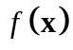, where is a x1 vector. The Jacobian and the symmetric Hessian  are defined as
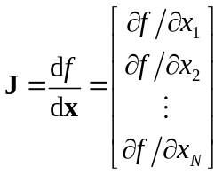 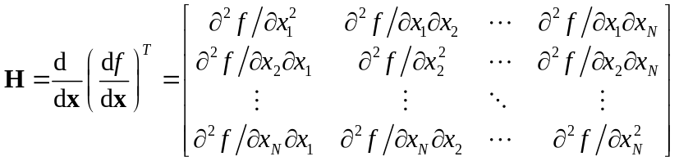.
Two types of calls to the function fun are made. The first type is used often and is a simple evaluation of the function at x given by
fval = fun(x,params1,params2,...);
The second type of call returns the Jacobian and Hessian
[fval,jacobian,hessian] = fun(x,params1,params2,...);
Therefore, to enhance the speed of the optimization, the M-file that evaluates the objective function should only evaluate the Jacobian and Hessian if nargout>1 as in the following example.
function [p,p1,p2] = banana(x)
%BANANA Rosenbrock's function
% INPUT:
% x = 2 element vector [x1 x2]
% OUTPUTS:
% p = P(x) = 100(x1^2-x2)^2 + (x1-1)^2
% p1 = P'(x) = [400(x1^3-x1x2) + 2(x1-1); -200(x1^2-x2)]
% p2 = P"(x) = [1200x1^2-400x2+2, -400x1; -400x1, 200]
% p is (fval)
% p1 is (jacobian)
% p2 is (Hessian)
%
%I/O: [p,p1,p2] = banana(x);

x12 = x(1)*x(1);
x13 = x(1)*x12;
x22 = x(2)*x(2);
alpha = 10; %1 is not very stiff, 10 is The stiff function

p = 10*alpha*(x13*x(1)-2*x12*x(2)+x22) + x12-2*x(1)+1;
if nargout>1
p1 = [40*alpha*(x13-x(1)*x(2)) + 2*(x(1)-1);
-20*alpha*(x12-x(2))];
p2 = [120*x12-40*x(2) + 2, -40*x(1);
-40*x(1), 20]*alpha;
end
This example shows that the Jacobian and Hessian are not evaluated unless explicitly called for by utilizing the nargout command. Since estimating (output p1) and (output p2) can be time consuming, this coding practice is expected to speed up the optimization.
A single step in a Gauss-Newton (G-N) optimization, 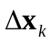 is given as
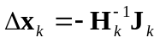
where the index corresponds to the step number.
A problem with the G-N methods is that the inverse of the Hessian may not exist at every step, or it can converge to a saddle point if the Hessian is not positive definite [T.F. Edgar, D.M. Himmelblau, Optimization of Chemical Processes, 1st ed., McGraw-Hill Higher Education, New York, NY, 1988]. As an alternative, the Levenberg-Marquardt (L-M) method was used for CMF [K. Levenberg, Q. Appl. Math 2 (1944) 164; D. Marquardt, S.I.A.M. J. Appl. Math 11 (1963) 431; Edgar et al.]. A single step for the L-M method is given by
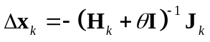
where is a damping parameter and is a x identity matrix. This has a direct analogy to ridge regression [A.E. Hoerl, R.W. Kennard, K.F. Baldwin, Commun. Statist. 4 (1975) 105] with , the ridge parameter, constraining the size of the step. This method is also called a damped G-N method [G. Tomasi, R. Bro, Comput. Stat. Data Anal. in press (2005)]. There are several details to implementing the L-M approach [M. Lampton, Comput. Phys. 11 (1997) 110]. Details associated with the LMOPTIMIZE function are discussed here.
At each iteration in the algorithm, the inverse of 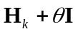 must be estimated. As a part of this process the singular value decomposition (SVD) of 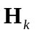 is calculated as
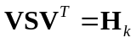 .
Note that the left and right singular vectors are the same (and equal to ) because the Hessian is symmetric. If the optimization surface is convex, will be positive definite and the diagonal matrix will have all positive values on the diagonal. However, the optimization problem may be such that this is not the case at every step. Therefore a small number is added to the diagonal of in an effort to ensure that the Hessian will always be positive definite. In the algorithm 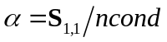, where 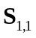 is the largest singular value and 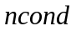 is the maximum condition number desired for the Hessian [ is input as options.ncond]. This can be viewed as adding a small dampening to the optimization and is always included at every step. In contrast, an additional damping factor that is allowed to adapt at each step is also included. The adapting dampening factor is given by 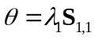 where the initial  is input to the algorithm as options.lamb(1). It is typical that is much larger than . The inverse for the L-M step is then estimated as
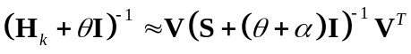
and is used to estimate a step distance .
The ratio 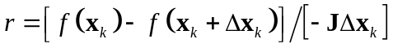 is a measure of the improvement in the objective function relative to the improvement if the objective function decreased linearly. If 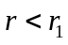 then a line search is initiated [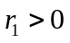 is a small number input as options.ramb(1)]. In this case, the damping factor is increased (so that the step size is reduced) by setting 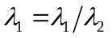 where 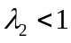 [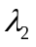 is input as options.lamb(2)], and a new step distance is estimated. The ratio is then estimated again. The damping factor is increased until 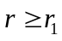 or the maximum number of line search steps 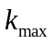 is reached [ is input as options.kmax]. (If increases sufficiently, the optimization resembles a damped steepest decent method.) If the maximum number of line search steps is reached, the step is “rejected” and only a small movement is made such that 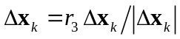 [ is input as options.ramb(3)].
If instead, the first estimate of the ratio is large enough such that then the line search is not initiated. If the ratio is sufficiently large such that 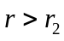, where 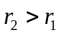 then the damping factor is decreased by setting 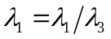 where 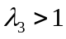 [ is input as options.ramb(2); 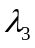 is input as options.lamb(3)].
A new value for is then estimated from 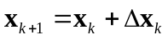 and the next step is repeated from that point. The process is repeated until one of the stopping criteria [options.stopcrit] are met.
Options
options = structure array with the following fields:
name: 'options', name indicating that this is an options structure.
display: [ 'off' | {'on'} ] governs level of display to the command window.
dispfreq: N, displays results every N^{th} iteration {default N=10}.
stopcrit: [1e-6 1e-6 10000 3600] defines the stopping criteria as [(relative tolerance) (absolute tolerance) (maximum number of iterations) (maximum time in seconds)].
x: [ {'off'} | 'on' ] saves (x) at each step.
fval: [ {'off'} | 'on' ] saves (fval) at each step.
Jacobian: [ {'off'} | 'on' ] saves last evaluation of the Jacobian.
Hessian: [ {'off'} | 'on' ] saves last evaluation of the Hessian.
ncond = 1e6, maximum condition number for the Hessian (see Algorithm).
lamb = [0.01 0.7 1.5], 3-element vector used for damping factor control (see Algorithm Section):
lamb(1): lamb(1) times the biggest eigenvalue of the Hessian is added to Hessian eigenvalues when taking the inverse; the result is damping.
lamb(2): lamb(1) = lamb(1)/lamb(2) causes deceleration in line search.
lamb(3): lamb(1) = lamb(1)/lamb(3) causes acceleration in line search.
ramb = [1e-4 0.5 1e-6], 3-element vector used to control the line search (see Algorithm Section):
ramb(1): if fullstep < ramb(1)*[linear step] back up (start line search).
ramb(2): if fullstep > ramb(2)*[linear step], accelerate [change lamb(1) by the acceleration parameter lamb(3)].
ramb(3): if linesearch rejected, make a small movement in direction of L-M step ramb(3)*[L-M step].
kmax = 50, maximum steps in line search (see Algorithm Section).
Examples
options = lmoptimize('options');
options.x = 'on';
options.display = 'off';
[x,fval,exitflag,out] = lmoptimize(@banana,x0,options);
plot(out.x(:,1),out.x(:,2),'-o','color', ...
[0.4 0.7 0.4],'markersize',2,'markerfacecolor', ...
[0 0.5 0],'markeredgecolor',[0 0.5 0])
See Also
function_handle, lmoptimizebnd
lmoptimizebnd
Purpose
Levenberg-Marquardt bounded non-linear optimization.
Synopsis

[x,fval,exitflag,out] =
lmoptimizebnd(fun,x0,xlow,xup,options,params)
Description
Starting at (x0) LMOPTIMIZE finds (x) that minimizes the function defined by the function handle (fun) where (x) has parameters. Inputs (xlow) and (xup) can be used to provide lower and upper bounds on the solution (x). The function (fun) must supply the Jacobian and Hessian i.e. they are not estimated by LMOPTIMIZEBND (an example description is provided in the Algorithm Section of the function LMOPTIMIZE).
INPUTS:
fun = function handle, the call to fun is
[fval,jacobian,hessian] = fun(x)
[see the Algorithm section for tips on writing (fun)]
(fval) is a scalar objective function value,
(jacobian) is a x1 vector of Jacobian values, and
(hessian) is a x matrix of Hessian values.
x0 = x1 initial guess of the function parameters.
xlow = x1 vector of corresponding lower bounds on (x). See options.alow. If an element of xlow == -inf, the corresponding parameter in (x) is unbounded on the low side.
xup = x1 vector of corresponding upper bounds on (x). See options.aup. If an element of xup == inf, the corresponding parameter in (x) is unbounded on the high side.
OPTIONAL INPUTS:
options = discussed below in the Options Section.
params = comma separated list of additional parameters passed to the objective function (fun), the call to (fun) is
[fval,jacobian,hessian] = fun(x,params1,params2,...).
OUTPUTS:
x = x1 vector of parameter value(s) at the function minimum.
fval = scalar value of the function evaluated at (x).
exitflag = describes the exit condition with the following values
1: converged to a solution (x) based on one of the tolerance criteria
0: convergence terminated based on maximum iterations or maximum time.
out = structure array with the following fields:
critfinal: final values of the stopping criteria (see options.stopcrit above).
x: intermediate values of (x) if options.x=='on'.
fval: intermeidate values of (fval) if options.fval=='on'.
Jacobian: last evaluation of the Jacobian if options.Jacobian=='on'.
Hessian: last evaluation of the Hessian if options.Hessian=='on'.
Algorithm
The algorithm is essentially the same as that discussed in LMOPTIMIZE and this section discusses only the two main differences between LMOPTIMIZEBND and LMOPTIMIZE.
The first difference is the addition of penalty functions used to enforce bounding. For example, the objective function used in LMOPTIMIZE is , but the objective function used by LMOPTIMIZEBND is 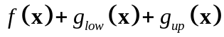. The penalty functions for upper, 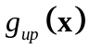, and lower bounds, 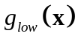, are similar, so only the lower penalty function is described.
Define as the lower boundary, 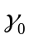 a small number (e.g. 0.001) and 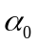 a large number [e.g. 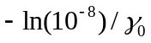], then for a single parameter the lower penalty function is given as
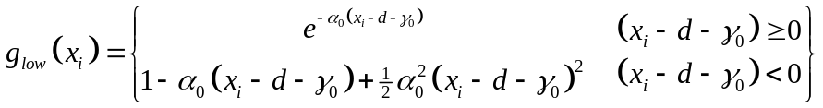 .
This function can be considered an external point function because it is defined outside the feasible region (outside the boundaries). It is continuous at the boundary and also has continuous first and second derivatives. This is in contrast to internal point functions such as a log function that is not continuous at the boundary [e.g. 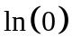 is not continuous]. The first and second derivatives of the penalty function are given by
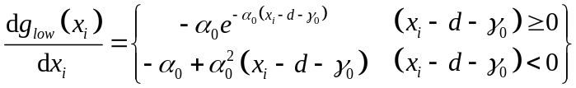 and
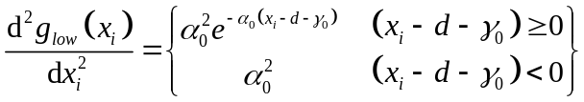 .
The external point penalty function does not guarantee that a step won’t move outside the boundaries into the infeasible region. It does, however provide a means for getting back inside the feasible region.
A second modification is included in the LMOPTIMIZEBND algorithm to avoid large steps outside the feasible region. If a step is such that any are outside the feasible region, the step size for those parameters is reduced. The reduction is 90% the distance of that parameter to the boundary. This typically changes the direction of the step .
Options
options = structure array with the following fields:
name: 'options', name indicating that this is an options structure.
display: [ 'off' | {'on'} ] governs level of display to the command window.
dispfreq: N, displays results every N^{th} iteration {default N=10}.
stopcrit: [1e-6 1e-6 10000 3600] defines the stopping criteria as [(relative tolerance) (absolute tolerance) (maximum number of iterations) (maximum time in seconds)].
x: [ {'off'} | 'on' ] saves (x) at each step.
fval: [ {'off'} | 'on' ] saves (fval) at each step.
Jacobian: [ {'off'} | 'on' ] saves last evaluation of the Jacobian.
Hessian: [ {'off'} | 'on' ] saves last evaluation of the Hessian.
ncond = 1e6, maximum condition number for the Hessian (see Algorithm).
lamb = [0.01 0.7 1.5], 3-element vector used for damping factor control (see Algorithm Section):
lamb(1): lamb(1) times the biggest eigenvalue of the Hessian is added to Hessian eigenvalues when taking the inverse; the result is damping.
lamb(2): lamb(1) = lamb(1)/lamb(2) causes deceleration in line search.
lamb(3): lamb(1) = lamb(1)/lamb(3) causes acceleration in line search.
ramb = [1e-4 0.5 1e-6], 3-element vector used to control the line search (see Algorithm Section):
ramb(1): if fullstep < ramb(1)*[linear step] back up (start line search).
ramb(2): if fullstep > ramb(2)*[linear step], accelerate [change lamb(1) by the acceleration parameter lamb(3)].
ramb(3): if linesearch rejected, make a small movement in direction of L-M step ramb(3)*[L-M step].
kmax = 50, maximum steps in line search (see Algorithm Section).
alow: [ ], x1 vector of penalty weights for lower bound, {default = ones(N,1)}. If an element is zero, the corresponding parameter in (x) is not bounded on the low side.
aup: [ ], x1 vector of penalty weights for upper bound, {default = ones(N,1)}. If an element is zero, the corresponding parameter in (x) is not bounded on the high side.
Examples
options = lmoptimize('options');
options.x = 'on';
options.display = 'off';
options.alow = [0 0]; %x(1) and x(2) unbounded on low side
options.aup = [1 0]; %x(1) bounded on high side and x(2)
% unbounded on high side

[x,fval,exitflag,out] = lmoptimize(@banana,x0,[0 0], ...
[0.9 0],options);
plot(out.x(:,1),out.x(:,2),'-o','color', ...
[0.4 0.7 0.4],'markersize',2,'markerfacecolor', ...
[0 0.5 0],'markeredgecolor',[0 0.5 0])
See Also
function_handle, lmoptimize

