Reference Guide
Formats and Conventions
The manual for the PLS_Toolbox uses a format consistent with that used for MATLAB. For additional information on usage see the above Functions section. The following format is used in the Reference section:
Purpose Provides short concise descriptions of a PLS_Toolbox command or function.
Synopsis Shows the input/output format of the command or function.
Description Describes what the command or function does and any rules or restrictions that apply.
Examples Provides examples of how the command or function can be used.
Options Describes advanced options of the command or function.
Algorithm Describes algorithms and routines used within the command or function.
See Also Refers to other related commands or functions in the PLS_Toolbox.
and the following conventions:
Monospace Commands, function names, and screen displays; for example, pca.
Italics Book titles, names of sections in this book, MATLAB toolbox names, and for introduction of new terms; for example, Chemometrics.
Monospace Optional input variables from PLS_Toolbox functions.
Routines in the PLS_Toolbox follow the convention of having samples in rows and variables in columns.
fitpeaks
Purpose
Peak fitting routine.
Synopsis

[peakdefo,fval,exitflag,out,fit,res] = fitpeaks(peakdef,y,ax,options)
Description
Based on the initial guess in input peakdef, FITPEAKS estimates the peak fit (also the Jacobian and Hessian), and makes a call to LMOPTIMIZEBND to find the best fit of the peaks to the data. (See LMOPTIMIZEBND for additional information.) Results are output to peakdefo.
Information about individual peaks is stored in standard peak structures (see PEAKSTRUCT). Information on multiple peaks is stored in a multi-record structure. Given a standard peak structure (peakdef) that contains an initial guess of peak locations and widths, FITPEAKS finds new parameters that best fits peaks to the rows of the 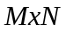 data matrix (y). Results are output to a standard peak structure (peakdefo).
Fields of (peakdef) required in the initial guess for each peak are (.fun), (.param), (.lb), (.penlb), (.ub), and (.penub).
INPUTS:
peakdef = multi-record standard peak structure with the following fields:
name: 'Peak', name indicating that this is a standard peak structure.
id: ' ', double or character string peak identification.
fun: [ {'Gaussian'} | 'Lorentzian' | 'PVoigt1' | 'PVoigt2' ], defines the peak function (see definitions in the Algorithm section).
param: Parameter list for each peak function. The number of parameters depends on the peak function used:
'Gaussian': [height, location, width],
'Lorentzian': [height, location, width],
'PVoigt1': [height, location, width, fraction Gaussian],
'PVoigt2': [height, location, width, fraction Gaussian].
lb: [ ], Lower bounds on the function parameters. This is a row vector with the same number of elements as peakdef.param.
penlb: [ ], Penalty wt for lower bounds, >=0. This is a row vector with the same number of elements as peakdef.param. If set to 0 this constraint is not employed.
ub: [ ], Upper bounds on the function parameters. This is a row vector with the same number of elements as peakdef.param.
penub: [ ], Penalty wt for upper bounds, >=0. This is a row vector with the same number of elements as peakdef.param. If set to 0 this constraint is not employed.
area: [ ], Estimated peak area.

y = MxN measured responses with peaks to fit. Each row of (y) is fit to the peaks given in (peakdef).
OPTIONAL INPUTS:
ax = 1xN x-axis to fit to {default ax=1:N}.
options = discussed below in the Options Section.
OUTPUTS:
peakdefo = The input peak structure (peakdef) with parameters changed to correspond to the best fit values.
fval = Scalar value of the objective function evaluated at termination of FITPEAKS.
exitflag = Describes the exit condition (see LMOPTIMIZEBND).
out = Structure array with information on the optimization/fitting (see LMOPTIMIZEBND).
fit = Model fit of the peaks, i.e it is the best fit to (y).
res = Residuals of fit of the peaks.
Algorithm
Peaks are fit to the functions defined below based on the definitions in the field (peakdef.fun). The functions can be evaluated using independent functions or a wrapper function PEAKFUNCTION. See PEAKFUNCTION for more help.
For peakdef.fun = 'Gaussian' the function is
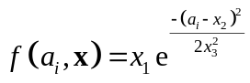
where 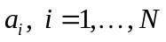 is the 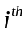 element of optional input (ax), and 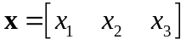 corresponds to the peak parameters in the three-element vector (peakdef.param). Constraints that should be used are (bounds in peakdef) are 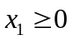 and 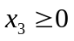.
For peakdef.fun = 'Lorentzian' the function is
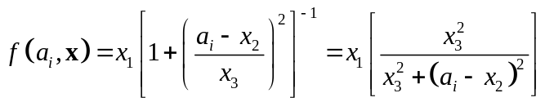 .
Constraints that should be used are (bounds in peakdef) are and .
For peakdef.fun = 'PVoigt1' the function is
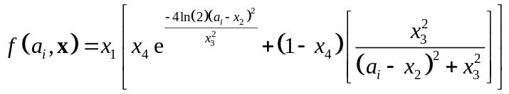
where 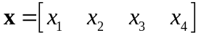 corresponds to the peak parameters in the four-element vector (peakdef.param). Constraints that should be used are (bounds in peakdef) are and , while 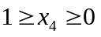. The Pseudo-Voigt peak shape is an estimate of the Gaussian and Lorentzian peak shapes convolved.
For peakdef.fun = 'PVoigt2' the function is
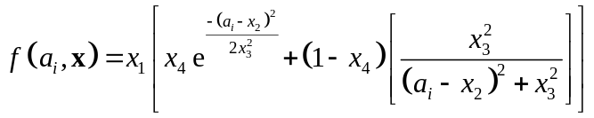
where corresponds to the peak parameters in the four-element vector (peakdef.param). Constraints that should be used (bounds in peakdef) are and , while . The Pseudo-Voigt peak shape is an estimate of the Gaussian and Lorentzian peak shapes convolved.
A comparison of the four peaks is given in the figure below, and was generated using the following code:
ax = 0:0.1:100;
y = zeros(4,length(ax));
plot(ax,peakgaussian([2 51 8],ax),'-b', ...
ax,peaklorentzian([2 51 8],ax),'--k', ...
ax,peakpvoigt1([2 51 8 0.5],ax),':g', ...
ax,peakpvoigt2([2 51 8 0.5],ax),'-.r')
legend('Gaussian','Lorentzian','PVoigt1','PVoigt2')
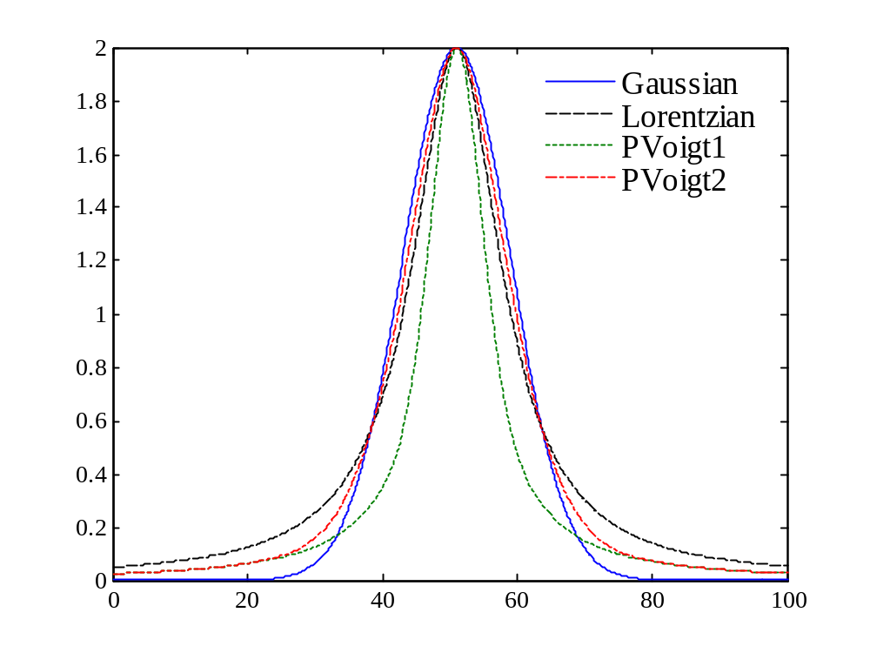
Options
options = structure array with the following fields:
name: 'options', name indicating that this is an options structure.
display: [ 'off' | {'on'} ] governs level of display to the command window.
optimopts: options structure from LMOPTIMIZEBND. This field is passed to LMOPTIMIZEBND and can be used to control the optimization / fitting.
Examples

%Make a single known peak
ax = 0:0.1:100;
y = peakgaussian([2 51 8],ax);

%Define first estimate and peak type
peakdef = peakstruct;
peakdef.param = [0.1 43 5]; %coef, position, spread
peakdef.lb = [0 0 0.0001]; %lower bounds on param
peakdef.penlb = [1e-6 1e-6 1e-6];
peakdef.ub = [10 99.9 40]; %upper bounds on params
peakdef.penub = [1e-6 1e-6 1e-6];

%Estimate fit and plot
yint = peakfunction(peakdef,ax);
[peakdef,fval,exitflag,out] = fitpeaks(peakdef,y,ax);
yfit = peakfunction(peakdef,ax); figure
plot(ax,yint,'m',ax,y,'b',ax,yfit,'r--')
legend('Initial','Actual','Fit')
See Also
peakfind, lmoptimizebnd, peakfunction, peakgaussian, peaklorentzian, peakpvoigt1, peakpvoigt2, peakstruct
localmax
Purpose
Automated identification of local maxima
Synopsis

i0 = localmax(x,w)
Description
Finds maxima in windows of width (w). Wider windowing is used to avoid local maxima that might be due to noise. The default window width is w=3. This function is called by PEAKFIND.
INPUT:
x = matrix of measured traces containing peaks each 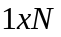 row of (x) is an individual trace.
OPTIONAL INPUT:
w = odd scalar window width for determining local maxima {default: w = 3}.
OUTPUT:
i0 = 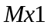 cell w/ indices of the location of the major peaks for each of the  traces in each cell.
Examples

load nir_data
plot(spec1.axisscale{2},spec1.data(1,:))
i0 = localmax(spec1.data(1,:));
vline(spec1.axisscale{2}(i0{1}))

i0 = localmax(spec1.data(1,:),5);
vline(spec1.axisscale{2}(i0{1}),'r')
See Also
fitpeaks, peakfind
peakfind (not done)
Purpose
Automated identification of peaks.
Synopsis

[i0,iw] = peakfind(x,width,tolfac,w,options)
[i0,iw] = peakfind(x,width,options)
Description
Given a set of measured traces (x) PEAKFIND attempts to find the location of the peaks. Different algorithms are available and each is discussed in the Algorithm Section.
INPUTS:
x = matrix of measured traces. Each row of (x) is an individual trace with potential peaks.
width = number of points in Savitzky-Golay filter.
OPTIONAL INPUTS:
options = discussed below in the Options Section.
OUTPUTS:
i0 = cell array with each cell containing the indices of the location of the major peaks for each of the traces.
iw = cell array with each cell containing the indices of the location of the windows containing each peak in (i0). (If not included in the output argument list, it is not calculated and the algorithm is slightly faster.) .
Algorithm
Each peak finding algorithm uses the smoothed and second derivative data (see SAVGOL) and an estimate of the residuals. The smoothed and second derivative are estimated as:
d0 = savgol(x,width,2,0);
d2 = savgol(x,width,2,2);
The residuals are defined for the row/trace as
residuals = sqrt(mean((x(i,:)-d0(i,:)).^2));
For options.algorithm = 'd0', a candidate set of peaks (pks) are first selected using
pks = localmax(d0(i,:),w);
Next, the input (tolfac) is used to estimate two thresholds (tol0) and (tol2) using
tol0 = tolfac*sqrt(mean((x(i,:)-d0(i,:)).^2));
tol2 = tol0*(max(d2(i,:))-min(d2(i,:)))/ …
(max(d0(i,:))-min(d0(i,:)));
Finally, the set of major peaks are selected from the initial candidate set
i0{i} = pks(d0(i,pks)>tol0 & d2(i,pks)<-tol2);
For options.algorithm = 'd2', Jer
For options.algorithm = 'd2r', Jer
Options
options = structure array with the following fields:
name: 'options', name indicating that this is an options structure.
display: [ 'off' | {'on'} ] governs level of display to the command window.
algorithm: [ {'d0'} | 'd2' | 'd2r' ] selects the peak finding algorithm (see the Algorithm Section for a description of each).
Examples

See Also
fitpeaks, localmax
peakfunction
Purpose
Outputs the estimated peaks from parameters in (peakdef)
Synopsis

[y,peakdef] = peakfunction(peakdef,ax)
Description
Given the multi-record standard peak structure (peakdef) and the corresponding wavelength/frequency axis (ax), the peak parameters in the field (peakdef.param) are used to generate peaks. This function is called by PEAKFITS and the result is the output (fit), and the peak area estimates in (peakdef) are updated. See PEAKFITS for more information. This function calls PEAKGAUSSIAN, PEAKLORENTZIAN, PEAKPVOIGT1, and PEAKVOIGT2.
INPUTS:
peakdef = standard peak structure (see PEAKSTRUCT) output by fitpeaks.
ax = corresponding wavelength/frequency axis. This is also input to the function FITPEAKS. Peak positions are based on this axis.
OUTPUTS:
y = estimated peaks based on the parameters in the input (peakdef).
peakdef = the original input (peakdef) with the area field estimated.
Examples

ax = 0:0.1:100;
y = peakgaussian([2 51 8],ax);%Make known peak
%Define first estimate and peak type
peakdef = peakstruct;
peakdef.param = [0.1 43 5]; %coef, position, spread
peakdef.lb = [0.0 0 0.0001]; %lower bounds on param
peakdef.penlb = [1 1 1];
peakdef.ub = [10 99.9 40]; %upper bounds on params
peakdef.penub = [1 1 1];
%Estimate fit and plot
yint = peakfunction(peakdef,ax);
[peakdef,fval,exitflag,out] = fitpeaks(peakdef,y,ax);
yfit = peakfunction(peakdef,ax); figure
plot(ax,yint,'m',ax,y,'b',ax,yfit,'r--')
legend('Initial','Actual','Fit')
See Also
fitpeaks, peakgaussian, peaklorentzian, peakpvoigt1, peakpvoigt2, peakstruct
peakgaussian
Purpose
Outputs a Gaussian function, Jacobian, and Hessian for a given set of input parameters and axis.
Synopsis

[y,y1,y2] = peakgaussian(x,ax)
Description
Given a 3-element vector of parameters (x) and a vector of independent variables e.g. a wavelength or frequency axis (ax), PEAKGAUSSIAN outputs a Gaussian peak (y). If more than one output is requested, it also outputs the Jacobian (y1) and Hessian (y2). Derivatives are with respect to the parameters and are evaluated at (x). This function is called by PEAKFUNCTION.
INPUTS:
x = 3 element vector with parameters
x(1) = coefficient ,
x(2) = mean , and
x(3) = spread .
ax = vector of independent variables e.g. a wavelength or frequency axis with elements , 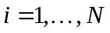.
OUTPUTS:
y = vector with the Gaussian function, 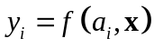.
y1 = 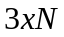matrix of the Jacobian of  evaluated at (x).
y2 = 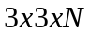matrix of the Hessian of evaluated at (x).
Algorithm
The function is
Examples

%Make a single known peak
ax = 0:0.1:100;
y = peakgaussian([2 51 8],ax);
plot(ax,y)
See Also
peakfunction, peaklorentzian, peakpvoigt1, peakpvoigt2, peakstruct
peakidtext
Purpose
Writes peak ID information on present graph of a set of peaks.
Synopsis
h = peakidtext(peakdef)

Description
When a set of peaks is plotted, PEAKIDTEXT can be used to put the peak id (peakdef.id) on the graph (see PEAKSTRUCT). For example, if (ax) is the wavelength, frequency, or time axis and (y) is a set of peaks then, for an initial guess given in (peakdef) the fit parameters are obtained using:
peakdefo = fitpeaks(peakdef,y,ax);
A plot can be made using:
plot(ax,y,'b',ax,peakfunction(peakdefo,ax),'r')
Next, labels are put on the graph using:
peakidtext(peakdefo)
This also puts a vertical line at the peak center and puts the text label, based on the contents of the (peakdefo.id) field, near the peak maximum.
INPUT:
peakdef = a standard peak structure (see PEAKSTRUCT).
OUTPUT:
h = vector of handles corresponding to the individual text labels.
See Also
fitpeaks, peakfunction, peakstruct
peaklorentzian
Purpose
Outputs a Lorentzian function, Jacobian, and Hessian for a given set of input parameters and axis.
Synopsis

[y,y1,y2] = peaklorentzian(x,ax)
Description
Given a 3-element vector of parameters (x) and a vector of independent variables e.g. a wavelength or frequency axis (ax), PEAKLORENTZIAN outputs a Lorentzian peak (y). If more than one output is requested, it also outputs the Jacobian (y1) and Hessian (y2). Derivatives are with respect to the parameters and are evaluated at (x). This function is called by PEAKFUNCTION.
INPUTS:
x = 3 element vector with parameters
x(1) = coefficient ,
x(2) = mean , and
x(3) = spread .
ax = vector of independent variables e.g. a wavelength or frequency axis with elements , .
OUTPUTS:
y = vector with the Lorentzian function, .
y1 = matrix of the Jacobian of evaluated at (x).
y2 = matrix of the Hessian of evaluated at (x).
Algorithm
The function is
Examples

%Make a single known peak
ax = 0:0.1:100;
y = peaklorentzian([2 51 8],ax);
plot(ax,y)
See Also
peakfunction, peakgaussian, peakpvoigt1, peakpvoigt2, peakstruct
peakstruct
Purpose
Makes an empty standard peak definition structure.
Synopsis

peakdef = peakstruct(fun,n)
Description
The output of PEAKSTRUCT is an empty standard peak structure, or multi-record peak structure.
No input is required. Optional inputs can be used to create different types of default peak definitions in each of the structure records.
OPTIONAL INPUTS:
fun = Peak function name {default = 'Gaussian'}. Available peak names (shapes) are:
'Gaussian', 'Lorentzian', 'PVoigt1', and 'PVoigt2'.
n = Number of records to include in the (peakdef) structure.
OUTPUTS:
peakdef = A structure array with the following fields:
name: 'Peak', indentifies (peakdef) as a peak definition structure.
id: integer or character string peak identifier.
fun: peak function name {e.g.'Gaussian'}.
param: 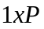 vector of parameters for each peak function:
fun = 'Gaussian'; param = [height, position, width].
fun = 'Lorenzian'; param = [height, position, width].
fun = 'PVoigt1'; param = [height, position, width, fraction Gaussian], where 0fraction Gaussian1.
fun = 'PVoigt2'; param = [height, position, width, fraction Gaussian], where 0fraction Gaussian1.
Descriptions of the functions and parameters are given in the Algorithm section of the FITPEAKS entry in the reference manual. Also see PEAKFUNCTION.
lb: vector of lower bounds on (.param).
penlb: vector of penalties for lower bounds. If an entry is 0, then the corresponding lower bound is not active.
ub: vector of upper bounds on (.param).
penub: vector of penalties for upper bounds. If an entry is 0, then the corresponding upper bound is not active.
Examples

peakdef = peakstruct('',3);
disp(peakdef(2))

peakdef(2) = peakstruct('PVoigt1');
peakdef(2).id = '2: Voigt';
disp(peakdef(2))
See Also
fitpeaks, peakfunction, peakgaussian, peaklorentzian, peakstruct, peakpvoigt1, peakpvoigt2
testfitpeaks
Purpose
Demo calls to the FITPEAKS function.
Synopsis

[peakdef,fval,exitflag,output] = testfitpeaks(test)
Description
TESTFITPEAKS is a set of example calls to FITPEAKS. Editing this M-file provides some insight into how the peak fitting utilities can be used.
No input is required.
OPTIONAL INPUT:
test = calls different peak fitting examples.
test = 1 fits a single Gaussian peak.
test = 2 fits two Gaussian peaks.
test = 3 fits a single Lorentzian peak.
test = 4 fits two Lorentzian peaks.
test = 5 fits a Gaussian and Lorentzian peak.
test = 6 fits a single PVoigt2 peak.
test = 7 fits a Gaussian and a PVoigt2 peak.
test = 8 fits a Gaussian and a PVoigt1 peak.
test = 9 fits a single PVoigt1 peak.
OUTPUTS:
peakdef = The input peak structure (peakdef) with parameters changed to correspond to the best fit values.
fval = Scalar value of the objective function evaluated at termination of FITPEAKS.
exitflag = Describes the exit condition (see LMOPTIMIZEBND).
out = Structure array with information on the optimization/fitting (see LMOPTIMIZEBND).
See Also
fitpeaks, peakfunction, peakstruct
peakpvoigt1
Purpose
Outputs a pseudo-Voigt function, Jacobian, and Hessian for a given set of input parameters and axis.
Synopsis

[y,y1,y2] = peakpvoit1(x,ax)
Description
Given a 4-element vector of parameters (x) and a vector of independent variables e.g. a wavelength or frequency axis (ax), PEAKPVOIT1 outputs a pseudo-voit peak (y). If more than one output is requested, it also outputs the Jacobian (y1) and Hessian (y2). Derivatives are with respect to the parameters and are evaluated at (x). This function is called by PEAKFUNCTION.
INPUTS:
x = 4 element vector with parameters
x(1) = coefficient ,
x(2) = mean ,
x(3) = spread , and
x(4) = fraction Gaussian 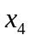.
ax = vector of independent variables e.g. a wavelength or frequency axis with elements , .
OUTPUTS:
y = vector with the Lorentzian function, .
y1 = 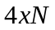matrix of the Jacobian of evaluated at (x).
y2 = 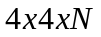matrix of the Hessian of evaluated at (x).
Algorithm
The function is
Examples

%Make a single known peak
ax = 0:0.1:100;
y = peakpvoigt1([2 51 8 0.5],ax);
plot(ax,y)
See Also
peakfunction, peakgaussian, peaklorentzian, peakpvoigt2, peakstruct
peakpvoigt2
Purpose
Outputs a pseudo-Voigt function, Jacobian, and Hessian for a given set of input parameters and axis.
Synopsis

[y,y1,y2] = peakpvoit1(x,ax);
Description
Given a 4-element vector of parameters (x) and a vector of independent variables e.g. a wavelength or frequency axis (ax), PEAKPVOIT2 outputs a pseudo-voit peak (y). If more than one output is requested, it also outputs the Jacobian (y1) and Hessian (y2). Derivatives are with respect to the parameters and are evaluated at (x). This function is called by PEAKFUNCTION.
INPUTS:
x = 4 element vector with parameters
x(1) = coefficient ,
x(2) = mean ,
x(3) = spread , and
x(4) = fraction Gaussian .
ax = vector of independent variables e.g. a wavelength or frequency axis with elements , .
OUTPUTS:
y = vector with the Lorentzian function, .
y1 = matrix of the Jacobian of evaluated at (x).
y2 = matrix of the Hessian of evaluated at (x).
Algorithm
The function is
Examples

%Make a single known peak
ax = 0:0.1:100;
y = peakpvoigt2([2 51 8 0.5],ax)
plot(ax,y)
See Also
peakfunction, peakgaussian, peaklorentzian, peakpvoigt1, peakstruct
testpeakdefs
Purpose
Checks peak parameters in a peak definition structure.
Synopsis

[out,msg,loc] = testpeakdefs(peakdef)
Description
TESTPEAKDEFS checks the consistency of the peak definitions in a peak definition structure and is useful for checking the initial guess for (peakdef). This function examines each record of a peak definition structure (peakdef) and determines:
1) if the lower bounds are lower than the initial guess (any parameters lower than the lower bounds is an error),
2) if the upper bounds are higher than the initial guess (any parameters higher than the upper bounds is an error), and
3) if the number of parameters in each peak definition are consistent with the corresponding peak function (peakdef.fun field).
INPUT:
peakdef.fun = a multi-record peak definition structure array where each record is a peak definition.
OUTPUTS:
out = output status code:
0 = no problems discovered.
-1 = problem encountered.
msg = error message (last error detected).
loc = location of detected problems. This is a two-column matrix with column one corresponding to a peak with an inconsistent definition, and column two corresponding to the inconsistent parameter definition (e.g. a paramter is < its lower bound).
If column two has a zero, this means that there is a peak definition with an inaccurate number of parameters for the specific peak shape (e.g. for peakdef.fun = Gaussian there are 3 parameters).
See Also
peakstruct

