2. Data Understanding

2.1 Data semantics
The dataset contains a set of information related both work and personal ones, regarding 1470 different company employees. The set is divided in a training set, and a test set, respectively composed of 33 attributes, consisting of 1176 and 294 records each, with a total ratio of 80:20. For each employee we have the following information:
- Age: discrete numerical attribute that representing the age.
- Gender: categorical attribute that indicates the sex of the subject.
- Status: categorical attribute regarding the marital status.
- Education: ordinal attribute indicating the subject's major educational level.
- Education Field: categorical attribute that specifies the field of study.

AKs_{m} - Attrition-Key status: categorical features that provide a measure of the commitment and emotional / contributory impact that the individual manifests while working, and in relationships with their colleagues. Generally, low values may indicate a strong attrition-alarm. To each attribute is related an approval rating: Low, Medium, High, Excellent.

- Environment Satisfaction: level of gratification given from the work environment.
- JobInvolvement: indicator on the centrality and involvement of work.
- JobSatisfaction: indicator of appreciation and satisfaction of the type of job.
- PerformanceRating: evaluation of work performance.
- RelationshipSatisfaction: level of interpersonal gratification in relationships.
- WorkLifeBalance: ability to balance one's work and private life.

Sa_{m} - Salary amount: positive numerical attributes that represent the amount of money paid to the worker, based on the type of service performed. The salary can be paid at previously established time intervals.
- MonthlyIncome: monthly income, gross or net, paid to the employee.
- HourlyRate: unit of capital (currency not specified) calculated on an hourly basis
- DailyRate: unit of capital (unspecified currency) calculated on a daily basis.
- MonthlyRate: unit of capital (currency not specified) calculated on a monthly basis.
- PercentSalaryHike: Percentage of yearly salary increase, presumably deducted annually.

Wh_{m} - Work history: positive numerical attributes that indicate the number of years the employee has worked within the same company, considering different points of view.
- YearsAtCompany: years of collaboration between the company and employee.
- YearsInCurrentRole: number of years working with the current role.
- YearsSinceLastPromotion: number of years passed by since the last promotion.
- YearsWithCurrManager: how many years the employee spent with the current manager.
- TrainingTimesLastYear: training time for the employee during the last year (not specified what times-days or weeks is)
- NumCompaniesWorked: number of enterprises that person worked for.
- TotalWorkingYears: the total number of years of experience of a person.

Wd_{m} - Work description: numeric and categorical attributes describing the work and the related relationship, under several aspects.
- DistanceFromHome: numerical value that indicates the distance to cover until the workplace.
- OverTime: binary value that indicates whether the employee is use to work overtime or not.
- JobLevel: discrete attribute that indicates the worker’s grade of authority within the enterprise structure. They are: executive management, middle management, management, advisor and employees [https://simplicable.com/new/job-levels]
- StockOptionLevel: discreet feature that indicates the 4 categories of shares that can be purchased by employees based on the position covered in the organization.
- BusinessTravel: categorical attribute based on the need for business trips. It can be: Travel Rarely, Travel Frequently or No Travel.
- Department: categorical variable employee’s business area. (eg in this dataste we have: Research & Development, Sales or Human Resources).
- Job role: categorical attribute indicating the position covered in the company (eg. In this dataset the main positions are Sales Executive, Research scentist and Laboratory Technician).
- Over18: attribute that indicates whether an individual is of age or not. This attribute is superfluous as we get this response from the Age attribute. Furthermore, in this dataset, it only has a single category, so it makes absolutely no contribution.
- StandardHours: discreetly attributed of dubious significance. It does not provide any knowledge as, in this dataset, it describes a single category.
- Attrition: categorical attribute (and target variable to predict). The boolean result indicates whether or not the analysed employee was fired from the company he is working for, or worked for in the period in which it was analysed.

2.2 Statistics and distribution of variables

Numeric Attributes
Before evaluating the data’s quality or modifying them, we have to analyse the statistics of each group, in particular the mean and standard deviation.
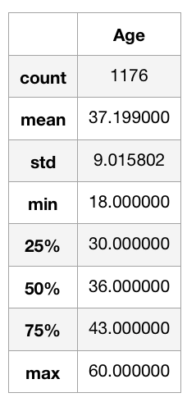
Age: the minimum age of employees is 18 up to a maximum of 60. The histograms shows a single distribution, with no outliers and an average of 37 years per employee.

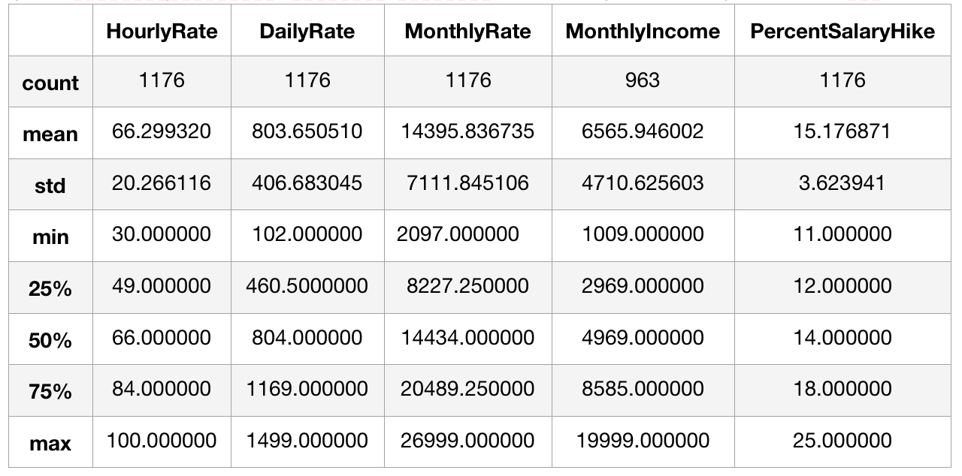
Sa_{m} The attributes belongs to a domain of positive numerical values. The attributes XXXRate and PercentSalaryHike, show balanced values. We can see how 50% of the employees had an increase of 11% to 14% of the “PercentSalaryHike”. As we can see from the box-plots, there is no missing values nor outliers. The “MonthlyIncome” average is 6566, which could significantly vary after the correction of the 213 missing values and the replacement of the outliers. The distribution is not homogeneous, but this was expected considering employees with extra-ordinary salaries are nothing but isolated cases and outliers. We can see that 50% of the employees have a maximum income of 5,000, while the remainder is distributed in a scattered way up to a maximum of 20,000, which is outside the 75%-percentile + 1.5 * IQR.

Wh_{m}: discrete numeric attributes with domain ranging from 0 to a maximum of 40 For “YearsAtCompany” and “TotalWorkingYears” we see an unbalanced distribution: the standard deviation is close to the mean, due to the high frequency of the smaller values, but that (frequency) decreases a lot for the higher ones. Probably this is due to a limited set of outliers that could affect the measurements. The attributes “TotalWorkingYears” and “DistanceFromHome” show instead a more stable distribution.

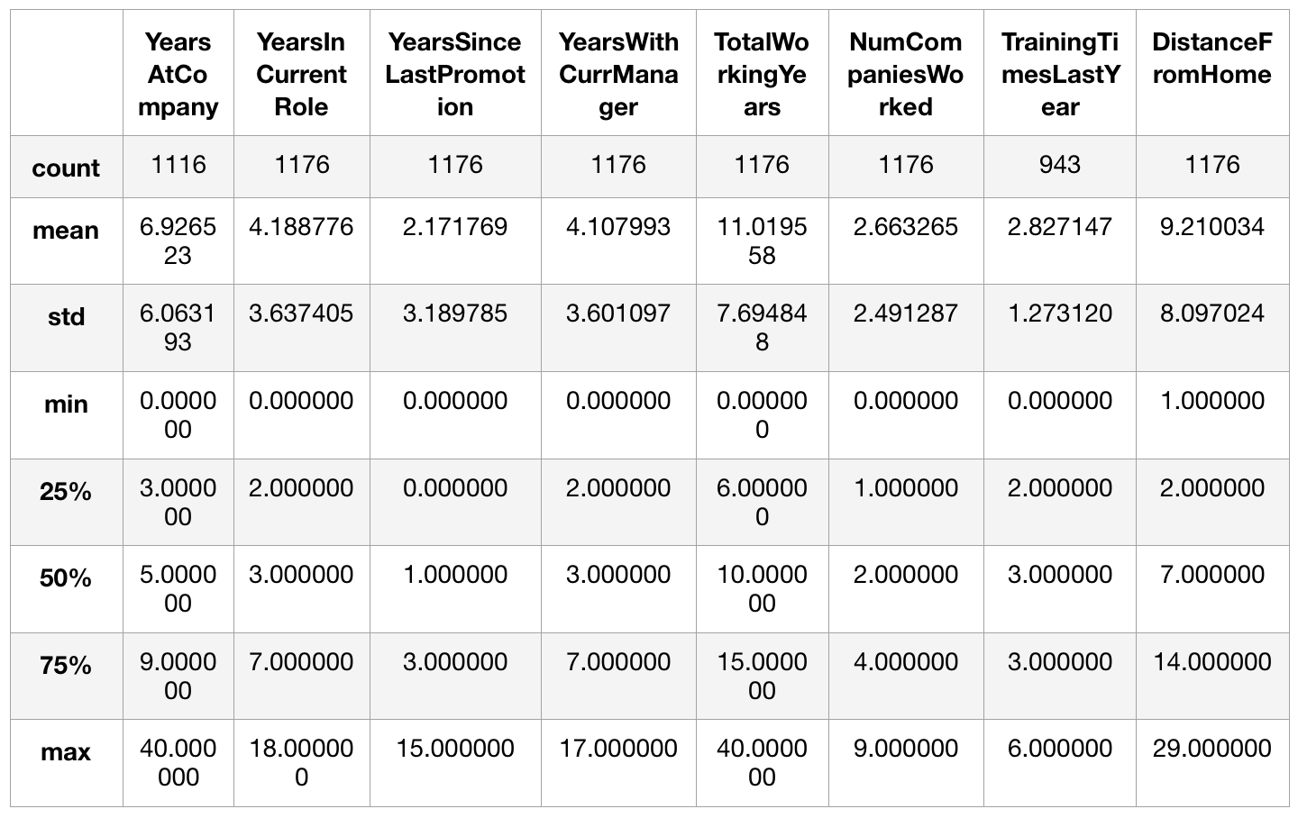
Categorical attributes

- Gender: binary attributes with 59 missing values (5.00%). In total there are 59.5% of men ('Male') and 40.5% of women ('Female') among all non-null values.
- MaritalStatus: made up of 46.1% are displaced (MArried), 32.6% are Single and the remaining 21.3% are divorced (Divorced).
- Education: ordinal attribute with discrete values each of which mapped to a well-defined study category. The table shows the associations and the normalized distribution of the educational qualifications of the employees.
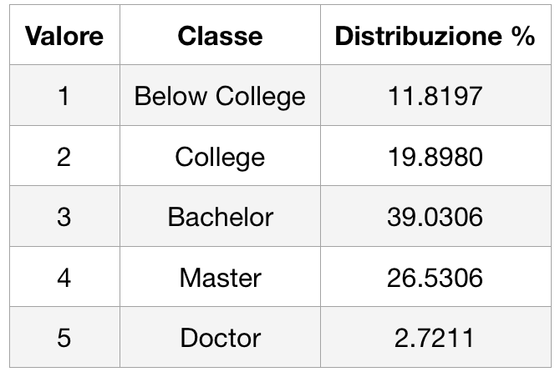
- EducationField: categorical attribute with 6 classes, consisting of 41.58% LifeSciences, 31.46% Medical, 10.62% Marketing, 9.09% Technical Degree, 1.78% Human Resources and 5.44% Other.

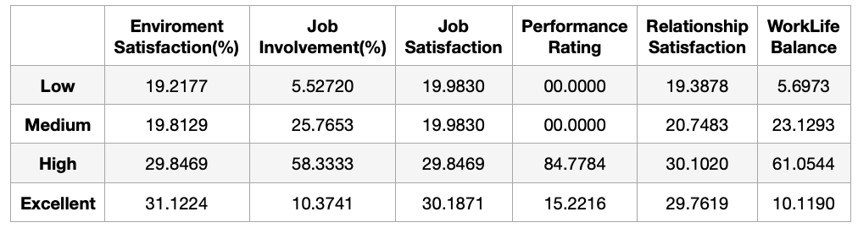
- The “Attrition-Key” is composed of 6 attributes with discrete values, each of which associates an integer value of the domain [1,4] to a rating class, respectively [Low, Medium, High, Excellent]. Each attribute is composed of syntactically correct values, therefore belonging to the domain and with no missing values. The bar charts also show the attrition number for that class.

- OverTime: shows 71.25% of “No” and 28.75% “Yes”.
- BusinessTravel: contains 107 (9.09%) missing values. Precisely the 71.47% “Travel_Rarely”, 17.96% “Travel_Frequently” and 10.57 “Non-Travel”. considering only non-null values
- StockOptionLevel:
- Department: attribute containing 3 types of sectors: 65.39% “Research & Development", 30.70% “Sales” and 3.91% “Human Resources”.
- JobRole and JobLevel: categorical and discrete ordinal respectively. In the tables we can read the distribution of the work categories and that of the levels.
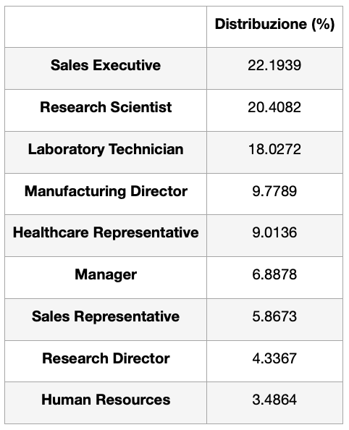
- JobLevel: discrete ordinal attribute, with 5 different levels

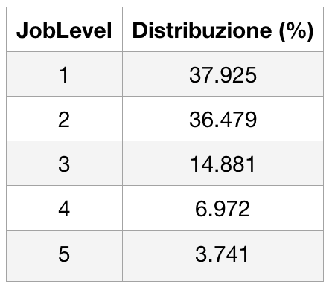

- Over18: contains 372 missing values and has a single category with 804 'Y' values. It provides redundant information, since we have the Age attribute.
- StandardHours: Numeric attribute with 570 (48.47%) null values. The remainder is made up of a single value set at 80. “Over18 and StandardHours” are giving no useful information and we decided to remove it to reduce the size of the dataset, bringing it to 31 attributes.
- Attrition: categorical attribute and target variable. It is made up of 984 (83.67%) 'No' and 192 (16.33%) 'Yes'. The following cross-charts show the attrition value related with some of the attributes. After normalisation, we can see the resignation index, stating that 47% of employees resign in the first 2 years of work and that the sales representative is the most resigned role, followed by human resources and laboratory technicians. In addition, more than 20% singles quits while married, and divorced people are less likely.

2.3 Evaluation of data quality (missing values, outliers) and transformation variable

2.3.1 Missing values
In this section we will describe how we managed anomalies: missing values, outliers and possible dataset dimensionality reduction. Given the small amount of data that constitutes the dataset (1176 different employees) we have tried our best not to delete further records, trying to replace values with approximations.
Attribute | Age | BusinessTravel | Gender | Monthly  Income | Over18 | Performance  Rating | StandardHours | TrainingTimeLastYear | YearsAtCompany
Missing Values | 176 | 107 | 59 | 213 | 372 | 138 | 570 | 233 | 60

For the attributes “BusinessTravel, Gender and PerformanceRating” we plotted different types of combination by matching attributes with each of them, similar to how we did for the Attrition attribute. We choose “Fashion” because, regardless of the comparison attribute, it remains the same for every subset. Consequently, the null values of Gender have been replaced with 'Male', those of PerformanceRating with the value 3, which indicates a rating equal to High and BusinessTravel with Travel_Rarely.

Differently, for numerical attributes we focused on correlations. As we can see from the table x.x, the “MonthlyIncome” attribute has a correlation index of 0.51 with “YearsAtCompany”. Consequently we decided to discretise the values ​​of “YearsAtCompany” in four different intervals: each bin contains the values ​​of a quartile. At that point we computed the average salary by grouping “MonthlyIncome” according to the so defined intervals. At the end of the computation, the correlation index hardly didn’t chance from 0.50, and we obtained a decrease in the standard deviation of 8.29%.
We worked in the same way for the “Age”, grouping it on the quartile basis in relation with “MonthlyIncome”, whose correlation index is equal to 0.50. Also in this case we have maintained the same correlation index, and a significant lowering of the standard deviation.
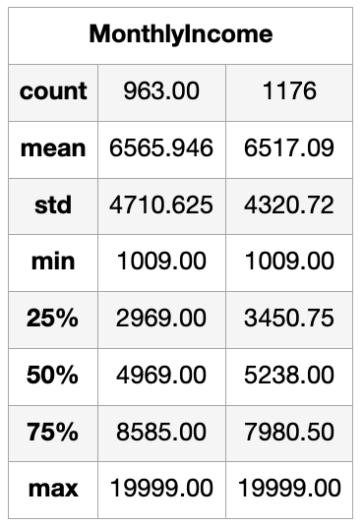
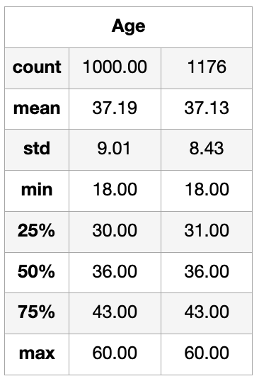
To sum up, we have chosen the quartiles to have a good 25% of the distribution on each quartile (294 records) to evaluate a reliable average value. A greater number of intervals would have further reduced the number of records to be computed, lowering the accuracy of the result. Furthermore, if I had considered intervals of equal width I could have had empty bins or with a very limited distribution on which to calculate the average.

The “TrainingTimeLastYears” attribute is composed of 19.81% of null values and the domain is discrete with integers ranging from 0 to 6. Therefore, instead of considering the mode (with 48.63%) we decided to replace the null values with values ranging within the respective probabilities: i.e. 0 to 2.72%, 1 to 3.74%, 2 to 48.63%, 3 to 27.72%, 4 to 6.97%, 5 to 6.97% and 6 to 3.23%, to keep the distribution as stable as possible.

2.3.2 Outliers
Since the histograms frequencies of the categorical attributes did not show any isolated group, we plotted box-plots of the numerical attributes. This let us find the outliers shown in the following table, counted as values of the distribution outside the intervals “Q1-1.5 * IQR” and “Q3 + 1.5 * IQR” using the IQR scores approach.

Attribute | MonthlyIncome | NumCompaniesWorked | TotalWorkingYears | TrainingTimes  LastYear | YearsAt  Company | YearsIn  CurrentRole | YearsSinceLastPromotion | YearsWithCurrManager
Num. Outliers (IQR) | 89 | 40 | 49 | 152 | 75 | 17 | 85 | 11
Thresholds  [(Q1-1.5*IQR), (Q3+1.5*IQR)] | [-3343.875,14775.125] | [-3.5,8.5] | [-7.5,28.5] | [0.5,4.5] | [-6.0,18.0] | [-5.5,14.5] | [-4.5,7.5] | [-5.5,14.5]
Domain | 0-19.999 | 0-9 | 0-40 | 0-6 | 0-40 | 0-18 | 0-15 | 0-17

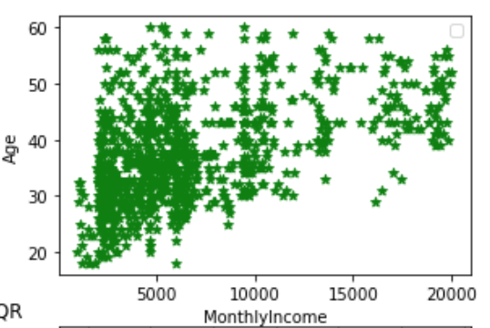
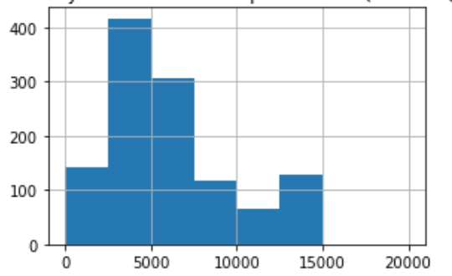
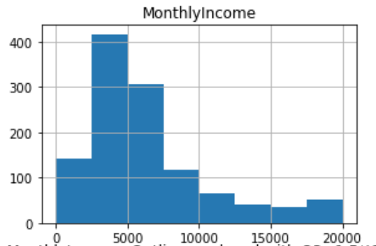
Just like in ‘section 2.2’, all the attributes except “MonthlyIncome” have a limited domain, ranging from 0 to 40 (TotalWorkingYears). “MonthlyIncome’s" outliers are all above the Q3 + 1.5 * IQR threshold and identify employees with an income greater than 14775.125 up to a maximum of 19.999. We evaluated the semantic accuracy of these values ​​by considering the correlations with “Age” and “YearsAtCompany” equal to 0.50 and 0.51 respectively, coming to the conclusion that the anomalies do not represent errors but simply an isolated group of employees, equal to 7.56% with higher income. From the scatter graph, we can see that the cluster of employees with higher income corresponds to the older ones. We decided so, to replace anomalies by assigning them an appropriate value. In the first analysis we replaced the outliers by assigning them the threshold value Q3 + 1.5 * IQR, but at the same time this extreme binning altered the distribution.

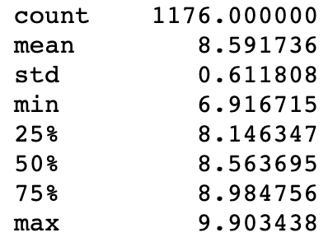
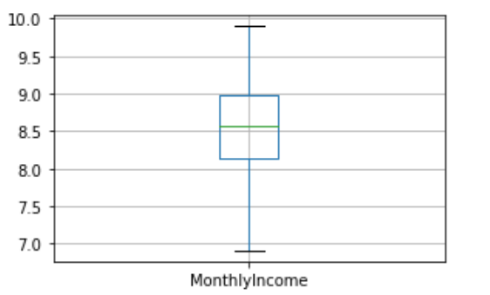
We decided to apply a logarithmic transformation which, in addition to significantly improving the mean and standard deviation, brought the outliers back within the thresholds, without affecting the correlation.

The remaining attributes have a very narrow domain and a limited number of anomalies.
We tried to eliminate outliers to understand how much the statistics could be improved, unfortunately the results were negligible: the mean and the standard deviation underwent not significant fluctuations. Considering the lack of correlation with other attributes and the limited number of detections in the dataset, we decided not to eliminate those anomalies.

2.3.3 Pairwise correlations and dimension reduction
The following table shows the correlations between attributes in the dataset after the quality assessment. The “Over18" and “StandardHours” attributes have been removed because of their uselessness as they only contained a domain value. Furthermore, “Over18” is redundant because of the “Age” variable.
In general, most of the attributes are very unrelated, except for some isolated cases such as “JobLevel” and “TotalWorkingYears” (with a 0.73), whose size could also be reduced. The attributes “YearsInCurrentRole", “YearsSinceLastPromotion” and “YearWithCurrManager” are redundant and have been merged on an average basis, inside the “YearsState” class.

