Bike Sharing dataset is available on Kaggle and UCI Machine Learning Dataset

Below are the steps followed in performing the Data Exploration and Wrangling to better understand and make meaningful conclusions.

1. Check if there are any null values, to replace those with zeros or remove the rows with null values.

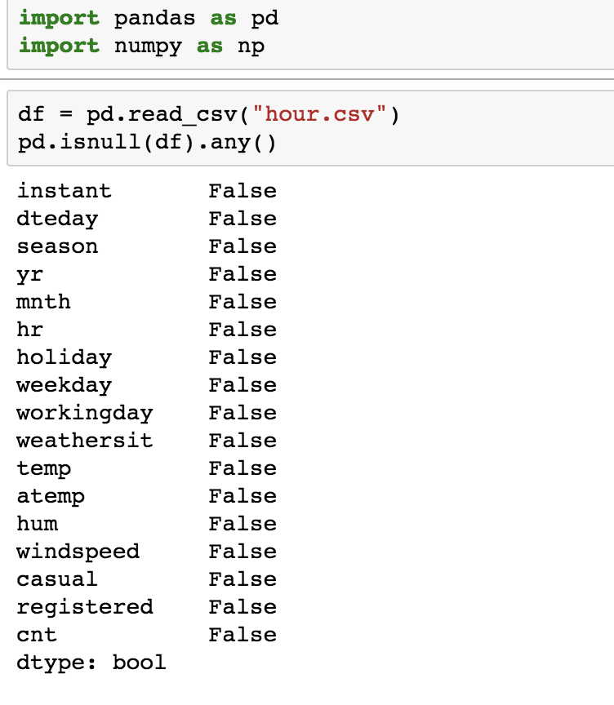

Dataset used does not have **null** values.

1. Check if the columns names and types are appropriate

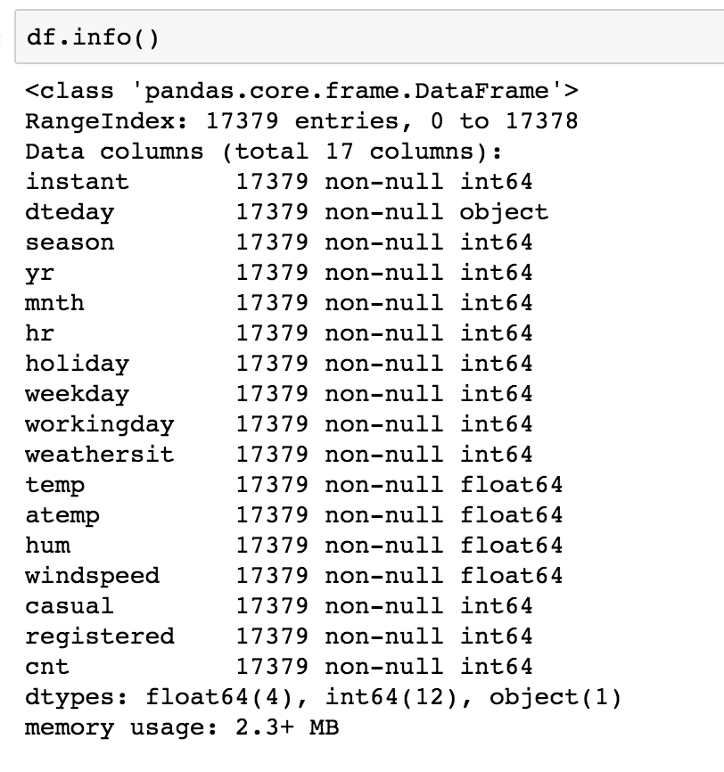

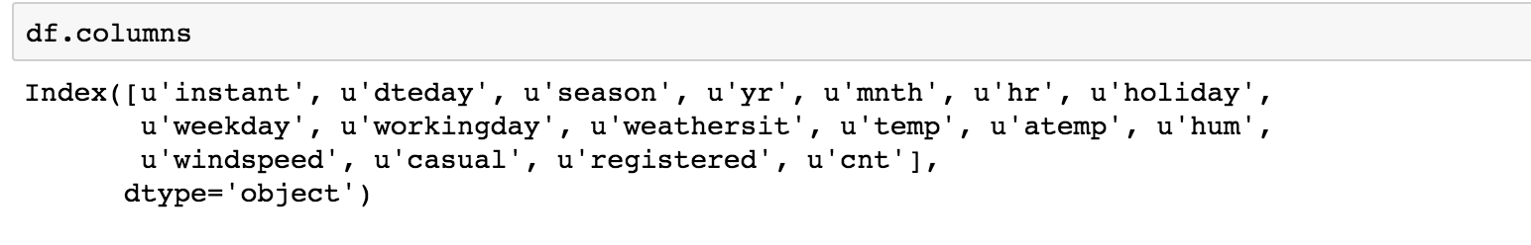

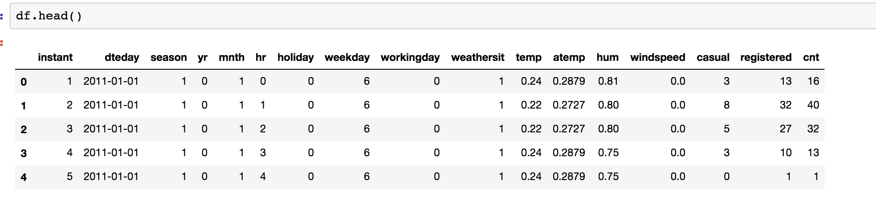

The date column with Name dteday can be modified to **datetime,** to perform dataslicing and resampling etc.

1. Convert the dteday to **datetime** and delete the column.

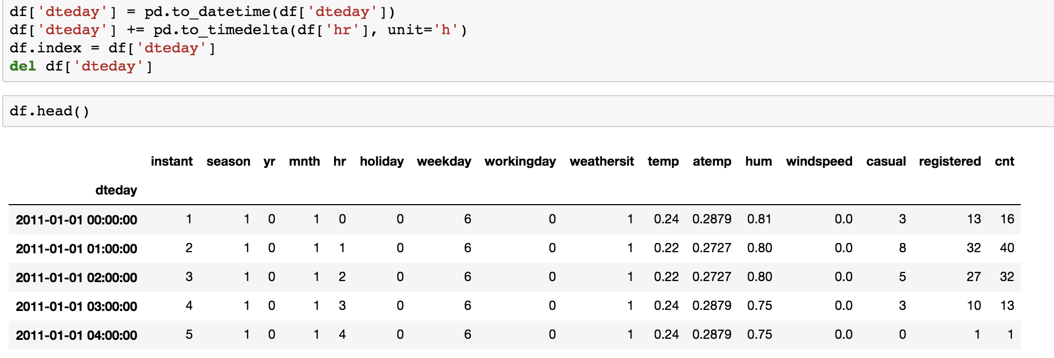

1. Column Names can also be changed to make them more clear for understanding.

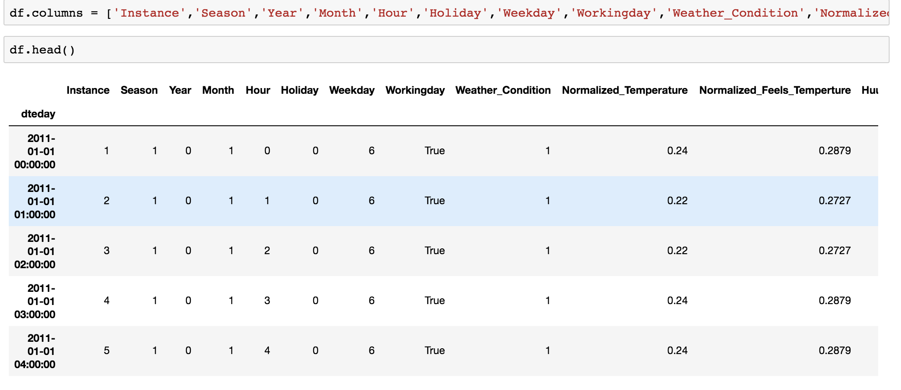

1. Some more exploring to see the variation in demand by Day.

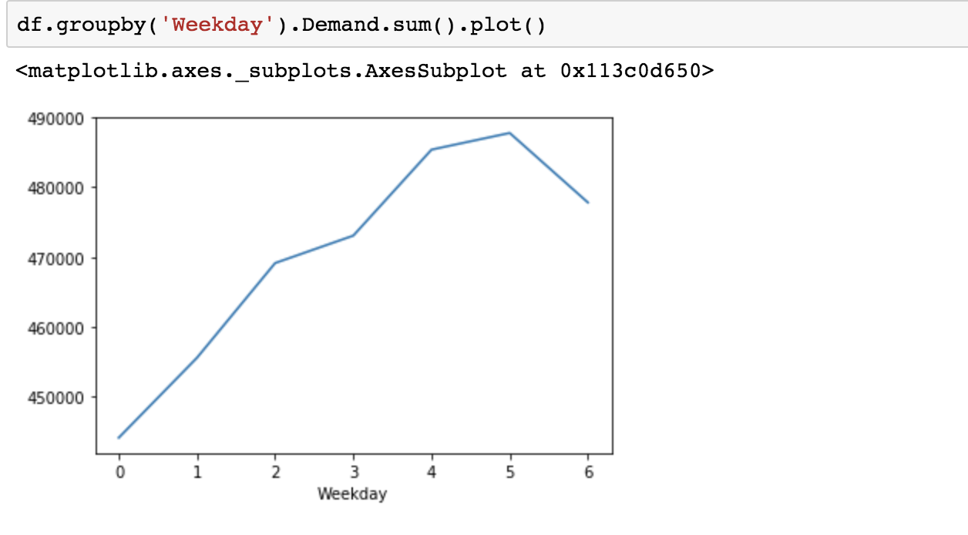

1. Check if Casual demand Exceeds Registered demand and How it varies.

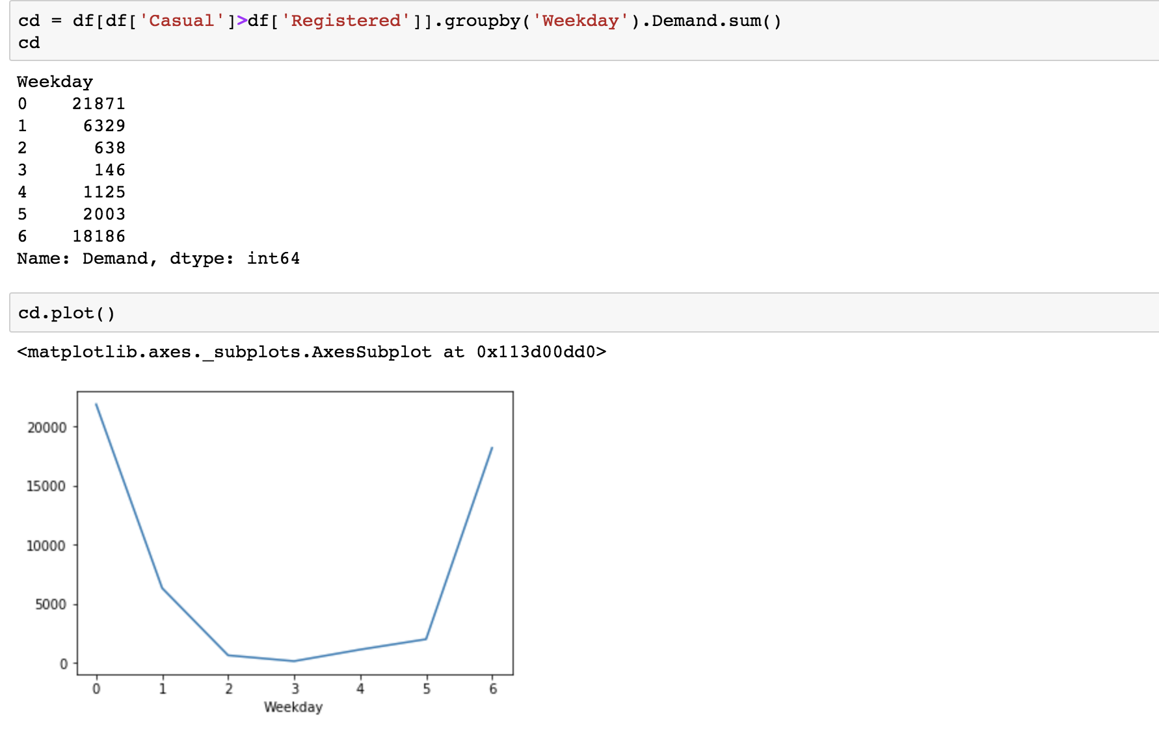

1. Create a Column to see which part of the day (Hours : 0-7(Early Morning), 8-15(During Day), 16-23(Evening))

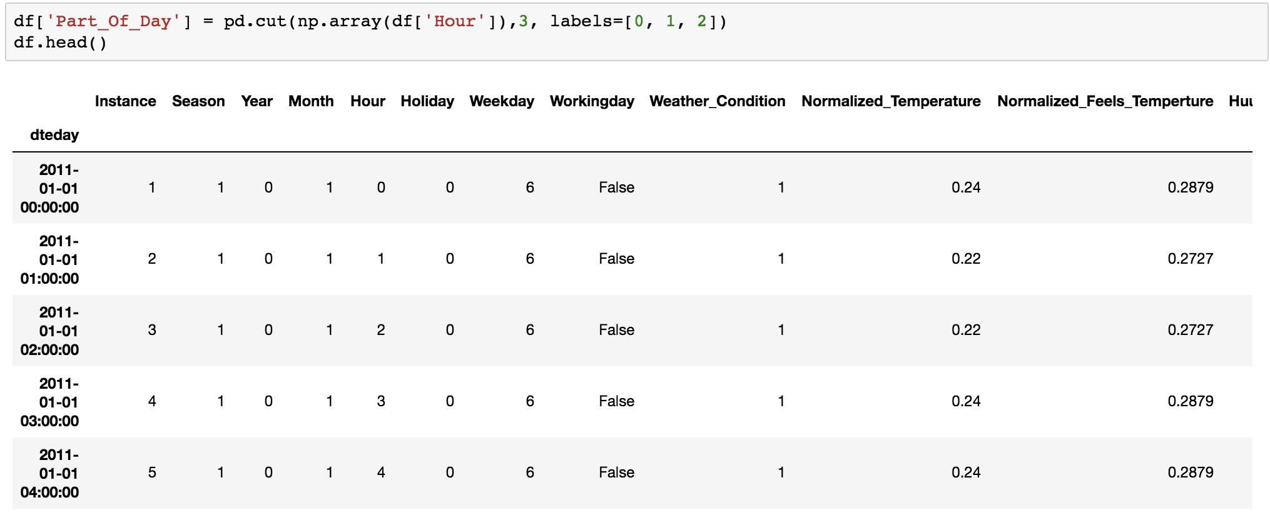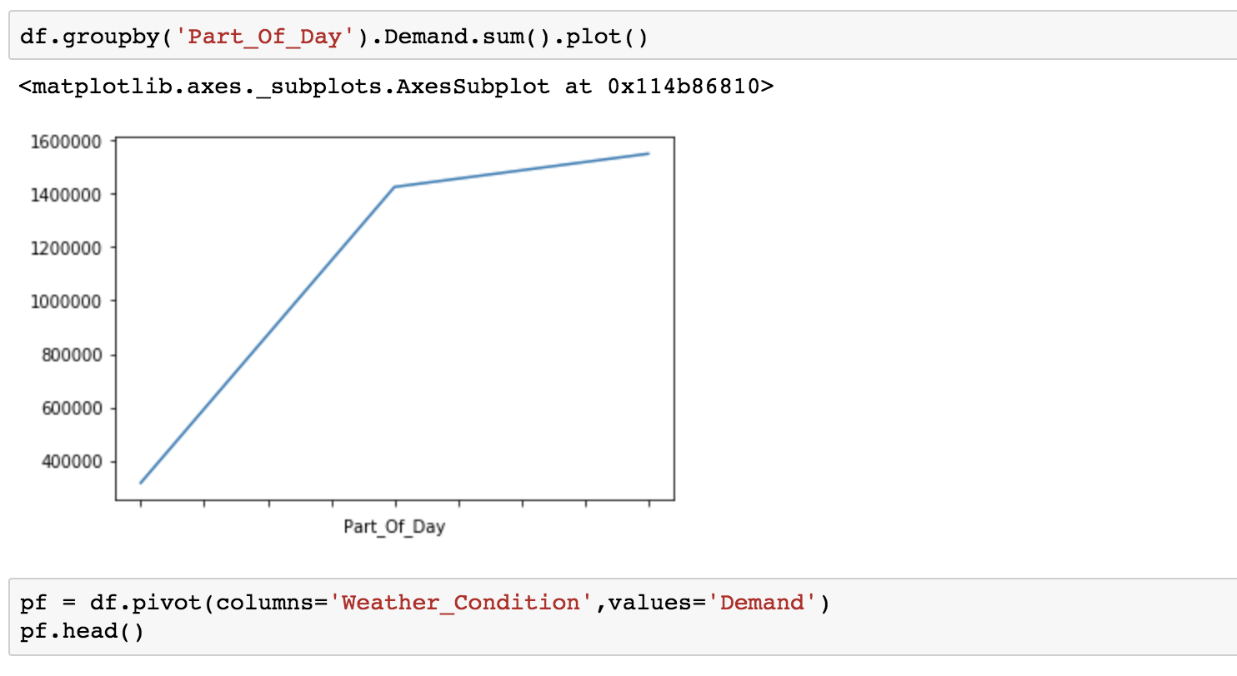

1. Working Day column is of type int with values 0 and 1, this can be appropriately updated to be a Boolean

