Bike Sharing dataset is available on Kaggle and UCI Machine Learning Dataset.

Below are some of the Inferential Statistics Applied on the dataset.

1. Performed ECDF for 2011 data and 2012 data

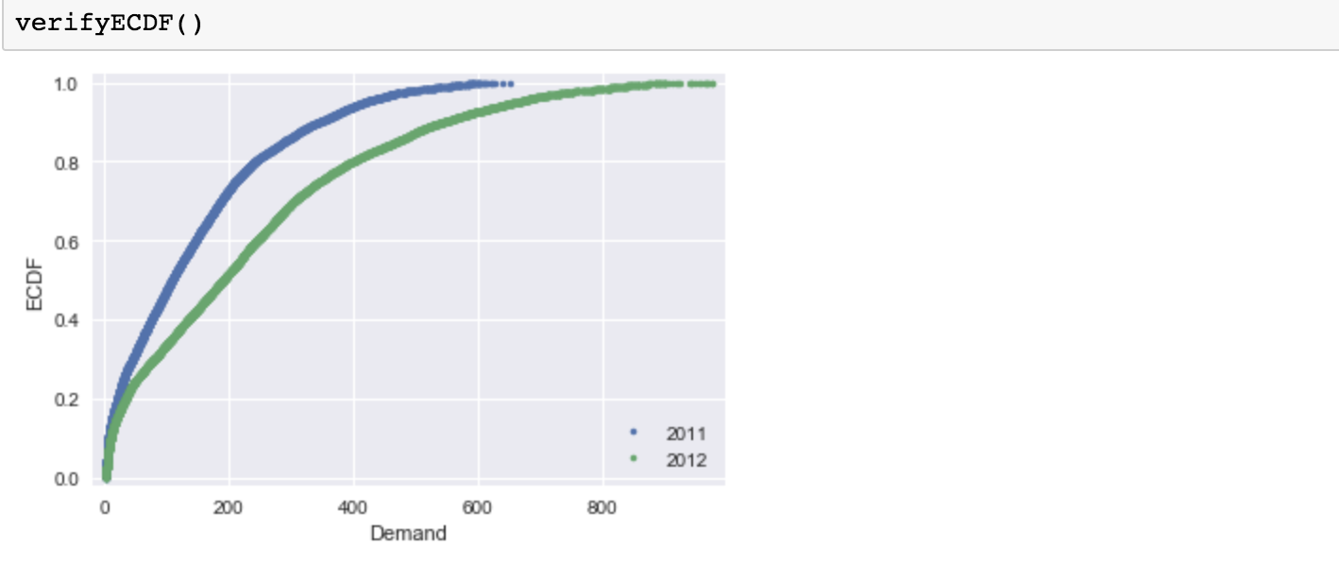

1. Swarm Plot Of 2011 and 2012 data

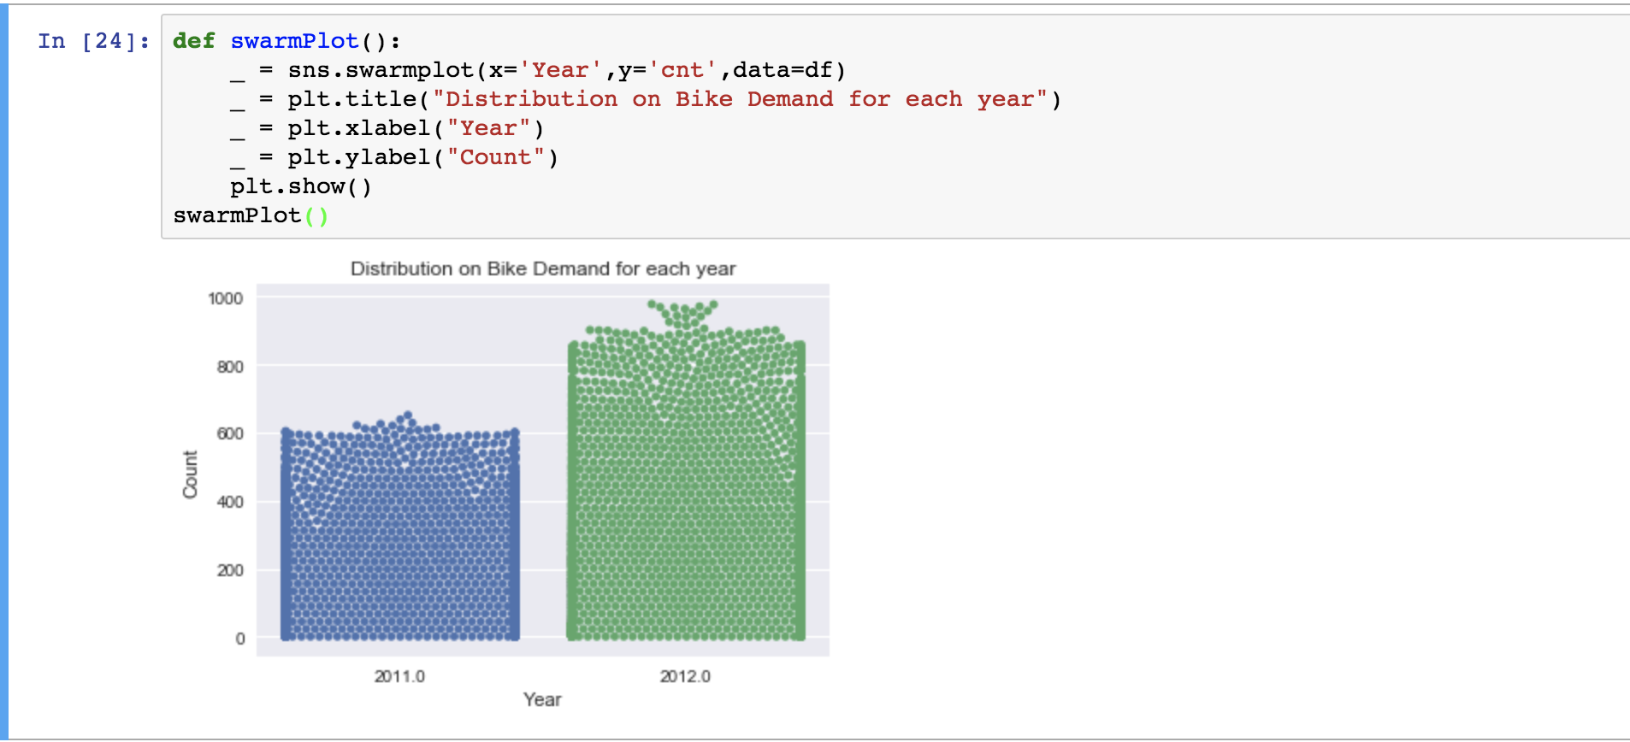

1. Parameter Estimates with bootstrap 
2. Demand in Casual and Registered rentals in year 2011 and 2012

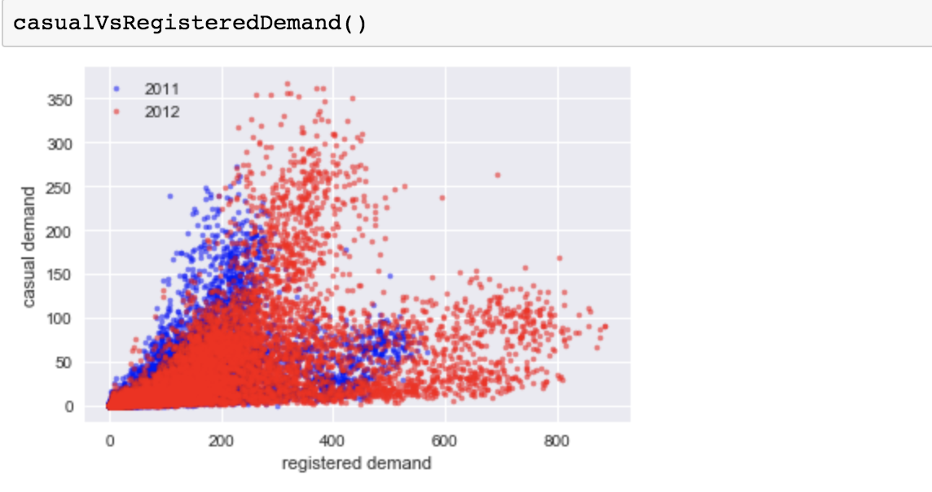

1. Compute Linear Regression, with paired bootstrapping

