Case_Study

1)Forked project from  [shubhamkushwah123/batch10](https://github.com/shubhamkushwah123/batch10)

2)Current Repo where Docs exists and used as git repo for entire project: <https://github.com/samudra-basu5/batch10>

3)Checking out code from git Repo

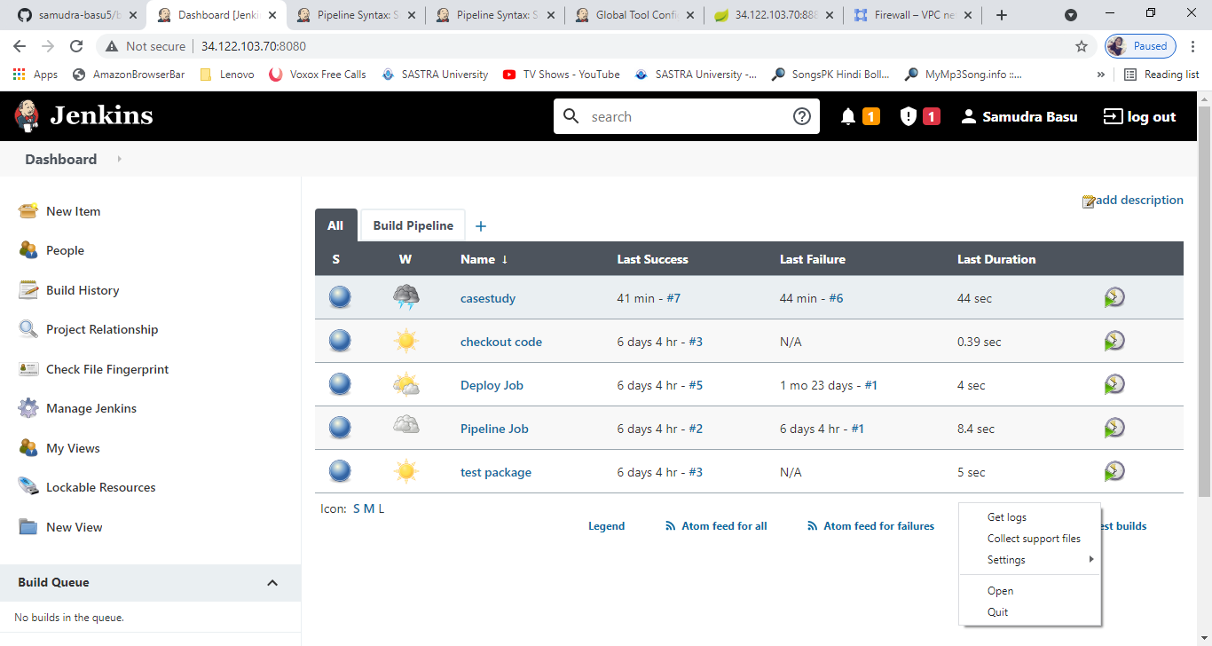

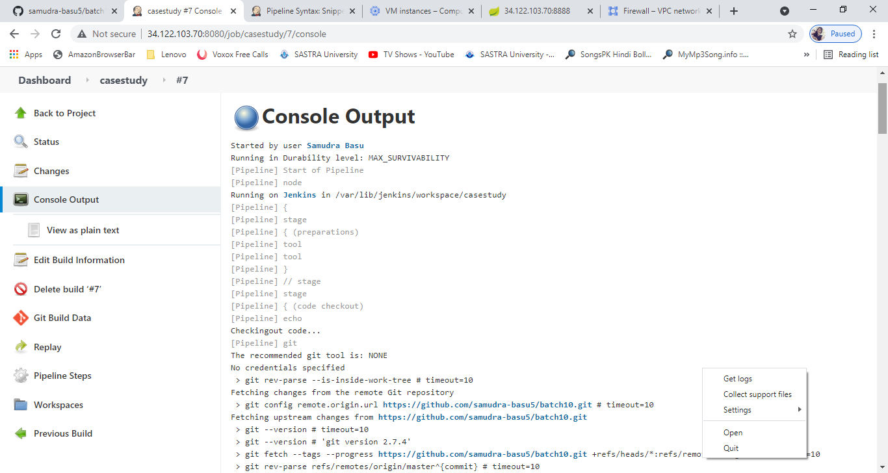

Jenkins runtime maven plugin

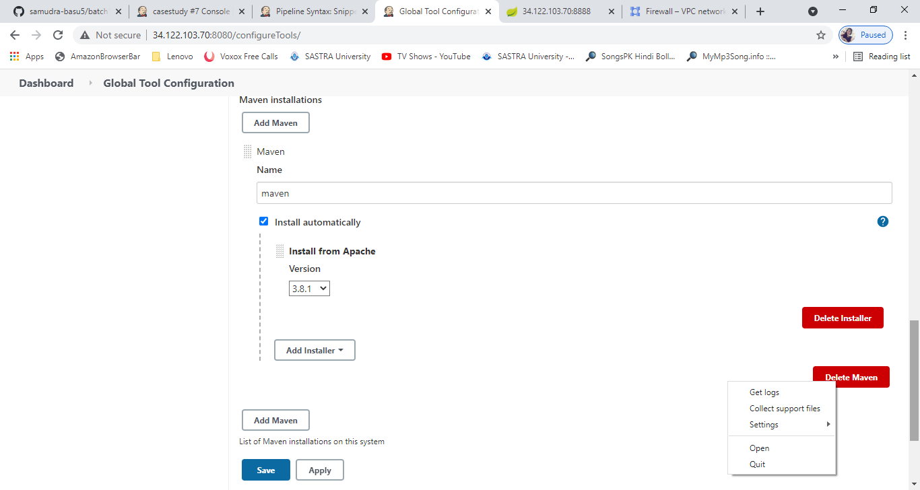

Test and package

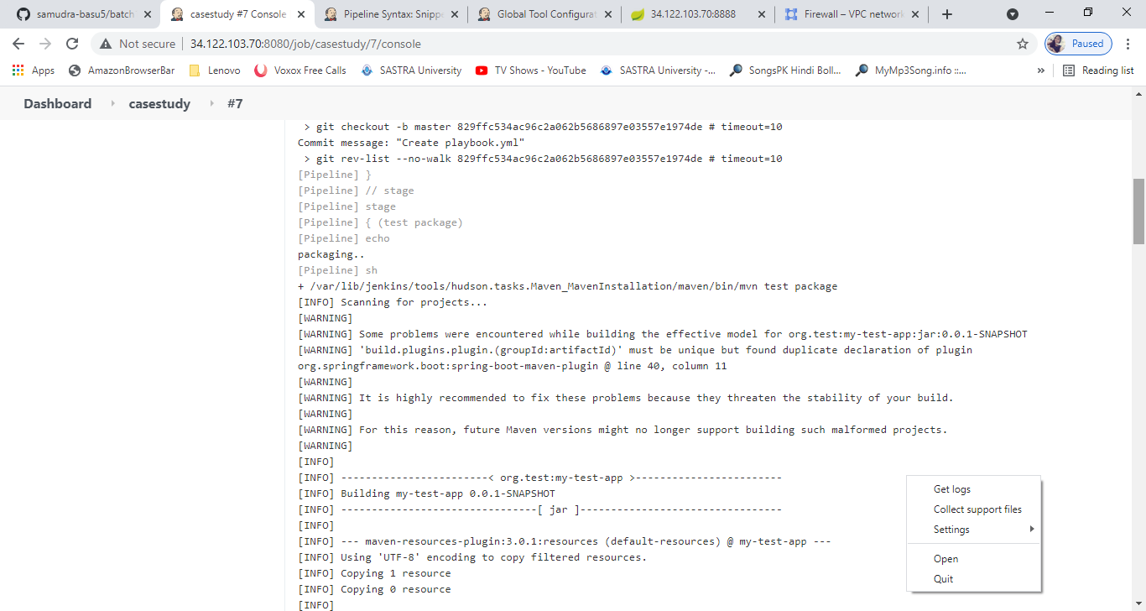

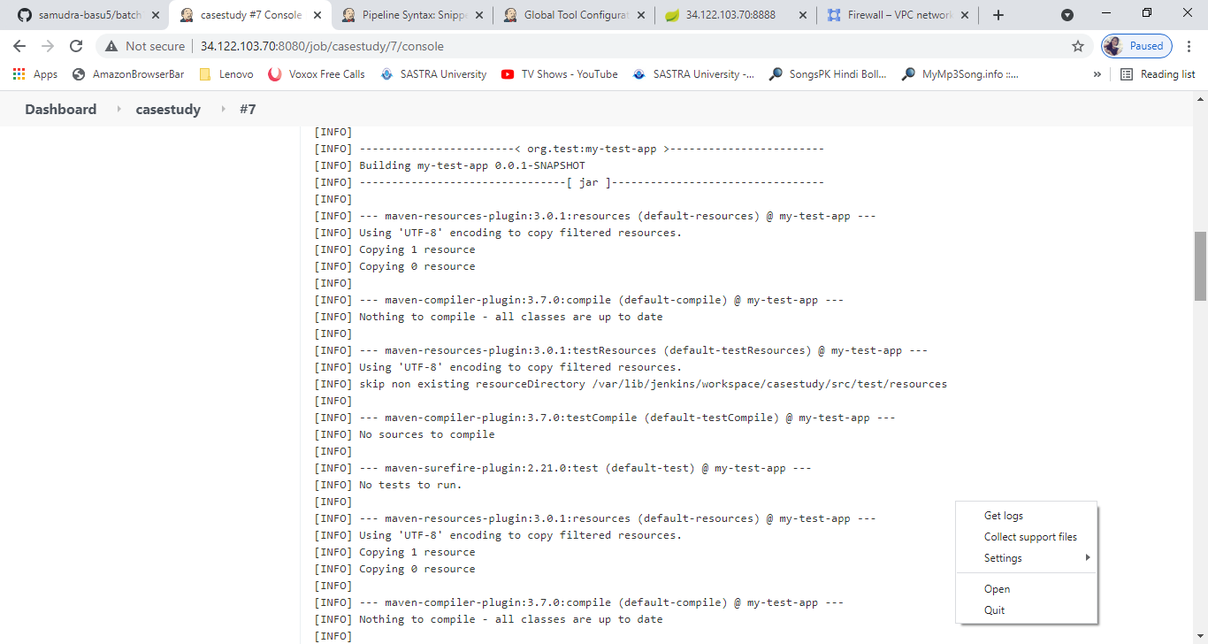

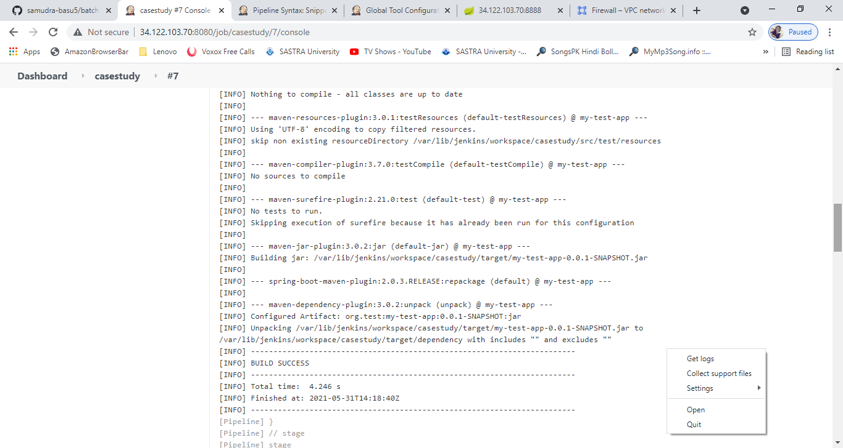

Building Image

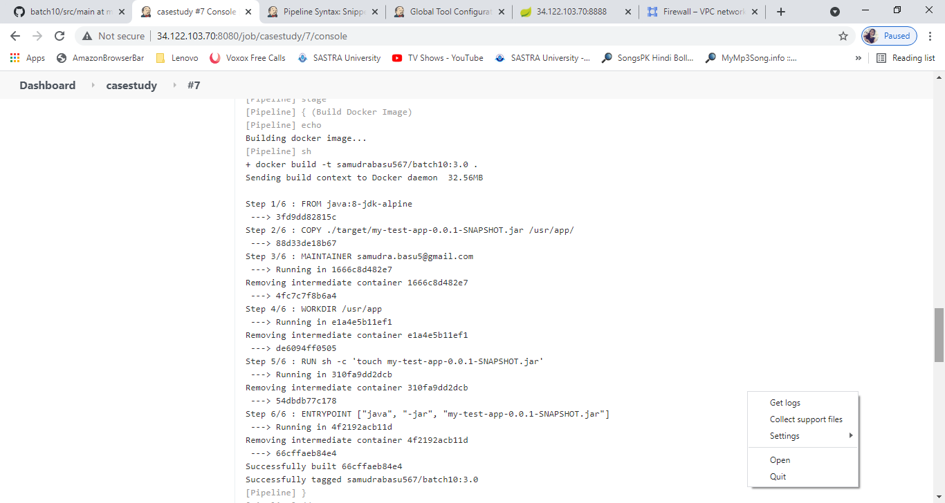

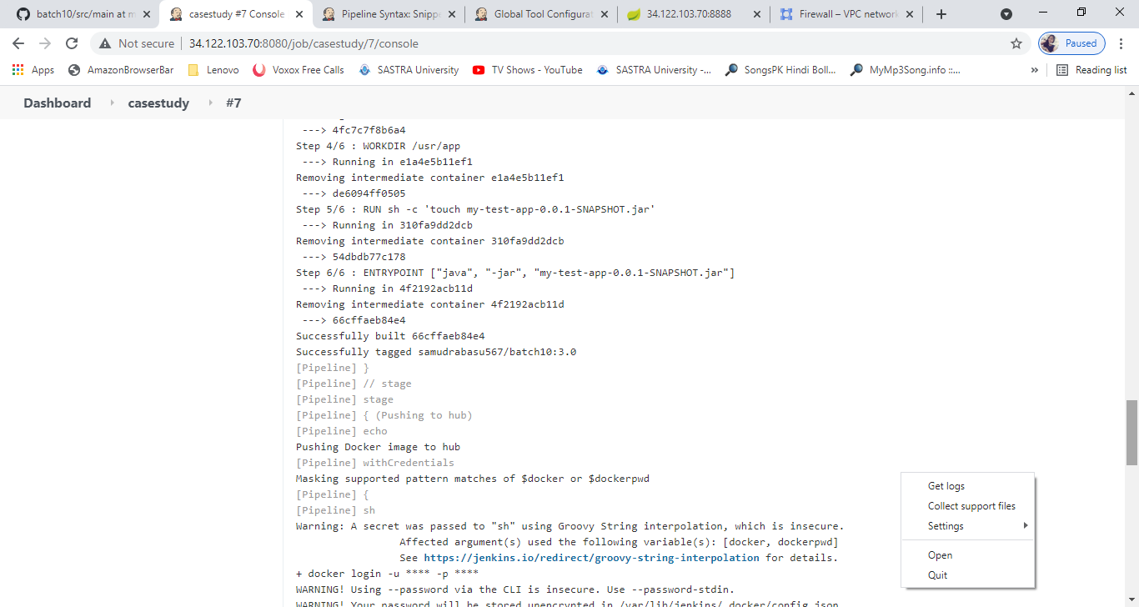

Pushing to hub

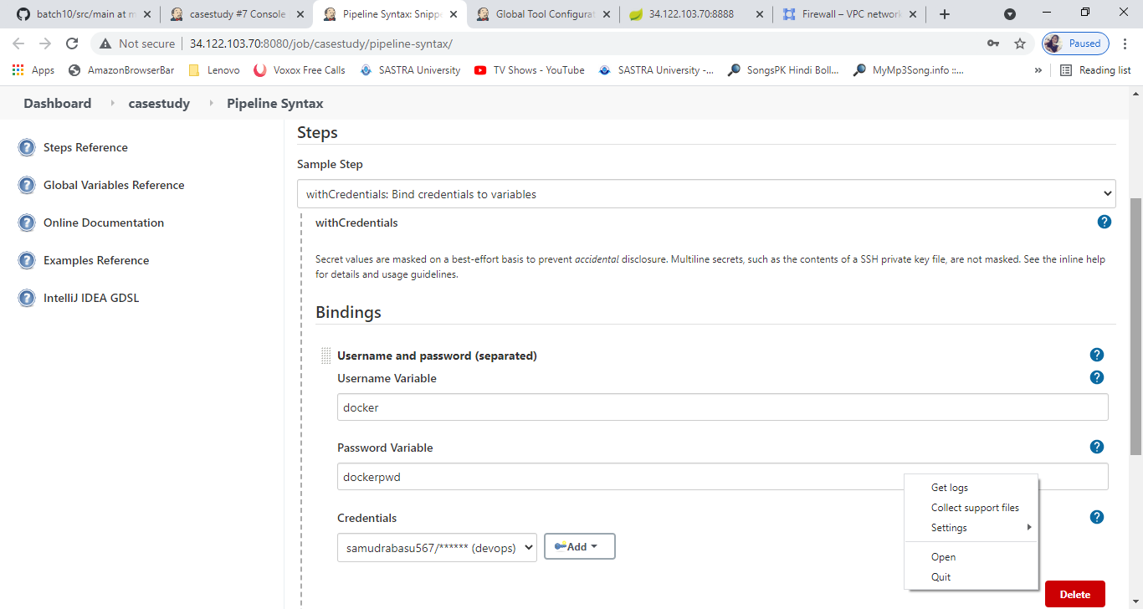

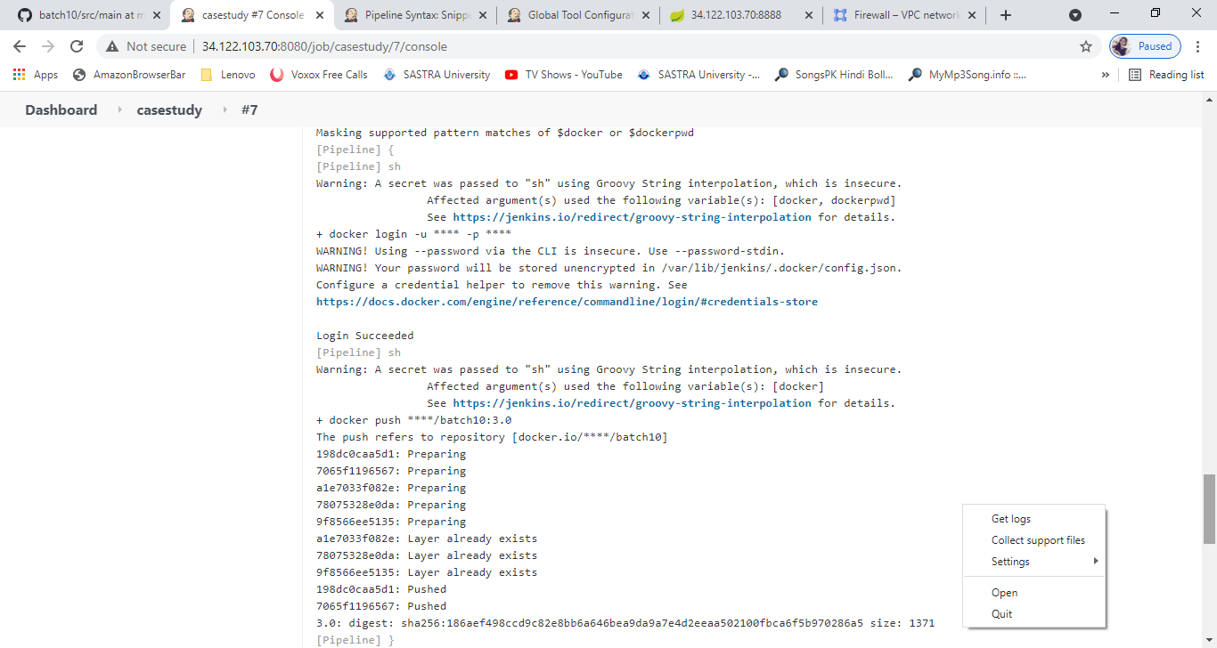

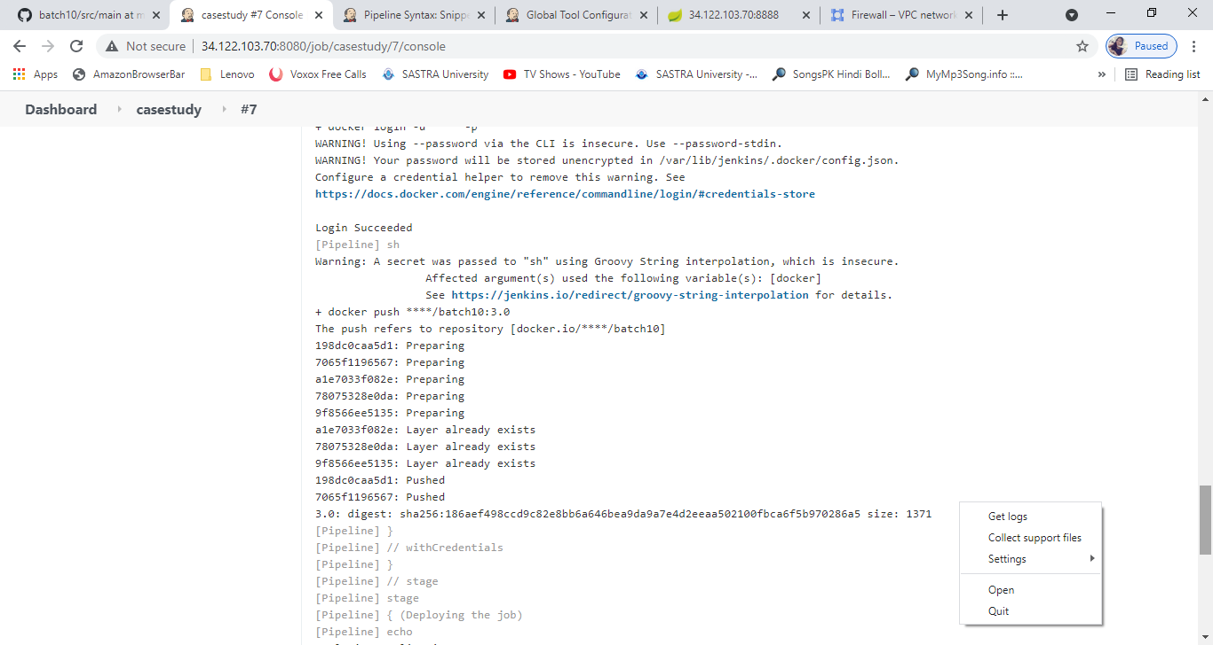

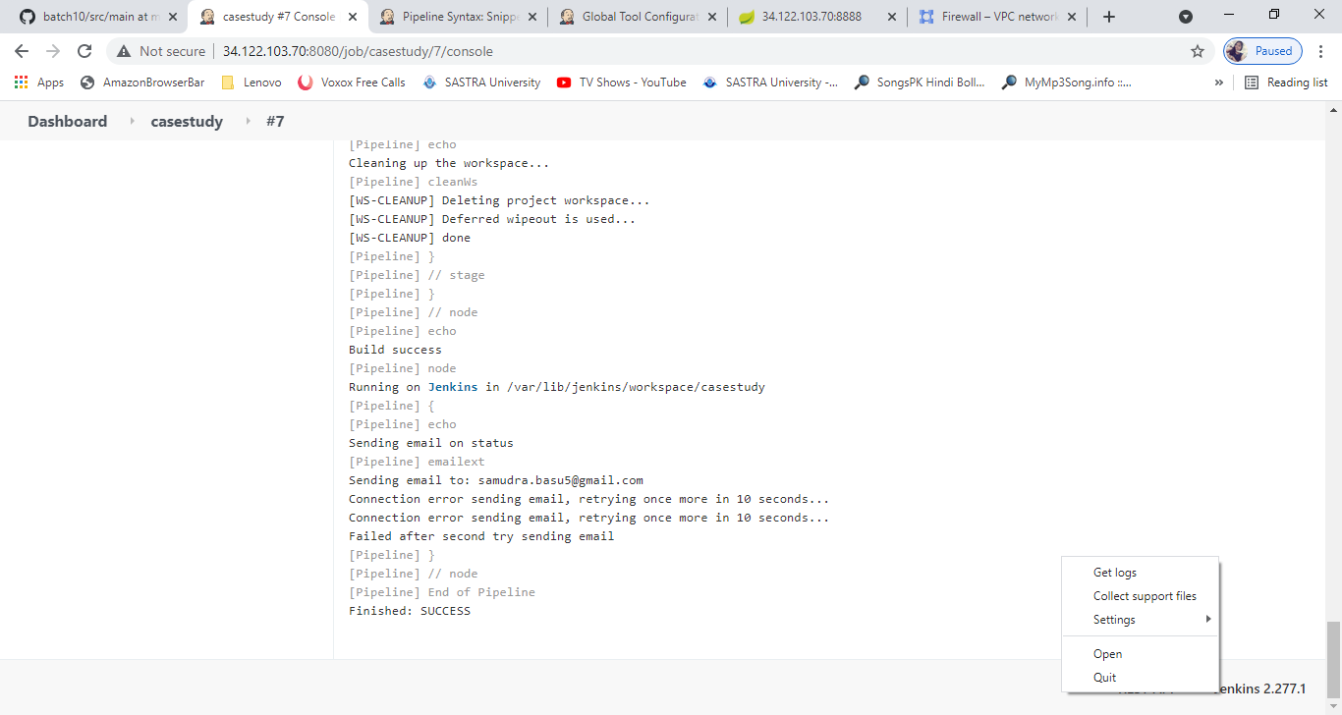

Ansible plugin

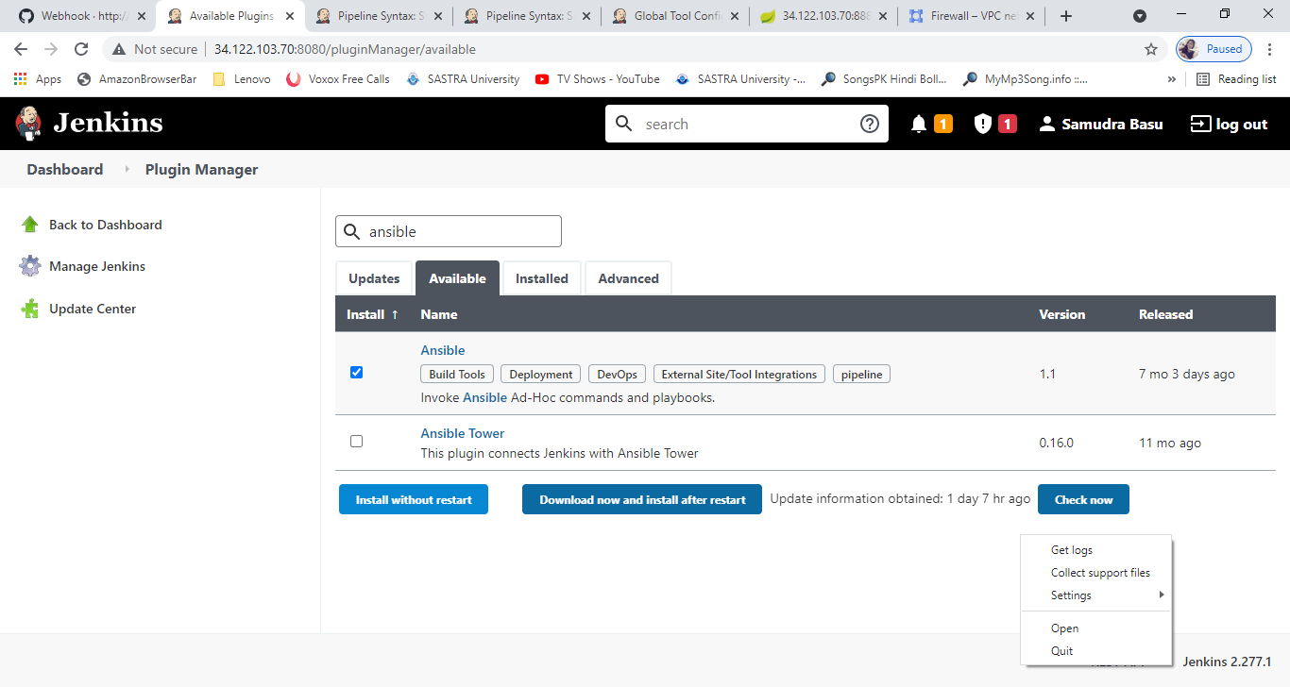

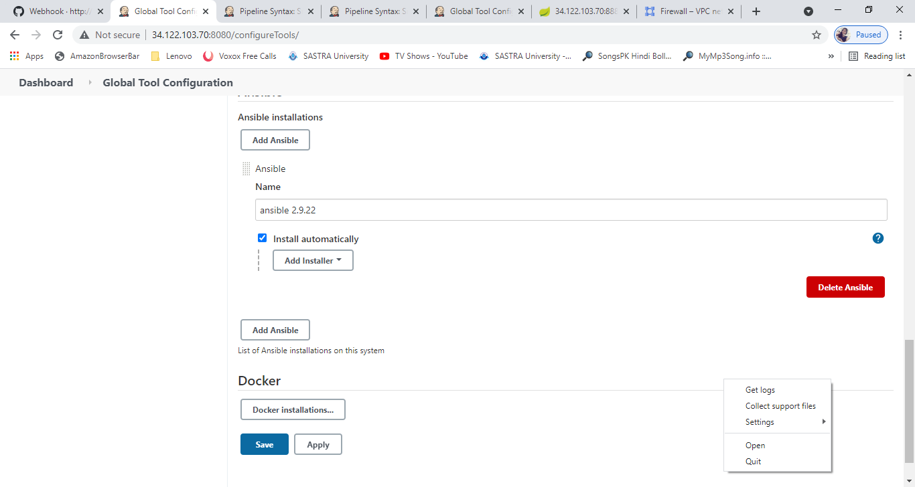

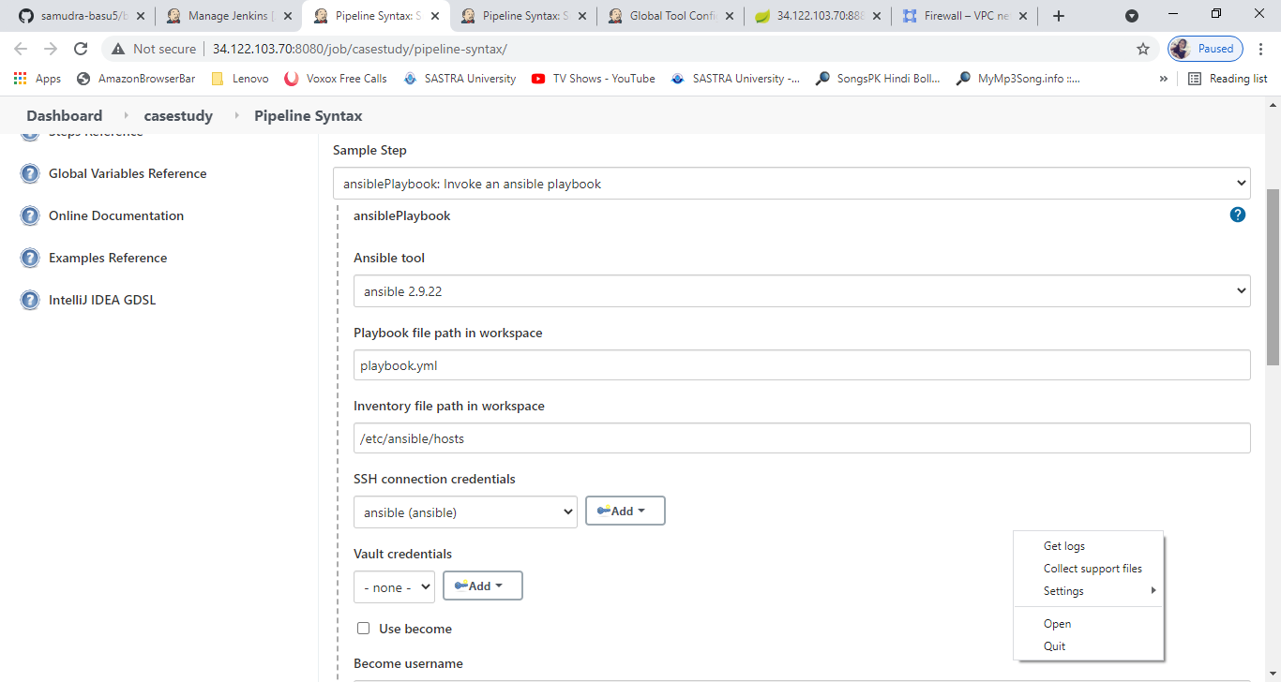

BUILD PIPELINE

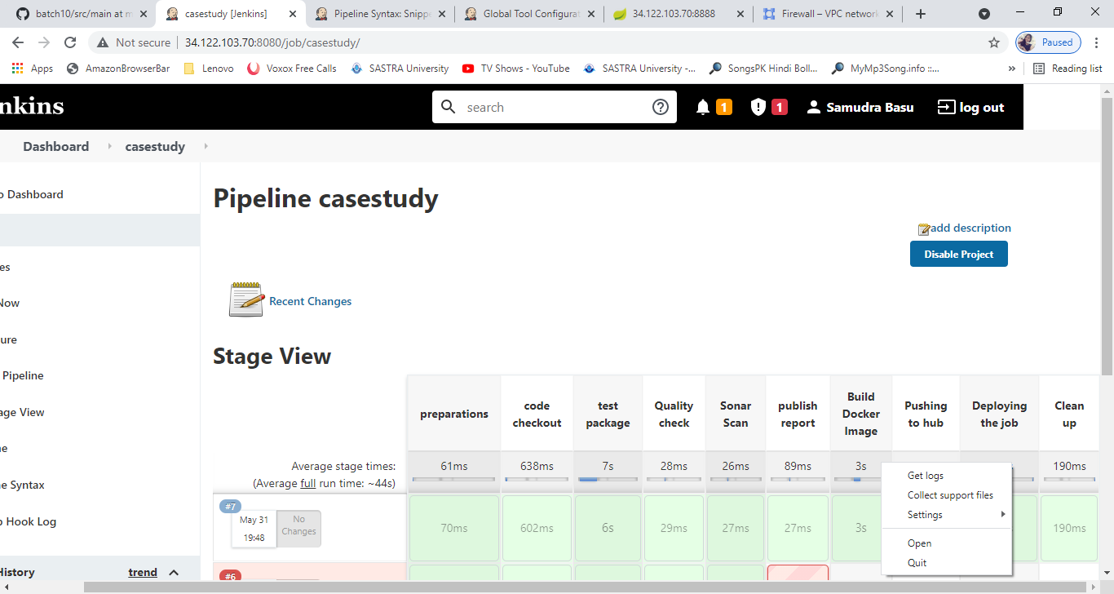

web hook

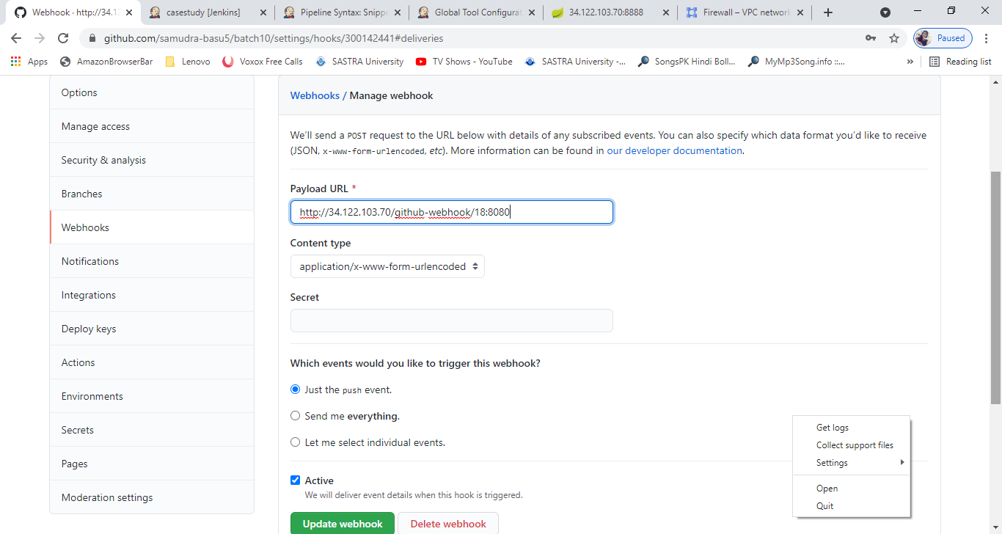



Pipeline Code:

try{

node{

def mavenHome

def mavenCMD

def dockerHome

def dockerCMD

def tagName = "3.0"

stage('preparations'){

mavenHome = tool name: 'maven', type: 'maven'

mavenCMD= "${mavenHome}/bin/mvn"

docker = tool name: 'docker', type: 'org.jenkinsci.plugins.docker.commons.tools.DockerTool'

dockerCMD = "$docker/bin/docker"

}

stage('code checkout'){

echo "Checkingout code..."

git 'https://github.com/samudra-basu5/batch10.git'

}

stage('test package'){

echo "packaging.."

sh "${mavenCMD} test package"

}

stage('Quality check'){

echo("Quality of code...")

// sh "${mavenCMD} -f pom.xml sonar:sonar"

}

stage('Sonar Scan'){

echo "Scanning application..."

//sh "${mavenCMD} sonar:sonar -Dsonar.host.url=http://xx.xxx.xx.xx:9000"

}

stage('publish report'){

echo " Publishing HTML report.."

publishHTML([allowMissing: false, alwaysLinkToLastBuild: false, keepAll: false, reportDir: '', reportFiles: 'index.html', reportName: 'HTML Report', reportTitles: ''])

}

stage('Build Docker Image'){

echo "Building docker image... "

sh "docker build -t samudrabasu567/batch10:${tagName} ."

}

stage('Pushing to hub'){

echo "Pushing Docker image to hub"

withCredentials([usernamePassword(credentialsId: 'devops', passwordVariable: 'dockerpwd', usernameVariable: 'docker')]) {

// some block

sh "docker login -u samudrabasu567 -p ${dockerpwd}"

sh "docker push samudrabasu567/batch10:${tagName}"

}

}

stage("Deploying the job")

{ echo "Deploying application"

ansiblePlaybook credentialsId: 'ansible', installation: 'ansible 2.9.22', inventory: '/etc/ansible/hosts', playbook: 'playbook.yml'

}

stage('Clean up'){

echo "Cleaning up the workspace..."

cleanWs()

}

}}

catch(Exception err){

echo "Exception occured..."

echo "Sending email to user..."

(currentBuild.result="FAILURE") && node("master"){

emailext body: 'Build failed due to some exceptions....', subject: 'Build Result', to: 'samudra.basu5@gmail.com'

}

//send an failure email notification to the user.

}

finally {

echo "Build success"

(currentBuild.result!="ABORTED") && node("master"){

echo "Sending email on status"

emailext body: 'Build Success!!!!', subject: 'Build Result', to: 'samudra.basu5@gmail.com'

}

//send an failure email notification to the user.

}

Output of application:

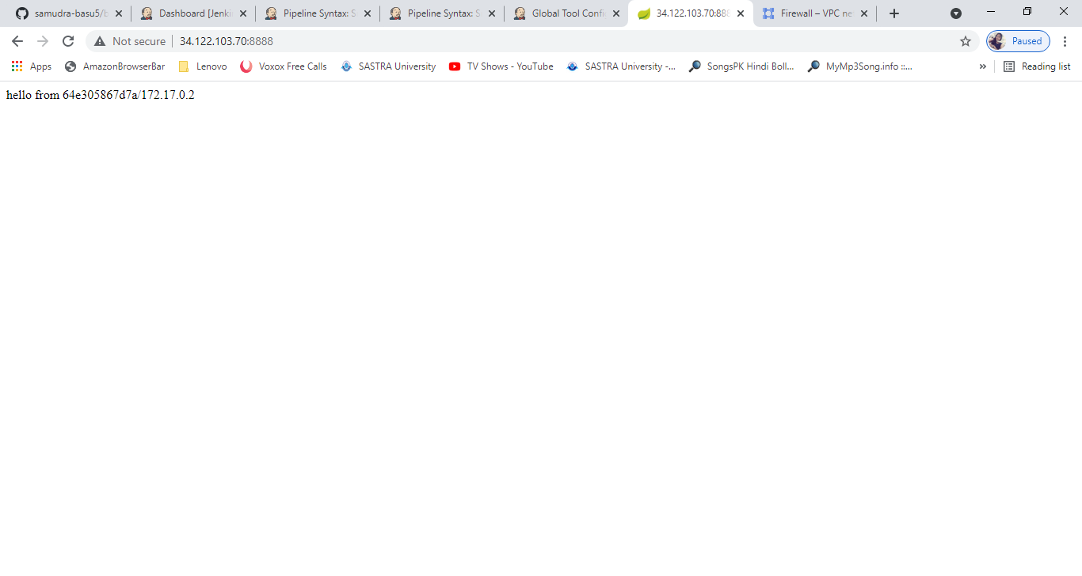

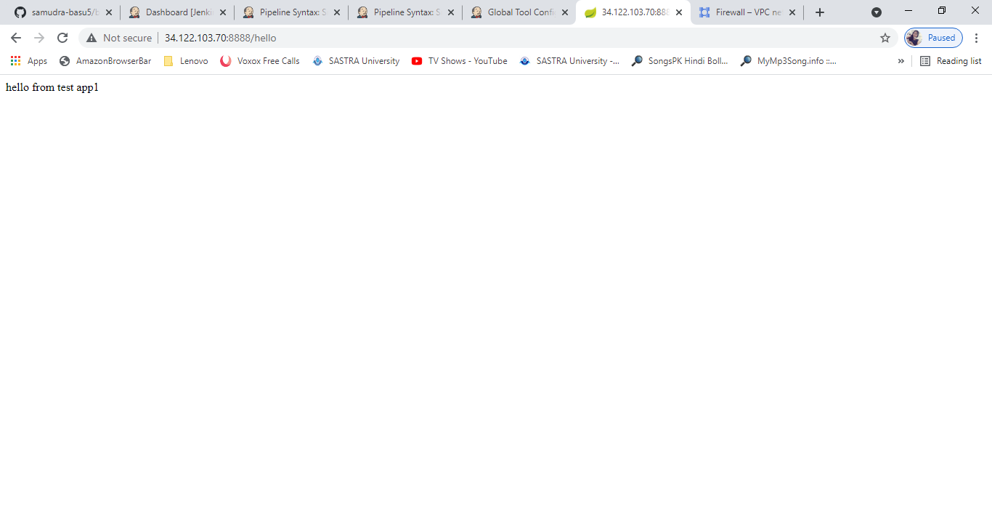

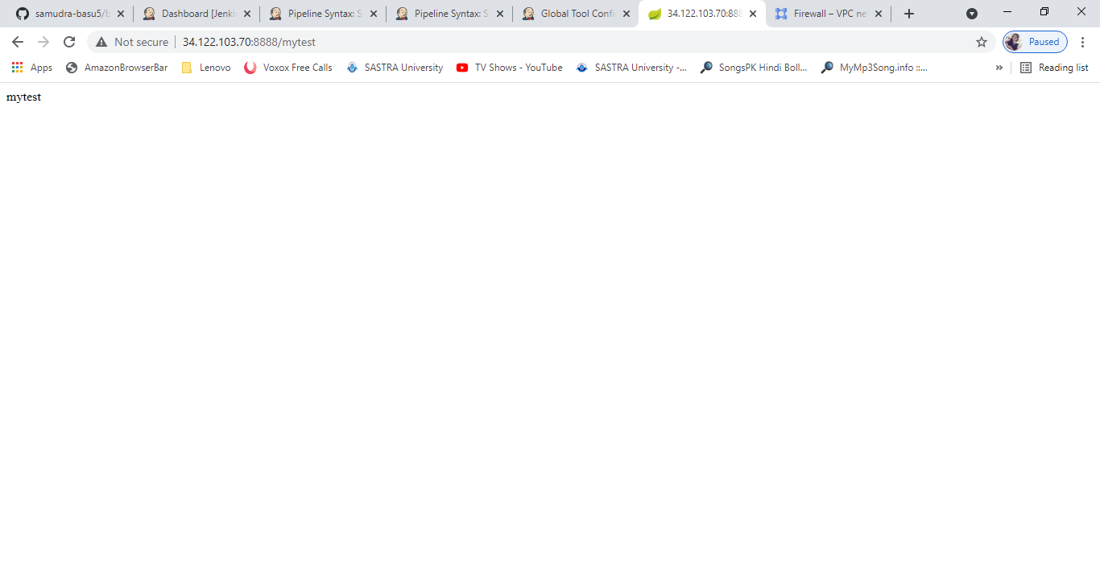

--------------------END-----------------------------