SAURIENT

Carbon Passport Platform
PoC Demo Storyboard
From industrial data to verified carbon intelligence
MEASURE | CALCULATE | VERIFY | PASSPORT | REPORT

Primary Demo Story: One steel batch becomes a trusted digital Carbon Passport
Visual edition: each scene now includes a UI mockup illustrating the intended investor-facing screen and interaction.
Audience: Government • Investor • Industry • Verifier

1. Purpose of the PoC
Objective: Demonstrate a believable, end-to-end carbon data journey rather than a collection of disconnected dashboards.
Core Story: Factory and supply-chain data is captured, converted into Scope 1/2/3 emissions, allocated to a product, independently reviewed, issued as a digital Carbon Passport, and surfaced to buyers, exporters and government.
Primary Demo Product: Steel Coil — Batch ST-2026-00981, manufactured at a Hyderabad facility and prepared for an EU export scenario.
Key Positioning: Carbon Passport is a digital MRV and product-carbon infrastructure platform that converts industrial, supply-chain and operational data into traceable, verifiable and interoperable carbon intelligence.

2. The 10–15 Minute Golden Path
Step | Screen | What the audience understands
1 | Organisation | Who is reporting and under what boundary
2 | Facility & Assets | Where carbon-producing activity happens
3 | Live / Simulated Telemetry | Where primary operational data comes from
4 | Scope 1/2/3 | How activity becomes carbon emissions
5 | Product Carbon Footprint | How company emissions become product-level carbon
6 | Data Lineage | Why the final number is auditable
7 | MRV | How the case enters verification
8 | Verifier Review | How evidence is independently reviewed
9 | Passport Issue + QR | How the trusted digital record is issued
10 | CBAM Readiness | How export-readiness data is packaged
11 | Government Dashboard | How aggregated intelligence supports policy

A. Establish the Source of Truth
SCENE 01

The Problem
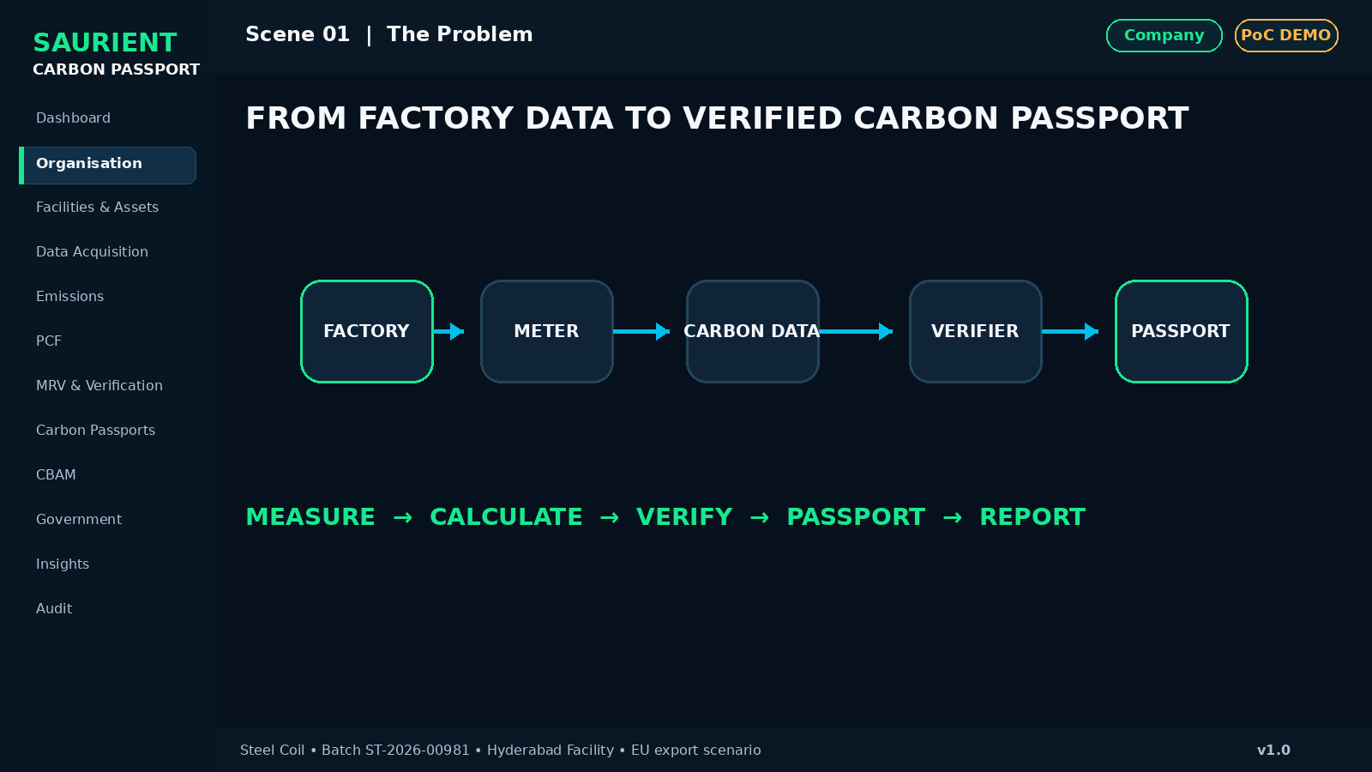
Investor visualization — Scene 01: The Problem
Screen | Hero / Opening
What appears on screen | Factory, smart meter, supply chain, exporter, verifier and government connected through one digital platform.
Why it matters | From Factory Data to Verified Carbon Passport
Key UI / metric | Industrial carbon data is fragmented across meters, ERP systems, invoices, suppliers, spreadsheets and audit documents.
Presenter narration | Today, industries collect carbon-related data from many different sources. Carbon Passport converts that fragmented information into one traceable and verifiable carbon record.
Primary action | Start Demo

SCENE 02

Meet the Demo Company
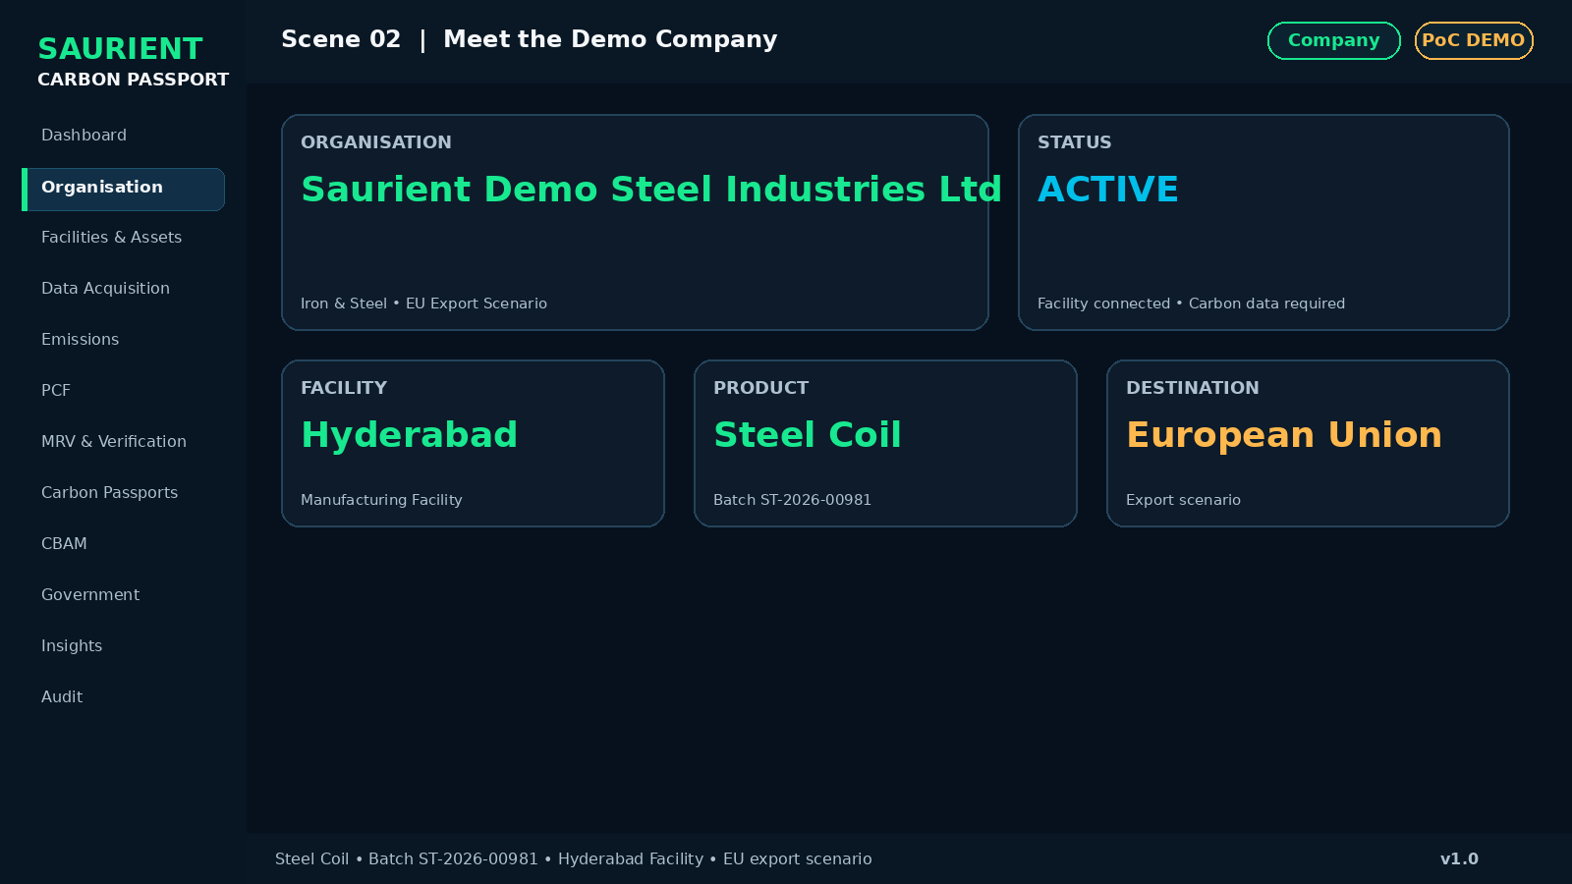
Investor visualization — Scene 02: Meet the Demo Company
Screen | Organisation Profile
What appears on screen | Saurient Demo Steel Industries Ltd; Hyderabad Manufacturing Facility; Iron & Steel; EU export scenario; connected facilities and devices.
Why it matters | A real company context before any carbon calculation begins.
Key UI / metric | Organisation Active • Facility Connected • Export Carbon Data Required
Presenter narration | Our journey starts with a steel manufacturer that needs a trusted product-level carbon record for customers, auditors and export reporting.
Primary action | Open Organisation

SCENE 03

Map the Factory
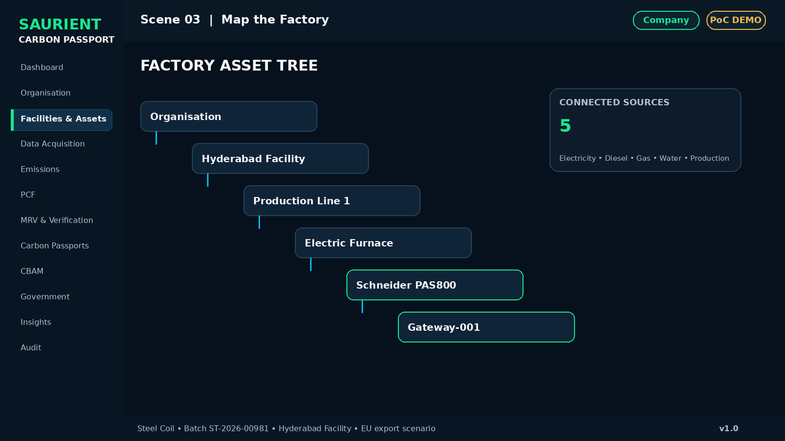
Investor visualization — Scene 03: Map the Factory
Screen | Organisation → Facility → Assets
What appears on screen | Organisation → Facility → Production Line → Furnace / Utilities → Meters & Sensors.
Why it matters | Every carbon result begins with a clear organisational and operational boundary.
Key UI / metric | Schneider PAS800 • Electricity • Diesel • Gas • Water • Production Counter
Presenter narration | We first define exactly where the emissions and production activity originate.
Primary action | View Asset Tree

SCENE 04

Live Industrial Data Arrives
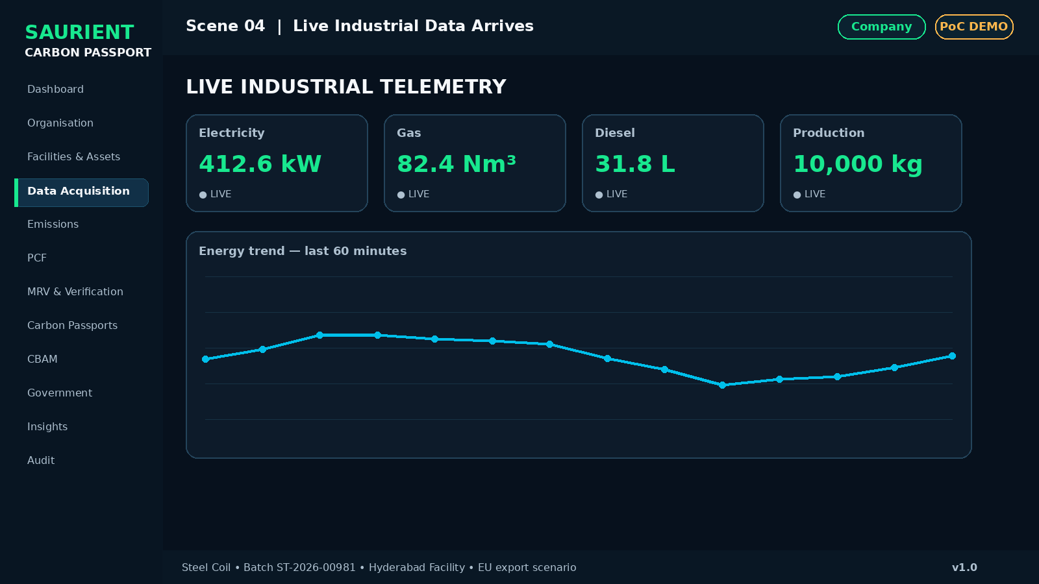
Investor visualization — Scene 04: Live Industrial Data Arrives
Screen | Data Acquisition Dashboard
What appears on screen | Animated / simulated readings for energy, power, diesel, gas, water and production quantity.
Why it matters | Carbon data can come directly from operational systems—not only spreadsheets.
Key UI / metric | LIVE TELEMETRY • clearly marked “Simulated industrial telemetry” for PoC
Presenter narration | Operational data flows from industrial systems through the gateway into the Carbon Passport data layer.
Primary action | Inspect Telemetry

SCENE 05

Data Quality Check
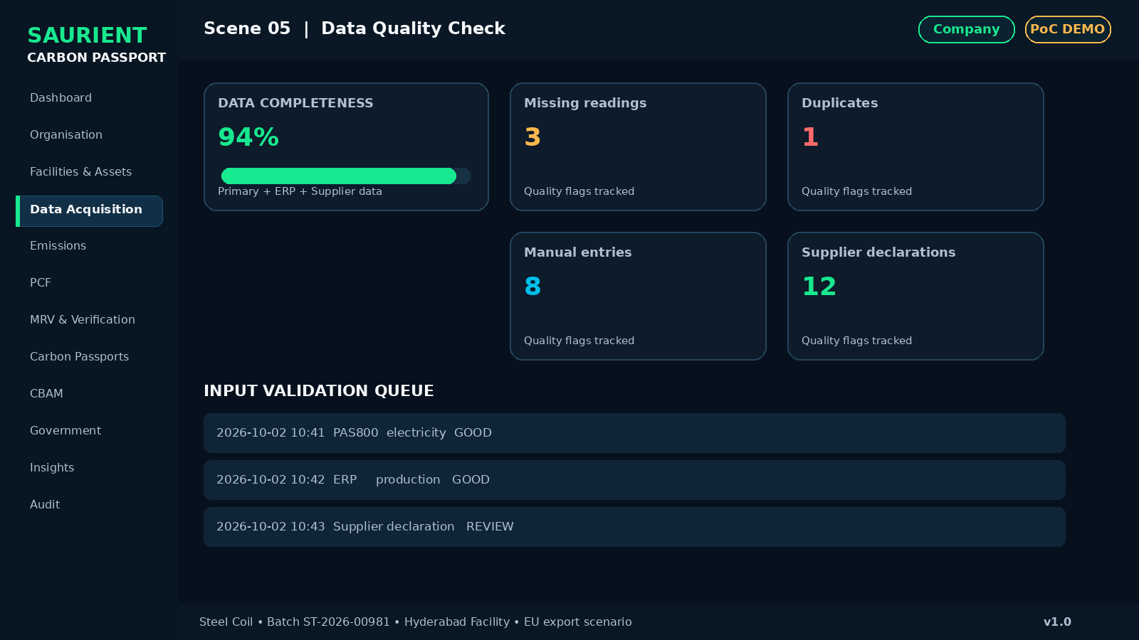
Investor visualization — Scene 05: Data Quality Check
Screen | Data Inbox / Data Quality
What appears on screen | Missing readings, duplicates, abnormal values, manual entries, device records, ERP records and supplier declarations.
Why it matters | The platform validates the input before calculating carbon.
Key UI / metric | Data Completeness 94% • Source type • Quality flag • Evidence status
Presenter narration | Before carbon is calculated, the system checks whether the underlying data is reliable and complete.
Primary action | Run Data Quality

SCENE 06

Emission Factor Registry
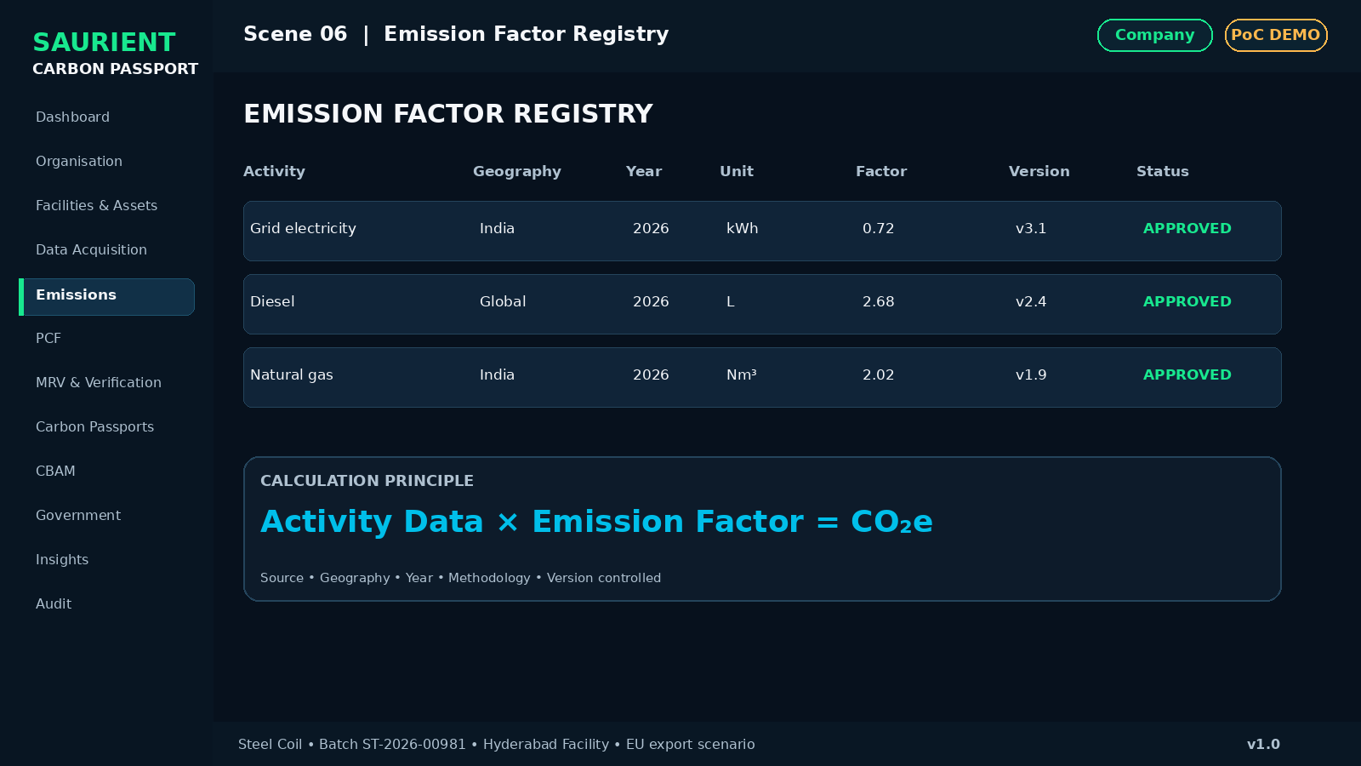
Investor visualization — Scene 06: Emission Factor Registry
Screen | Emission Factors
What appears on screen | Activity Data × Emission Factor = CO₂e. Show source, geography, year, unit, methodology, version and validity.
Why it matters | Every factor is governed and traceable.
Key UI / metric | Approved Factor • Version controlled • Geography aware
Presenter narration | Every carbon calculation can be traced back to its activity data and the emission factor used.
Primary action | Open Factor

SCENE 07

Carbon Rule Engine
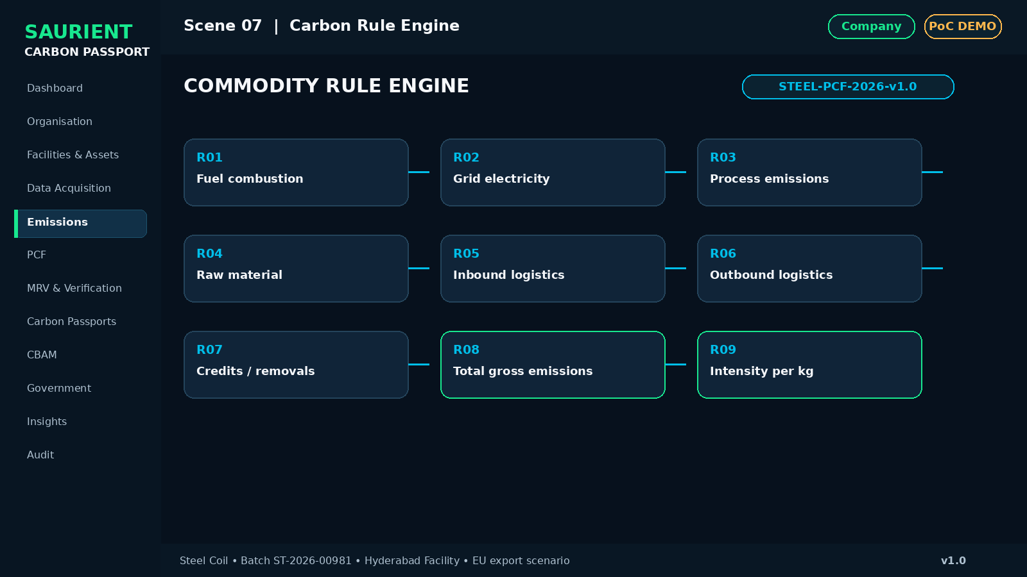
Investor visualization — Scene 07: Carbon Rule Engine
Screen | Calculation Rules
What appears on screen | Commodity-specific rules R01–R09, including total gross emissions and intensity per kg.
Why it matters | The engine is configurable, not a hard-coded calculator.
Key UI / metric | Commodity: Steel • Rule Set: STEEL-PCF-2026-v1.0
Presenter narration | Rules can be mapped to a commodity, methodology, geography or compliance requirement.
Primary action | Run Rule Set

SCENE 08

Scope 1 / 2 / 3
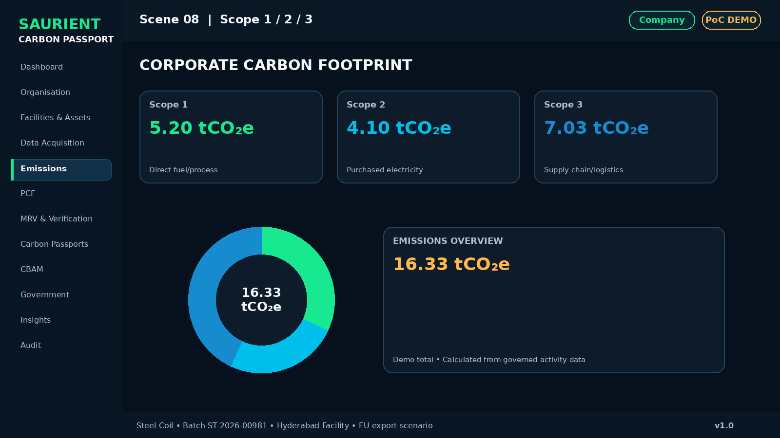
Investor visualization — Scene 08: Scope 1 / 2 / 3
Screen | Corporate Carbon Footprint
What appears on screen | Scope 1 direct fuel/process; Scope 2 purchased energy; Scope 3 supply chain/logistics.
Why it matters | Operational activity is transformed into governed carbon accounting.
Key UI / metric | Demo total: 16.33 tCO₂e • mark all figures as demo data
Presenter narration | The platform converts primary and secondary activity into Scope 1, Scope 2 and Scope 3 emissions.
Primary action | View Emissions

B. Build the Product Carbon Footprint
SCENE 09

Select the Product Batch
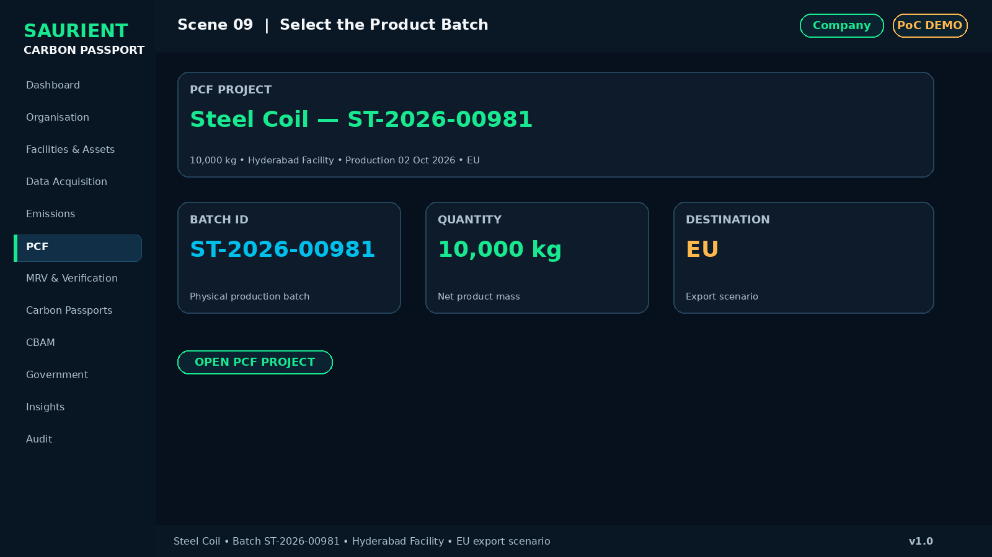
Investor visualization — Scene 09: Select the Product Batch
Screen | PCF → Projects
What appears on screen | Steel Coil ST-2026-00981; 10,000 kg; production date; facility; destination; product category.
Why it matters | The journey moves from organisation-level accounting to one physical batch.
Key UI / metric | Batch identity • Quantity • Facility • Destination
Presenter narration | Now we calculate the carbon footprint of one specific product batch.
Primary action | Open PCF Project

SCENE 10

Define PCF Boundary
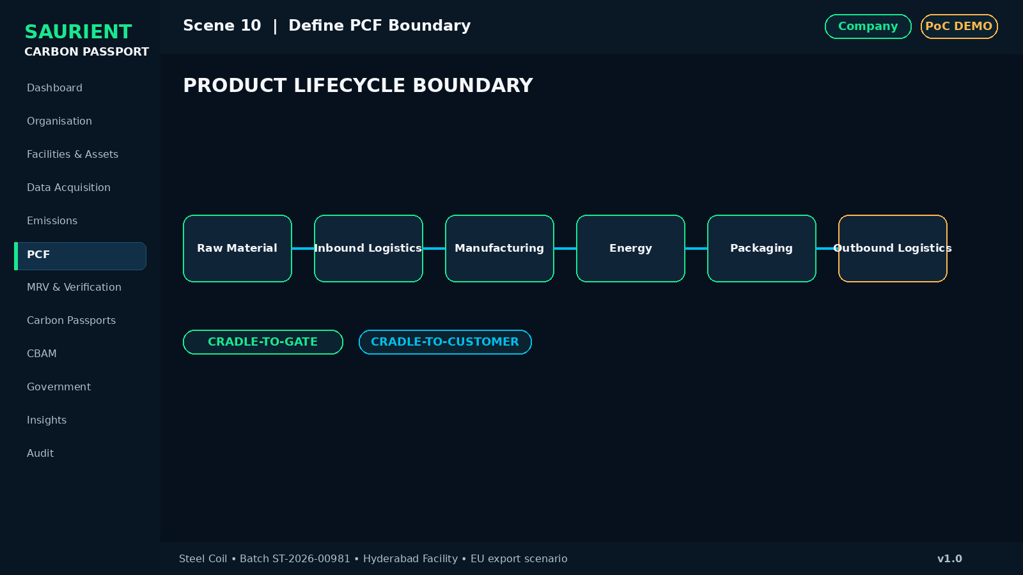
Investor visualization — Scene 10: Define PCF Boundary
Screen | PCF → Boundary
What appears on screen | Lifecycle chain: Raw Material → Inbound Logistics → Manufacturing → Energy → Packaging → Outbound Logistics.
Why it matters | The footprint is governed by an explicit lifecycle boundary.
Key UI / metric | Cradle-to-Gate / Cradle-to-Customer • Included / Excluded
Presenter narration | The selected boundary determines which lifecycle activities contribute to the product footprint.
Primary action | Confirm Boundary

SCENE 11

Build the Inventory
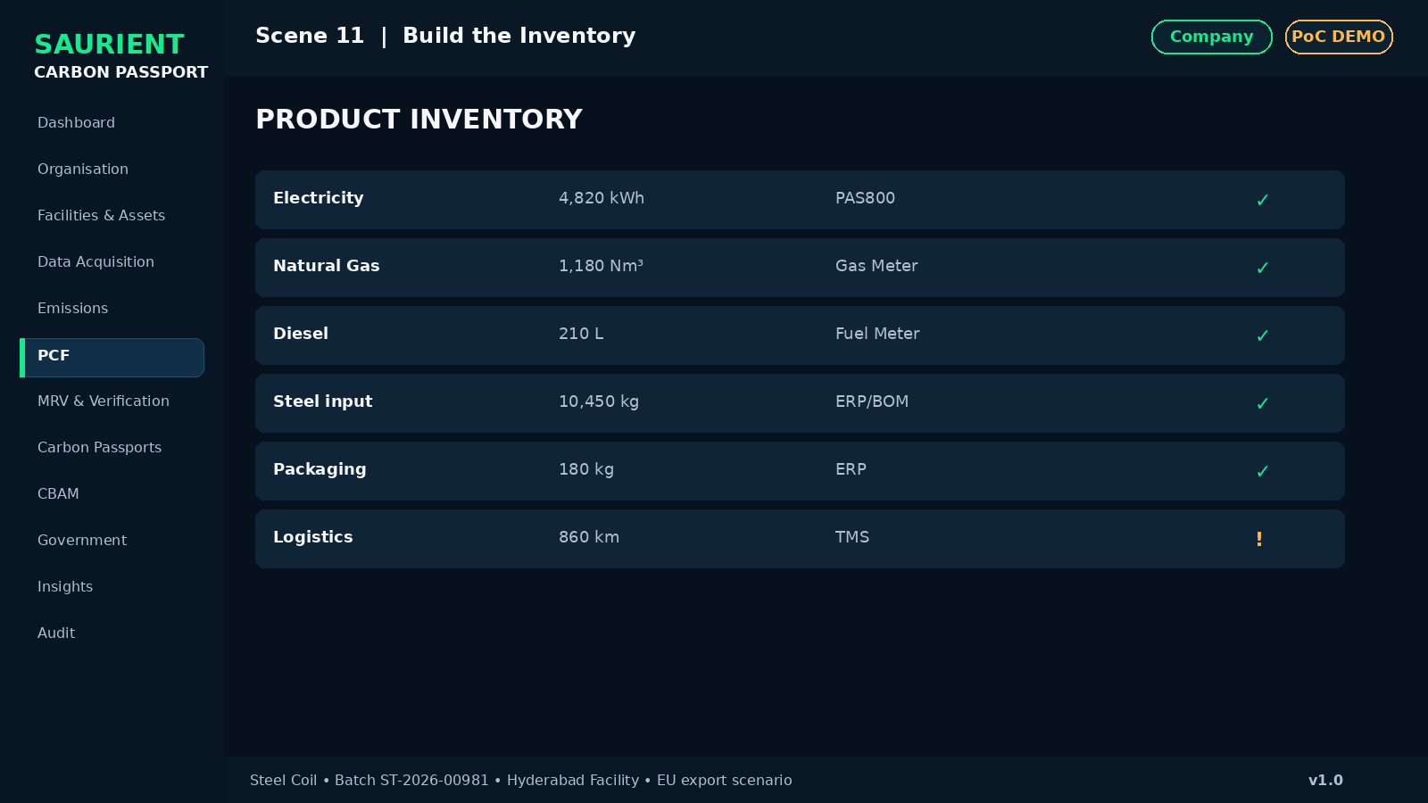
Investor visualization — Scene 11: Build the Inventory
Screen | PCF → Inventory
What appears on screen | Electricity, diesel, gas, steel input, packaging, water, logistics, waste, supplier emissions.
Why it matters | The product footprint is backed by a transparent activity inventory.
Key UI / metric | Source • Quantity • Unit • Evidence • Status
Presenter narration | Every activity that contributes to the product is captured and linked to evidence.
Primary action | Validate Inventory

SCENE 12

Allocate Shared Emissions
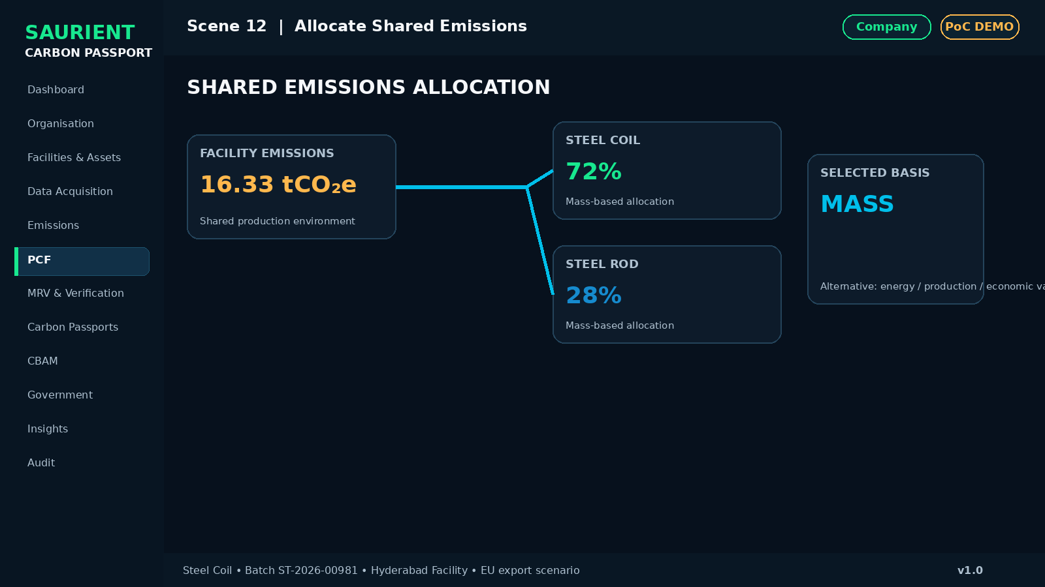
Investor visualization — Scene 12: Allocate Shared Emissions
Screen | PCF → Allocation
What appears on screen | Allocate facility emissions across Steel Coil and Steel Rod using mass / energy / production / economic value.
Why it matters | Shared facility emissions are allocated transparently.
Key UI / metric | Selected basis: Mass-based allocation
Presenter narration | Where a facility makes multiple products, Carbon Passport makes the allocation method explicit and auditable.
Primary action | Apply Allocation

SCENE 13

Calculate Logistics Carbon
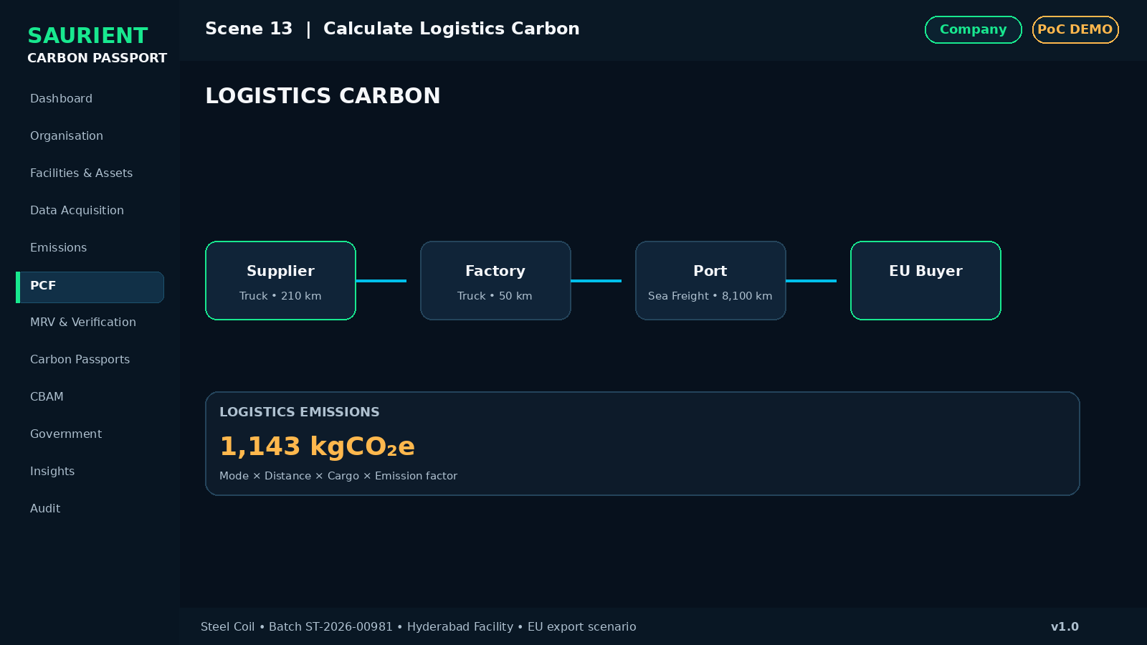
Investor visualization — Scene 13: Calculate Logistics Carbon
Screen | PCF → Logistics
What appears on screen | Supplier-to-factory truck, factory-to-port truck, port-to-EU sea freight.
Why it matters | Transport becomes part of the same lineage.
Key UI / metric | Mode • Distance • Cargo • Factor • Emissions
Presenter narration | Inbound and outbound logistics can be included in the product carbon calculation using defined transport data and factors.
Primary action | Calculate Logistics

SCENE 14

PCF Result
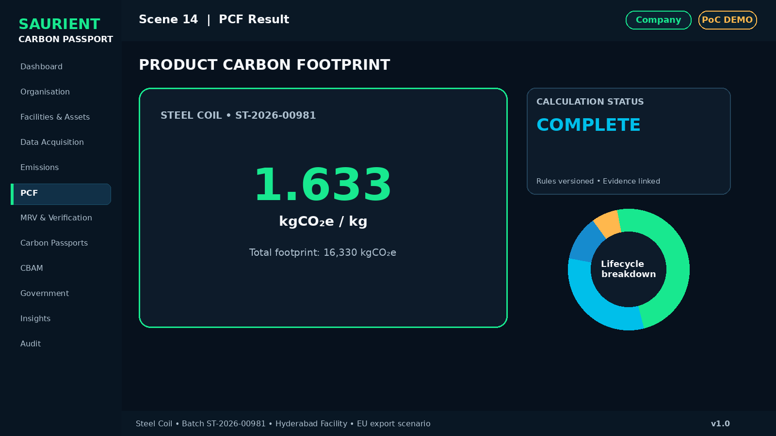
Investor visualization — Scene 14: PCF Result
Screen | Product Carbon Footprint Result
What appears on screen | Hero metric 1.633 kgCO₂e/kg and demo total 16,330 kgCO₂e, with lifecycle contribution breakdown.
Why it matters | The audience sees the product-level answer.
Key UI / metric | Calculation Complete • Demo Data
Presenter narration | The platform has now created a product-level carbon footprint from the underlying operational and supply-chain data.
Primary action | Open Lineage

SCENE 15

Data Lineage
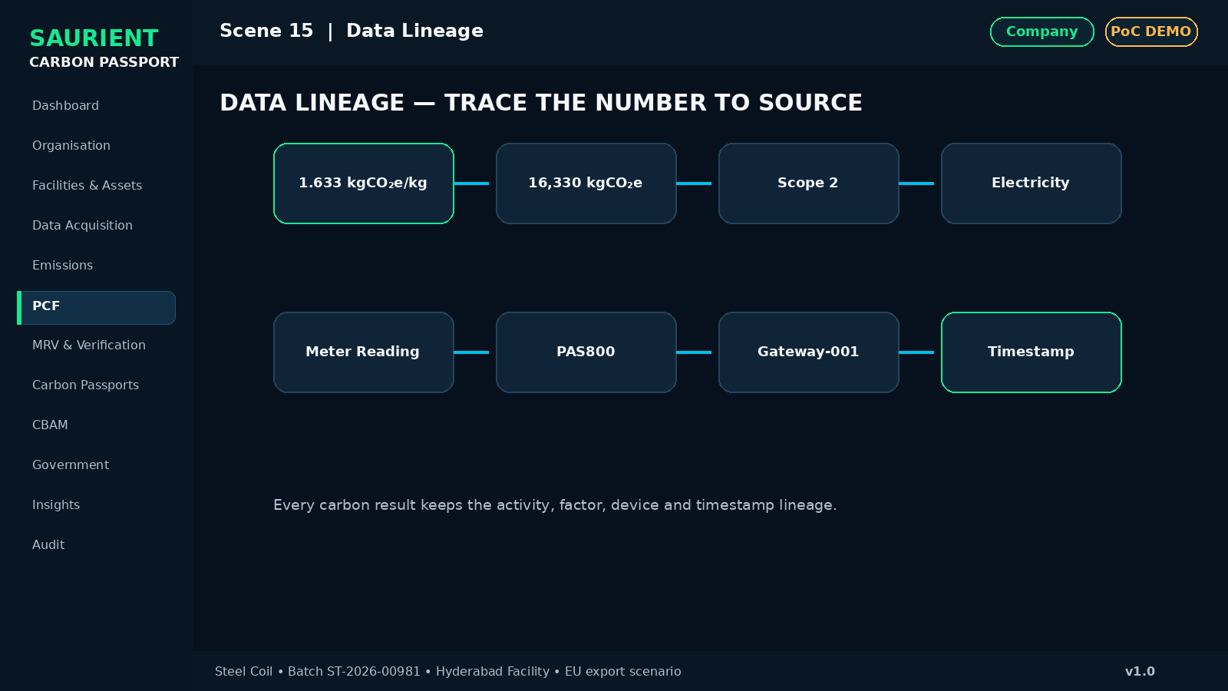
Investor visualization — Scene 15: Data Lineage
Screen | PCF → Lineage
What appears on screen | Carbon intensity → total emissions → scope → activity → meter reading → device → timestamp.
Why it matters | A final carbon number can be drilled back to its source.
Key UI / metric | Example chain: 1.633 kgCO₂e/kg → Electricity → Schneider PAS800 → Gateway-001 → timestamp
Presenter narration | This is the core trust layer: the final footprint is traceable to the evidence and source data that produced it.
Primary action | Trace to Source

SCENE 16

Carbon Data Confidence
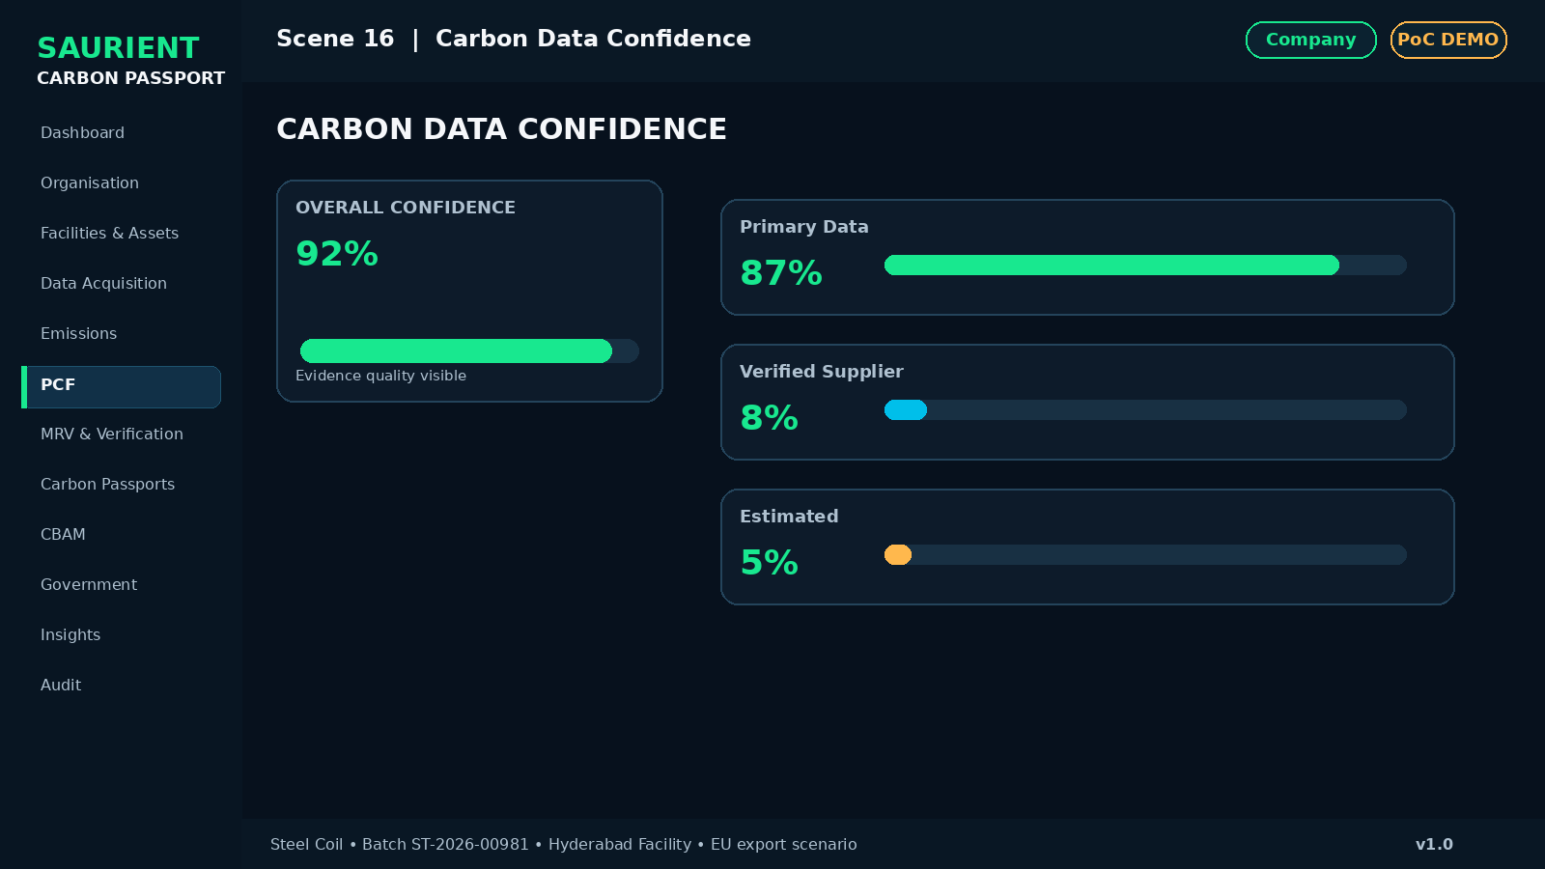
Investor visualization — Scene 16: Carbon Data Confidence
Screen | Data Quality / Confidence
What appears on screen | Primary data, supplier-verified data, supplier-declared data and estimates shown separately.
Why it matters | Not all carbon numbers have the same evidence quality.
Key UI / metric | Example: 92% confidence • 87% Primary • 8% Verified Supplier • 5% Estimated
Presenter narration | Carbon Passport makes data quality visible instead of hiding assumptions inside one final number.
Primary action | View Confidence

C. MRV, Verification and Passport Issuance
SCENE 17

Submit to MRV
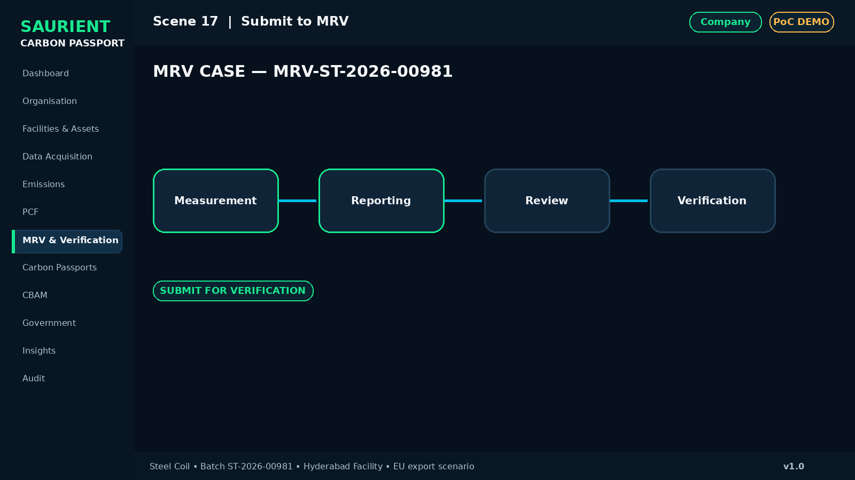
Investor visualization — Scene 17: Submit to MRV
Screen | MRV → Project
What appears on screen | Create MRV case MRV-ST-2026-00981 with Measurement → Reporting → Review → Verification.
Why it matters | The company does not self-certify the final passport.
Key UI / metric | Awaiting Verifier
Presenter narration | The PCF now enters an independent review and verification workflow.
Primary action | Submit for Verification

SCENE 18

Switch Role
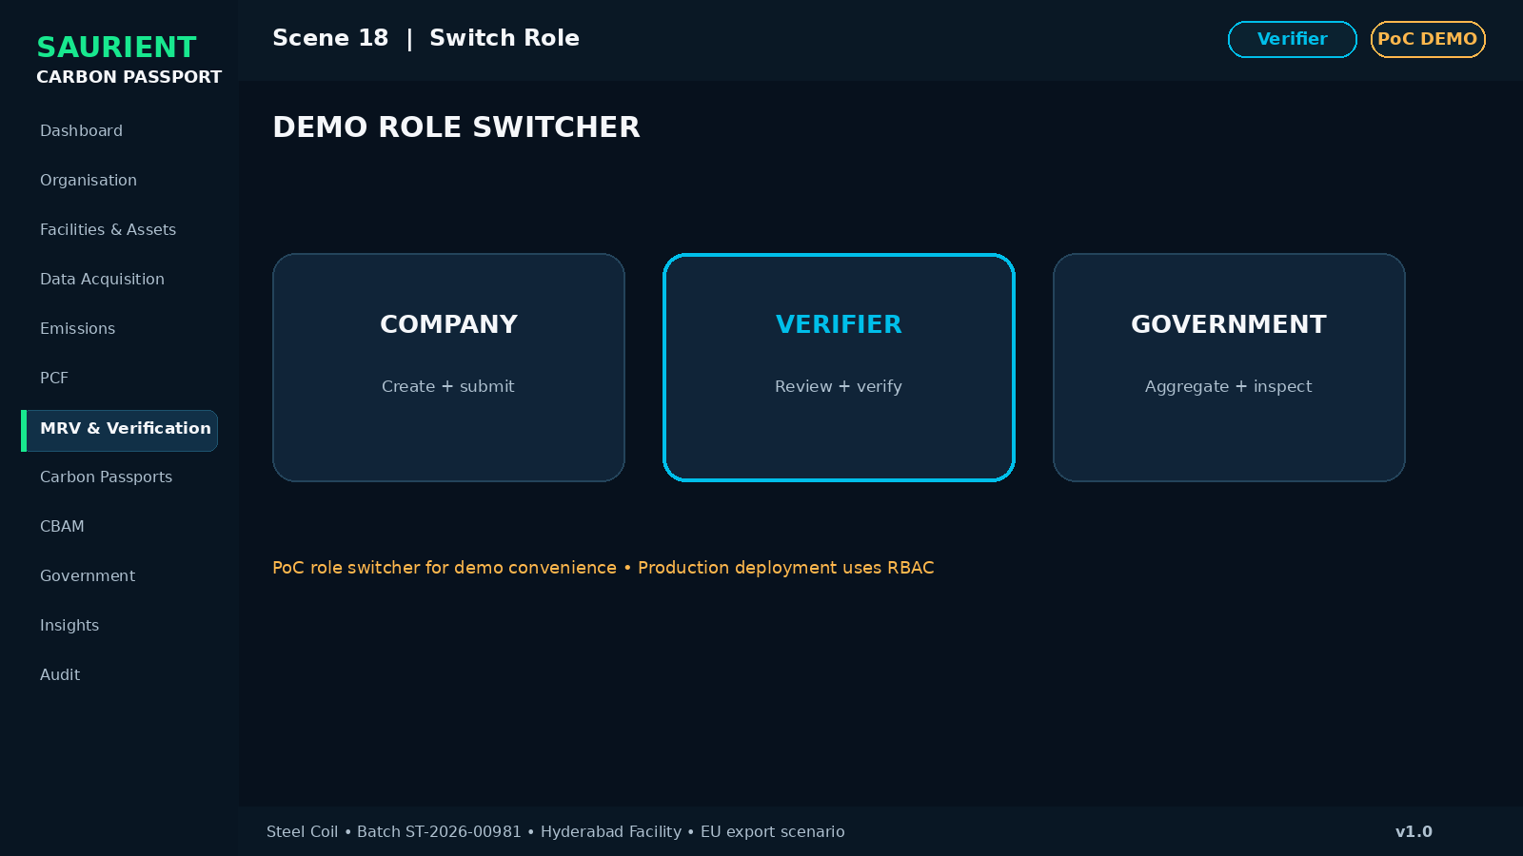
Investor visualization — Scene 18: Switch Role
Screen | Role Selector
What appears on screen | Top-right selector: Company | Verifier | Government.
Why it matters | The PoC demonstrates the full ecosystem without multiple login friction.
Key UI / metric | For demo only; real deployment uses RBAC
Presenter narration | We now switch from the company operator’s view to the verifier’s independent workbench.
Primary action | Switch to Verifier

SCENE 19

Verifier Workbench
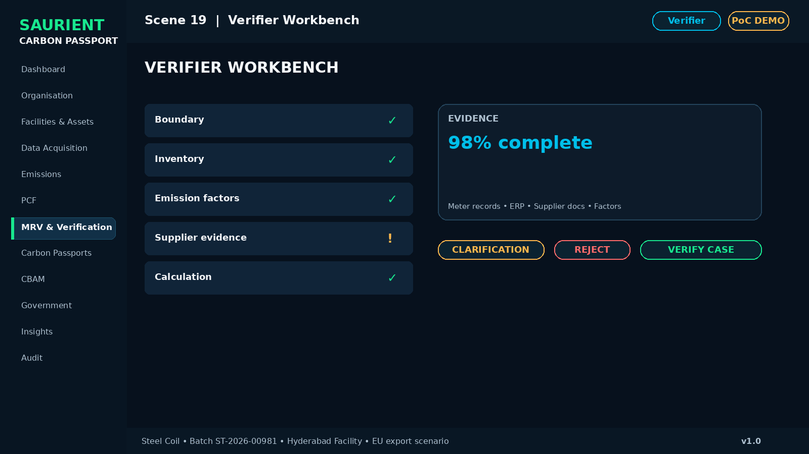
Investor visualization — Scene 19: Verifier Workbench
Screen | MRV & Verification → Case Detail
What appears on screen | Boundary, activity data, factors, methodology, evidence, completeness and supplier estimate checks.
Why it matters | The verifier sees the evidence chain, not only the final result.
Key UI / metric | Request Clarification • Reject • Verify
Presenter narration | Verification is evidence-led, with review checkpoints and a complete audit trail.
Primary action | Verify Case

SCENE 20

Verification Complete
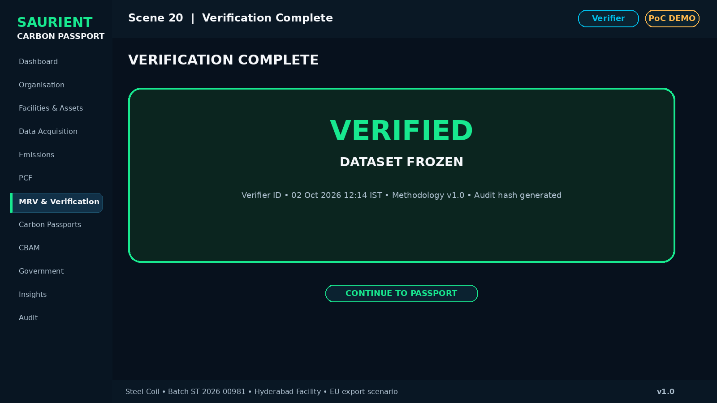
Investor visualization — Scene 20: Verification Complete
Screen | Verification Result
What appears on screen | Verifier ID, timestamp, methodology, report, audit hash and frozen approved dataset.
Why it matters | A verified record becomes controlled and tamper-evident.
Key UI / metric | VERIFIED • FROZEN
Presenter narration | Once verified, the approved dataset becomes the authoritative source for passport issuance.
Primary action | Continue to Passport

SCENE 21

Passport Readiness
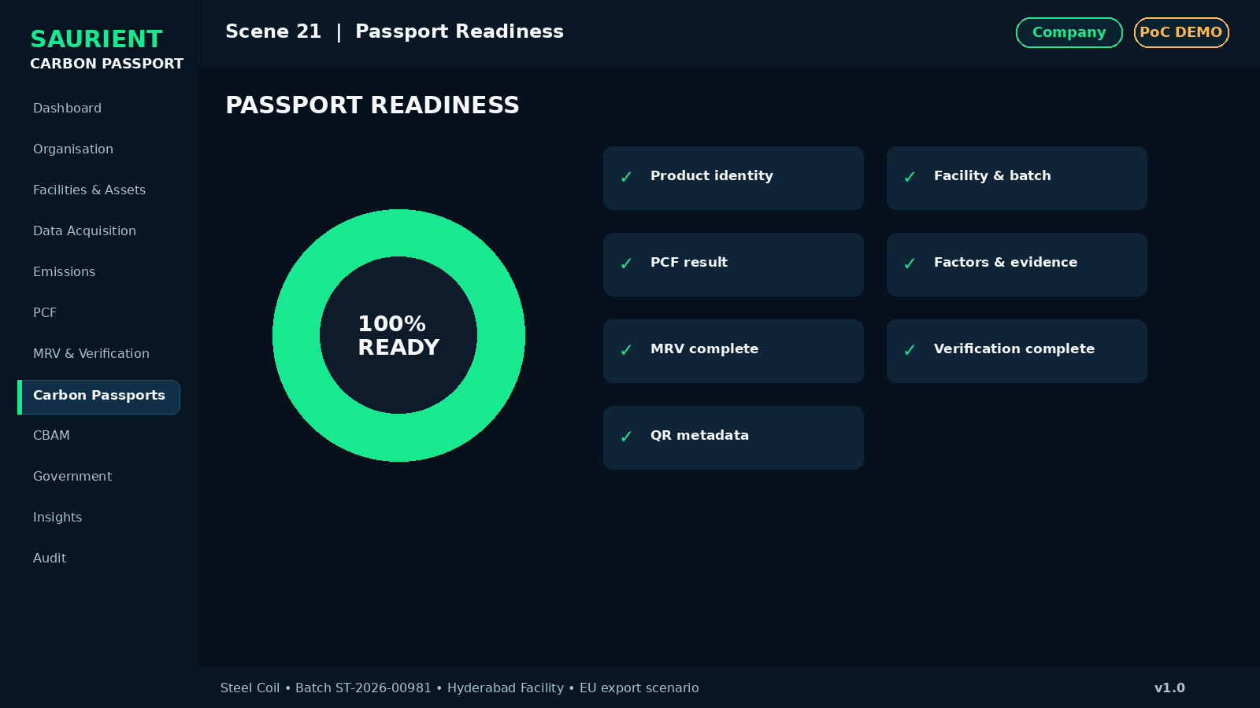
Investor visualization — Scene 21: Passport Readiness
Screen | Carbon Passport → Readiness
What appears on screen | Checklist for product identity, facility, PCF, factors, evidence, MRV, verification and QR metadata.
Why it matters | The passport is issued only when required evidence is complete.
Key UI / metric | Passport Readiness 100%
Presenter narration | The platform prevents passport issuance until the required data and verification conditions are satisfied.
Primary action | Preview Passport

SCENE 22

Passport Preview
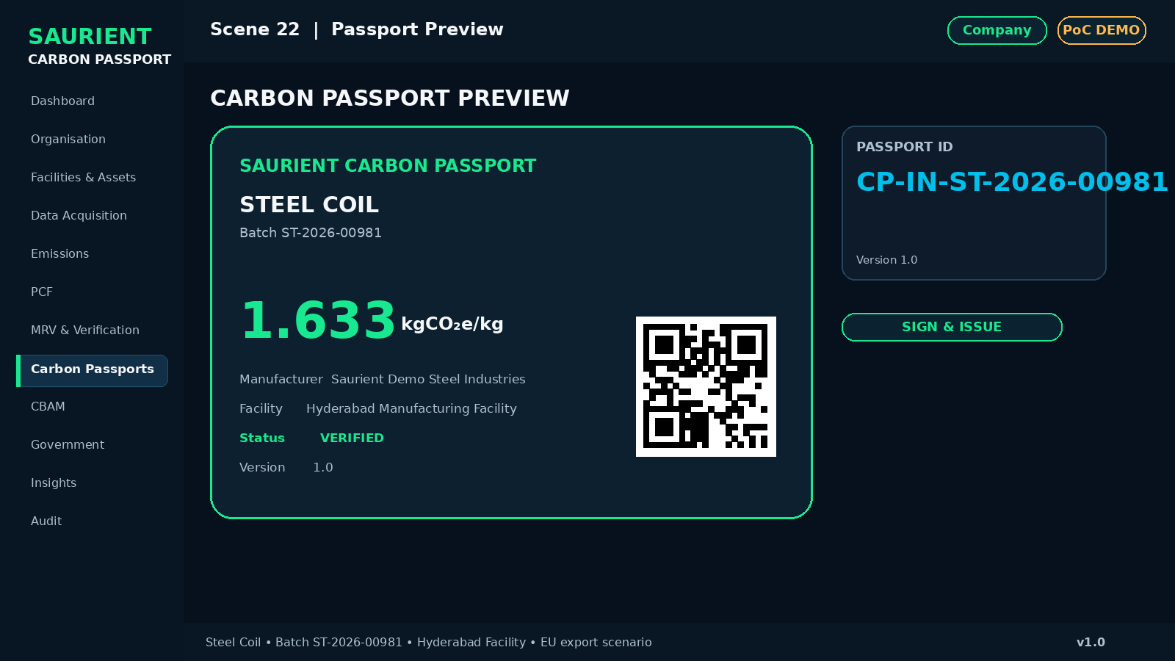
Investor visualization — Scene 22: Passport Preview
Screen | Carbon Passport → Preview
What appears on screen | Digital passport with ID, product, batch, manufacturer, facility, PCF, total footprint, verification and version.
Why it matters | The carbon record becomes a portable digital product identity.
Key UI / metric | CP-IN-ST-2026-00981 • Version 1.0
Presenter narration | This is the final carbon record that can be shared with authorised stakeholders.
Primary action | Sign & Issue

SCENE 23

Sign & Issue
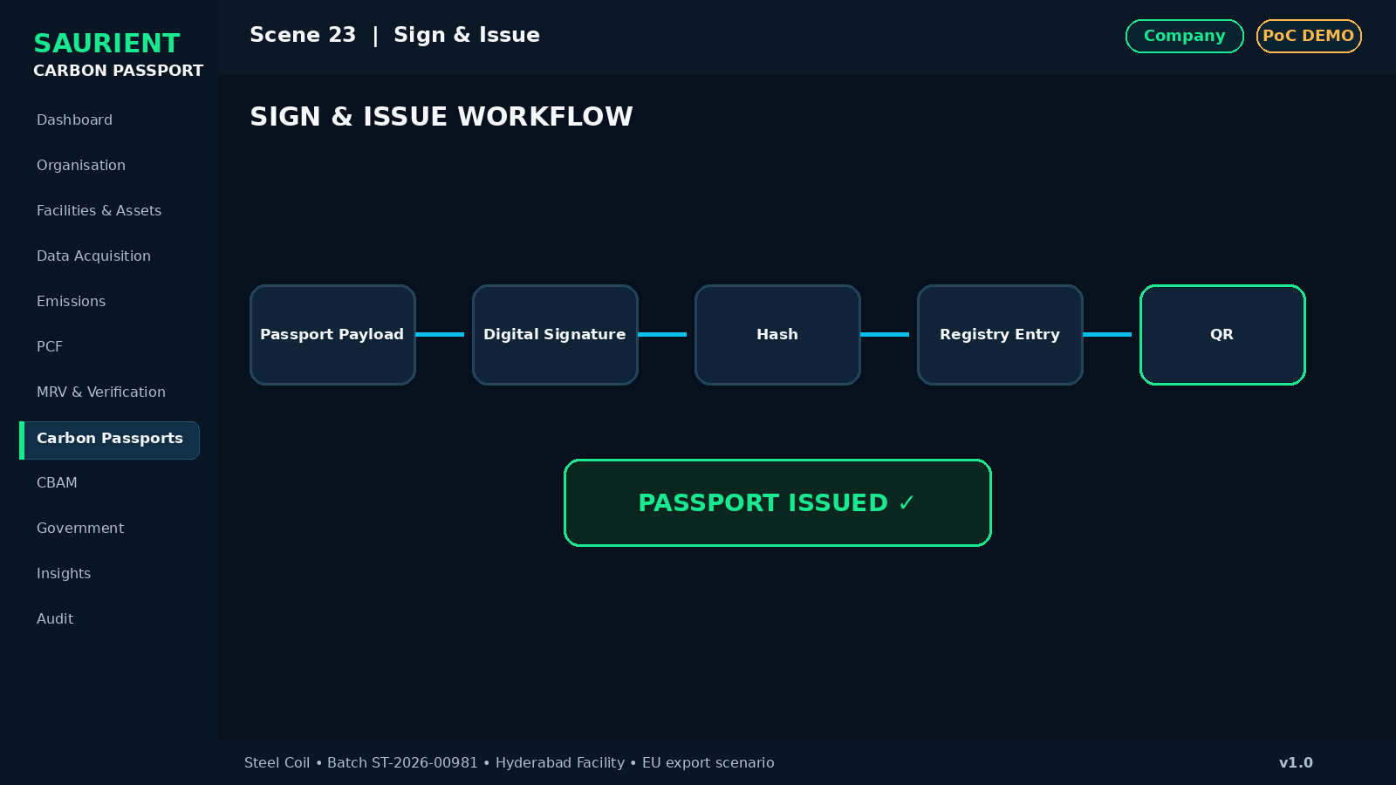
Investor visualization — Scene 23: Sign & Issue
Screen | Carbon Passport → Sign & Issue
What appears on screen | Passport Payload → Digital Signature → Hash → Registry Entry → QR.
Why it matters | Issuance is controlled, versioned and verifiable.
Key UI / metric | PASSPORT ISSUED
Presenter narration | The verified dataset is transformed into a signed digital Carbon Passport and entered into the registry.
Primary action | Show QR

SCENE 24

QR Verification
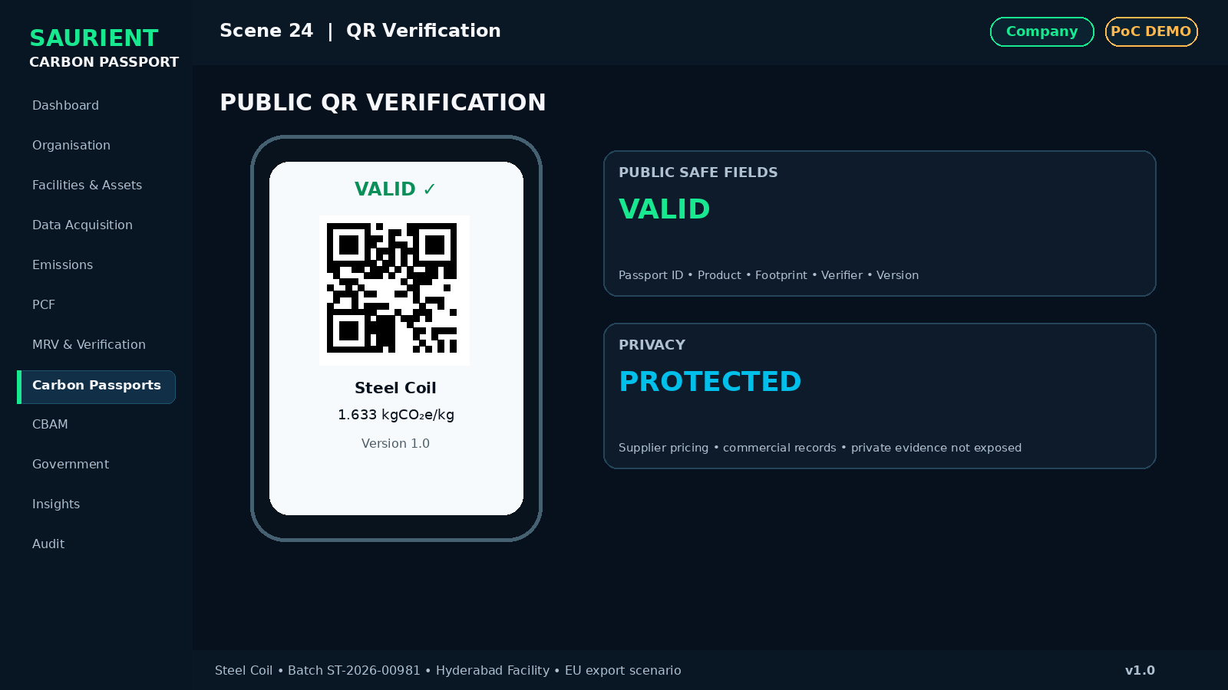
Investor visualization — Scene 24: QR Verification
Screen | Public Verification
What appears on screen | Public mobile-friendly page showing safe fields only; no confidential supplier data.
Why it matters | Any authorised/public viewer can check authenticity without exposing sensitive data.
Key UI / metric | VALID • Passport ID • Product • Footprint • Verifier • Version
Presenter narration | A buyer, auditor or regulator can verify the passport while confidential commercial data remains protected.
Primary action | Verify Passport

SCENE 25

Registry
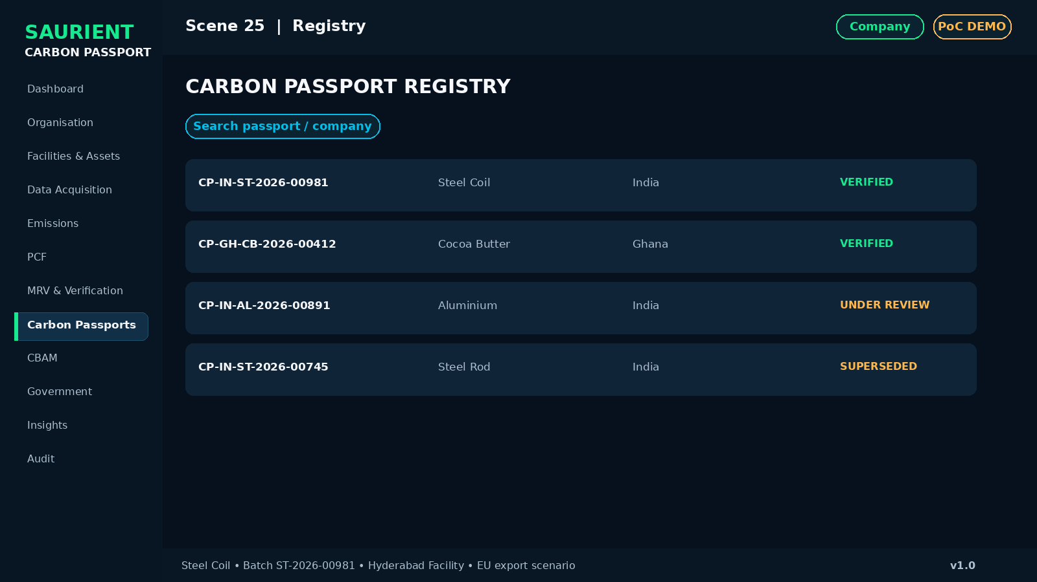
Investor visualization — Scene 25: Registry
Screen | Carbon Passport → Registry
What appears on screen | Searchable passports by company, commodity, facility, country, status and verification date.
Why it matters | Issued passports form a governed digital registry.
Key UI / metric | Verified • Under Review • Revoked / Superseded where relevant
Presenter narration | Every issued passport can be discovered, filtered and checked according to access permissions.
Primary action | Open Passport Detail

SCENE 26

Versioning
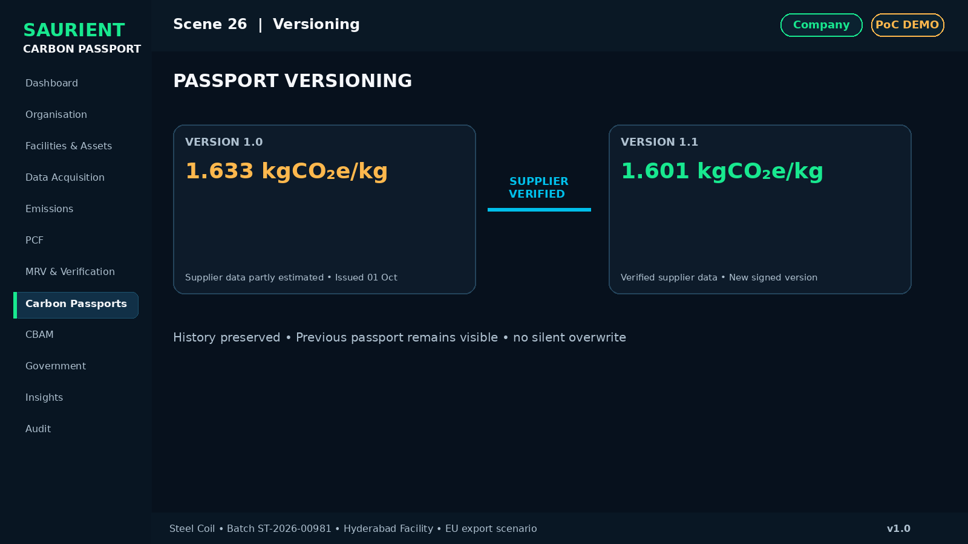
Investor visualization — Scene 26: Versioning
Screen | Carbon Passport → Versions
What appears on screen | Supplier estimated data becomes verified; PCF recalculates; v1.0 becomes v1.1 while old record remains visible.
Why it matters | Carbon information can evolve without deleting history.
Key UI / metric | 1.633 → 1.601 kgCO₂e/kg • v1.0 → v1.1
Presenter narration | When underlying data improves, the system creates a new version rather than silently overwriting history.
Primary action | Compare Versions

SCENE 27

Audit Trail
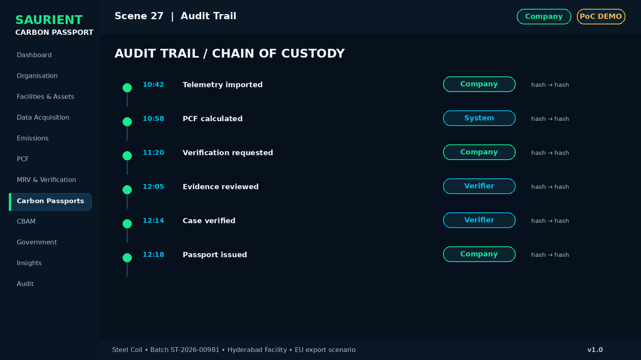
Investor visualization — Scene 27: Audit Trail
Screen | Audit Log
What appears on screen | Chronological timeline of import, calculation, verification request, evidence update, approval and issue.
Why it matters | Every material action is attributable and time-stamped.
Key UI / metric | User • Role • Timestamp • Action • Previous Hash • New Hash
Presenter narration | The complete chain of custody remains visible for assurance and audit purposes.
Primary action | Open Audit Export

D. Export and Government Intelligence
SCENE 28

CBAM Readiness
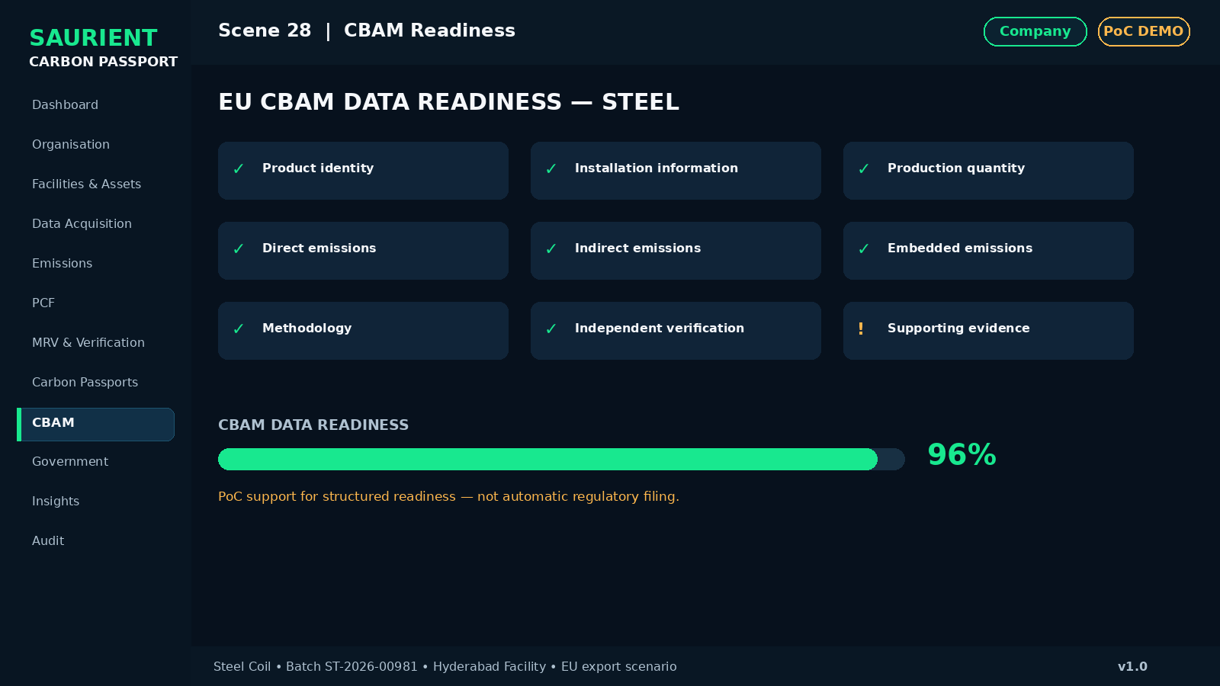
Investor visualization — Scene 28: CBAM Readiness
Screen | CBAM → Readiness
What appears on screen | Commodity, destination, installation info, production quantity, direct/indirect emissions, embedded emissions, methodology and verification.
Why it matters | The platform can organise product carbon data into export-compliance-ready structures.
Key UI / metric | CBAM Readiness 96% • PoC only; do not claim automatic regulatory filing
Presenter narration | Carbon Passport packages the necessary carbon information so exporters can prepare structured regulatory and buyer submissions.
Primary action | Generate Data Package

SCENE 29

Export Package
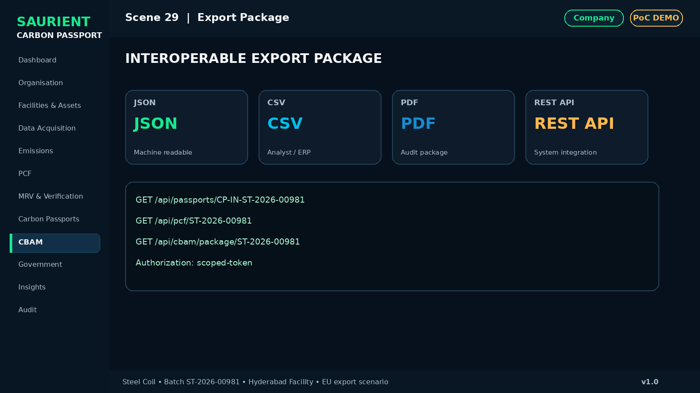
Investor visualization — Scene 29: Export Package
Screen | CBAM / API Export
What appears on screen | Generate JSON, CSV and PDF package; show example REST endpoints for passport, PCF and CBAM data.
Why it matters | The data is interoperable rather than locked in one UI.
Key UI / metric | API-first • Structured export • Permissions
Presenter narration | The value of the platform increases when carbon records can move securely between enterprise, buyer, auditor and public systems.
Primary action | Download / Send

SCENE 30

Government Role
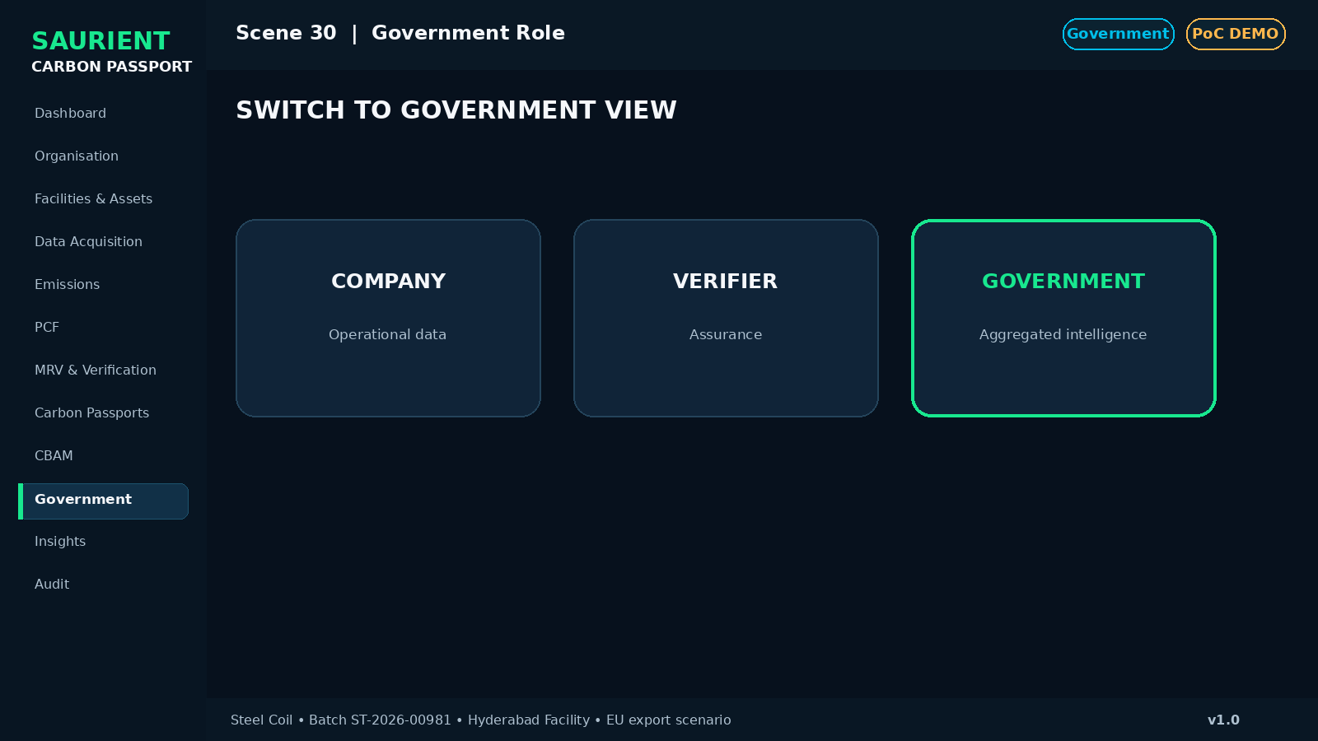
Investor visualization — Scene 30: Government Role
Screen | Role Selector
What appears on screen | Switch to Government dashboard.
Why it matters | The same trusted data can serve aggregated policy intelligence.
Key UI / metric | Government view is aggregated and permission-controlled
Presenter narration | We now move from a single manufacturer to programme-level carbon intelligence.
Primary action | Switch to Government

SCENE 31

Government Carbon Intelligence
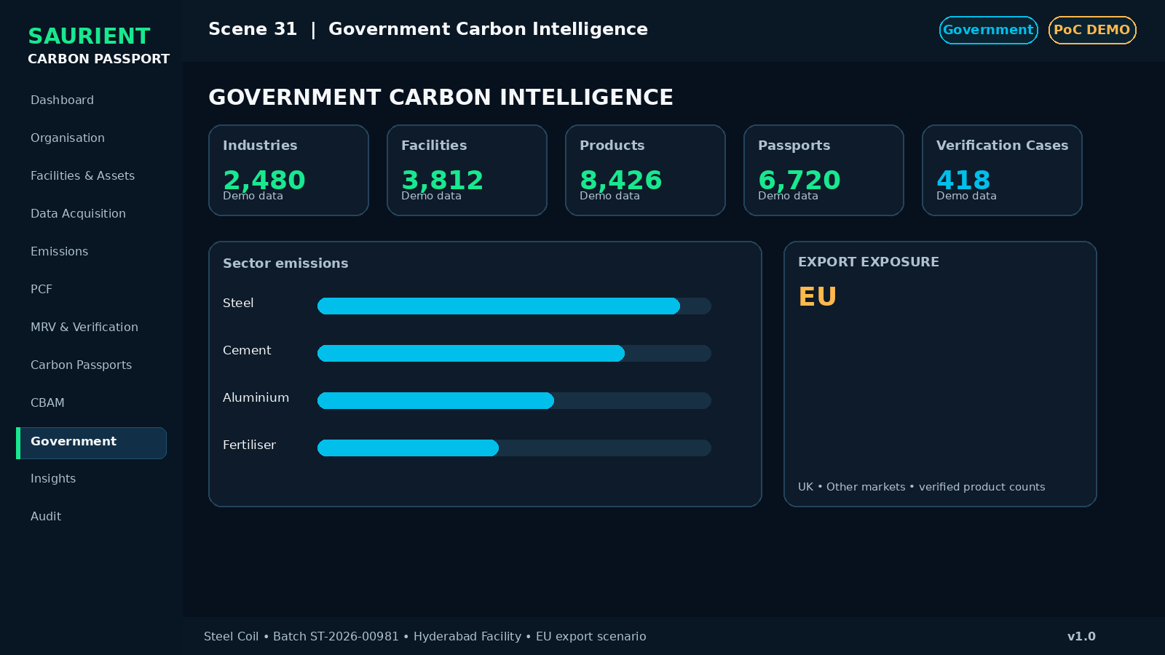
Investor visualization — Scene 31: Government Carbon Intelligence
Screen | Government Dashboard
What appears on screen | Registered industries, facilities, verified products, passports, verification cases, sector charts and export exposure.
Why it matters | Government sees programme performance without managing every spreadsheet.
Key UI / metric | KPIs should be realistic PoC demo data and clearly labelled
Presenter narration | The platform can provide aggregated carbon intelligence across industries, sectors, regions and export categories.
Primary action | Drill Down

SCENE 32

Government Drill Down
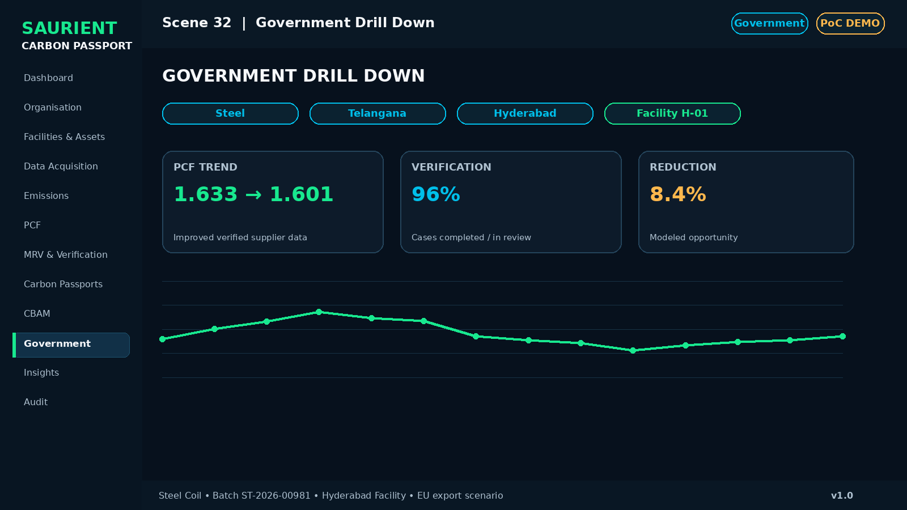
Investor visualization — Scene 32: Government Drill Down
Screen | Sector → State → District → Facility
What appears on screen | Example drilldown Steel → Telangana → Hyderabad → Facility with PCF trend, verification and reduction indicators.
Why it matters | Policy users can move from aggregate to controlled operational visibility.
Key UI / metric | Do not expose confidential supplier/commercial records
Presenter narration | Government receives insight while sensitive industry data remains protected by role and permission.
Primary action | Open Facility

SCENE 33

Climate / NDC Mapping
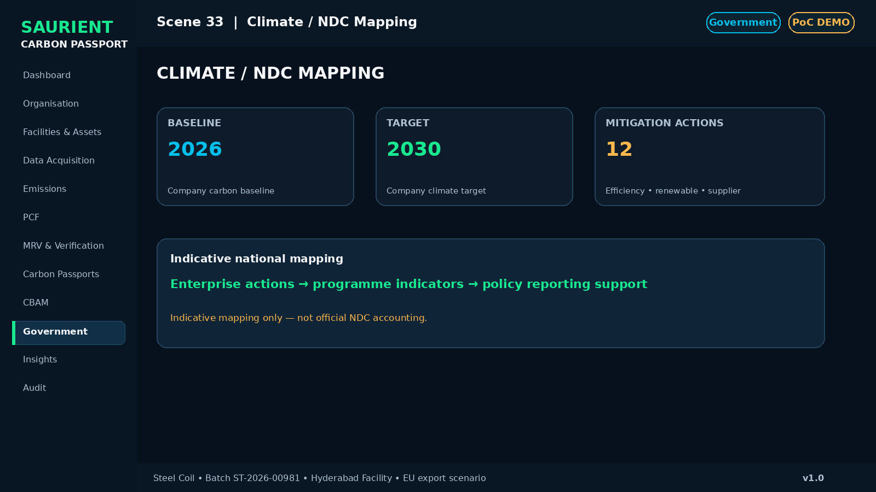
Investor visualization — Scene 33: Climate / NDC Mapping
Screen | Climate Targets
What appears on screen | Company baseline, 2030 target, mitigation actions and indicative national mapping.
Why it matters | The platform can connect enterprise reduction activity to broader climate-programme reporting.
Key UI / metric | Always display: Indicative mapping — not official NDC accounting
Presenter narration | Carbon Passport can support climate-programme tracking without claiming to replace official national accounting systems.
Primary action | View Actions

SCENE 34

Reduction Intelligence
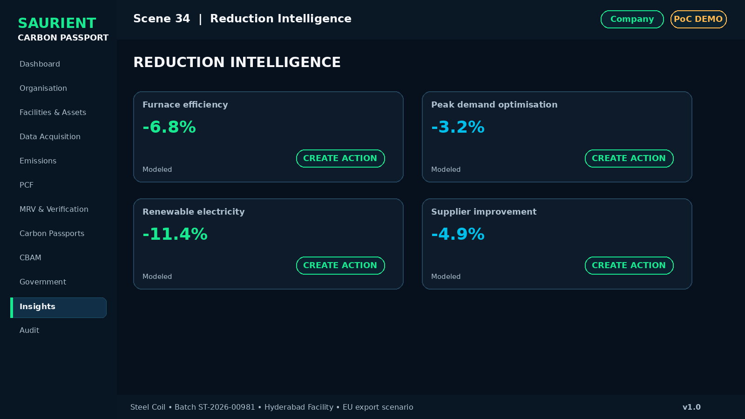
Investor visualization — Scene 34: Reduction Intelligence
Screen | Insights
What appears on screen | Opportunity cards for furnace efficiency, peak demand, supplier improvements and renewable electricity.
Why it matters | The product should help reduce carbon, not only measure it.
Key UI / metric | Potential reduction values must be demo / modeled estimates
Presenter narration | Once a credible baseline exists, the same data layer can identify and track operational decarbonisation opportunities.
Primary action | Create Action

E. Architecture, Commercial Model and Pilot Ask
SCENE 35

Platform Architecture
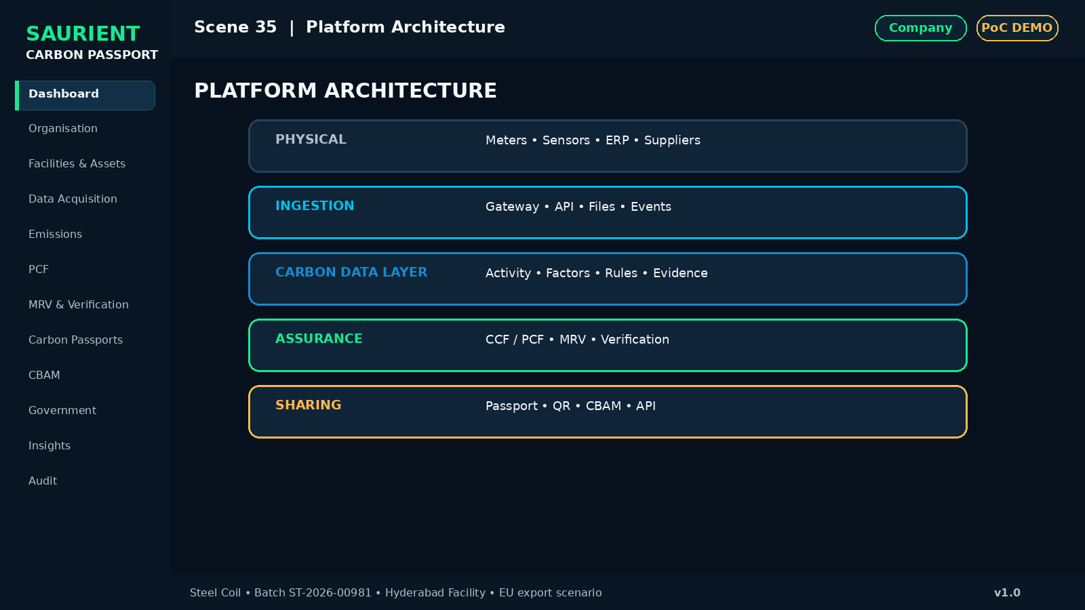
Investor visualization — Scene 35: Platform Architecture
Screen | Architecture
What appears on screen | Smart Meters / ERP / Suppliers / Sensors → Ingestion → Carbon Data Layer → CCF/PCF → MRV → Verification → Passport → QR/CBAM/API.
Why it matters | The audience sees how the product is technically organised.
Key UI / metric | Keep this diagram simple and non-confidential for investors
Presenter narration | The architecture separates data acquisition, calculation, assurance and sharing so each layer can scale independently.
Primary action | Next: Business Model

SCENE 36

Investor View
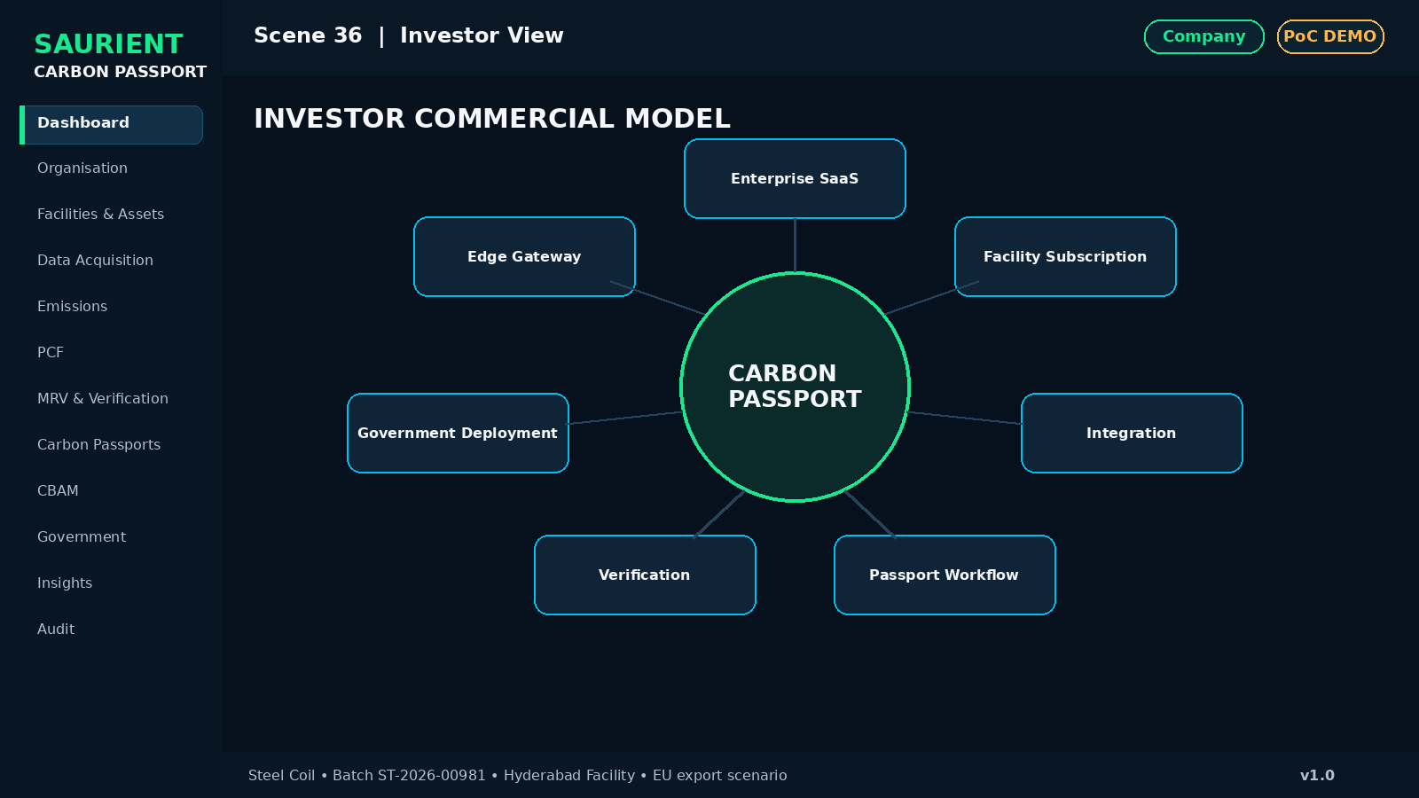
Investor visualization — Scene 36: Investor View
Screen | Commercial Model
What appears on screen | Enterprise SaaS + Facility Subscription + Integration + Passport Issuance + Verification Workflow + Government Deployment + optional edge gateway.
Why it matters | The product has multiple monetisation paths beyond a certificate fee.
Key UI / metric | Avoid overclaiming revenue; present model and pilot economics
Presenter narration | Carbon Passport can be sold as infrastructure, software and integration—not simply as a one-time carbon report.
Primary action | View Pilot Economics

SCENE 37

Government Pilot Proposal
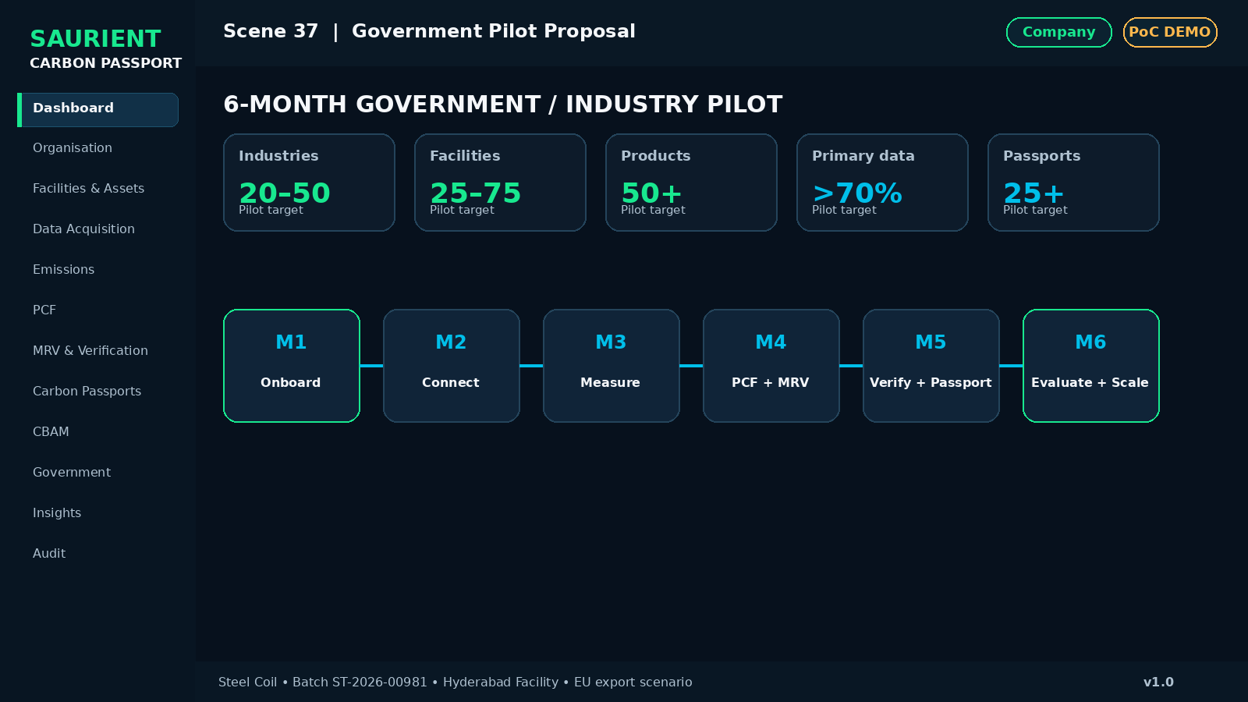
Investor visualization — Scene 37: Government Pilot Proposal
Screen | Pilot Proposal
What appears on screen | 20–50 industries across steel, cement, aluminium, fertiliser and export-oriented MSMEs; 6-month structured pilot.
Why it matters | The ask is a controlled pilot with measurable outcomes—not nationwide adoption on day one.
Key UI / metric | KPIs: facilities, primary-data %, products assessed, passports, verification turnaround, hotspots, reductions, export readiness
Presenter narration | The proposed pilot demonstrates whether a trusted digital carbon infrastructure can operate across real industrial workflows before wider scale-up.
Primary action | Start Pilot Discussion

SCENE 38

Final Vision
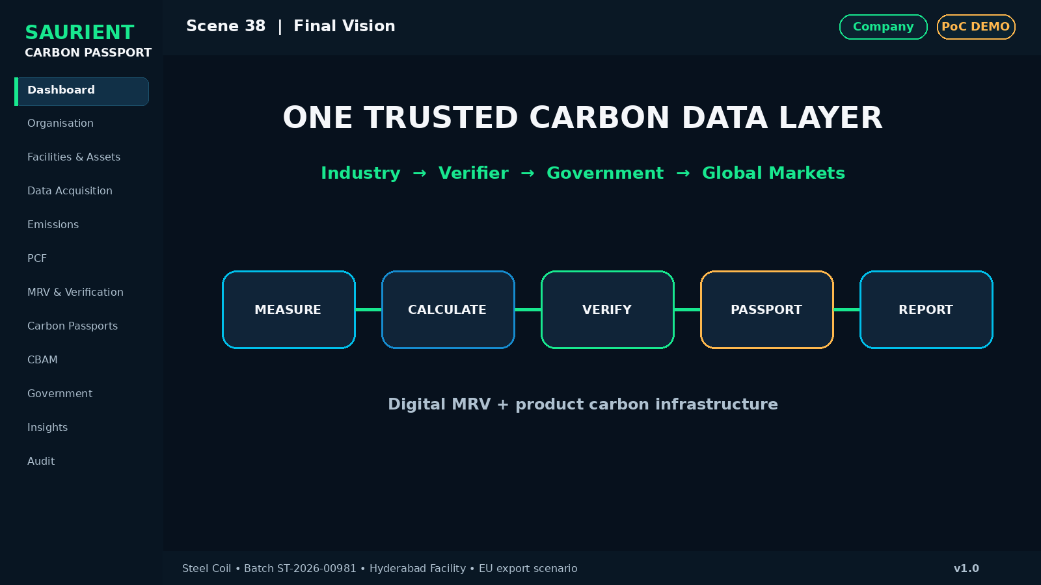
Investor visualization — Scene 38: Final Vision
Screen | Closing
What appears on screen | One Trusted Carbon Data Layer connecting Industry → Verifier → Government → Global Markets.
Why it matters | The audience remembers one clear message.
Key UI / metric | MEASURE → CALCULATE → VERIFY → PASSPORT → REPORT
Presenter narration | Carbon Passport is not another carbon calculator. It is a trusted digital carbon infrastructure layer connecting physical data, calculation, MRV, independent verification and interoperable product-level carbon records.
Primary action | End Demo

6. Live Demo Choreography
Recommended live sequence for a government or investor meeting:
Company → Facility → Live Data → PCF → Data Lineage → MRV → Verifier → Issue Passport → Scan QR → CBAM → Government Dashboard

The “wow moment”
- Show live/simulated meter values changing.
- Recalculate the product footprint.
- Submit the record for verification.
- Switch to Verifier and approve it.
- Issue the passport and generate the QR.
- Scan the QR on a phone and show the public verification page.
- Switch to Government and show the aggregate passport count / dashboard update.

7. What Must Actually Work in the PoC
- Create organisation, facility and product/batch.
- Receive or simulate meter telemetry with timestamp and device identity.
- Calculate Scope 1/2/3 and PCF through a versioned rule engine.
- Create an MRV case and approve it from a verifier role.
- Generate a unique Carbon Passport, QR and public verification URL.
- Change underlying data, recalculate and issue a new version while preserving history.

8. What Can Be Demo-Assisted Initially
- Government analytics using realistic mock data.
- CBAM export package generation without claiming automatic submission into regulatory systems.
- Supplier portal records and evidence files.
- Reduction recommendations and confidence scores using clearly identified demonstration logic.
- Blockchain integration shown as future-ready architecture; cryptographic hash and versioned audit trail are enough for the PoC.

9. Government Pitch Structure
Start with the problem: Manufacturers and public programmes need trustworthy, traceable and verifiable emissions data across factories, products and supply chains.
Show the system: Demonstrate the end-to-end journey from primary data to a verified digital passport.
Show government value: Aggregated sector, geography, verification, export-readiness and reduction intelligence.
Ask for a pilot: Propose a 20–50 industry, multi-sector pilot with clear success measures.
Keep governance clear: Position the platform as digital MRV and carbon-data infrastructure. Do not present it as an official sovereign registry, carbon-credit issuer or regulator unless formally authorised.

10. Investor Pitch Structure
- Problem: fragmented industrial carbon data and evidence.
- Solution: one governed data layer connecting physical systems, calculation, MRV, verification and passport issuance.
- Proof: live end-to-end product-batch demo.
- Differentiation: data lineage, configurable rules, primary data integration, verification workflow and interoperable passport.
- Business model: SaaS + facility + integrations + passport workflow + enterprise/government deployment + optional industrial gateway.
- Scale: repeatable commodity rules, multi-tenant architecture, API integrations and verifier ecosystem.

11. Pilot Success Metrics
Metric | Why it matters | Example PoC target
Industries onboarded | Tests multi-company adoption | 20–50
Facilities connected | Tests operational coverage | 25–75
Primary-data share | Measures reduction in estimate dependency | >70% for selected processes
Products assessed | Tests repeatable PCF workflow | 50+
Passports issued | Tests verification-to-issuance journey | 25+ verified demo/pilot records
Verification turnaround | Tests workflow efficiency | Track baseline vs platform workflow
Data quality exceptions | Shows governance value | 100% exceptions logged and resolved/tracked
Reduction opportunities | Links measurement to action | At least 1 measurable opportunity per facility

12. Closing Message
ONE TRUSTED CARBON DATA LAYER
Industry → Verifier → Government → Global Markets
MEASURE → CALCULATE → VERIFY → PASSPORT → REPORT
Carbon Passport is a digital MRV and product-carbon infrastructure platform designed to turn operational and supply-chain data into traceable, verifiable and interoperable carbon intelligence.

Carbon Passport — Technology Stack
The carbon-poc repository is built as a cloud-native platform with the following components:
Layer | Technologies
Frontend | React 18, TypeScript, Vite 6, Tailwind CSS, Recharts, Lucide React
Backend | Go 1.26, REST API, GraphQL, Google CEL Engine
Cloud-Native / Kubernetes | Kubernetes Operator with Custom Resource Definitions (CRDs), controller-runtime, client-go
Database & Caching | PostgreSQL 16, Redis 7
Infrastructure & DevOps | Docker, Kind (Kubernetes in Docker), Make
Future Development — Post-PoC
Area | Planned Development
AI Agent Access | Develop an MCP server exposing read-only APIs so AI agents can query and analyse platform data through conversational interfaces.
Production Infrastructure | Move from the local Kind cluster to a production Kubernetes environment.
Multitenancy & Scaling | Support multiple organisations with tenant isolation and scale towards a target of 1 million carbon passports.
Production Readiness | Strengthen the codebase with automated testing, security controls, monitoring, reliability, and maintainability.

