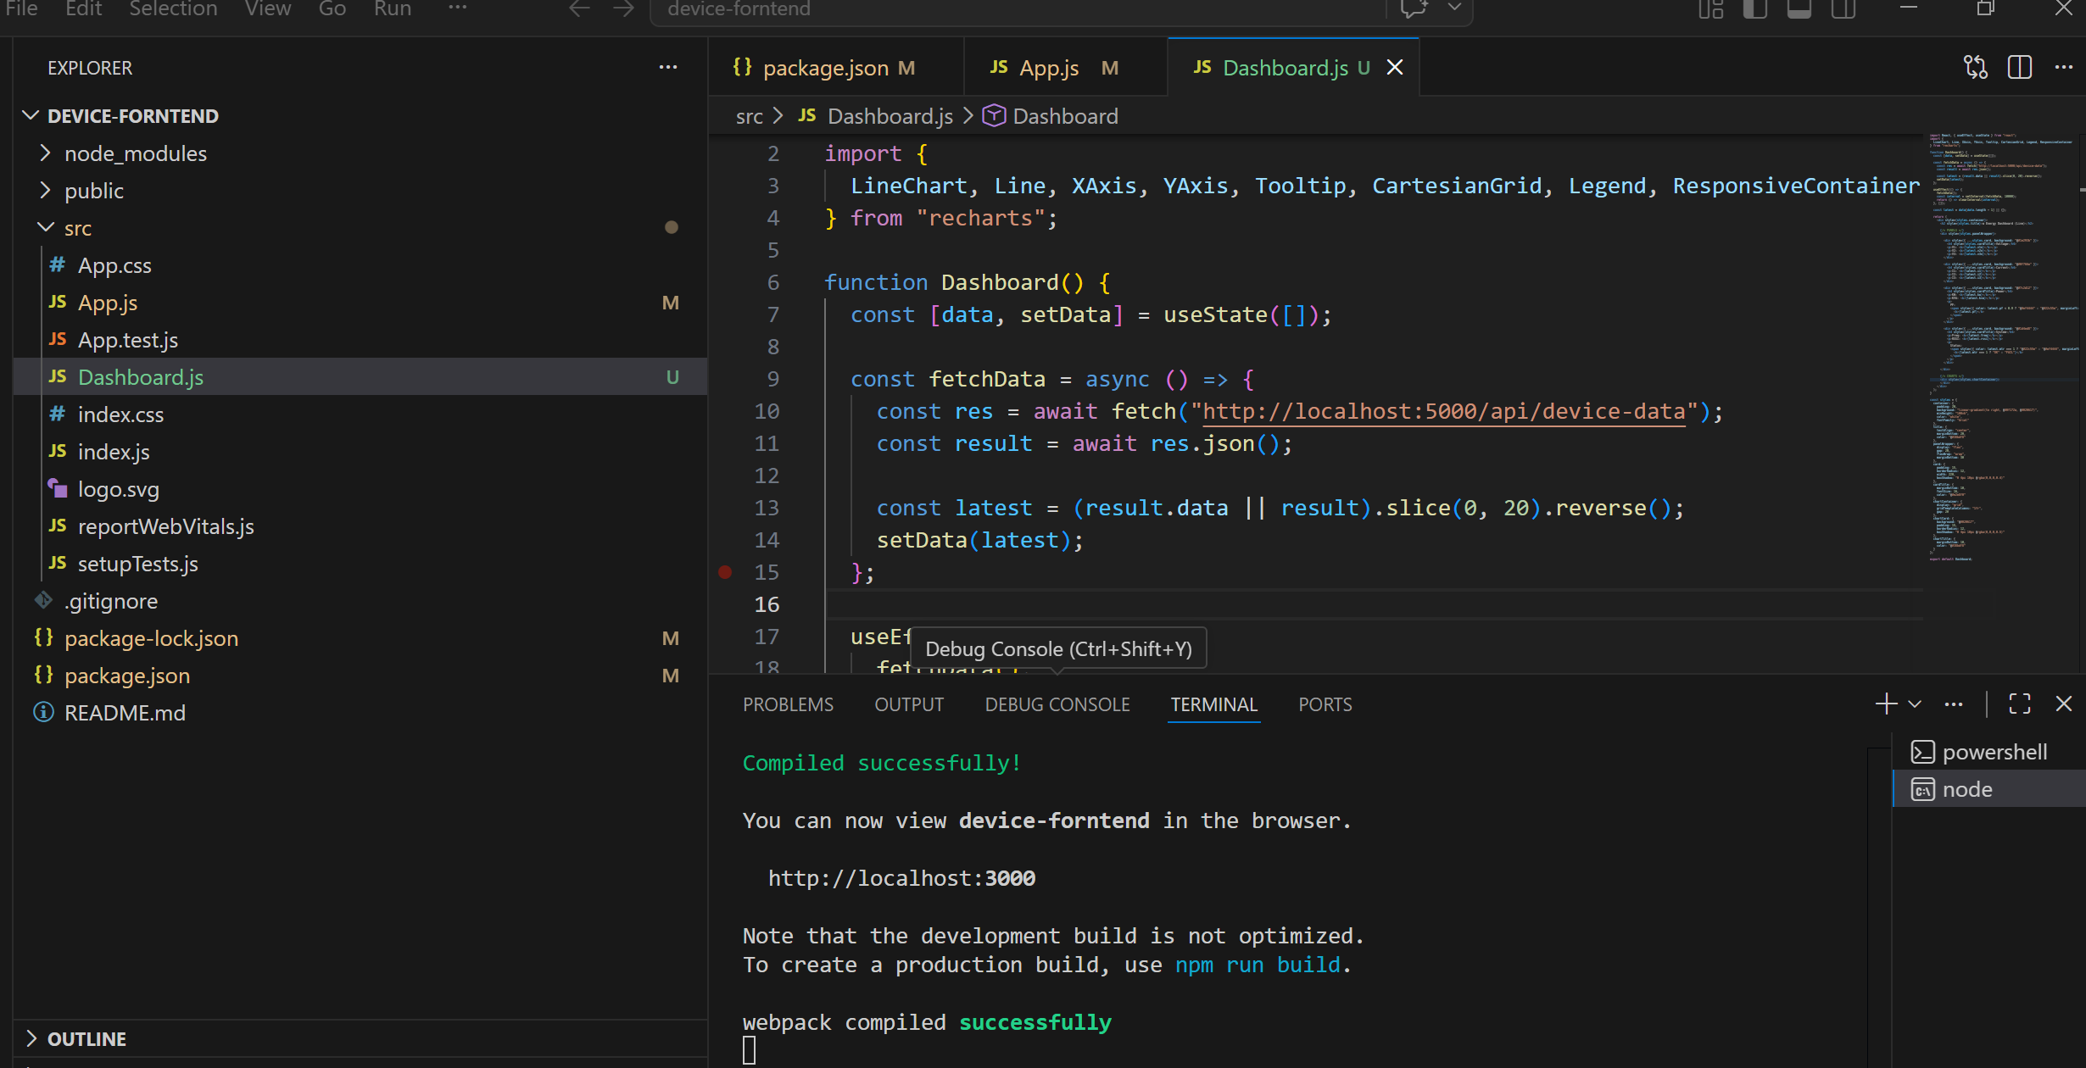

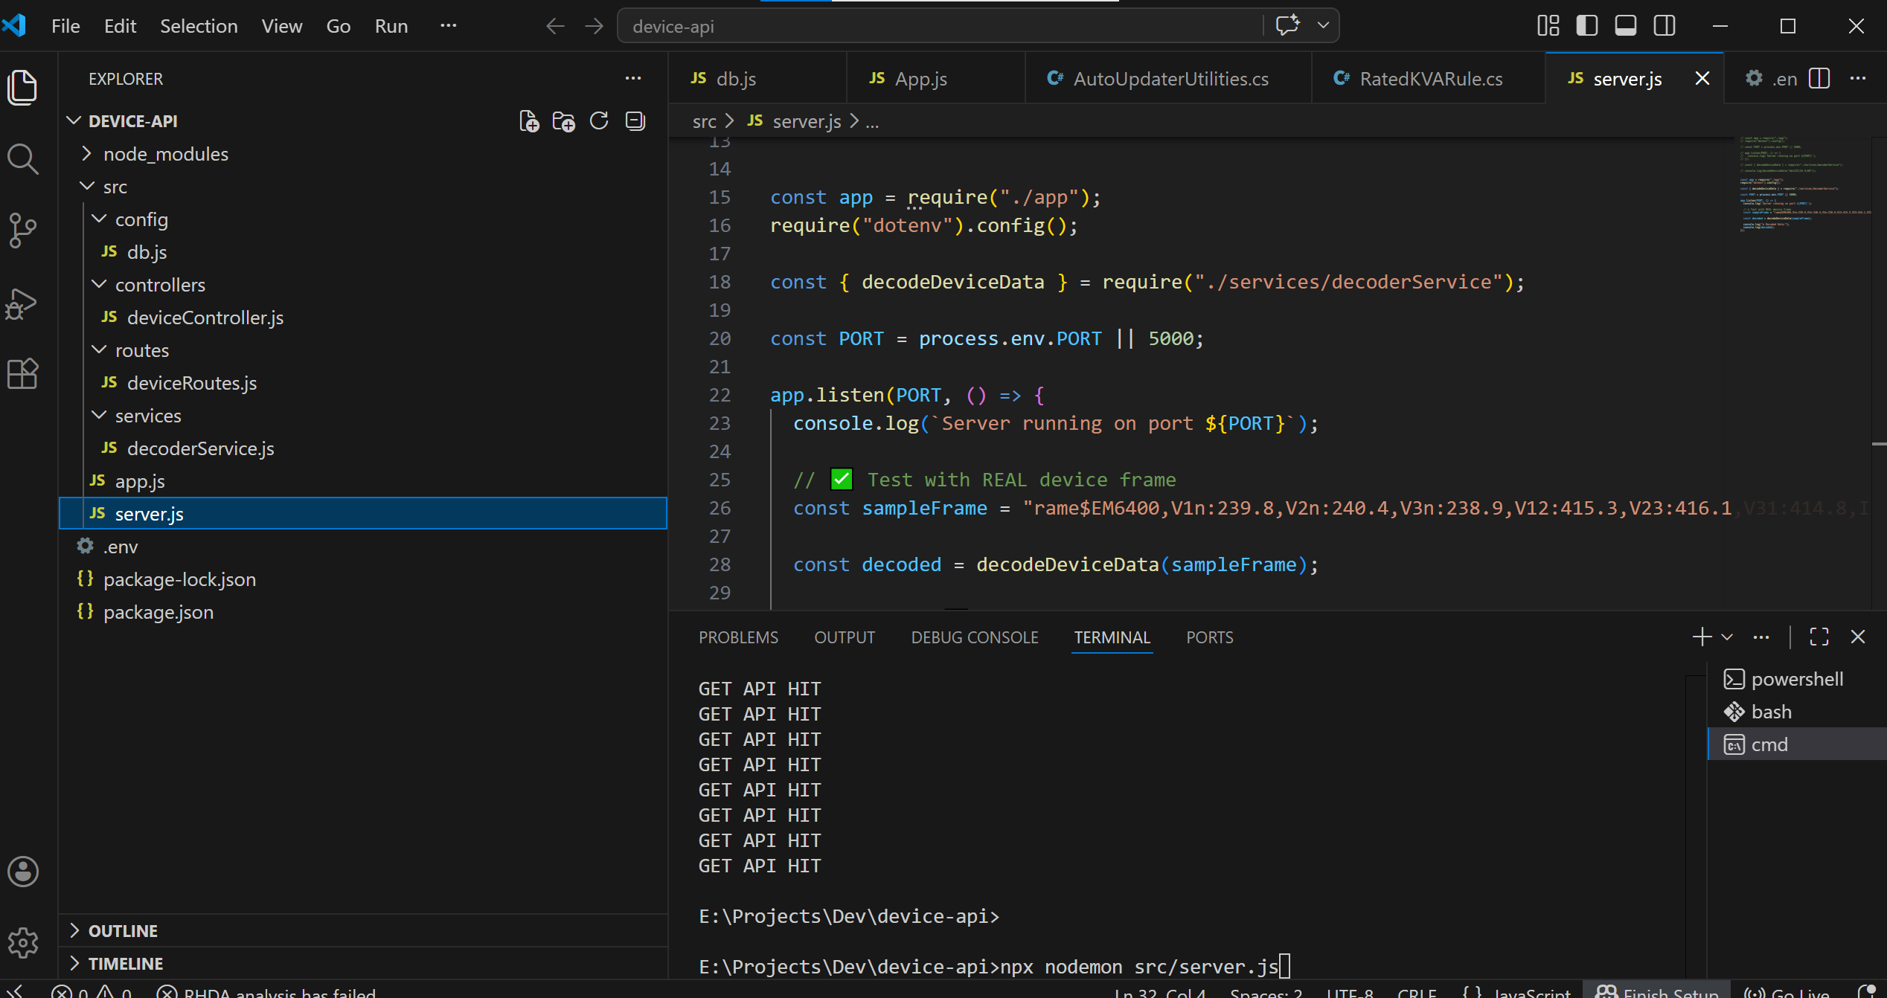

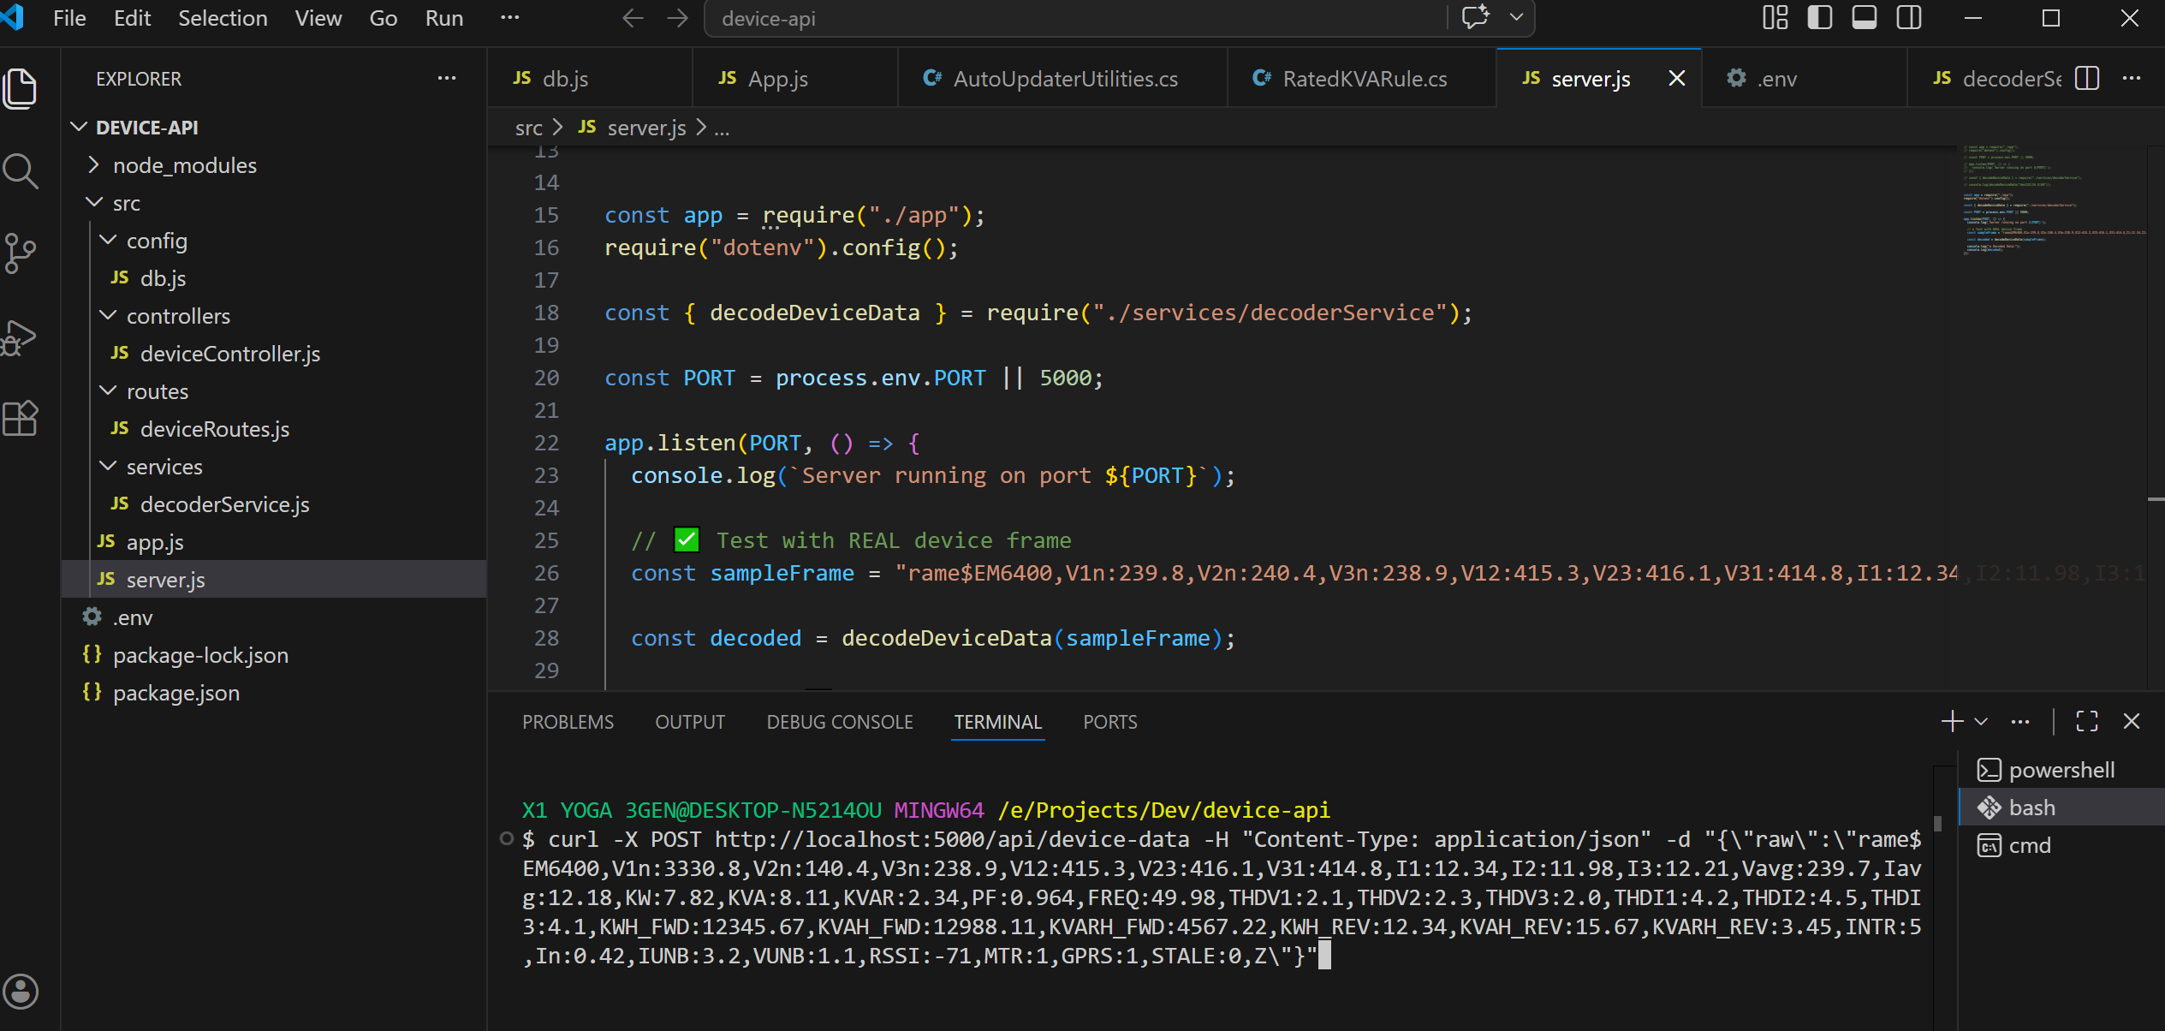

E:\Projects\Dev\device-api>npx nodemon src/server.js

Forend url

http://localhost:5000/api/device-data

Bash command

curl -X POST http://localhost:5000/api/device-data -H "Content-Type: application/json" -d "{\"raw\":\"rame$EM6400,V1n:1322.8,V2n:140.4,V3n:238.9,V12:415.3,V23:416.1,V31:414.8,I1:12.34,I2:11.98,I3:12.21,Vavg:239.7,Iavg:12.18,KW:7.82,KVA:8.11,KVAR:2.34,PF:0.964,FREQ:49.98,THDV1:2.1,THDV2:2.3,THDV3:2.0,THDI1:4.2,THDI2:4.5,THDI3:4.1,KWH_FWD:12345.67,KVAH_FWD:12988.11,KVARH_FWD:4567.22,KWH_REV:12.34,KVAH_REV:15.67,KVARH_REV:3.45,INTR:5,In:0.42,IUNB:3.2,VUNB:1.1,RSSI:-71,MTR:1,GPRS:1,STALE:0,Z\"}"

