How it works:
This document provides a high level overview of how the Python code in Network Scanner V2 works. I’m detailing how V2 works since V1 will be the same, but lacking the MAC address lookup tool. It will also acknowledge the questions that I still have about the code I’ve created. It’s important to acknowledge (as it does in the README.md file) that this project was adapted from a tutorial that was not my work and that the creation of this “How it works” document is mostly for my own benefit to solidify my own understanding of the networking tools I’m using.

Resource for documentation on the ARP() command: https://www.geeksforgeeks.org/network-scanning-using-scapy-module-python/

Lines 4-7:
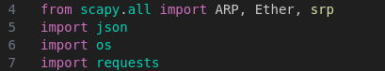

Lines 4-7 import the necessary libraries for the program to work. See theThe file “./Documentation/requirements.txt” for the packages and their versions installed on my virtual Python environment at the time of creation. Keep in mind that not all of these are necessary for this code to run, many are package dependencies and some I may have imported into the python virtual environment by accident.

Lines 9-18:

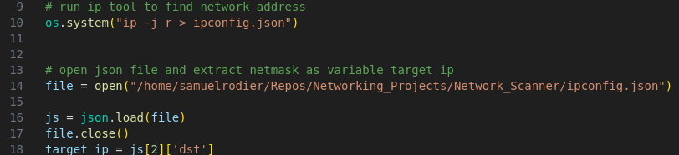
Lines 10 uses the ‘os’ library to run some code in the linux terminal. The code that it runs uses the ip tool, a networking tool that allows you to view and modify your computer’s ARP table, to extract your computer’s network address in a human readable format and output it as a JSON file that I pipe to a file called “ipconfig.json”. The file “./ipconfig.json” is hidden for my own privacy’s sake (See it listed in the “./.gitignore” file).
Lines 14-17 open, extract the information from “./ipconfig.json”, store it as the object ‘js’, and then close the file. I chose to use the complete file path. If you are cloning this repository, you will need to adapt this file path to reflect where you have this Python script stored.
Line 18 simply extracts the network range and saves it as the object ‘target_ip’ is the CIDR notation of the network address, which in the future will let my code know which IP addresses to scan when looking for devices connected to the same network.

Lines 20-30:
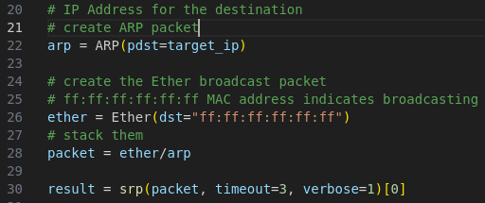

Line 22 creates an ARP request packet and sets the target of the packet as the range of Ips that the variable target_ip specifies.

(Interestingly, the Scapy module will allow you to craft every aspect of the ARP packet that you’re creating)

Line 26 creates an ethernet packet with the destination set to all f’s. This denotes that the message is a broadcast message and will be sent to every device on the network. In typical ethernet protocol communication, an ethernet packet must specify the IP and MAC address of the device that it wants to send a message to. But what happens if your computer doesn’t know who has the MAC address of the computer it wants to speak to? It has to send a broadcast message to everyone on the network in order to figure this information out.

Line 28 inserts the arp request as the payload of the ethernet packet, or the message contained in the ethernet packet.

Line 30 uses the srp() command to send the packet and listen for the response. It stores the responses under the result variable.

Lines 30-50
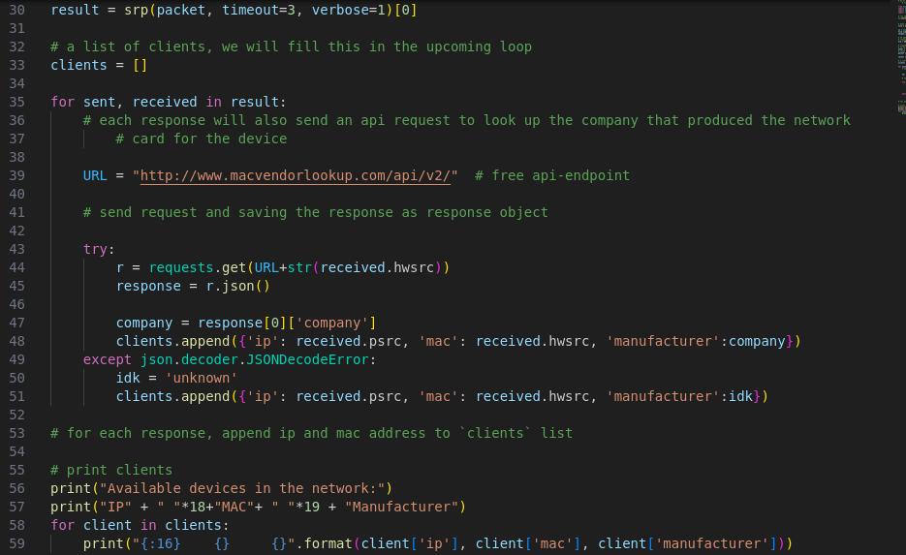
Lines 33-51 Are the process of extracting the IP and MAC addresses from the response packets received from the ARP Request message and using the MAC address lookup API to search the manufacturer. It stores all of this information in a dictionary.

Lines 56-59 print the information in a human-readable format.

