Net_scanner.py Errors and Learning Nuggets

The goal is to create a python program that will find all of the devices connected to the network, their IP addresses, their MAC addresses and tell me what kind of device they are.

This document just shows a few errors that I ran into, what I tried to do to fix it, and what I learned.

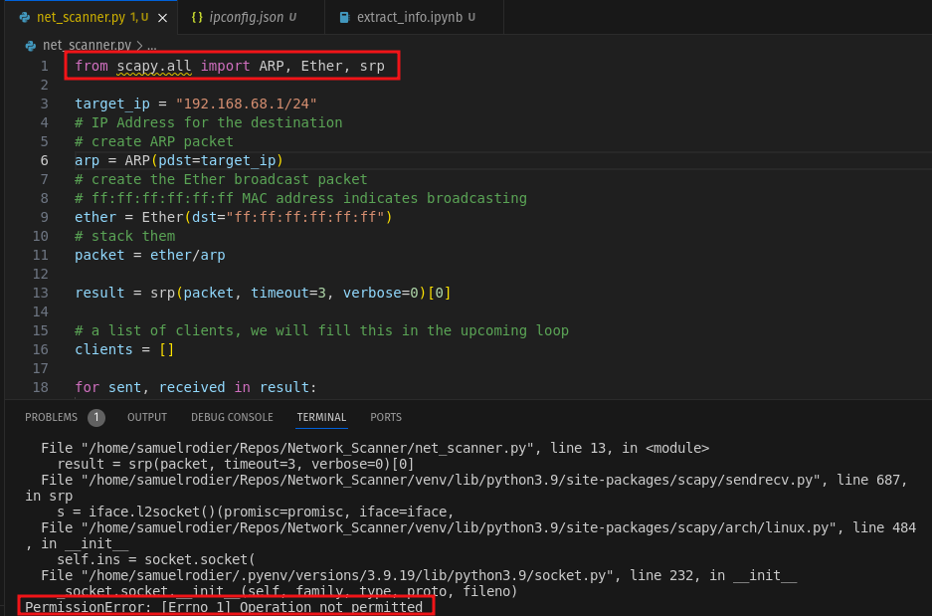
Error 1: When I run my python code, I get a Permission Error:
I first need to allow my python script admin privileges. In order to do this, I need to allow the file to be run from the command line which requires that I first enable python in the system (running python3 in the command line) and then run the file. OR I can add some code to the beginning of my code that activates python in the terminal with admin privileges.

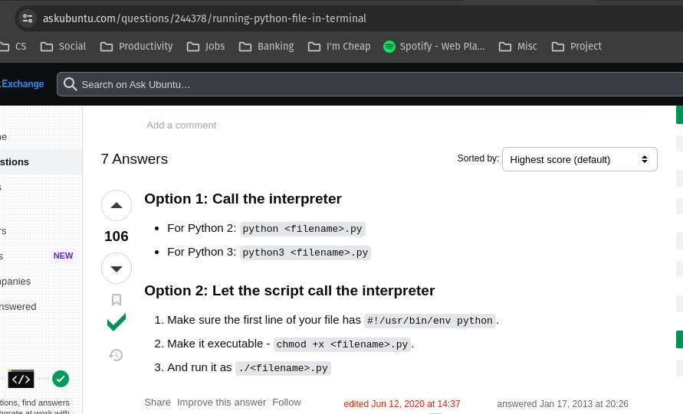

Executing this code from the command line allows the tool to work properly:
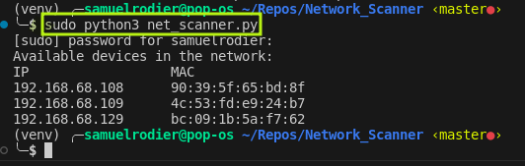

Not well understood:
- When I first tried this, it didn’t work. I had thought it was because the Scapy documentation specifies what versions of python it supports, and 3.12, the version I was using was not specifically listed. I created a new virtual environment with the latest version of 3.9 and made sure that scapy was installed properly in pip. Once I did that, it worked, however when I switched back to 3.12, it still worked, which kinda confused me.
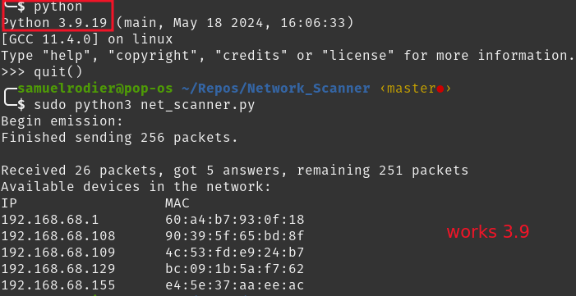
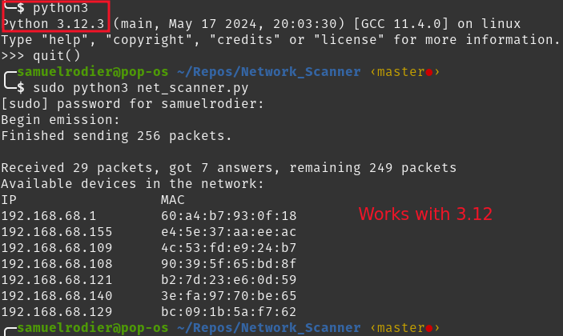

What I learned:

Alexa devices do not respond to ICMP calls. When I run my program in verbose mode, it only finds 7 devices. At the time of me writing this, there are 4 people with cell phones, Holly is using her laptop, and I have my work laptop and personal laptop connected to the internet. There are however 5 Alexa’s connected on the network.

The OS library allows you to run commands in your terminal from a python script. If I had known this earlier, I could have simplified other scripts.

