Net_ScannerV2 Errors and Learning Nuggets
The difference between V1 and V2 is that V2 incorporates a MAC address lookup tool and extracts the name of the manufacturer of the network connected device. This document walks through some of the errors encountered and what I did about them.

JSON error:
When I added in the api mac lookup, it kept throwing this error:
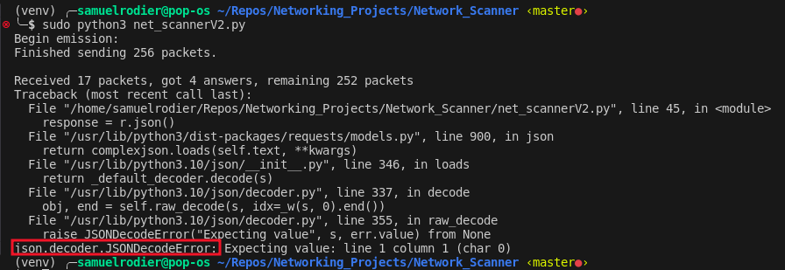
Line 45 was erroring out:

Since the code used a for-loop to request 1 mac address at a time, I printed the results of each line to find out where it errored out. In retrospect, This actually wasn’t helpful, and I should have figured that a result wasn’t returning good info once I saw where the error was coming from.

Soon enough, I checked the API documentation and found this:
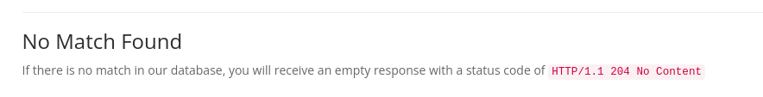
This meant to me that a response was failing perhaps because of a MAC address that couldn’t return a result.

So to fix it, I implemented try logic into my code, which inserted ‘unknown’ as manufacturer in case the code encountered the json error:

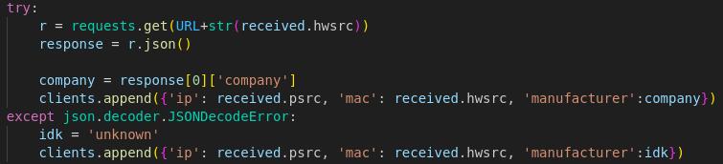
Interestingly enough, I was curious and wanted to figure out what my phone’s IP address was. I looked in the wifi settings found my IP address and compared it to the output of my program. I found that my phone was the device with the unknown manufacturer. I then checked phone’s About section and found a different MAC address than was listed by my program. I then realized that there was an option for public networks that hid your MAC address from the network.
So I learned that Iphone’s hide their MAC address for security.

