|  |
| --- |
| EIA-FR |
| Cahier des charges |
| Project Title |
|  |
| **Student name** |
| **Date** |

|  |
| --- |
|  |

Supervisor/s :

Professor/s :

**Table of Content**

1 Introduction 1

2 Context of the project 1

3 Main Goals 2

3.1 Goal 1 2

3.2 Goal 2 : 2

4 Secondary goals and future developments 2

4.1 Goal 1 : 2

5 Technologies 2

6 Tasks 2

6.1 Preliminary studies: 2

6.2 Conception: 3

6.3 Implementation: 3

6.4 Validation and tests: 3

6.5 Documentation: 4

7 GANTT diagram 5

8 Glossary 6

9 References 6

# 

# Introduction

General introduction of the project and positioning in the degree program.

# Context of the project

Specific description of the project with summary of the concepts learned during the first analysis of an existing preliminary project or of external related work.

# Main Goals

The main goal of the project explained during the first meeting.

## Goal 1

## Goal 2 :

# Secondary goals and future developments

Additional goals that you could suggest or that could not be achieved in the available time frame.

## Goal 1 :

# Technologies

Main systems, software and programming languages you will use during this project.

# Tasks

Detailed tasks for each phase of the project according to the previous main goals:

## Preliminary studies:

## Conception:

## Implementation:

## Validation and tests:

## Documentation:

# GANTT diagram

The GANTT diagram is very useful to estimate the time necessary for the completion of each task. Even if it is not respected, it is interesting to see which task took more time than expected. Analyzing the causes of these mismatches could be useful to improve our abilities to estimate time needs for a given task or to detect hidden problems that could be resolved for future projects. The GANTT Diagram can be made using Microsoft Project (available on the MSDNAA library) or [with open source alternatives](http://sourceforge.net/projects/projectlibre/).

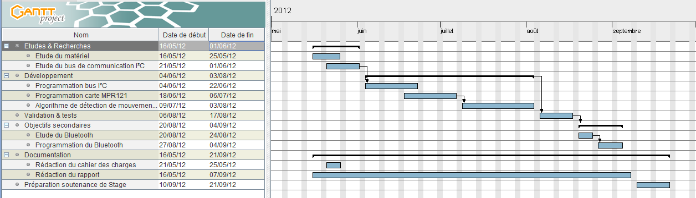

# Glossary

In this chapter you could explain acronyms or special terms that can be difficult to understand to a non-expert reader.

# References

Link to websites or references to books or articles related to this project