**C/C++ FALAFEL LAB REPORT**

**1) Enter your name, student ID, platform (Mac or PC) and date**

Name and Student ID: Samuel Indurkar 0888068

Class: CIS054 C/C++ Programming

Platform (Mac or PC): g++ and eclipse  
Date: 6/2/17

**DESCRIPTION:**A falafel is a very popular Middle Eastern food. It is served as a sandwich stuffed in pita bread usually containing lettuce, tomatoes and some round balls of fried chickpeas. The fried balls of chickpeas look like meatballs but are green on the inside and are very nutritious.

Modify the Falafel program to do the following:

1) Create a counter for each type of item sold (Falafels, Sodas, Extras).   
2) When the ‘T’ key is pressed for the total, display the count and subtotal for each item, the subtotal for all items, compute tax at 8.7%, display the amount of tax, and the final total for all items plus the tax.   
3) Use a constant (const in C++, or #define in C) to define the tax rate.  
4) Each display should contain two digits past the decimal point.

5) The program must process unexpected or illegal inputs. If the user enters a menu selection that is invalid, an error message must be displayed.

**LAB REPORT:  
2) Determine the Inputs, Processing and Outputs before creating the program**

|  |  |  |
| --- | --- | --- |
| **INPUTS** | **PROCESSING** | **OUTPUTS** |
| FTXS | ask users what they want  F T X S  after their order is complete  add up whatever they ordered  display total to the user | total. |

**3) Fill in the EXPECTED & ACTUAL RESULTS**

|  |  |  |
| --- | --- | --- |
| **TEST DATA VALUES**  Provide several different examples of menu selections | **EXPECTED RESULT**  Computed values before the program is run | **ACTUAL RESULT**  Fill in the output displayed  by the program |
| f | 5.60 | 5.60 |
| f  s | 8.03 | 8.03 |
| f  x  s | 9.74 | 9.74 |
| f  x | 7.30 | 7.30 |

**DISCUSSION:**

**4) Complete the DISCUSSION section. It does not need to be long, but it needs to be complete.**4a) What did you do to develop the program? ("Followed the Directions" is not a complete description)

to develop this program i first display the menu to the user

then with the use of a switch statement the users enter in their order.

after they are done ordering i display the total (the bill)

also i had a separate void function for displaying the menu

4b) What problems did you have and how did you overcome the problems?

I did not necessarily have any big problems, a few syntax errors here and there but no big logic problems.

**PROGRAM OUTPUT:**

**5) Show screen shots for at least TWO sample purchases of the program execution.**

Refer to previous lab assignments for instructions on how to capture a screen or portions of a screen for either the PC or a Mac. Provide a screenshot into the lab report showing several items purchased. Provide another screenshot showing the result of an unexpected or illegal input.

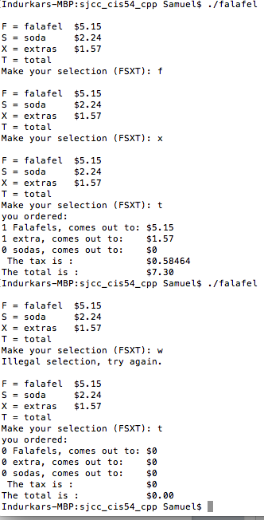

**PROGRAM LISTING:**

**6) Copy and paste the code that YOU typed to make the program work. Your program should include a comment block at the top that shows the name of the program, date, version and your name.**

/*

* falafel.cpp

*

* Created on: Jul 3, 2017

* Author: Samuel

*/

// falafel.cpp : Defines the entry point for the console application.

// CIS054 C/C++ Programming

// Dan McElroy

// June 2015

#include <iostream>

#include <cctype>

#include <cstdio>

void DisplayMenu(); // display the menu

using namespace std;

int main(int argc, char* argv[])

{

double total = 0.00;

double price;

char selection;

int F=0 , X=0 , S=0;

const double tax = 1.087;

do

{

DisplayMenu();

price = 0;

cout << "Make your selection (FSXT): ";

cin >> selection;

switch ( toupper(selection) )

{

case 'F':

F++;

price = 5.15;

break;

case 'S':

S++;

price = 2.24;

break;

case 'X':

X++;

price = 1.57;

break;

case 'T':

break;

default:

cout << "Illegal selection, try again." << endl;

}

total += price;

} while (selection != 'T' && selection != 't');

cout << "you ordered: " <<endl;

cout << F <<" Falafels, comes out to: $" << F * 5.15 << endl;

cout << X <<" extra, comes out to: $" << X*1.57 <<endl;

cout << S <<" sodas, comes out to: $" << S * 2.24 << endl;

cout << " The tax is : $" <<(tax-1)*total << endl;

printf("The total is : $%-10.2f\n", total*tax);

return 0;

}

void DisplayMenu()

{

cout << endl; // blank line before start of menu

cout << "F = falafel $5.15" << endl;

cout << "S = soda $2.24" << endl;

cout << "X = extras $1.57" << endl;

cout << "T = total" << endl;

}