**Final Exam Project**

**1) Enter your name, student ID, platform and date**

**Name:** Samuel Indurkar 0888068

**Class: CIS054 C/C++ Programming**

**Platform (Mac or PC):** mac and eclipse **Date:** 7/27/17

**2) PROJECT DESCRIPTION**

Create an application that searches a file of male and female first names. A link to the file is provided on the class webpage. "FirstNames2015.txt" is a list of the most popular baby names in the United States and was provided by the Social Security Administration.   
  
Each line in the file contains a boy's name and a girl's name. The file is space-delimited, meaning that the space character is used to separate the boy name from the girl name. The file begins with:

Noah Emma

Liam Olivia

Mason Sophia

Jacob Ava

William Isabella

Ethan Mia

James Abigail

Write a program that asks the user to enter a name. The program then searches the file for the name and displays the position of the name in the file if it matches either a boy name or a girl name. The program also displays a message if the name could not be found. Sample outputs:

Enter a name to search: Daniel

Daniel is ranked 12 for boy names

Daniel was not found for girls

Enter a name to search: Cassandra

Cassandra is ranked 511 for girl names

Cassandra was not found for boys

Enter a name to search: Taylor

Taylor is ranked 76 for girl names

Taylor is ranked 462 for boy names

NOTE: You can use any method you wish to match the name input on the keyboard with the names in the file. You can compare two strings ignoring upper/lower case by using **#include<cstring>** in C++ or **#include<string.h>**  in C and the following comparison if ( stricmp(string1,string2) == 0)

If your compiler does not have stricmp, you may need to use _stricmp or strcasecmp.

HIPO CHART

|  |  |  |
| --- | --- | --- |
| **INPUTS** | **PROCESSING** | **OUTPUTS** |
| Ask the user to enter a name | After taking the name from user, then open the file, conduct a line by line search using a while loop. Read the two names from the file into two variables called boyName and girlName. while keeping track of current linenumber, if the name was found then display that it was found and display its rank number (line number). If the while loop is exited and the name to search didn’t match any of my names then i display “was not found” | If boyname found then display the line number, else display “not found”. Do the exact same procedure for girl and If girlname found then display the line number, else display “not found”. |

**3) DISCUSSION**

a) What did you do to develop the program? ("Followed the Directions" is not a complete description

To develop the program i ask the user to input a name. Then i opened the file, conducted a line by line search using a while loop. I read the two names from the file into two variables called boyName and girlName and while keeping track of what line i am currently in, if the name was found in that line then i display that it was found and display its rank number (line number). If the while loop is exited and the name to search didn’t match any of my names then i display “was not found”.

b) What problems did you have and how did you overcome the problems?

I had no problems.

**4) PROGRAM OUTPUT**  
Submit seven screen shots:  
1) search result for your first name  
2) search result for a name used for both boys and girls, such as Taylor, or Dylan

3) search result for a name used only for boys  
4) search result for a name used only for girls  
5) search result for a name that at the very top of the file  
6) search result for a name that is at the very bottom of the file

7) search result for a name that is not in the file

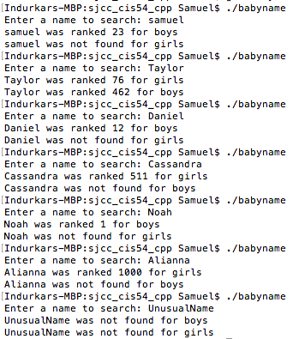

**5) PROGRAM LISTING**  
Copy and paste YOUR code.

/*

* babyname.cpp

*

* Created on: Jul 27, 2017

* Author: Samuel

*/

#include <iostream>

#include <cstring>

#include <fstream>

using namespace std;

int main( )

{

ifstream myfile;

char boyName[100];

char girlName[100];

char nameToSearch[100];

int lineNum=0;

int Bfound = 0, Gfound = 0;

myfile.open("babynames.txt");

cout << "Enter a name to search: " ;

cin >> nameToSearch;

while ( !myfile.eof() )

{

lineNum++;

myfile >> boyName >> girlName ;

if (strcasecmp( boyName , nameToSearch) == 0)

{

cout<< nameToSearch << " was ranked " << lineNum << " for boys" << endl;

Bfound = 1;

}

if (strcasecmp( girlName , nameToSearch) == 0)

{

cout<< nameToSearch << " was ranked " << lineNum << " for girls" << endl;

Gfound = 1;

}

}

if (Bfound != 1)

{

cout << nameToSearch << " was not found for boys" << endl;

}

if (Gfound != 1)

{

cout << nameToSearch << " was not found for girls" << endl;

}

}