**C++ LENGTH OF LINE PROGRAM LAB REPORT**

**1) Enter your name, student ID, platform (Mac or PC) and date**

Name and Student ID: Samuel Indurkar, 0888068

Class: CIS054 C/C++ Programming

Platform (Mac or PC): GCC and Eclipse on MAC  
Date: 7/3/2017

**DESCRIPTION:**

Create a program that uses a function to determine the length of a line by inputting the X,Y coordinates of the line endpoints. Show the result with a precision of four decimal places. The function prototype is to be specified as follows:

double LengthOfLine (double X1, double Y1, double X2, double Y2); // returns length of line

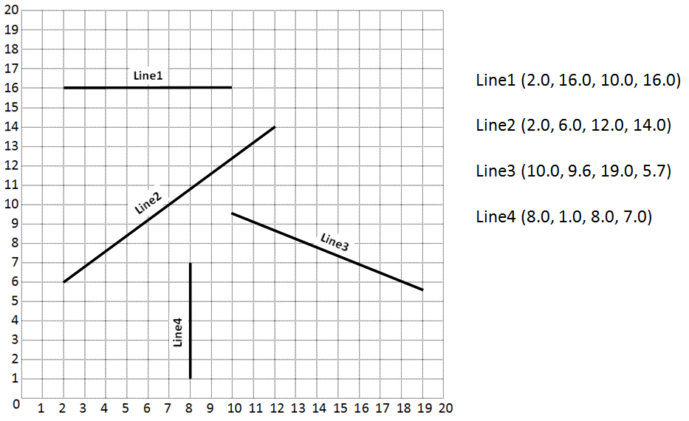

|  |  |  |
| --- | --- | --- |
| **INPUTS** | **PROCESSING** | **OUTPUTS** |
| x1, x2, y1, y2 | compute the hypotenuse as follows:  x = x2 - x1;  y = y2 - y1;  hypotenuse = sqrt( x*x + y*y) | hypotenuse |

**2) Determine the Inputs, Processing and Outputs before creating the program**

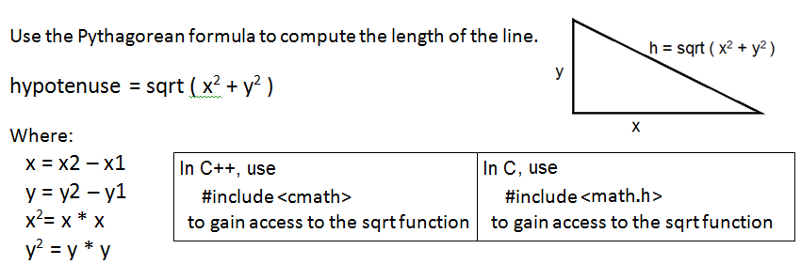

**3) Fill in the EXPECTED & ACTUAL RESULTS**

|  |  |  |
| --- | --- | --- |
| **TEST DATA VALUES** | **EXPECTED RESULT**  Computed values before the program is run | **ACTUAL RESULT**  Fill in the output displayed  by the program |
| 2.0 16.0 10.0 16.0 | 8.000 | 8.0000 |
| 2.0 6.0 12.0 14.0 | 12.8062 | 12.8062 |
| 10.0 9.6 19.0 5.7 | 9.8087 | 9.8087 |
| 8.0 1.0 8.0 7.0 | 6.0000 | 6.0000 |

**DISCUSSION:**

**4) Complete the DISCUSSION section. It does not need to be long, but it needs to be complete.**4a) What did you do to develop the program? ("Followed the Directions" is not a complete description)

Prompted the user to enter four values stored them as x1, x2, y1, y2. Then calculated the corresponding x and y as follows:

x = x2 - x1;

y = y2 - y1;

then calculated the final answer as follows:

hypotenuse = sqrt( x*x + y*y)

4b) What problems did you have and how did you overcome the problems?

No problems.

**PROGRAM OUTPUT:**

**5) Show four screen shots, one for each of the TEST DATA VALUES in the above table.**

Refer to previous lab assignments for instructions on how to capture a screen or portions of a screen for either the PC or a Mac

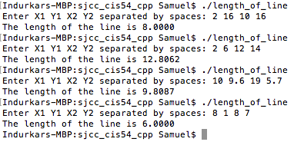

**PROGRAM LISTING:**

**6) Copy and paste the code that YOU typed to make the program work. Your program should include a comment block at the top that shows the name of the program, date, version and your name.**

/*

* length_of_line.c

*

* Created on: Jul 3, 2017

* Author: Samuel

*/

#include <stdio.h> /* used by printf and scanf */

#include <math.h> /* used by sqrt */

double LengthOfLine (double X1, double Y1, double X2, double Y2);

int main(int argc, char* argv[])

{

double X1, Y1, X2, Y2, length; // declare the variables

printf ("Enter X1 Y1 X2 Y2 separated by spaces: ");

scanf ("%lf %lf %lf %lf", &X1, &Y1, &X2, &Y2);

length = LengthOfLine(X1, Y1, X2, Y2);

printf ("The length of the line is %.4lf\n", length);

return 0;

}

double LengthOfLine (double X1, double Y1, double X2, double Y2)

{

double a, b, c; // c is the computed length of the line

a = X2 - X1;

b = Y2 - Y1;

c = sqrt(a*a + b*b);

return c;

}