**C/C++ ENGLISH AND METRIC CONVERSION LAB REPORT**

**1) Enter your name, student ID, platform (Mac or PC) and date**

Name and StudentID: Samuel Indurkar, 0888068

Class: CIS054 C/C++ Programming

Platform (Mac or PC): gcc and eclipse on MAC  
Language (C or C++): C++

Date: 6/29/2017

**OBJECTIVES:**

Complete the program to convert Metric measurements in cm to English inches. Reject negative and illegal values when inputting numeric data.

**PROJECT DESCRIPTION:**

Complete the program to do the following:   
1) Complete the HIPO and Test Values chart below

2) Input a selection from a menu that selects English-Metric or Metric-English  
3) Complete the program to process and display Metric-English conversions  
4) Update the code that inputs inches and centimeters to reject negative and illegal numeric values. Refer to the   
 code on the PlayersOnTeam for the C and C++ versions. An if statement with its block of code appears directly  
 after the scanf (C) or cin (C++) statements in the PlayersOnTeam code. It is not necessary to check for illegal values   
 in the menu function because characters are being input instead of numeric data.

|  |  |  |
| --- | --- | --- |
| **INPUTS** | **PROCESSING** | **OUTPUTS** |
| 1. inches 2. centimeters | 1. centimeters = inches * 2.54 2. inches = centimeters / 2.54 | 1. centimeters 2. inches |

**LAB REPORT:**

**2) Fill in the TEST VALUES & RESULTS table**Fill in the **Test Data Values** and **Expected Results** as shown on the lab assignment from Canvas.  
Fill in the **Actual Results** after you have run and tested your program

|  |  |  |
| --- | --- | --- |
| **TEST DATA VALUES**  **cm or inches** | **EXPECTED RESULT**  Computed values before the program is run | **ACTUAL RESULT**  Fill in the output displayed  by the program |
| 1 inch | 2.54 cm | 2.54 cm |
| 15 inch | 38.1 cm | 38.1 cm |
| 1 cm | 0.393701 in | 0.393701 in |
| 15 cm | 5.90551 in | 5.90551 in |

**DISCUSSION:**

**3) Complete the DISCUSSION section. It does not need to be long, but it needs to be complete.**3a) How does the menu selection function pass the user's request back to the main program.

the menu selection function has a do/while loop which keeps repeating as long as the selection is not equal to E, M, or Q. Once user enters the correct value it is returned back to main as a char.

3b) How does the program reject negative and illegal values when inputting numeric data?

I put a do/while loop which keeps repeating as long as the user input is negative and once a positive number is inputed it moves onto the calculation.

3c) What are the differences between the C++ code and the C code?

the C++ code uses cin and out while the c code uses scanf and printf.

**PROGRAM OUTPUT:**

**4) Show four screen shots of the program execution.**

1. inches to centimeters – show two conversions, including what happens when an illegal menu selection is input

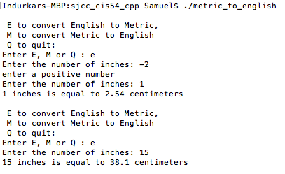

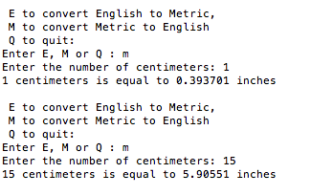

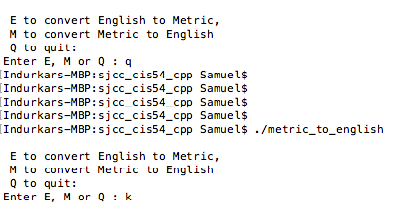

For the Mac, hold down **command + shift + control** keys and press the **4** key and select just the output panel

Use **command+V** to paste the clipboard into the lab report.

For Windows, There are two ways you can capture a screen shot of only your program:

* Use Microsoft's **Snipping Tool** by clicking on the **Start** icon and selecting **"All Programs"** then **"Accessories".** Use the mouse to select the area of the screen you want to save then click Ctrl-C or select the menu items Edit-Copy to save the image to the clipboard.
* Capture the active window to the clipboard by holding down the **Alt** key and tapping the **PrintScreen** key. NOTE: some notebook computers require that you hold down a [**Fn**] key and **Alt** keys to activate the **PrintScreen** function. NOTE: Do not click PrintScreen without the Alt key. This would capture the entire screen which would make your program output difficult to see.

Use **Ctrl+V** to paste the clipboard into the lab report.

**PROGRAM LISTING:**

**5) Copy and paste the code that YOU typed to make the program work. Your program should include a comment block at the top that shows the name of the program, date, version and your name.**

**/\***

**\* metric_to_english.cpp**

**\***

**\* Created on: Jun 29, 2017**

**\* Author: Samuel**

**\*/**

**// C++MetricToEnglish.cpp : Defines the entry point for the console application. //**

**#include <iostream>**

**#include <cstdio>**

**#include <cctype>**

**// prototype declarations**

**char menuSelect();**

**using namespace std;**

**int main(int argc, char* argv[])**

**{**

**double inches;**

**double centimeters;**

**char select;**

**do {**

**select = menuSelect();**

**if (select == 'E')**

**{**

**do {**

**cout << "Enter the number of inches: ";**

**cin >> inches;**

**if (inches < 0)**

**{**

**cout << "enter a positive number \n";**

**}**

**} while (inches < 0);**

**centimeters = inches * 2.54;**

**cout << inches << " inches is equal to " << centimeters << " centimeters" << endl;**

**}**

**else if (select == 'M')**

**{**

**do {**

**cout << "Enter the number of centimeters: ";**

**cin >> centimeters;**

**if (centimeters < 0)**

**cout << "enter a positive number \n";**

**} while (centimeters < 0);**

**inches = centimeters / 2.54;**

**cout << centimeters << " centimeters is equal to " << inches << " inches" << endl;**

**}**

**}while (select != 'Q');**

**return 0;**

**}**

**char menuSelect()**

**{**

**char selection;**

**do {**

**cout << "\n E to convert English to Metric, \n";**

**cout << " M to convert Metric to English \n";**

**cout << " Q to quit: \n";**

**cout << "Enter E, M or Q : ";**

**cin >> selection;**

**selection = toupper(selection); // convert to uppercase**

**}while (selection != 'E' && selection != 'M' && selection != 'Q'); // verify legal selection**

**return selection;**

**}**