**C/C++ PAYCHECK PROGRAM LAB REPORT**

**1) Enter your name, student ID, platform (Mac or PC) and date**

Name and Student ID: Samuel Indurkar 0888068

Class: CIS054 C/C++ Programming

Platform (Mac or PC): Mac gcc and eclipse  
Date: 6/20/17

**OBJECTIVES:**

Enter and successfully run a C or C++ program

Use console input to read data from the keyboard  
Calculate regular and overtime pay using **if…else** statements

Use console output to display data to the monitor

**DESCRIPTION:**

Design a C or C++ program that does the following: 1) Read the number of hours worked and the pay rate, 2) compute the pay including overtime at time-and-a-half 3) display the gross pay, not including taxes or any other deductions.

|  |  |  |
| --- | --- | --- |
| **INPUTS** | **PROCESSING** | **OUTPUTS** |
| Hours  PayRate | Read **hours** from the keyboard into a double  Read **payRate** from the keyboard into a double  Determine **regularHours** (up to 40)  Determine **overtimeHours** (hours over 40)  **regularPay** = **regularHours** * **payRate**  **overtimePay** = **overtimeHours** * **payRate** * 1.5  **grossPay** = **regularPay** + **overtimePay**  Display **grossPay** | GrossPay |

**LAB REPORT:**

**2) Fill in the TEST VALUES & RESULTS table**Fill in the **Test Data Values** and **Expected Results** as shown on the lab assignment from Moodle.  
Fill in the **Actual Results** after you have run and tested your program

|  |  |  |
| --- | --- | --- |
| **TEST DATA VALUES** | **EXPECTED RESULT**  Computed values before  the program is run | **ACTUAL RESULT**  Fill in the output displayed  by the program |
| Hours = 39, PayRate = 20 | $780.00 | $780.00 |
| Hours = 40, PayRate = 20 | $800.00 | $800.00 |
| Hours = 41, PayRate = 20 | $830.00 | $830.00 |

**DISCUSSION:**

**3) Complete the DISCUSSION section. It does not need to be long, but it needs to be complete.**3a) What did you do to develop the program? ("Followed the Directions" is not a complete description

For the first 40 hours we multiply it by the base rate. Then for the remaining hours (overtime hours >40) we multiply those by the overtime rate, which is regular rate * 1.5. Then, we add the two together.

3b) What problems did you have and how did you overcome the problems?

I did not encounter many problems. The only problem I encountered was creating a variable with name “regPay” for example and later trying to call it with “regpay”. I overcame these problems by making all variable names uniform.

**PROGRAM OUTPUT:**

**4) Show three screen shots of the program.**

1. A paycheck computed when the hours worked is less than 40
2. A paycheck computed when the hours worked is equal to 40
3. A paycheck computed when the hours worked is greater than 40

For the Mac, hold down **command + shift + control** keys and press the **3** key.

Use **command+V** to paste the clipboard into the lab report.

For Windows, There are two ways you can capture a screen shot of only your program:

* Use Microsoft's **Snipping Tool** by clicking on the **Start** icon and selecting **"All Programs"** then **"Accessories".** Use the mouse to select the area of the screen you want to save then click Ctrl-C or select the menu items Edit-Copy to save the image to the clipboard.
* Capture the active window to the clipboard by holding down the **Alt** key and tapping the **PrintScreen** key. NOTE: some notebook computers require that you hold down a [**Fn**] key and **Alt** keys to activate the **PrintScreen** function. NOTE: Do not click PrintScreen without the Alt key. This would capture the entire screen which would make your program output difficult to see.

Use **Ctrl+V** to paste the clipboard into the lab report.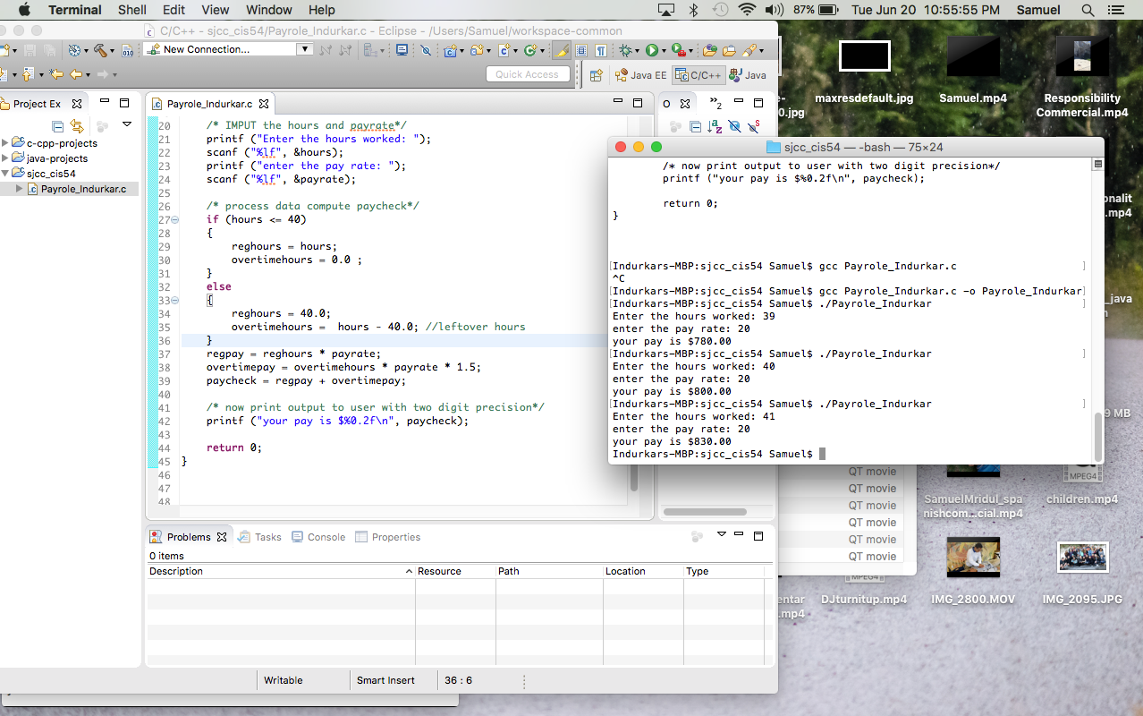

**Please look at the terminal window where the three inputs and outputs are tested and shown.**

**SCREENSHOTS ATTACHED WITH SUBMISSION TOO**

**PROGRAM LISTING:**

**5) Copy and paste the code that YOU typed to make the program work. Your program should include a comment block at the top that shows the name of the program, date, version and your name.**

/* Payrole_Indurkar.c

*

* Created on: Jun 20, 2017

* Author: Samuel

*/

#include <stdio.h>

int main(int argc, char* argv[])

{

/* Declare the Variables*/

double hours;

double payrate;

double reghours;

double overtimehours;

double regpay;

double overtimepay;

double paycheck;

/* IMPUT the hours and payrate*/

printf ("Enter the hours worked: ");

scanf ("%lf", &hours);

printf ("enter the pay rate: ");

scanf ("%lf", &payrate);

/* process data compute paycheck*/

if (hours <= 40)

{

reghours = hours;

overtimehours = 0.0 ;

}

else

{

reghours = 40.0;

overtimehours = hours - 40.0; //leftover hours

}

regpay = reghours * payrate;

overtimepay = overtimehours * payrate * 1.5;

paycheck = regpay + overtimepay;

/* now print output to user with two digit precision*/

printf ("your pay is $%0.2f\n", paycheck);

return 0;

}