**C/C++ ROCK PAPER SCISSORS LAB REPORT**

**1) Enter your name, student ID, platform (Mac or PC) and date**

Name and Student ID: Samuel Indurkar, 0888068

Class: CIS054 C/C++ Programming

Platform (Mac or PC): gcc and eclipse on MAC  
Date: 6/26/2017

**OBJECTIVES:**

Input player inputs using cout/cin (for C++) or printf/scanf (for C)  
Use nested if/else if/else statements to determine the outcome of the game

Identify illegal inputs from the user and display an error message

Use a while loop to repeat the game

**DESCRIPTION:** Chapter 3 Programming Project #1 (page 170 8th Edition, page 172 9th Edition)

Write a program to score the rock-paper-scissor game. Each of two users types in either R,P, or S. The program then announces the winner as well as the basis for determining the winner: Paper covers rock, Rock breaks scissors, Scissors cut paper, or Nobody wins. Be sure to allow the user to use lowercase as well as uppercase letters. Your program should include a loop that lets the user play again until the user says she or he is done.

**2) Determine the Inputs, Processing and Outputs before creating the program**

|  |  |  |
| --- | --- | --- |
| **INPUTS** | **PROCESSING** | **OUTPUTS** |
| **players’ move (r,p, or s)** | **Use English pseudo-code here. Do not paste the processing section of your C++ program in this table.** | **Who won and why they won** |

**3) Fill in the EXPECTED & ACTUAL RESULTS**

|  |  |  |
| --- | --- | --- |
| **TEST DATA VALUES** | **EXPECTED RESULT**  Computed values before the program is run | **ACTUAL RESULT**  Fill in the output displayed  by the program |
| Player 1 Player 2  R R  R P  R S  P R  P P  P S  S R  S P  S S  X R  R X | Player 1 Player 2  R R tie  R P player 2 wins  R S player1 wins  P R player 1 wins  P P tie  P S player 2 wins  S R player 2 wins  S P player 1 wins  S S tie  X R illegal entry  R X illegal entry | Player 1 Player 2  R R tie  R P player 2 wins  R S player1 wins  P R player 1 wins  P P tie  P S player 2 wins  S R player 2 wins  S P player 1 wins  S S tie  X R illegal entry  R X illegal entry |

**PARTIAL SOLUTION:**

**4) You can use the code shown below as a reference to start your program, or you can create your own program from scratch. The program below shows only the solution when the first player enters the letter R to select rock.**

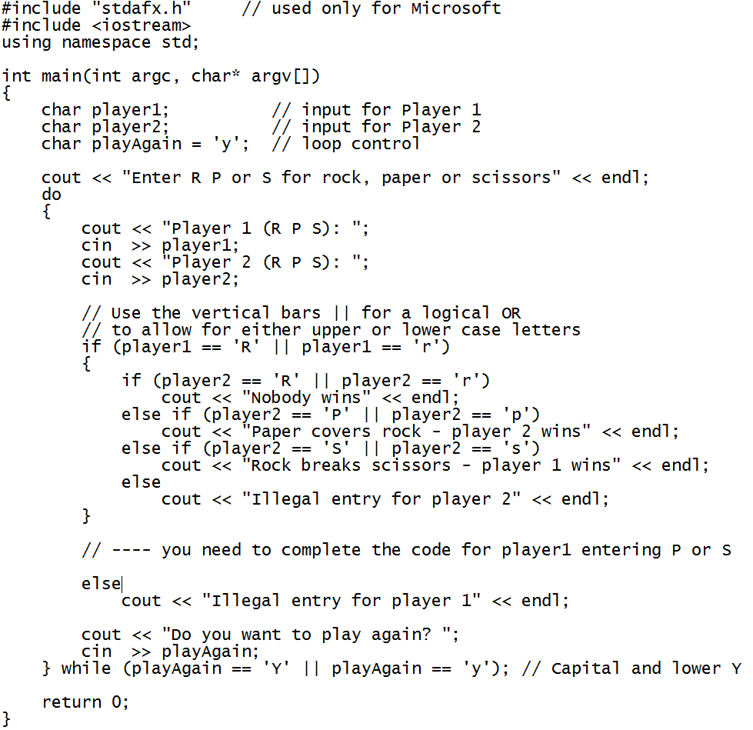

**DISCUSSION:**

**Complete the DISCUSSION section. It does not need to be long, but it needs to be complete.**5a) What did you do to develop the program? ("Followed the Directions" is not a complete description)

First I asked the users for the move for player1. Then I asked the user for the move for player2.

I made sure they had entered a correct value of R, P, S.

I then did a case by case comparison.

I put it in a do-while loop

5b) What problems did you have and how did you overcome the problems?

I didn’t experience any problems while writing this program.

**PROGRAM OUTPUT:**

**6) Show screen shots of the program.**

Show screenshots AFTER the program has executed. Show nine screenshots of each of the winning possibilities and one screenshot demonstrating what the program does with an illegal input.

For the Mac, hold down **command + shift + control** keys and press the **3** key.   
Use **command-V** to paste the clipboard into the lab report.

For Windows, There are two ways you can capture a screen shot of only your program:

* Use Microsoft's **Snipping Tool** by clicking on the **Start** i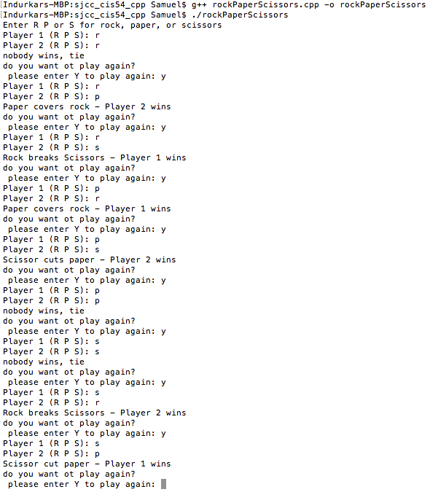con and selecting **"All Programs"** then **"Accessories".** Use the mouse to select the area of the screen you want to save then click Ctrl-C or select the menu items Edit-Copy to save the image to the clipboard.
* Capture the active window to the clipboard by holding down the **Alt** key and tapping the **PrintScreen** key. NOTE: some notebook computers require that you hold down a [**Fn**] key and **Alt** keys to activate the **PrintScreen** function. NOTE: Do not click PrintScreen without the Alt key. This would capture the entire screen which would make your program output difficult to see.

Use **Ctrl+V** to paste the clipboard into the lab report.

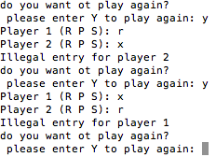

**PROGRAM LISTING:**

**7) Copy and paste the code that YOU typed to make the program work. Your program should include a comment block at the top that shows the name of the program, date, version and your name.**

**/\***

**\* rockPaperScissors.cpp**

**\*version 1**

**\* Created on: Jun 26, 2017**

**\* Author: Samuel**

**\*/**

**#include <iostream>**

**using namespace std;**

**int main (int argc, char* argv[ ] )**

**{**

**char player1; //input for player1**

**char player2; //input for player2**

**char playAgain = 'y'; //play again**

**cout << "Enter R P or S for rock, paper, or scissors" <<endl;**

**while (playAgain == 'Y' || playAgain == 'y')**

**{**

**cout << "Player 1 (R P S): ";**

**cin >> player1;**

**cout << "Player 2 (R P S): ";**

**cin >> player2;**

**player1 = toupper(player1);**

**player2 = toupper(player2);**

**// now to compute who won**

**if (player1 == 'R')**

**{**

**if (player1 == player2)**

**cout <<"nobody wins, tie" << endl;**

**else if (player2 == 'P')**

**cout << "Paper covers rock - Player 2 wins" <<endl;**

**else if (player2 == 'S')**

**cout << "Rock breaks Scissors - Player 1 wins" <<endl;**

**else**

**cout << "Illegal entry for player 2" << endl;**

**}**

**else if (player1 == 'S')**

**{**

**if (player1 == player2)**

**cout <<"nobody wins, tie" << endl;**

**else if (player2 == 'P')**

**cout << "Scissor cut paper - Player 1 wins" <<endl;**

**else if (player2 == 'R')**

**cout << "Rock breaks Scissors - Player 2 wins" <<endl;**

**else**

**cout << "Illegal entry for player 2" << endl;**

**}**

**else if (player1 == 'P')**

**{**

**if (player1 == player2)**

**cout <<"nobody wins, tie" << endl;**

**else if (player2 == 'R')**

**cout << "Paper covers rock - Player 1 wins" <<endl;**

**else if (player2 == 'S')**

**cout << "Scissor cuts paper - Player 2 wins" <<endl;**

**else**

**cout << "Illegal entry for player 2" << endl;**

**}**

**else {**

**cout << "Illegal entry for player 1 \n";**

**}**

**cout << "do you want ot play again? \n";**

**cout << " please enter Y to play again: ";**

**cin >> playAgain;**

**}**

**return 0;**

**}**