**C++ "TAX TABLE LOOKUP" Lab Report**

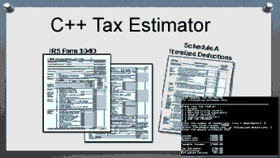**1) Enter your name, student ID and date**

Name: Samuel Indurkar, 0888068

Student ID: 0888068  
Platform (Mac or PC): MAC

Date: 7/10/2017

**PROJECT DESCRIPTION:**When people fill out their tax return,  they have the option of itemizing their deductions or using a standard deduction. If people are buying a house and have a mortgage, have donated a lot of money to charities, have high medical bills or other deductions, it may be better to itemize and list all their deductions. For many people it may be better to take the 'standard deduction'

The program should ask for the following information in this order:  
  
When all the data has been collected, the program displays  
  
I have completed most of the code for the Tax Estimator project. The program needs to be updated to ask if the the user wants to itemize or use the standard deduction.

a) Income in dollars  
b) -Exemptions in dollars  
c) -Deductions in dollars  
d) Taxable income

e) Computed tax in dollars (from the tax tables)  
f) -Amount withheld in dollars (usually from the W2 from your employer)  
g) Refund or amount owed in dollars

a) Tax status - single, married filing jointly, etc.  
b) Number of exemptions (people you can claim on your taxes 1, 2, 3, etc.)  
c) Total income in dollars  
d) Select either standard deduction or itemized deduction  
 1. If the standard deduction is selected, the amount is to be looked up from an array. The array is to   
 filled with the data shown in the table below.  
 2. If the itemized deduction is selected, the dollar amount of the deduction is to be read from the   
 keyboard.   
e) Amount withheld in dollars (usually from the W2 from your employer)

If the user selects to itemize, then the program is to ask for the itemized deductions.

If the user selects the standard deduction, then the program looks up the amount of deduction from a table, based on the filing status (single, married, etc.)

The project currently allows the user to input the amount of the itemized deductions, but the program has not been completed to use the standard deductions. If the standard deduction option is selected when running the program, the deductions should place the standard deductions in an array and look up the deduction from the array. The array is to be filled with the following data:

**Taxpayer Status      Standard Deduction  
=========================================**

Single                      6300.00  
Married filing jointly     12600.00  
Married filing separately   6300.00  
Head of Household           9250.00

Qualifying Widow(er)    12600.00

**LAB REPORT:**

**2) Fill in the TEST VALUES & RESULTS table**Fill in the **Button Clicked** and **Expected Results** as shown on the lab assignment from Canvas.  
Fill in the **Actual Results** after you have run and tested your program

|  |  |  |  |
| --- | --- | --- | --- |
| **FILING STATUS** | **DEDUCTION SELECTION** | **EXPECTED RESULTS** | **ACTUAL RESULTS** |
| Single | Standard | Don’t know what to enter | see screen shot below |
| Married filing jointly | Standard | Don’t know what to enter | see screen shot below |
| Head of Household | Standard | Don’t know what to enter | see screen shot below |
| Single | Itemized = 3400 | Don’t know what to enter | see screen shot below |

**DISCUSSION:  
3) Complete the DISCUSSION section in English. It does not need to be long, but it needs to be complete.**3a) What did you do to develop the program?

In the main program, added a cost to prompt the user what type of deduction he wants. Based on this input, I added an “if else” statement to either use itemized deduction or use the standard deduction. For standard deduction, I entered the provided values into an array and used it during calculation

3b) What problems did you have and how did you overcome the problems?

Earlier I wrote using switch statement. But when I read your problem statement more carefully, and saw your video carefully, it had to be re-written using an array, so I re-wrote it using the array.

After re-writing the program using array, the “status” enum starts with 1 but the array index starts with 0 so the program was incorrect because it was using incorrect standard deduction. So then I fixed the index by subtracting 1.

Also you mention:

“Fill in the **Button Clicked** and **Expected Results** as shown on the lab assignment from Canvas”

I couldn't find button clicked.

I don’t know what to enter in “Expected Results”.

Sample run of the program

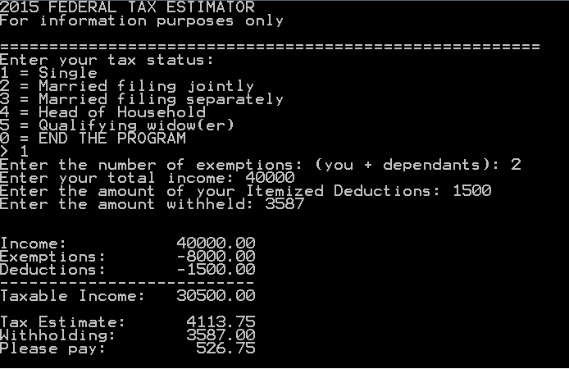

**PROGRAM OUTPUT:  
4) Show screen shots of the program when it is running.** Refer to previous lab assignments on how to capture a screen shot and paste it into the lab report.

|  |  |
| --- | --- |
| Filing Status = Single Deduction Selection = Standard | Filing Status = Married filing jointly Deduction Selection = Standard |
|  |  |
| Filing Status = Head of Household Deduction Selection = Standard | Filing Status = Single Deduction Selection = Itemized at 3400 |
|  |  |

**PROGRAM LISTING:  
5) Copy and paste ONLY the code that you wrote to implement the choice of standard deduction or itemized deduction.**

I added this in main

.. .. ..

.. .. ..

.. .. ..

cout << " 0 --> Standard\n 1 --> Itemized \n Which deduction do you want to use: ";

cin >> itemize_deduction;

if (itemize_deduction == 1)

{

deductions = itemizeDeductions(status);

}

else

{

deductions = standardDeductions(status);

}

.. .. ..

.. .. ..

end-of-main.

double standardDeductions(int status)

{

double deductions;

/*use the following standard deductions

Single 6300.00

Married filing jointly     12600.00

Married filing separately   6300.00

Head of Household           9250.00

Qualifying Widow(er)    12600.00

*/

double standard_deduct[] = { 6300.00, 12600.00, 6300.00, 9250.00, 12600.00 };

deductions = standard_deduct[status - 1];

cout << "Your standard Deduction is: " <<deductions <<endl;

return deductions;

}