-=====================GIT===================================

SCM:Source Code management.

Svn,bit keeper,bitbucket,p4,etc

SVN—Sub version,Centralized repository mgt.

GIT 🡪Open source,distributed repository mgt.

1)when we want to maintain versioning and files we will share in distributed manner then we will use git.

2)we always maintain projects or applications in servers.

especially to maintain source code we have servers like github,bigbucket etc

3)first we will create A remote repository in github and we will keep all our files into that.

4) so we will take latest from that repository and and we will modify file and will move to Remote github server by using one software called git.

based on operating system we should install respective git software

for windows it is git bash.

after installation of git bash we have set of rules to move files to github.

Before rules ,in github server we have two types of accounts

1)public and

2)private accounts(paid one)

in github server

1)created one repository (by default it is master)

2)under that one file test.txt and edited with some conted and saved

now process to access the git hub server and changes should be moving to github server

before that how the process will hapeen when we move our changes to github server

GITHUb->Continuous versioning control system

Working Directory

| Add

Staging Directory

| Commit &Pull

Local Directory

| Push

Remote Directory

git also work as Linux

1)for git clone no need to give credentials

2)in .git file contain config file it contain user credentials and gibhub repositiries

git status

if any file in red color the file is in work space region

if it is in green color it went to staging or index area

under repository we need to add collabarators for do commit and push in to repository

in bit bucket we call bucket as a repository

at a time from git,we will connect to multiple versioning controle systems

but each vesrioning control systems we will conncet to one repository only.

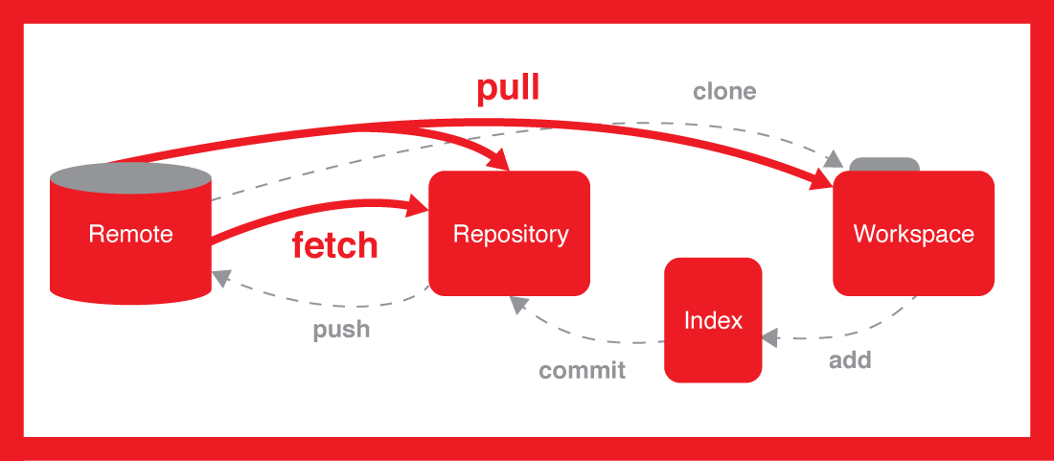

To download GIT:

<https://git-scm.com/download/>

GIT GUI 🡪Graphical interface for GIT.

GIT bash🡪command line interface for GIT.

If some repository should work as git repository we should initialize that repository with git init command.

#Git init

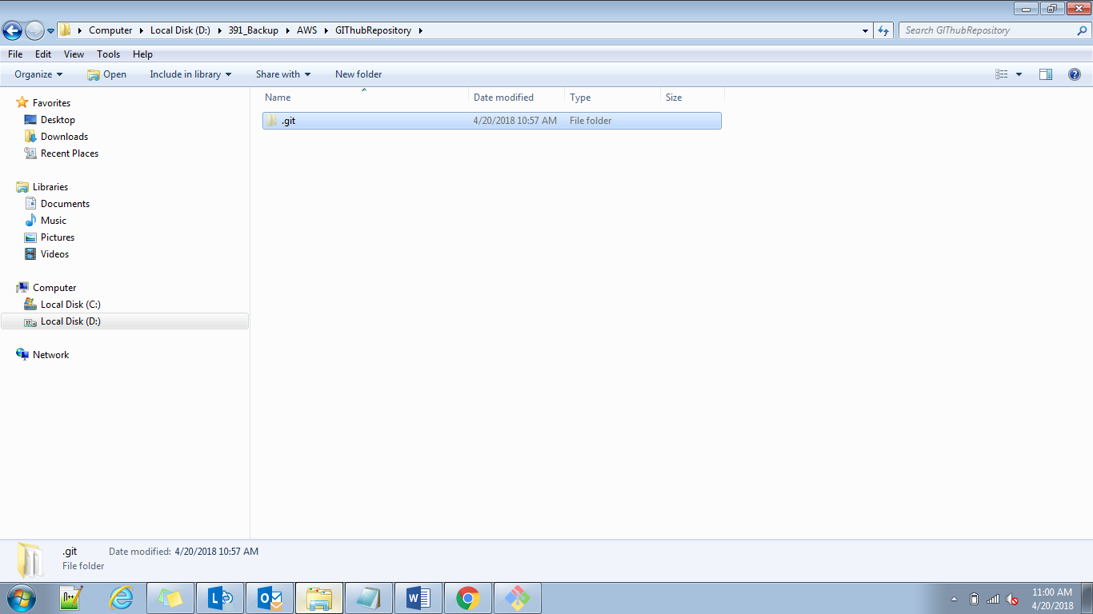

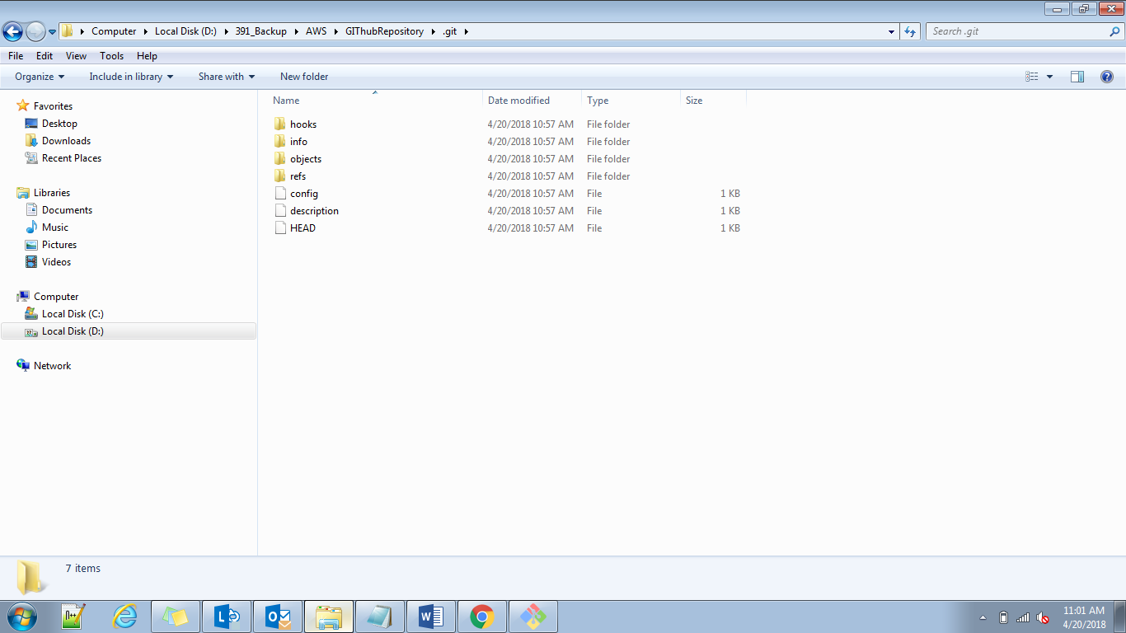

When we initialize git repository ,automatically one branch is created with name master.

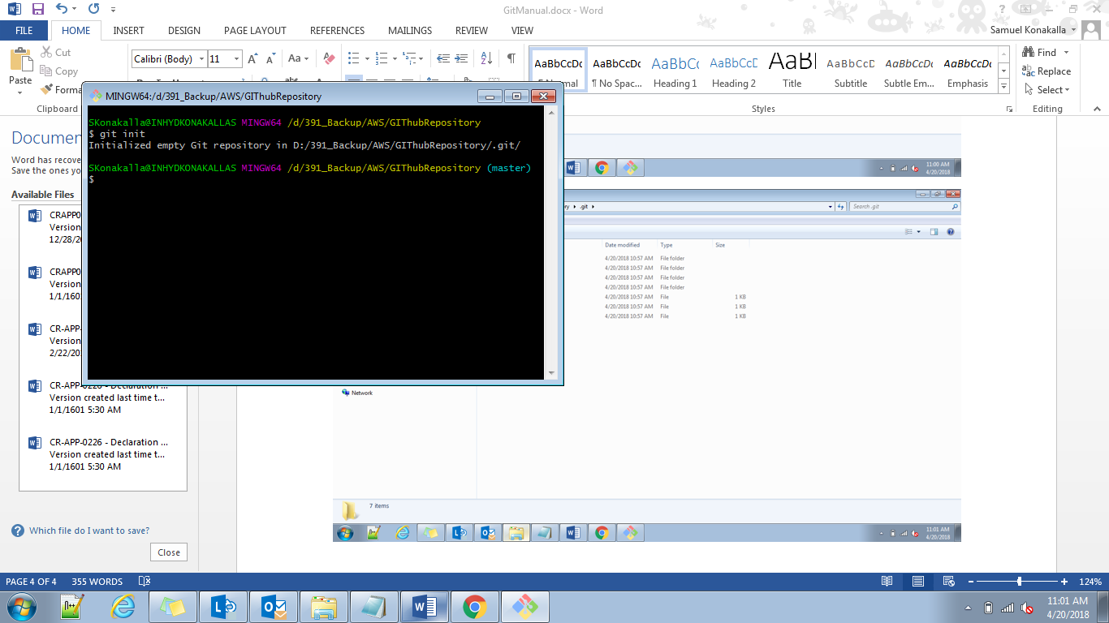

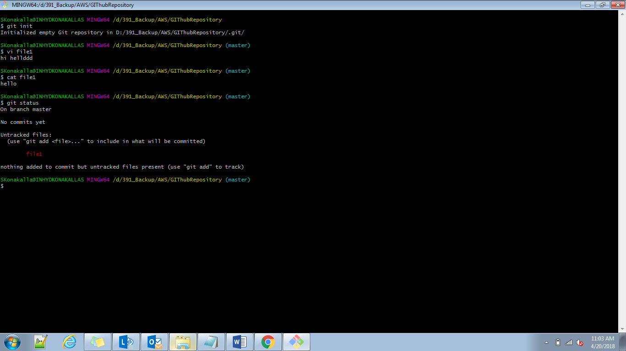

Whenever a file is in red color ,it is in working directory .

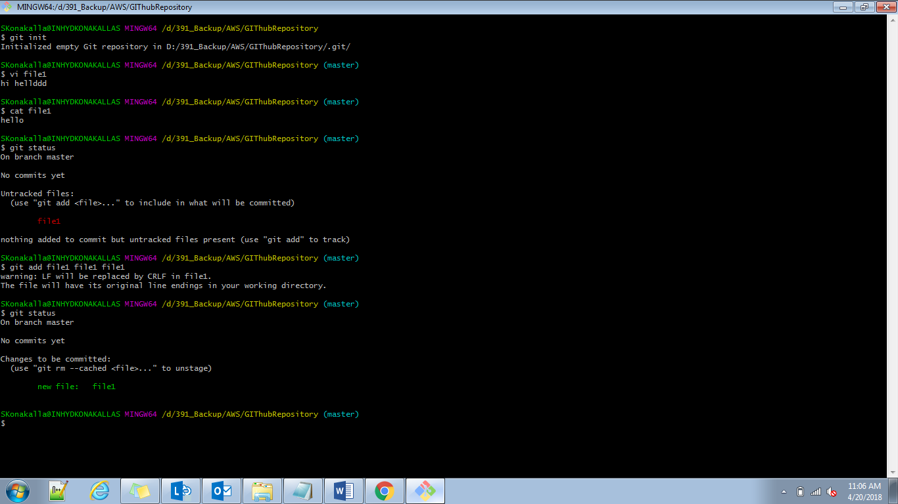

If it is in green color means it is in staging or index area.

Before we are doing any commits we have to configure our credentials with git repository.

Git config –global user.name “samuelkonakalla”

Git config –global user.email “[common.man43215@gmail.com](mailto:common.man43215@gmail.com)”

Suppose if we want to maintain a local central repository,we use below command

Git init –bare --shared

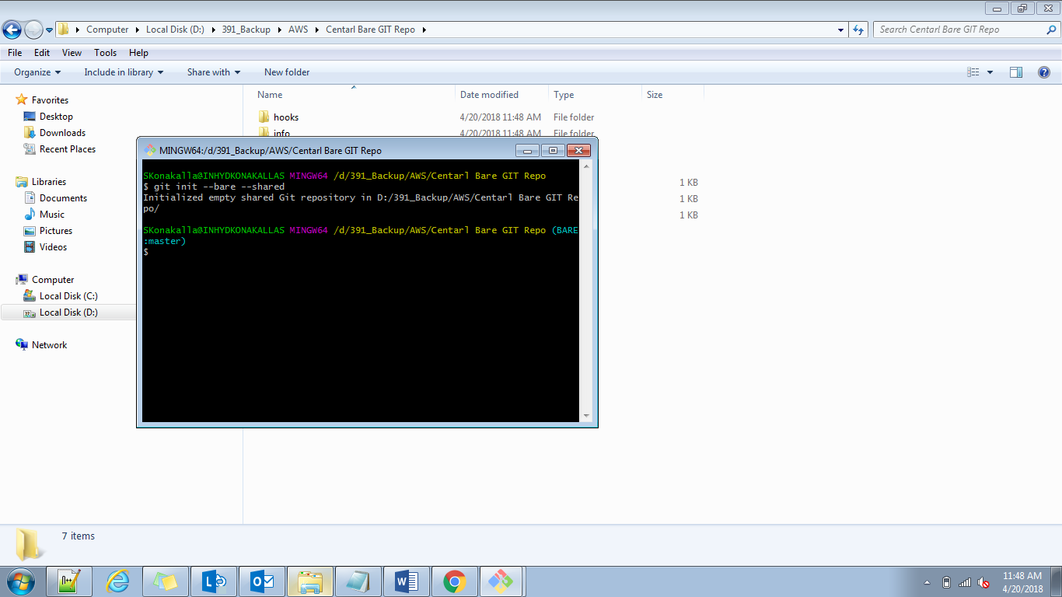

But always we will use github repo for pushing our files.and in central repo (bare )we cant modify files but in github we can.

Files will be stored in opbjects.

Git init –bare –shared.

If we want move our files from local git to central repository in same system.

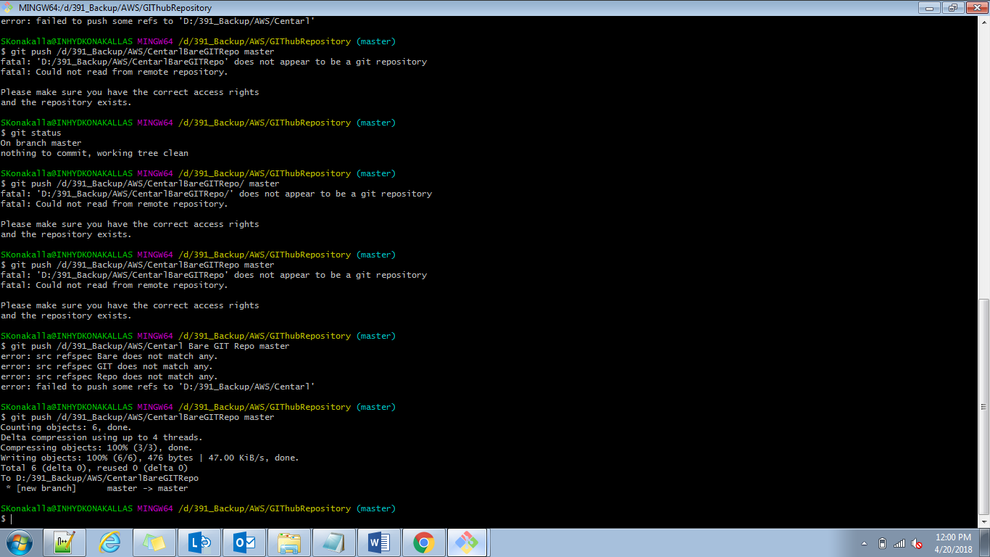

At working directory we will modifry our files.

At staging directory commits should be happened ,here which user is commiting files this information is available.

If we want to find files in local repository by using git log command.

Files are in working or staging by using color code .(git status)

Working 🡪 red color –untracked files.

Staging -🡪green color,changes to be committed.

Git config –list

User id and email id set or not.

SKonakalla@INHYDKONAKALLAS MINGW64 /d/391_Backup/AWS/GIThubRepository (master)

$ git log

commit a216b91e2bf25c17459542664d6e871c5cda7235 (HEAD -> master)—Sha code

Author: samuelkonakalla <common.man43215@gmail.com>

Date: Fri Apr 20 13:01:41 2018 +0530

a1

commit 2eb4032e42a5bbe5345602aaf051442b6ea4e947

Author: samuelkonakalla <common.man43215@gmail.com>

Date: Fri Apr 20 11:13:55 2018 +0530

syam file first commit

commit 3254c7ce33db3ce40403ce462d0415274f08d137

Author: samuelkonakalla <common.man43215@gmail.com>

Date: Fri Apr 20 11:09:16 2018 +0530

hello this is first commit

git add –A,git add .,git add *🡪all files we need to move from workspace to staging.

Suppose in above we added files to staging so if we want o commit few files then

Git commit –m “only f4 commit” f4.

Suppose if we have two files in staging ,one file we want to move to working so

Staging to working

Git reset head f4 (staging to working space)

Local to staging(sha code commit id).

Git reset –soft commitid(this commit id is before ur commit id)

Local to workspace

Git reset –mixed commitid

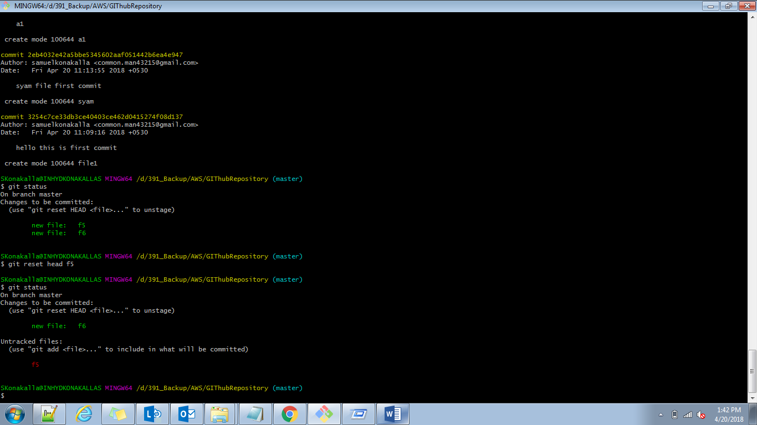

Git hub 🡪public 🡪read access to anonymous users and no read access.

Private 🡪no read and write.

If we display logs in one line

Git log –oneline

Only we need top 2 logs

Git log -2 or git log –n 2

Specific author

Git log –author==samuelkonakalla

We need logs from below date

Git log –since=2018-04-19

We need logs until below date

Git log –until=2018-04-19

Branches:

Git branch🡪all branches it will list

Git branch syambranch🡪new branch is created with name syambrnach

Git checkout master🡪switching to master branch

To merge somebranch with current branch

Suppose now we are in master ,we want to merge this one with IFT copy.

Git merge IFTcopy(brnachname)

Git push origin master

In above push statement,states that as per git the files are in local directory we will move files to remote,in above commands we did only merging not adding and commit but still we can push because whenever we are merging automatically log will be updated in master level with IFT,so already changes are done so when we push automatically it will update in remote level.

To remove a branch

Git branch –d syambranch

Suppose if we are in radhibranch we cant delete radhibranch ,if we want to remove radhibranch we switch to some other branch and then remove that branch.

Creating a branch and checkout that branch immediately

Git checkout –b syambuddybranch

If we want to remove branch from remote repository.

Git push –d origin radhibranch

Git is distributed version control system.

--It’s a system that records changes to our files over time.

--we can recall specific versions of those files at any given time.

Git config user.name

Git config user.email

Difference between two commits.

Git diff bcb2ffe79791d691245f79e4aab2e89ed2089ba38e8ab321066 e1d00d86090489ce35c7eb1cfe09b

Git branch –D syambranch (forceful deletion)

I deleted one file now I did add to git

Git rm file1

Git add file1

Now this file moved to staging ,now I don’t want to move this file ,so I go back to workspace directory.

Git reset head file1

Now file came to staging but not visible in repository.so we need to do

Git checkout – file1

How to get deleted file,by using sha code.

Git checkout hascode^1 todayfile

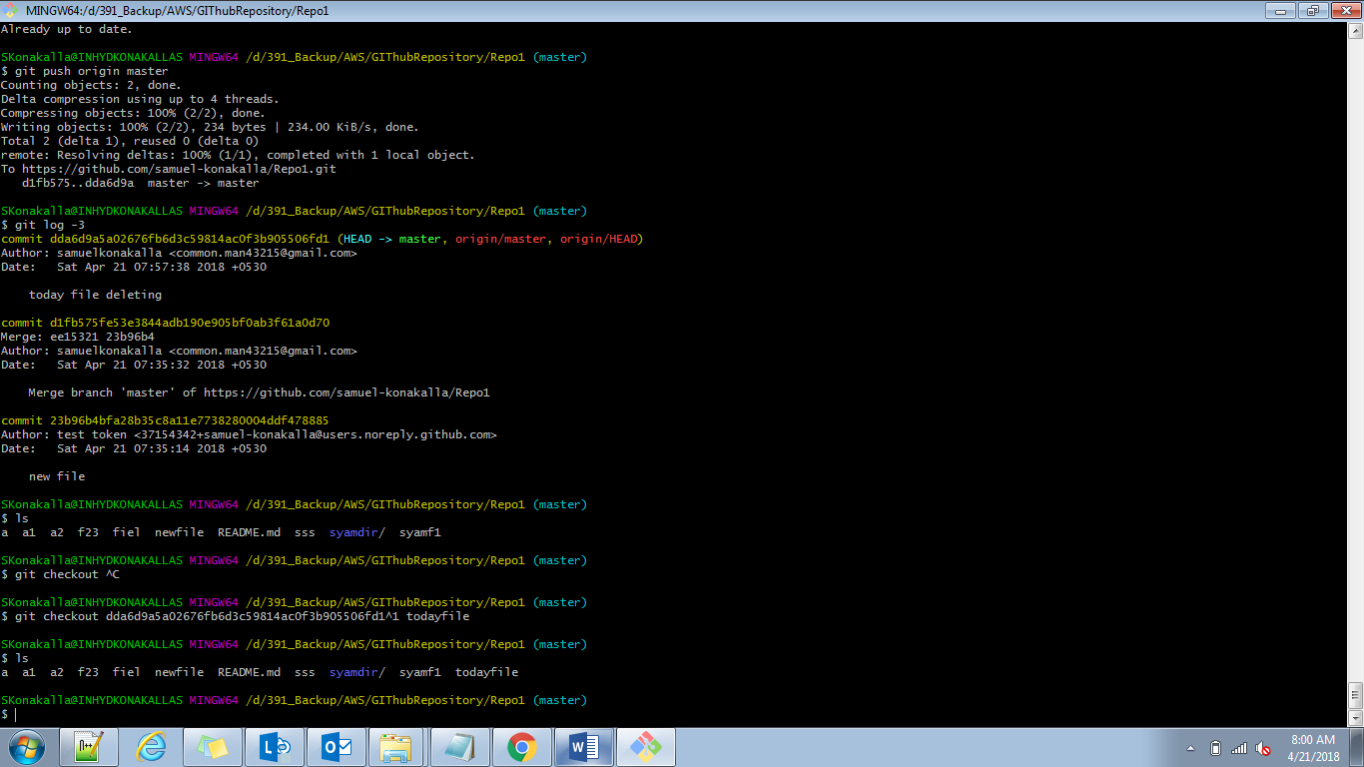

If we want to move files to bitbucket,same process before that we need add bit bucket repository to git

Git remote add bitbucket <https://bitbucketurl.com>

Adding commit will be same .

Git push bitbucket master

Git pull bitbucket master.

Git pull –force

If we want to add ssh keys to project generate ssh key in machine.copy public key and add into github repository/settings/deploykeys/add ssh key.allow write acces to this key.

After adding that key we should activate that key

ssh -T git@github.com

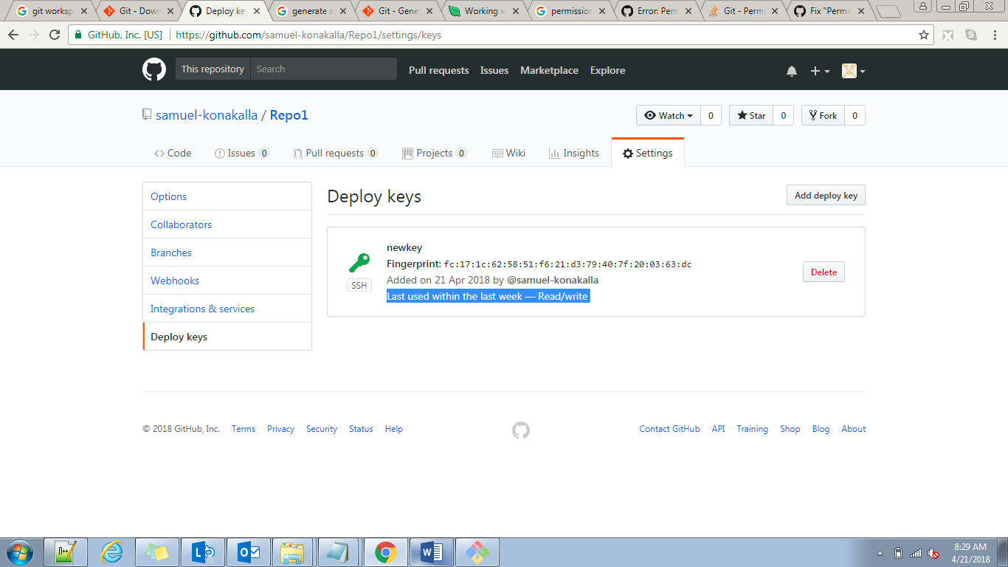

If file already available in local repository,after modifying that file directly in single statement we can commit.

Git commit –am “file commiting” -🡪for existing files only.

I have created one file with .gitignore ,in that I added few file extensions.so whenever I created those files it wil not show in work space region,git will ignore those files.

Vi .gitignore

*.php

*.class

*.sh

!index.php

SKonakalla@INHYDKONAKALLAS MINGW64 /d/391_Backup/AWS/GIThubRepository/Repo1 (master)

$ touch hello.php hb.sh syam.txt

SKonakalla@INHYDKONAKALLAS MINGW64 /d/391_Backup/AWS/GIThubRepository/Repo1 (master)

$ git status

On branch master

Your branch is up to date with 'origin/master'.

Untracked files:

(use "git add <file>..." to include in what will be committed)

syam.txt

nothing added to commit but untracked files present (use "git add" to track)

touch index.php

git status

it show this file because we are allowing this file in .gitignore

if we want to add forcefully

git add –f b.php

Stash:stash is a temporaery area under git.

Suppose we have two branches A and B.if we create f1 in A branch it is available in B also.so if we avoid this we will use stash.it is a temporary area we will store staging files into it.

Git add f1.

SKonakalla@INHYDKONAKALLAS MINGW64 /d/391_Backup/AWS/GIThubRepository/Repo1 (syambranch)

$ git stash save "f1 file storing in stash"

Saved working directory and index state On syambranch: sowhat file storing in stash

Git status

F1 file not available in staging,it is moved to stash area.

Git stash list

Copy paste into our branch 🡪git stash apply stash@{0}

Cut paste 🡪git stash pop stash@{0}-->it is removed from stash area and pasted into present branch staging directory.

The log file will be different from each branch.

Rebase apply on private branches.

Two branches master and syam.

Master contains

F1 readme.

Syam I created newly,so it is also contains same files f1 and readme.

Now I created one more file f2 in syam.

Cat > f2.

Syamf2 file

Now (syambranch)

Git add .;git commit –m “f2 created from syambranch”;

Git rebase master;git push origin syambranch

Git checkout master

Git merge syambranch

Git push origin master.