PROJECT FOLDER STRUCTURE

Alessandro Samuel-Rosa

29 February 2019

# Introduction

This is a citation of the work of SAMUEL-ROSA et al. (2015):

Using more detailed environmental covariates results in only a modest increase in the prediction accuracy of linear prediction models. (SAMUEL-ROSA et al., 2015)

# Material and Methods

How does a simple equation look like?

Lets try a more complex equation:

# Results and Discussion

We now insert a figure in the document.

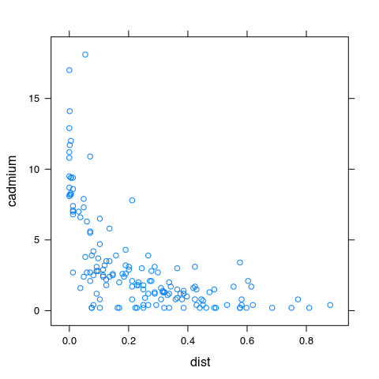

Figure 1 This is the title of the figure.

Next we insert a list of items:

* First item;
* Second item;
* Third item;
* Fourth item.

We can also insert a table in the document:

This is the title of the table

|  |  |  |
| --- | --- | --- |
| zinc | cadmium | dist |
| 1022 | 11.7 | 0.001358 |
| 1141 | 8.6 | 0.01222 |
| 640 | 6.5 | 0.103 |
| 257 | 2.6 | 0.1901 |
| 269 | 2.8 | 0.2771 |

# Conclusions

This is how a numbered list looks like:

1. First item:
2. First subitem;
3. Second subitem;
4. Second item.

# References

SAMUEL-ROSA, A. et al. Do more detailed environmental covariates deliver more accurate soil maps? **Geoderma**, v. 243–244, p. 214–227, Mai. 2015.